Using the uDrive at CSUN

What is the uDrive?

uDrive is an auxiliary storage area that provides additional disk space for campus users who wish to store their desktop files and folders on a remote server. This campus server houses all files and email messages that are sent to users’ CSUN email accounts.

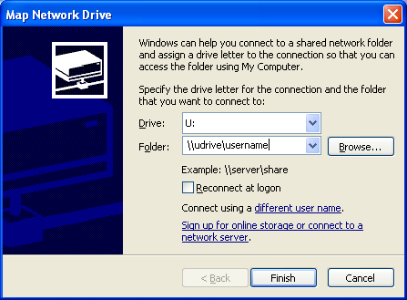

How to Connect to the uDrive

- Right click the My Computer icon on your desktop, and select Map Network Drive... The “Map Network Drive” window appears.
- In the Drive: box, click the down arrow and select the U: drive from the list of available drive names from the drop down menu, the default drive name, Z:.
- Click in the Folder: text box and type: \\udrive\xxxx where xxxx is your campus account’s user name, e.g., jsmith.
- Click Finish
- In the Connect to udrive window, type your campus user name (same as xxxx above) and password, and click OK or press Enter.
- A window listing your files and folders, including your public_html folder, will be displayed in the My Computer window. You may copy, move, and delete files to and from this drive, the same way you use any window in XP.

The Title Bar of this window reads something like xxxx on ‘uDrive@CSUN (udrive)’ (Z:) where xxxx is your campus account’s user name. This window displays the My Computer component of Windows. In fact, most of its features are the same as those in My Computer. It may also be used in Windows Explorer view mode.

The first time you map to the uDrive you will see the files that currently reside in your campus account. Many of these files may not be familiar to you. You may ignore these files and simply use the drive to copy, move, organize, and navigate through your files, folders, and drives.

