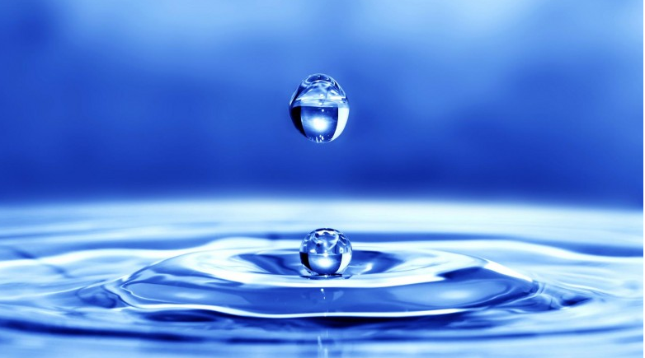

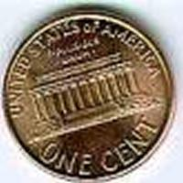

**I. Title: STEM-INTEGRATED LESSON DESIGN: *Water on a Penny***

**II.       Grade Level and Subject Area: 3rd to 5th Grade Science**

**III.      Standards:**

**Next Generation Science Standards (NGSS):**

K-5-ETS1-1.

Ask questions, make observations, and gather information

K-5-ETS1-2.

Develop a simple sketch, drawing, or physical model to illustrate how the shape of an object helps it function as needed to solve a given problem.

K-5-ETS1-3.

Analyze data from tests of two or more objects designed to solve the same problem to compare the strengths and weaknesses of how each performs.

**ELA/Literacy:**

[CCSS.ELA-LITERACY.W.1.6](http://www.corestandards.org/ELA-Literacy/W/1/6/)

With guidance and support from adults, use a variety of digital tools to produce and publish writing, including in collaboration with peers.

[CCSS.ELA-LITERACY.W.1.7](http://www.corestandards.org/ELA-Literacy/W/1/7/)

Participate in shared research and writing projects (use engineering design process)

[CCSS.ELA-LITERACY.W.1.8](http://www.corestandards.org/ELA-Literacy/W/1/8/)

With guidance and support from adults, recall information from experiences or gather information from provided sources to answer a question.

**Listening & Speaking:**

[CCSS.ELA-LITERACY.SL.1.1.A](http://www.corestandards.org/ELA-Literacy/SL/1/1/a/)

Follow agreed-upon rules for discussions (e.g., listening to others with care,

speaking one at a time about the topics and texts under discussion).

[CCSS.ELA-LITERACY.SL.1.1.B](http://www.corestandards.org/ELA-Literacy/SL/1/1/b/)

Build on others' talk in conversations by responding to the comments of

others through multiple exchanges.

[CCSS.ELA-LITERACY.SL.1.1.C](http://www.corestandards.org/ELA-Literacy/SL/1/1/c/)

Ask questions to clear up any confusion about the topics and texts under discussion.

[CCSS.ELA-LITERACY.SL.1.3](http://www.corestandards.org/ELA-Literacy/SL/1/3/)  
 Ask and answer questions about what a speaker says in order to gather additional information or clarify something that is not understood.

**CCSS Mathematics:**

[CCSS.MATH.CONTENT.1.G.A.1](http://www.corestandards.org/Math/Content/1/G/A/1/)

Distinguish between defining attributes (e.g., triangles are closed and three- sided) versus non-defining attributes (e.g., color, orientation, overall size); build and draw shapes to possess defining attributes.

[CCSS.MATH.CONTENT.1.G.A.2](http://www.corestandards.org/Math/Content/1/G/A/2/)

Compose two-dimensional shapes (rectangles, squares, trapezoids, triangles, half-circles, and quarter-circles) or three-dimensional shapes (cubes, right rectangular prisms, right circular cones, and right circular cylinders) to create a composite shape, and compose new shapes from the composite shape.

[CCSS.MATH.CONTENT.1.MD.A.1](http://www.corestandards.org/Math/Content/1/MD/A/1/)

Order three objects by length; compare the lengths of two objects indirectly by using a third object.

**IV. Engaging Context:**

* Variety of substances: water, oil, alcohol rubbing compound
* Use of Eye Droppers
* Penny for each group
* Ipads or Netbooks with GoogleSheets for Predicting and Data record
* YouTube on the molecular process of water cohesion

**V.        Justification Statement**

This lesson combines several different disciplines: science, technology for utilizing googlesheets to record predictions and data; literacy/ communication, engineering, and mathematics.

**VI.       Measurable Objectives**

Students will engage in the science “lab;” then learn the vocabulary associated with the scientific concept of water cohesion; and then apply that knowledge to create a poster that helps them to teach what they have learned about the reason why water domes on a penny and other substances do not. This lesson begins the process of understanding the molecular and chemical composition of matter. At the end of the lesson it is expected that it will have inspired awe and wonder about the natural world as well as engage each student in using scientific and engineering vocabulary; using basic science principals, and using writing skills and art to express student imagination and creativity,

Teams will present their understanding to the class by creating a poster display illustrating their understanding of *cohesion*.

**VII.     Total Time:**One Class Periods of 50 minutes.

**VIII.   Social Skills and or Habits of Mind to Engage/Assess**

|  |  |
| --- | --- |
| [ ] Persistence  [ ] Decreasing impulsivity  [ ] Empathic listening  [ ] Flexibility in thinking  [ ] Metacognitive awareness  [ ] Checking for accuracy  [ ] Questioning | [ ] Problem posing  [ ] Drawing on past knowledge  [ ] Application to new situations  [ ] Precision of language and thought  [ ] Using all the senses  [ ] Ingenuity, originality, insightfulness   and creativity  [ ] Inquisitiveness, curiosity  [ ] Enjoyment of problem solving |

**IX.      Level of Voice Appropriate for Activity:**

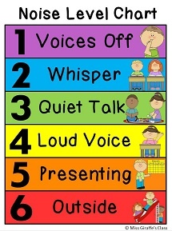

**During lab**

**During poster design**

**During group presentations**

**X.        NASA 5E Framework**

**Engage:** Direct Instruction on how we are going to learn about properties of water purity by dropping it using an eye dropper onto a penny. We will use our science skills of predicting (hypothesis testing) comparing and analyzing. We will compare water’s properties to two other substances: oil and alcohol. **(**Basic information is given by teacher about group tasks and how to use the materials and record predictions Students will each make predictions and also record their questions or wonderings about why the substances behave the way they do).

We will learn why water acts the way it does and why it is so important to us as we face the California Drought Conditions

**Explore:**Students will complete the water on a penny lab sharing the role of eye dropper for each of the three substances. Students must stay in their roles but can help with other group members’ tasks. They will watch the cohesion video together and then explore ideas as to how the water formed a dome on the penny.

**XI. Formation of Groups:  8 groups of 3 students** (Can be modified for class composition).   

**Grouping by favorite subject: Math, Science, English, Art, PE. I tell students to go to the corner labeled with their favorite class or class they feel they are best at. Then, you can then make groups by pulling one student from each corner. This works well because it results in students that each have differing learning strengths/styles based on Gardner’s Multiple Intelligences. Because this challenge requires both scientific, speaking writing listening, mathematics, engineering, and art work, there will be something for everyone to shine at.**

**Role Assignments**

* **The Materials Manager (Collects materials from the teacher. Gathers new material as needed by the group). Carries the unused substances to the teacher and returns all supplies.**
* **The Recorder/Reporter (Writes down the names of group members and records their predictions. Also records how many drops of each substance stay on the penny before overflowing. Also helps the group decide how they want to present their poster to the class).**
* **The Checker/ Facilitator (Leads discussion, asks questions, helps move the experiment along, suggests next steps and pays attention to the time limits)**

**Extend/Explain:**As students complete the water on a penny lab they naturally share their prior knowledge, observations and questions about why the substances behave the way they do when dropped one by one from the eye dropper.

After watching the animation of water cohesion they will have more questions that they attempt to explain to one another. Then the work of st**udents in creating a poster assists them in becoming more familiar with the new vocabulary terms that they experienced during the lab.**

**XI. Materials List**

* Water Droppers
* Water Cohesion Video
* Rate Your Mates Online Evaluation (Google Docs)
* Easel Paper and Markers for Team Design
* IPads or Net books if possible
* YouTube video presentation if firewall permits

<https://www.youtube.com/watch?v=VHnFMPxteGo>

**Evauate: (Assess):**  There are several formative and summative ways to assess learning in this engaged learning lesson. The first is in the individual lab write ups that show students’ original predictions and questions they had during the experiments. The students have also used mathematics. If Googlesheets has been used students gain skill in seeing data plotted in bar graphs and pie-charts. Poster and visual presentations where students use Art to draw a visual that helps them to describe theresultsalso serves as an assessment

* Content Summative Assessment: Portmanteau-activity on Vocabulary Words and definitions (spelling accuracy as per grade level)
* Poster plus Presentation as a Team. Individual information detailing student learning takeaways from the project.
* Formative Assessment of Non-Cognitive Factors: Self Assessment Using the Habits of Mind Check Sheet and Write-up Form (Google Docs).
* Content Formative Assessment: Kahoot online quick quiz using iPads to test for scientific knowledge.