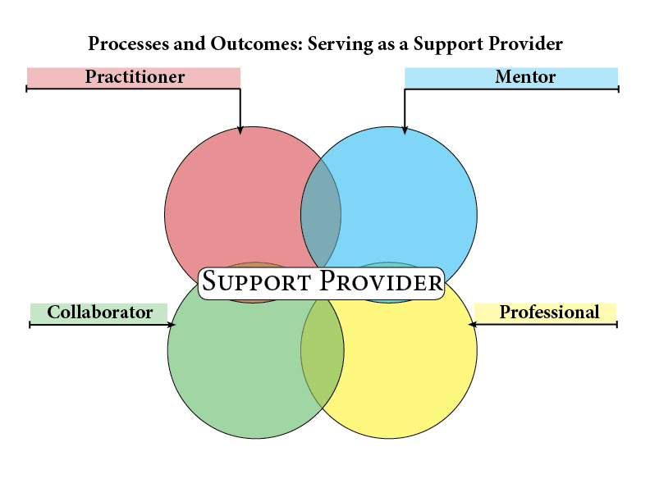

-Understands the role that veteran teachers play for aspiring teachers

-Takes time to support candidate

-Understands the ‘continuum of practice”

- Communicates a commitment to assure the professional development of the candidate

-Provides opportunities for teacher candidate to plan, teach, and reflect upon student learning outcomes

-Demonstrates availability and openness in the mentoring process

-Demonstrates a willingness to serve as a professional coach to the teacher candidate

-Demonstrates the ethics and demeanor of a professional educator

-Demonstrates respect as a member of a school faculty

-Engages in both in and out of school activities

-Shows evidence of professional growth over time

-Demonstrates an ethic of caring in making contributions to the profession that may include leadership roles

-Guides teacher candidates through processes of planning teaching, reflecting and applying

-Communicates observations in generative and helpful ways

-Models professional ethic of continuous learning and development of professional knowledge

-Engages in reflective practice

-Models appreciation of diversity in culture and ideas and students’ funds of knowledge

-Demonstrates effective classroom management skills

-Differentiates instruction to promote equity and fairness

-Possesses strong content knowledge

--Models effective questioning and active listening

Models the use of formative assessment and feedback

-Establishes strong parent-teacher relationships