**Artifact Selection on Teaching Evidence**

**Candidate** Secondary Teacher

***The What***

Standard: State what standard has been addressed/met? Date: 4/20/15

**3d3. Feedback to students:** Students receive instructive and timely feedback that will move their learning forward

Standard: State what standard has been addressed/met? Date: 4/8/15

**5b2. Promotes a culture of professional inquiry and collaboration:** the teacher promotes a culture of inquiry for the purpose of improving teaching and learning and collaborates with colleagues to do so.

Standard: State what standard has addressed/been met? Date: 3/30/15

**5a2. Use of reflection to inform future instruction:** the teacher uses reflection to inform future lessons.

***The How***

What evidence does this artifact show?

Assessment: Graded exit tickets with feedback used in the lesson, as the pre and post assessments (Figure 1), discussed in the C-3 form (Figure 2).

Figure 1:

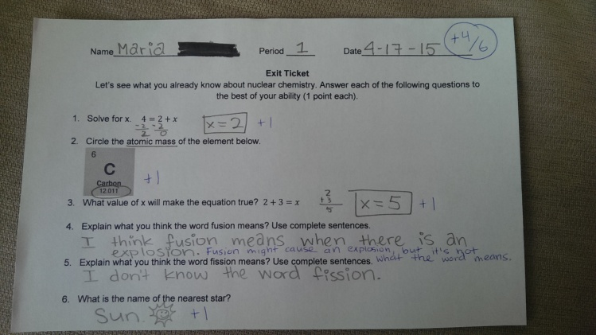 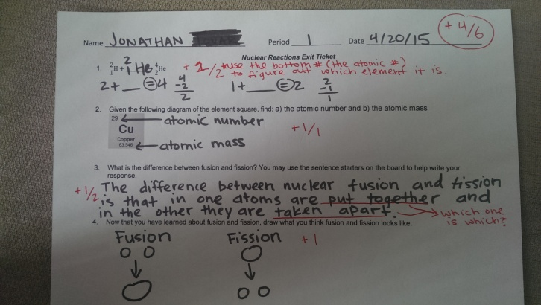

Figure 2:

|  |
| --- |
| 1. How will you provide interventions for students categorized as *minimal or partial*? What additional support may be needed? |
| To begin with, I will pass back the graded exit tickets from the previous lesson, which not only provide feedback to the students on what they got right and wrong, but gives additional input on how they can fix their mistakes/misconceptions in the future. These students will benefit from the guided notes that they will have access to, while working out problems. I will scaffold the conversations, so that I make sure to emphasize the concepts that were most missed. I will make sure that the students that scored below the expectations are seated next to students that scored at, or above the expectations, so as to help them during the pair shares and white board work. I will also make sure to check on these students frequently throughout the lesson, to see if any further clarification, or re-teaching is necessary. |

Assessment: “The effect of using guided notes for at risk high school science students.” by Sandra Jane Climenhaga

Figure 3

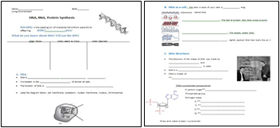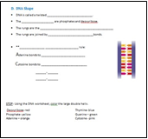

Assessment: B- 3 and B-4 forms filled out with support provider.

Figure 4

|  |
| --- |
| **CSTP 6:**  Developing as a Professional Educator |
| During lesson saw that the example of a catalyst that was given in the video was not getting the kids to focus on the correct aspect, when making their own analogies, so paused the lesson to give her own example of a catalyst instead.  After lesson told me she thought of a great way to turn her example into a mini-lab that she would try to get the supplies to do on a day when there is extra time this year, but if not, to definitely incorporate into next year’s lesson.  After seeing how the students filled out their summaries, reflected on how to write the information in the t-chart a little more clearly next time around, and what points needed to be clarified at the beginning of the next day’s lesson, before moving on. |

Figure 5

|  |
| --- |
| Key evidence shared after observation:  As students were working on their own reaction rate analogies, there was some confusing between the differences between changing the volume, versus changing the surface area, as evident by the examples they were creating.  Also on the analogy worksheet, it was clear that students understood that a catalyst made the reaction easier, but they were not all representing it as something that put the molecules into the correct orientation.  During the reflection/summary of the class, some students were only coming up with four out of the five ways to increase reaction rates, because they were unclear on the fact that increasing number of particles and decreasing volume were both forms of increasing concentration. There was also a small population of students who did not realize that increasing energy and increasing temperature were the same thing. |
| Insights:  Based on the evidence, there needed to be more emphasis placed on the academic language: volume, surface area, and concentration. This could have been incorporated into the warm-up, or as a caveat while filling out the notes. Adding visuals that go with the descriptions in the t-chart would be helpful.  The student’s idea of a catalyst should become much clearer, as I am dedicating a lesson tomorrow to how a catalyst works, however, making that lesson more hands on would be very helpful. By giving the students a mini investigatory lab that really emphasizes that a catalyst must put the molecules in the correct orientation, in order for them to use less energy when they react, there should be less confusion associated with this abstract concept.  Although I made the connection that both decreasing volume and increasing number of particles were both ways of increasing concentration, it was almost added to the t-chart as an afterthought. Next year I will not rely so much on the fact that the students remember this prior knowledge from the previous unit and will go over this concept in more depth, as well as, making sure the setup of the t-chart is very clear to the students. Part of this will involve organizing the t-chart better, but it will also involve doing more metacognition as I fill it out on the board. |

***The Why***

Your statement of why the pieces show that you have addressed/met each of the standards:

Figure 1 shows that I returned the students’ work the next day with written feedback. Rather than simply supplying them with the correct answer, I asked questions, or gave them leading information, so that they could still find the answer on their own, leading to better learning. I also made it clear what they received points for, so that the expectations were made clear. In figure 2, I highlighted where I discussed how this could be used as a tool for my students who needed further scaffolding throughout the lesson. It also acts as positive reinforcement, for those doing well.

Figure 3 is a picture from an article I looked up in response to my team’s desire to use guided notes in our lessons. My colleagues felt that it would make the lesson run more smoothly, especially for the math teachers who were teaching a scientific concept in their class. Before agreeing on this I decided to see if there was any research on the effectiveness of guided notes. The article led me to find that they can be highly useful for struggling learners, as well as, giving me examples of possible layouts. This research not only helped with this lesson, but inspired me to share this research with my colleagues, which got a positive response, and I am now looking forward to sharing more research among our group.

In figure 4 (C-3), my support provider is discussing the amendments I made to my initial lesson, in response to the students’ needs. This lead me to see how I was reflecting on my teaching practice during a lesson, which encouraged further reflection previous to the lesson. In figure 5 (C-4), I described these reflections, which led to changes that I am going to incorporate into the lesson net time I teach it, as well as further teaching that employed the next day.

**Adapted from Blackline 3.6**

Copyright © 2008 by Corwin Press. All rights reserved. Reprinted from *The Port jolio Connection: Student Work Linked to Standards, Third Edition,* by Susan Belgrad, Kay Burke, and Robin Fogarty. Thousand Oaks, CA: Corwin Press, [www.corwinpress.com](http://www.corwinpress.com). Reproduction authorized only for the local school site or nonprofit organization that has purchased this book.