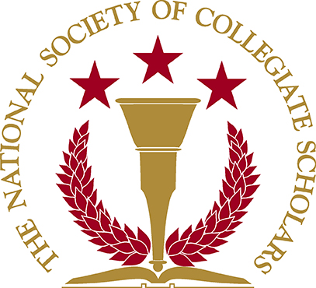

NSCS General Meeting
September 25, 2008

- Induction
  - October 19, 2008 (Sunday) from 2-4pm in the Northridge Center
    - Northridge center is downstairs next to the ticket box office.
    - Attire is business casual
    - Speak with Joe if you want to be Inducted (for those who are in the club that hasn’t been Inducted yet).
  - Volunteers? None
- Fundraiser
  - Shakey’s Pizza
    - Next Wednesday (10/1/08) and Thursday (10/2/08) from 4-9pm.
- VP of Fundraising
  - Anyone interested?
- PFCS – Kayli
- Anyone interested in shadowing Kayli and eventually take over the position next year?
i. The plan is to follow Kayli to learn what to do; get some experience; and take over as PFCS VP.
- Community Service – Cassaundra
  - Children’s Hunger Fund, Oct. 4, 08 from 9-12pm
  - Meet at G4 parking lot at 8:30 am.
  - Community Service to help pack food for kids
  - Hours can be used for a class
- Meeting minutes and other information are posted on our website, www.csun.edu/~nscs
  - Available online is next meeting dates; bio of officers; announcements, etc.
- Next Meeting: October 9, 2008 at 7pm; same room (Ventura Room)
  - If worried about walking at night to dorms; bring friends along that can give rides; ask one of the officers for a ride if you live nearby; call police escort
- Questions
- Ideas
  - Day of the Child
    - @ Santa Monica Pier
    - Adopt a child for the day
    - Experience what it feels like to be a parent
  - Relay for Life
    - March 31st.
    - 24hr event where someone from our organization must walk around campus continuously to fight for cancer of our choice.
    - Includes DJs, movies, music; anything to keep you awake
    - Feel free to camp out.
    - All money made goes to help cancer of your choice

