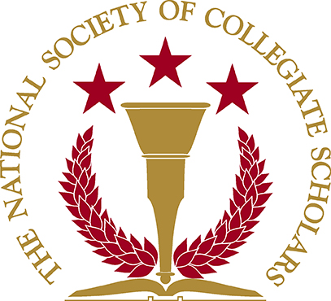

NSCS General Meeting
September 11, 2008

- Ice breaker – introduction of all the members
- Introduction of the board members
  - Members can send email to Jyoti for ideas
  - Get involved with other organizations
- NSCS Events
  - Induction Ceremony – Nancy
    - @ Northridge Center
    - October 19, 2008; Sunday @ 2pm-4pm
    - Must bring canned food to get in; canned food donate to food shelter afterwards; bring canned food for each person whose attending including person inducted.
    - Business casual attire
    - Will be pre-selling T-shirts—can buy t-shirts early or for a higher charge later on.
    - Emails will be sent out to ask members if they want to volunteer to help set up.
  - IED – Joe
    - Integrity Exploration Day
    - Probably on Saturday
    - Basically have high school students get a taste of what college feels like
  - PFCS – Kayli
      - Planning For College Success
      - Go to local high schools (i.e. Reseda High); talk to students about how to get ready for college
    - March to College
      - Bring high school students onto CSUN campus and give them a tour (i.e. sit through classes, tour dorms, bookstore)
    - Tutoring
      - Emails will be sent out for available schedules.
  - Community Service – Cassaundra
    - Day is needed to plan for community service
    - Members will need to be active in events and community services in order to get letter of recommendation.
  - Fund Raisers - Jyoti
- Other Announcements (if any)
  - Emails will be sent out if announcements arises.
- Questions
- NEXT MEETING IS ON THURSDAY, SEPT 25, 2008

