C | E | C | S | Log On Instructions

To Log into the Computers:
Enter your CSUN Portal username and password. Use the “CSUN” option under the “Log on to” at the login screen.

CSUN Username:
The CSUN username consist of two or three initials and some numbers. It is not firstname.lastname

To Get Your Login Information:
If you are unsure about your username or password or, if you have not yet activated it, logon to the computer using the below login information:

Username: account
Password: account
Log on to: CSUN

This will log you into the computer and take you directly to http://www.csun.edu/account
Log on to this webpage with your student ID number and your PIN number on the bottom half of the page. Once you are logged in, click on the link to the left to change your password. After resetting the password, please press Ctrl-Alt-Delete keys simultaneously and click on Log Off.

Problems:
Even if you already have a CSUN user account, and are certain of the username and password, you may still need to go to this website if your account does not let you log on to the CECS computers. If this is the case, login to the website with your current username and password, and then change your password.

A Valid Password Must Contain:
- A minimum of 6 characters
- A maximum of 8 characters
- At least 1 number
- At least 1 of these special characters: ! $ & * < >

For Additional Assistance:
To receive additional assistance please contact the Information Systems office location in JD1109 or JD1112. Office Hours: Monday -Thursday 8am –9pm and Friday 8am – 5pm.

C | E | C | S | Z Drive Access

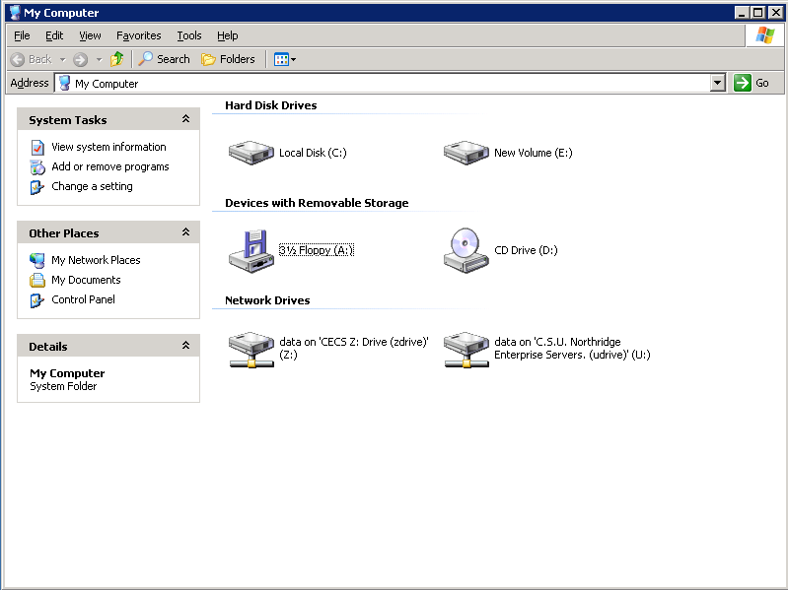
Z Drive:
Available to each Engineering and Computer Science majors and students taking CECS classes there is an individual Z Drive which is a 100Mb network drive. The Z Drive can be accessed at any of the CECS Labs. It will be listed under “My Computer” in any of these labs.

Problems:
If your Z Drive is not listed under “My Computer” follow the below steps:
- Go to http://www.csun.edu/account , login with your CSUN Portal username and password. Now check the U Drive service box, reset your CSUN portal password and log off the CSUN Account Utility site. This will activate your campus U Drive.
- Go http://www.ecs.csun.edu/zdrive and enter you CSUN Portal username and password then click “submit” to have your Z Drive created.
- Log off the computer you are at. Now log back in. Your Z Drive should now be present.

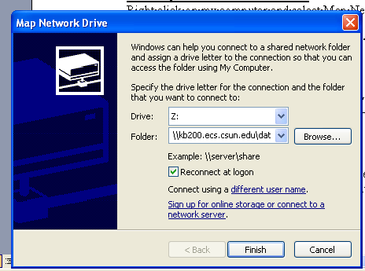
To Map the Z Drive Manual:
Right click on my computer and select Map Network Drive select Z: for the drive and for folder, type \\zdrive.ecs.csun.edu\username
Students have 100 MB of disk space on their Z Drive. Please read the Problems section above if you are unable to map your Z Drive.
Saving Files:
Students can save files on their Z Drive, floppy disks or on zip disks. USB drives can also be used by plugging the drive into the USB port on the right side or in the back of the computer.

For Additional Assistance:
To receive additional assistance please go to the Information Systems office located in JD1112 or JD1109. Office Hours: Monday -Thursday 8am –9pm and Friday 8am – 5pm.

