PERMISSION VERIFICATION FORM (PVF)
This form must be completed and returned even if there are no figures or tables in your section.

Author & Chapter Information

^{((Print or type name )}
^{(Sign)} |  | ^{(Date)}
^{(Chapter title)} |  | ^{(Chapter number)}

Option A/No Permission Required - My work, text/figure(s)/table(s), is original, has not been published before, or is in the public domain.

Option B/Written Permission IS Required -- I, the author, will obtain written permission from the copyright owner for the materials that have been published before and that requires permission via one of the following methods:
- Completing the attached Copyright Permission Request form (page 2).
- Making an online request directly to the copyright holder and/or contact person.
- Contacting the Copyright Clearance Center www.copyright.com

Permissions Required (please write/type legibly)
Please provide the complete original source line information in the columns below for any material requiring permission. This information must also be included as a full source line citation after material appearing within your chapter(s).
You must mark below as appropriate as to whether permission has been requested and/or received.
Copies of all received permission grants must be submitted to your Project Coordinator.

 | Source Information
Material in T&F work  (Fig or Table number/Text) | Author | Title | Publisher | Page no./  Publication year | Permission has been
 |  |  |  |  | Requested  (YES/ NO) | Received  (YES/NO)
 |  |  |  |  | *Grants must be submitted

COPYRIGHT PERMISSION REQUEST

To: |  |  | From:
Contact: |  |  | Contact:
Address: |  |  | Address:
City/St/Zip: |  |  | City/St/Zip:
Country: |  |  | Country:
Full Tel No.: |  |  | Full Tel No.:

I am preparing material for: ____________________________________________________________________
in_________________________________________________________________________________________
to be published by Taylor & Francis. I hereby request permission for non-exclusive world rights in this and all subsequent editions, revisions and derivative works, in English and in foreign translations, in all formats, including CD-ROM and electronic media, from the following:

I would like to include the following material from your publication:

Title:
Author:
Publication Date:

Text title and page:

Figure(s): __________________________________ Table(s): _____________________________________
_________________________________ ______________________________________
Will appear in the T & F publication as text or labeled as:
Figure(s): __________________________________ Table(s): _____________________________________
___________________________________ ____________________________________________
Please sign the release form below. Suitable credit will be given in the use of the material; if you have a preferred statement, please indicate it below. If you are not the copyright controller, please indicate to whom I should apply. Your prompt consideration of this request is appreciated.

Yours very truly,

___________________________________
^{Requestor}

I (we) grant the permission requested above.

By:________________________ Date: ___________

Taylor and Francis Use Only
Cat number:
Chapter:
Contributor:

Original copyrighted figure:

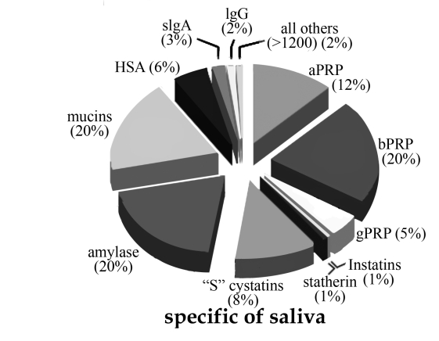

Copyrighted figure altered more than 40%:

