Simple Steps to Making a Web Page with N-Vu
And posting to the U Drive

- Open N-Vu – a blank document will be created. Set the title of the document by going to the Format menu and selecting “Page Title and Properties”. Add a title; the other information is not necessary.

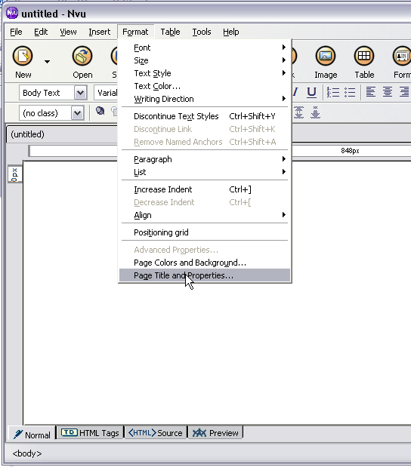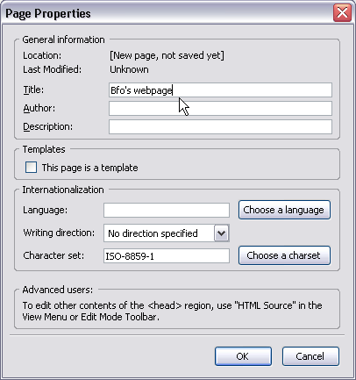

- Save the file using the extension ‘.html’. You do not need to keep the same name for the file name as for the file. If this is your first page, you should use “index.html” (why is this?). Other file names should be relatively short with only letters and numbers (no punctuation and use underscore ‘_’ for spaces).

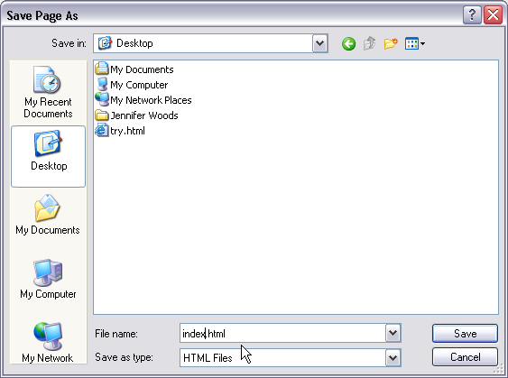

- Add text to your page by clicking, typing and formatting (just like a word processor). To change the background color select Format and Page Colors and Background. Select “Use custom colors” and click on the swatch for background.
- You can add tables for more formatting options (e.g. two columns). Click on the Table button (or Insert menu: Table…). Select the number of rows and columns. If you want an invisible table, click on the Precisely tab and set the Border to 0 (zero – table will show up as red line which will not be visible in a browser).

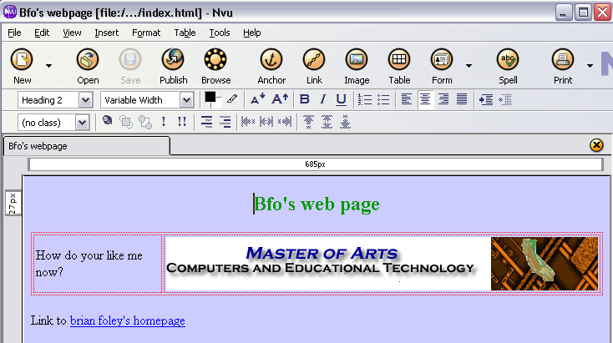

- To make a link, set your cursor in the correct location and Insert menu: Link…. Type the text to display the link and enter the URL for the location to link to. For a link to another page in your site only include the folder an file names (e.g. “nextpage.html” a relative link). For a link to another site, include “http://” and the full URL (and absolute link). | 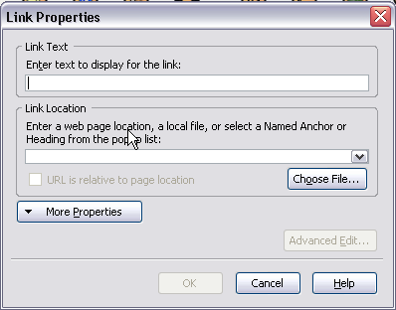

- To add a picture, you need to find a picture and save it as a separate file (e.g. mypict.jpg). Put this picture into the appropriate location in your website. This could be in the same location as your html page, or in a folder called “images” or “graphics”. The select Insert menu: Image…. For Image Location click on Choose File and select your image. You can set many properties of your image using this window (you can recall this window by double-clicking on any picture in NVu). To make your picture a hotlink, choose the Link tab and enter a URL for the file to link to (either a relative or absolute link).

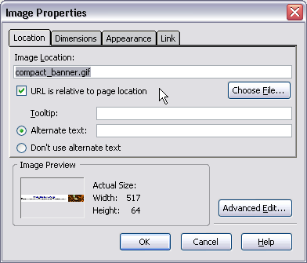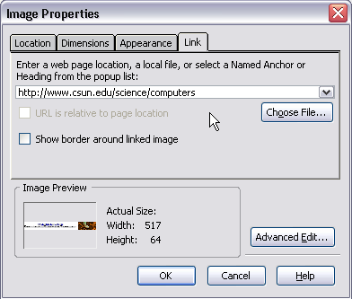

- Save your work (often) and take a look at what it looks like in a browser by clicking on the Browse button.
- Uploading to the site? TBA – when you are ready copy all your files to their same relative locations on your udrive in the folder public_html

