Your name here
7/30/26
SED 514 Assignment 1
COMPUTER BASICS

- Parts of a computer:
(A) Identify each of the following parts of a computer and give its function.
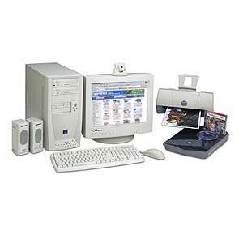
video camera

Computer Part | Function
Video camera | Take pictures, make movies and video conferencing

(B) Identify each of the following parts of a computer logic board (motherboard) and give its function.

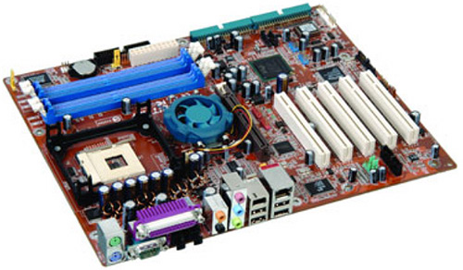

Motherboard Part | Function
CPU and Cooling Fan
PCI Slots
SDRAM Slots
Power Connector
Ports (USB, Keyboard, Sound, Monitor)

- Memory: Which of the following are differences between the computer memory (RAM) and the hard drive? (check all that are correct differences)

- Computer memory is measured in megabites and hard drives are measured in gigabites.
- Computer memory is erased when the computer turns off but hard drives retain information when the power is off.
- Computer memory uses binary numbers and hard drives use hexidecimal
- Computer memory is electrical and hard drives memory is magnetic.
- Computer memory can be accessed much faster than hard drive memory

- Storage Options: Write a couple of sentences describing each of the following types of data storage.

Floppy disc:

Zip Disc:

Flash (USB) Drive:

CD ROM:

CD R:

CD RW:

DVD ROM:

- Input and Output: Make a list of all the input and output devices that you can think of. The most obvious ones are completed for you.

Input Devices | Output Devices
Keyboard | Monitor

- Buying a computer: This is a list of information that you want to consider when buying a computer. Write a couple of sentences describing each of the following types of performance information. Include the units in which each is measured (if appropriate).

Central Processing Unit:

Processor Clock Speed:

RAM:

Video RAM:

Cache:

Monitor size:

Monitor dot pitch:

- Operating Systems
(A) What is an operating system? Write a paragraph to describe the function of operating systems.

(B) Choose your system: Identify the following operating systems with the correct description.

- Windows XP =  - Mac OSX =  - Unix =  - Linux =  - Palm OS =  - DOS = | - Operating system for handheld computers that includes a touch sensitive screen for writing letters and for selecting.  - An open source (free) operating system based on Unix which can be used on servers or desktop computers  - The latest version of the most popular operating system in the world  - A new operating system based on Unix but with a very modern graphical interface  - One of the earliest operating systems for desktop computers which used a command line interface.  - The primary operating system for large servers has been in use since the 70s. Started in Berkeley.

- Windows: Identify the parts of the Windows screen and describe each

Windows XP Part | Function

(4) Basic Commands: Place a check in the space to the left of each command you have mastered (i.e. know how to execute) in Windows.

 | Windows (view of files) |  | Folders (directories)
 | size windows |  | make folders
 | Move windows |  | understand pathnames
 | Open/close windows |  | copy folders
 | Scroll windows |  | nest folders
 | Zoom windows |  | discard and recover folders
 | activate/deactivate windows |  | lock/ unlock folders
 | Files (documents, applications) |  | Volumes (disks)
 | select files |  | format disks for DOS or Mac
 | drag file icons |  | copy disks
 | change names of files |  | erase volumes
 | Copy files |  | eject disks
 | delete files |  | rename disks
 | Move files |  | write protect disks
 | lock/unlock files
 | unfreeze computer, break oprea\tion
 | launch applications |  | Help
 | save files |  | access Balloon Help
 | backup files |  | access Program Help
 |  |  | access OS Guide
 | Network
 | select server (use chooser) |  | Other
 | select printer (use chooser) |  | control sound volume
 |  |  | get system information
 |  |  | switch programs
 |  |  | Shutdown

- Contributors to the development of the computer: Select two individuals who have made significant contributions to the development of the computer. List the contribution(s) of each individual and briefly describe its importance.
NOTE – remember to reference your sources of information

Photo | Contributions

(12) Adaptive Devices: Discuss the value of the computer as a prosthetic device. Describe three data input or output devices that may be used to make computers more accessible to students with specific physical handicaps.

(14) Binary system: Explain why computers must represent information in binary code. Identify the decimal equivalents and ASCII characters for each of the following bytes.
bit= binary digit
byte= 8 bits
ASCII Code
Dec. | Char. | Dec. | Char. | Dec. | Char. | Dec. | Char. | Dec. | Char.
32 | space | 51 | 3 | 70 | F | 89 | Y | 108 | l
33 | ! | 52 | 4 | 71 | G | 90 | Z | 109 | m
34 | " | 53 | 5 | 72 | H | 91 | [ | 110 | n
35 | # | 54 | 6 | 73 | I | 92 | \ | 111 | o
36 | $ | 55 | 7 | 74 | J | 93 | ] | 112 | p
37 | % | 56 | 8 | 75 | K | 94 | ^ | 113 | q
38 | & | 57 | 9 | 76 | L | 95 | - | 114 | r
39 | ' | 58 | : | 77 | M | 96 | . | 115 | s
40 | ( | 59 | ; | 78 | N | 97 | a | 116 | t
41 | ) | 60 | < | 79 | O | 98 | b | 117 | u
42 | * | 61 | = | 80 | P | 99 | c | 118 | v
43 | + | 62 | > | 81 | Q | 100 | d | 119 | w
44 | ' | 63 | ? | 82 | R | 101 | e | 120 | x
45 | _ | 64 | @ | 83 | S | 102 | f | 120 | y
46 | . | 65 | A | 84 | T | 103 | g | 122 | z
47 | / | 66 | B | 85 | U | 104 | h | 123 | {
48 | 0 | 67 | C | 86 | V | 105 | i | 124 | :
49 | 1 | 68 | D | 87 | W | 106 | j | 125 | }
50 | 2 | 69 | E | 88 | X | 107 | k | 126 | --
ASCII Printable characters

Place value: | 128 | 64 | 32 | 16 | 8 | 4 | 2 | 1 | Decimal equiv | ASCII character
 | 0 | 0 | 1 | 0 | 0 | 1 | 1 | 1 | 39 | '
 | 0 | 1 | 1 | 1 | 0 | 1 | 0 | 1
 | 0 | 1 | 1 | 1 | 1 | 1 | 0 | 0
 | 0 | 0 | 1 | 0 | 0 | 1 | 1 | 0
 | 0 | 1 | 0 | 1 | 0 | 1 | 0 | 1

