Register for the Sourcing Game
Go to http://ism.responsive.net/gl/som686/
You will see the following page. Make up an individual login id and password for yourself, enter it into the form, and click “Register”. Later when the game is running you will use your individual id and password to access the game.
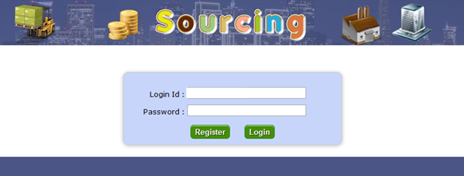
COMPLETE INDIVIDUAL REGISTRATION
Enter the course code stated in the syllabus (all lower-case) in the next form:
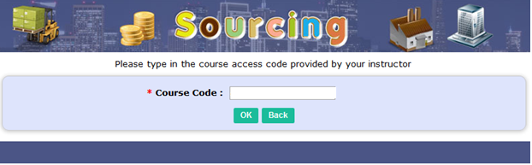
Confirm your password, enter your 8-digit registration code, and your name into the following form. The Section Id isn’t used, you can leave it as “0”. Then click “Register”
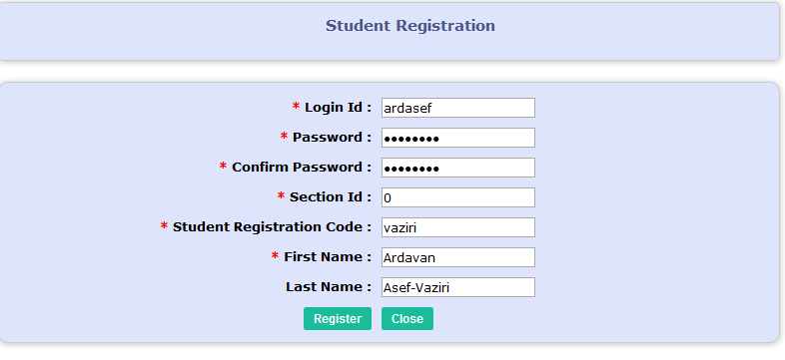
NOTE: If you receive a message that the ID is already in use, try the following:
a) Do not copy and paste the code. Type it in manually.
b) See if you already registered with the code by following the instructions in “CONFIRMING YOU ARE REGISTERED” below.
c) If that doesn’t work, e-mail your name and code to your instructor to check it.
CREATE A NEW TEAM OR JOIN AN EXISTING TEAM
On the next page, you can create a new team or join an existing team. To join a team, click the “Join” button next to your desired team and enter the team’s password in the resulting popup. You will need to get the team’s password from your teammate that created the team.
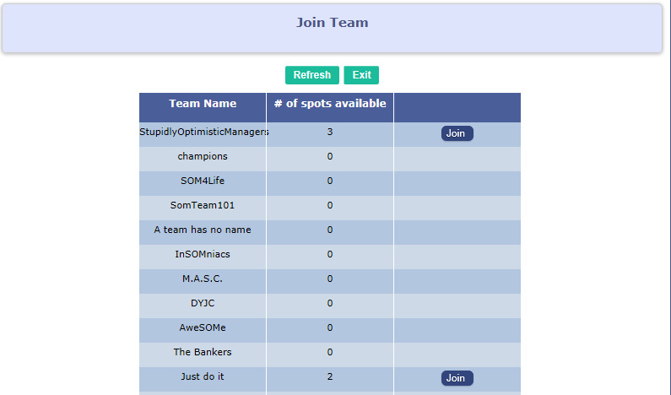

If you want to create a new team instead of joining an existing team, scroll to the bottom of the window and click Create New Team.


Make up a new team name and a new team password, and replace the default values in the form:

After you create your new team you must still join the team! Click the join button next to the name as described above and enter.
After joining a team you can confirm who is on your team by clicking the underlined team name. You can leave a team by clicking the “Leave” button, but be sure to join another team.
CONFIRMING YOU ARE REGISTERED
Go back to the original link at http://op.responsive.net/gl/csun and click on the link in Step 3 to get back to the Sourcing Game start page. Enter your id and password and click “Login.”
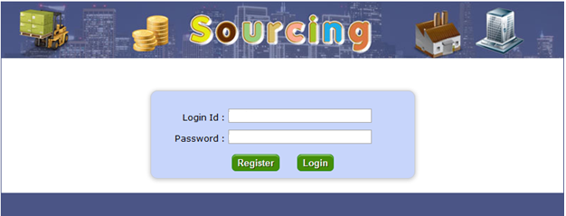

If you are registered, you will either see a game board or the following message, depending on whether or not the game has started:

If you see that message, you have completed registration. If you have registered but are not on a team, you will be prompted to join a team or create a team, as described earlier in this document. If you are not registered at all you will see an “Incorrect Password or Login Id” message.
REVERSING OR CHANGING A REGISTRATION
You can change your registration by repeating the registration process described above: go to the Sourcing Game start page, enter the ID and password you previously registered, and click “Register.” Then make any desired changes and confirm. Or if you want to delete yourself entirely, freeing up your individual code, click “delete”.
