Teaching Associate- Summer Term (JC 2324) Process Summary

Office of Human Resources / Academic Personnel & Operations

Teaching Associates (TAs) planning to work Summer Session 2023 must be hired in job code 2324 (Teaching Associates- Summer Term) via PAR form. The session dates and deadlines are noted below:
Session | Dates / Weeks | TA Summer Term PAR Due
1 | May 30 to August 22, 2023 (12 Weeks) | May 30, 2023
2 | May 30 to July 11, 2023 (6 Weeks) | May 30, 2023
3 | July 12 to August 22, 2023 (6 Weeks) | July 12, 2023

To ensure accurate and timely processing and payment of Summer TA appointments, a college point-person will submit to Human Resources, attention Chantal Sood, an approved Summer TA PAR form. This document is necessary in order to convert academic year pay to summer equivalency.
- The Approved Summer Teaching Associate (TA) PAR must contain the following information:
  - Teaching Associate’s Name
  - Empl ID & Rec #
  - Monthly Base Rate from AY Appointment (Job Code 2354)
  - Summer WTUs
  - Summer Session working
  - Summer TA Actual Salary
Note: The information provided on the Summer TA calculation portion of the PAR may serve as the department’s control document to facilitate the preparation of the TA’s appointment letter. The approved PAR form (one per session) will be used by HR to hire and separate the TA’s summer appointment. Corrections and/or revision of units, session dates, early separations, and cancellations of appointments must be communicated to HR Academic Personnel & Operations immediately.

Teaching Associate- Summer Term Process Summary (Continued)
Enter the following information on the Summer TA PAR form:
Line Item | Required Information
1 | College Name, Date
2 | Empl ID #, Record #, Empl Position #
3 | Name (First, Middle Initial, Last)
4 | Summer Session info as appropriate
6 | TA AY Info, Department
8 | Dept ID, AY Job Code, AY Duration, Summer WTU, AY Base Salary
9 | Select the session TA is teaching by placing an “x” in the appropriate box (one box only)

NO ADDITIONAL ENTRIES REQUIRED
Obtain approval signatures and submit Summer TA PAR Form to HR-
Figure 1 TA Summer Term Workflow (Revised 04/2020)
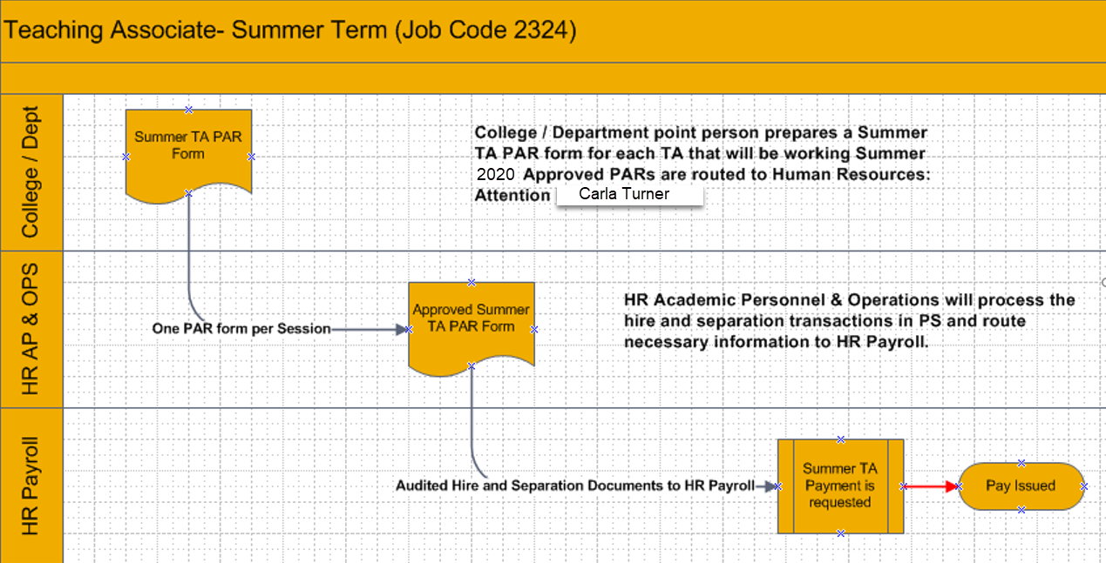
2023
Chantal Sood

This information is necessary in order to convert AY pay to equivalent summer pay.
The Summer TA Actual Salary is the expected gross due TA for total summer work in the selected session.

