HR: Academic Personnel

Summer 2020 Hiring &
Processing
Guide

Sponsored by The Tseng College

Presented by The Office of Human Resources
& The Office of Faculty Affairs

Tuesday, May 5, 2020
Via Zoom Webinar

Available On-Line at:
https://www.csun.edu/hr/hr-toolkit

Summer 2020
Academic Personnel Hiring & Processing Guide

Summer 2020 – Overview 2
Self-Support vs. State Support 2
Summer Session Dates 2
Summer 2020 Processing Deadlines and Payroll Dates 2
Faculty - Summer Module 2
Teaching Associates & Graduate Assistants – PARs 3
Instructional Student Assistants & Student Assistants – Hourly Student Employee Summer Form 3
Processing 4
AY Full-time and Part-time/Temporary Faculty 4
Teaching Associates and Graduate Assistants 5
Instructional Student Assistants & Student Assistants 5
Manager’s Workbench 5
Summer 2020 Processing-At-A-Glance 6
Appointments & Workloads 7
Order of Assignments 7
FERP Faculty 7
12-Month Department Chairs 7
Non-Exempt Staff Hired as Instructors 8
Additional Employment (125% Rule) 8
TA Appointments, Posting, and Notifications 8
Workloads 9
Salary Information 10
Faculty and Lecturers 10
Department Chairs 10
New Summer Hire Faculty 10
Enrollment Based Compensation 11
Indirect Instructional Compensation (IIC) 11
Academic Student Employees 12
Teaching Associates 12
Appointment Letters 12
Faculty 12
Academic Student Employees 12
Templates 12
Cancellation of Appointments/Classes 13
Faculty and Teaching Associates 13
Graduate Assistants and Instructional Student Assistants 13
Faculty Entitlements 14
Contractual Provisions / Benefits 14
Faculty Appointed Solely to Summer Term Employment 14
Benefits 14
Faculty Summer Health Benefits Stipend 14
Teaching Associate Vacation Benefits 14
Summer 2020 PARs Needed List and Samples 15
Summer Sample PAR #1 – Department Cancels Class after Start of Session 16
Summer Sample PAR #2 – Faculty Member Withdraws From Appointment 16
Summer Sample PAR #3 – Faculty Member Starts Appointment Late 17
Summer Sample PAR #4 – Low Enrollment Salary Adjustment 17
Summer Sample PAR #5 – Low Enrollment Class and Late Start 18
Summer Sample PAR #6 – Teaching One Regular & One Low Enrolled Class 18
Summer Sample PAR #7 – Department Chair Teaching In Summer 19
Summer Sample PAR #8 – Rehired Annuitant Teaching In Summer 19
Summer Sample PAR #9 – Teaching Associate Teaching In Summer 20
Summer Sample PAR #10 – Service Retirement PAR 20
Summer Sample PAR #11 – Separation / Resignation 21
Summer Sample PAR #12 – Completion of 5 Years of FERP 21
Summer Sample PAR #13A– Newly Retired Faculty Beginning FERP – 1 of 2 22
Summer Sample PAR #13B – Newly Retired Faculty Beginning FERP – 2 of 2 22

Summer 2020 – Overview

Self-Support vs. State Support
For Summer 2020, the majority of classes offered at CSU Northridge will be offered as self-supported summer session courses through The Tseng College. Faculty hired to teach self-support designated classes will be hired by campus departments into job code 2357 – Instructional Faculty, Summer Session – Extension via the Summer Module.

Only special programs with six (6) departments have been authorized to offer state-supported summer session courses in Summer 2020; these are: ELPS (Ed.D.); Physical Therapy (DPT); Social Work (MSW); Nursing (Accelerated Degree - ADN-BSN); Athletic Training (BS); Faculty hired to teach state support designated classes will be hired by these campus departments into job code 2457 – Instructional Faculty, Summer Session, State Support via the Summer Module.

Summer Session Dates

Summer Session 1 [R1, 12 Weeks (60 Days)] Tuesday, May 26 – Tuesday, August 18, 2020
Summer Session 2 [R2, 6 Weeks (30 Days)] Tuesday, May 26 – Tuesday, July 7, 2020*
Summer Session 3 [R3, 6 Weeks (30 Days)] Wednesday, July 8 – Tuesday, August 18, 2020
*Friday, July 3, 2020 – Independence Day Holiday – Campus Closed

Summer 2020 Processing Deadlines and Payroll Dates

Faculty - Summer Module
Faculty are hired in the Summer Module in sequential order by session, and paid after the session ends.

Summer 2020 | Session 1 | Session 2 | Session 3
Effective Start Date | Tuesday, May 26, 2020 | Tuesday, May 26, 2020 | Wednesday, July 8, 2020
Effective End Date | Tuesday, August 18, 2020 | Tuesday, July 7, 2020 | Tuesday, August 18, 2020
Weeks | 12 | 6 | 6
Academic Workdays | 60 | 30 | 30
Module Keying Deadline | May 22, 2020 | May 22, 2020 | June 26, 2020
Module Approval Deadline | June 9, 2020 | June 9, 2020 | July 21, 2020
Census Data (for Calculating Low Enrollment) | June 6, 2020 | June 6, 2020 | July 18, 2020
All PARs Due to HR  (Low Enrollment, Adjustment, Other Hires) | July 24, 2020 | June 26, 2020 | July 24, 2020
Grades Due | August 25, 2020 | July 14, 2020 | August 25, 2020
Pay Day | August 31, 2020 | July 30, 2020 | August 31, 2020

Academic Student Employees and Student Assistants

Teaching Associates & Graduate Assistants – PARs
For Summer 2020:

Departments hiring Teaching Associates – Summer Term (2324) and/or Graduate Assistants – Monthly (2325) must submit a PAR to Human Resources (Attn: HR OPERATIONS) by not later than May 7th for appointments beginning in May. TAs and GAs will be hired and separated by Human Resources.

TAs and GAs are paid on a monthly basis.

Pay Period Submit PAR By: Payroll Date:
05/01/2020 – 05/31/2020 May 7, 2020 May 29, 2020*
06/01/2020 – 06/30/2020 June 8, 2020 June 30, 2020
07/01/2020 – 07/30/2020 July 8, 2020 July 30, 2020
07/31/2020 – 08/31/2020 August 7, 2020 August 31, 2020
* May 30th warrant would represent three days of pay (May 26-29, 2020).

Instructional Student Assistants & Student Assistants – Hourly Student Employee Summer Form
For Summer, 2020:

- Per campus directive, no student employee will be paid beyond May 22, 2020 without an approval from the President’s Office.
  - Therefore, all student employee jobs will be terminated effective 5/22/20.
  - All hours must be entered before the mass termination process run on June 3rd, 2020.
- Once President’s approval is received, only then can the student employee remain active for summer or be hired/rehired for Summer Session via the Student Module.

ISAs, SAs and NCS are processed through online positive pay (Weekly Elapsed Time Module), and paid on a mid-monthly basis. Time and Attendance should be keyed according to the Time and Labor Deadlines on the University Payroll Calendar.

Pay Period: Payroll Date:
05/01/2020 – 05/31/2020 Monday, June 15, 2020
06/01/2020 – 06/30/2020 Wednesday, July 15, 2020
07/01/2020 – 07/30/2020 Friday, August 14, 2020
07/31/2020 – 08/31/2020 Tuesday, September 15, 2020

Processing

AY Full-time and Part-time/Temporary Faculty

When hiring a faculty member via the Summer Module or a PAR, you will need to determine and indicate whether to use Class Code 2357 – Self-Support Summer or Class Code 2457 – State Support Summer. Only those departments who received prior approval to hire instructors as State Support for Summer 2020 should use Class Code 2457. The Range/Rank for all Summer faculty will be 1 (indicating “semester campus”).

Summer Module
The Summer Module will be available for hiring beginning Monday, May 4, 2020.

When entering a faculty appointment in the Summer Module, the module will provide a drop down choice of hiring into either the 2357 Self-Support Class Code, or the 2457 State-Support Class Code. You will need to choose the correct class code.

Class Code 2357 – Instructional Faculty, Summer Session – Extension (self-support funded courses), will be used to hire ALL faculty offering instruction as part of the Self-Supported Summer terms into the Summer Module.

Class Code 2457 – Instructional Faculty, Summer Session – State Support (regular, general state funded course schedule), will be used to hire all faculty offering instruction as part of the State-Supported Summer terms into the Summer Module.

The module does not allow for retroactive entries, so sessions must be entered in date (Session) order; Sessions that begin with the same effective date may be entered in any order.

If searching for “Session” the module will present four choices. Please be careful to choose the appropriate session code:

01 = Summer Session 01 03 = Summer Session 03
02 = Summer Session 02 09 = Summer Early Start

Transactions that cannot be processed in the Summer Hiring Module should be processed via a PAR. Cancellation in the Module only applies to people who are appointed, do not work and therefore are to receive no compensation. Do not use “Cancellation” to correct or ‘redo’ an incorrect entry or to cancel a class after the first class.

PARs

- Department Chairs & Rehired Annuitants
- Late Hires & Non-Sequential Hiring
- Early Separation or Class Cancellation after Start of Session
- Low Enrollment Based Compensation Adjustments
- Salary Updates or Other Corrections

Appointing of Rehired Annuitants and Department Chairs that will be teaching in Summer for additional pay is to be done on PARs. Please indicate the appropriate Class/Job Code. See “Salary Information” for additional information on processing Department Chair appointments. Corrections and appointments that involve Updating Salaries, Late Starts, Enrollment-based Reduced Compensation, and early Separations due to cancellations or withdrawals should be processed via a PAR.

All PARs should be submitted to Human Resources as soon as possible and not later than Friday, June 26, 2020 for Session 2 appointments, or Friday, July 24, 2020 for Session 1 and/or Session 3 appointments. Meeting these deadlines helps avoid late payments or overpayments and the need for establishing an Account Receivable.

Teaching Associates and Graduate Assistants
PAR Form
For Summer 2020, Teaching Associates should be hired in job code 2324 (Summer Term) and Graduate Assistants should be hired in job code 2325 (Monthly) by submitting a PAR to Human Resources.

TA’s (2324) and GA’s (2325) must be in a CSU graduate degree program and either currently enrolled or continuing their enrollment in the Fall term. Teaching Associates are employed to perform instruction in the department in which they are seeking a degree. Graduate students in credential programs or graduate programs outside the CSU are not eligible to be employed in a student classification. (A TA or GA who graduates this Spring cannot be hired to continue in a student classification. If they are hired as a Lecturer to teach in Summer, they must be hired via a PAR.)

Instructional Student Assistants & Student Assistants
The Student Module and the Hourly Student Employee Summer Form

An “Hourly Student Employee Summer Form” must be completed by every undergraduate and graduate student employed in the summer in a Student Assistant, Instructional Student Assistant, or Non Resident Alien Student Assistant position. Please use the “Hourly Student Employee Summer Form” as a guide to hire the student employee into the correct job code, and for information on FICA tax exemption and the maximum number of hours to be worked per week.

Manager’s Workbench
Pooled 2357 Summer Self-Support positions, 2457 Summer State-Support, and 1874 (Taxable Student Assistant) positions exist from last Summer for all departments that had positions established in Summer 2014. If you require additional 2357 positions or changes in the “reports to” please submit a completed Action Request Form to Human Resources, UN 165, MD 8229. Any necessary changes to the funding strip for summer instructional personnel should be made directly by the department.

Summer 2020 Processing-At-A-Glance

Position | Entry Point
 | Summer Session Module | Part Time Faculty Module | Student Module | Personnel Action Request (PAR) Form | Hourly  Student Employee Summer Form | Action Request Form (ARF)
2357, 2457 Faculty (Hired or Rehired from 2358, 2360 position) | √
2357, 2457 Faculty, NEW | √
2357, 2457 Faculty, Late Start |  |  |  | √
2357, 2457 Faculty, Low Enrollment Adjustment |  |  |  | √
2481 Department Chair hired as 2357 or 2457 |  |  |  | √
2357, 2457 Rehired Annuitant (non-FERP) |  |  |  | √
2357, 2457- New position # needed OR |  |  |  | √ |  | √
New position # for a different reporting relationship
All Faculty Salary Updates and After-the-Fact Corrections |  |  |  | √
2324 - Teaching Associate – Summer Term |  |  |  | √
2325 - Graduate Assistants (monthly) |  |  |  | √
1150, 1152 - Instructional Student Assistant |  |  | √ |  | √
1870 - Student Assistant |  |  | √ |  | √
1874 – Taxable Student Assistant (Bridge Student Assistant) |  |  | √ |  | √
1868 – Student Non-Citizen Status |  |  | √ |  | √

Appointments & Workloads

Faculty are to be appointed at the same academic or librarian rank held during the immediate past academic year. Acceptance of an appointment and course assignment includes an agreement by the employee to meet the class on the first day regardless of enrollment, for classes not cancelled prior to that time. If the course to which a faculty member has been assigned has fewer than twenty (20) students, at the second class meeting, the faculty member may withdraw from the appointment at that time. If a class is cancelled or a faculty member withdraws from a low enrolled class, s/he is to be paid on a pro-rata basis for each day of class taught prior to cancellation. If a faculty member continues to teach a low enrolled class, they will be paid via enrollment based compensation (see Salary Information).
Summer term employment for Unit 11 Graduate Assistants (2325) and Instructional Student Assistants IS NOT a conditional temporary appointment. If a Graduate Assistant position that has been offered and accepted is no longer available, the employee shall be placed in an appointment at the same level of compensation for the academic terms stated in the appointment notification or receive the same compensation in lieu of the position.
Summer term employment for Unit 3 Faculty instructional personnel, whether self-support (2357) or state-support (2457) IS a conditional temporary appointment for a specific period of time, in that it may be cancelled based on budget and/or enrollment.

Summer term employment for Unit 11 Teaching Associates (2324), and Student Assistants IS a conditional temporary appointment for a specific period of time. Student appointments may be cancelled based on budget and enrollment, but the student employee is to be paid for any hours assigned/worked prior to the cancellation (on a pro-rata basis).

Order of Assignments
Appointment of summer instructional faculty in job code 2357 Self-Support does not need to adhere to the Order of Assignment criteria.

Only the appointment of summer instructional faculty into job code 2457 State-Support must adhere to Order of Assignment criteria as outlined in Article 21.24 of the Collective Bargaining Agreement. For assistance with questions on the order of assignment or entitlement, please contact Faculty Affairs at extension 2962. Those departments authorized to hire faculty into State-Support classifications should offer work first to enough probationary and tenured faculty so that of all faculty appointed in State-Support summer term, the percentage by headcount who are probationary and tenured faculty is no less than 41%.

FERP Faculty
FERP Faculty cannot teach for extra pay during Summer.

12-Month Department Chairs

The MOU between the CSU and CFA allowing for 12-Month Department Chairs (Code 2481) to teach during Summer up to the 125% limit remains in effect through the 2014-2017 Collective Bargaining Agreement. This MOU allows Department Chairs to participate in the 25% additional employment provision under Article 36, even if the additional employment is funded from general fund sources or consists of employment not of a substantially different nature from the Department Chair’s primary or normal employment.
7

Non-Exempt Staff Hired as Instructors
12-Month Department Chairs who teach in the summer need to charge vacation day(s) for any hours in excess of 10 hours per week over the entire summer term. The calculation of vacation days to be used by Department Chairs is charged in full day increments. Please contact Faculty Affairs for assistance if you have any questions.

Example: A 12-month Department Chair teaching a 3 unit course in any Summer Session would need to charge a total of 2 vacation days (16 hours) for the summer term. Total teaching hours = 45.33 hours per unit X 3 units= 136 hours. A Department Chair would be allowed 120 hours (10 hours a week X 12 weeks) per the 125% rule.

Thus, for a 3-unit class, 136 hours (3 units) – 120 hours allowed for 12-month Department Chair’s summer session = 16 hours or 2 vacation days to be taken for the summer term. For a Department Chair teaching 6 units during the summer, 45.33 hours per unit X 6 units= 272 hours. With 120 hours allowed for 12-month Department Chair’s summer session, 152 hours or 19 days of vacation would need to be taken for the summer term. Since Chairs are exempt they need to take vacation in full day increments only.

This time must be entered and approved in the Time and Labor Module by the Department/College.

Additional Employment (125% Rule)
12-Month Faculty are not covered by the above Summer MOU and as such cannot teach additional courses during Summer.
Employees who work in a non-exempt staff position and are hired in an exempt Academic Personnel position must be paid overtime when the concurrent appointments result in a time-base greater than 1.0. The cost of overtime is to be paid by the department assigning the additional work. Be sure that total employment does not exceed 125% as allowable.
Additional employment and overload limits (125%) for AY Faculty are calculated and applied independently during summer periods. Please see the enclosed workload chart or contact Faculty Affairs at extension 2962.

TA Appointments, Posting, and Notifications
Summer Employment for Teaching Associates shall follow the same recruitment process as the Academic Year with the exception of Article 2.7 and 2.12 (Please see Article 21 of the Unit 11 contract). Written notice of appointment/reappointment shall be provided no less than 30 days before the start of the appointment. If a position(s) becomes available in less than 30 days before the commencement of the appointments, notice shall be provided as soon as practicable after the decision is made.

Summer TA position openings shall require an approved Teaching Associate Position Opening form. (Please send an electronic form to Albert Alcazar at albert.alcazar@csun.edu). Departments will be notified of the approved position by Faculty Affairs. Faculty Affairs will post the position on the Faculty Affairs ASE website. In addition, Departments are required to post the position(s) on their respective website.

Workloads

Academic Year Faculty

AY Faculty are still restricted by the number of units they can work in the summer. Using the following chart, an AY faculty member cannot exceed a workload of more than 50 hours per week.

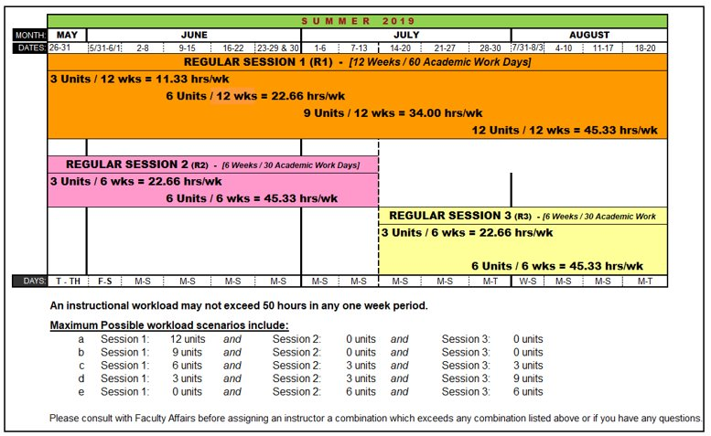

Academic Student Employees
Unless otherwise noted below, Academic Student Employees are limited to a maximum of 40 work hours per week. The above chart will assist you in determining the maximum number of hours an ASE paid by units may work during summer.

Teaching Associates may be appointed at any time-base and up to full time if not enrolled in classes. If appointed at half-time or more, a TA may not be appointed concurrently in another student classification. TAs appointed for less than half time may be appointed concurrently in another student classification, up to a combined total of 20 hours per week.

Graduate Assistants may be appointed at any time-base up to and including halftime (20 hours = .5 FTE) while enrolled in classes. GAs may be appointed at any time-base less than full time if not enrolled in classes. GAs may be appointed concurrently in another student classification up to a combined total of no more than 20 hours per week.

Instructional Student Assistant appointments may be made for no more than 20 hours per week while the student is enrolled in class. An ISA may work more than 20 hours per week while not enrolled in class.

Salary Information

Faculty and Lecturers

For eligible 2360 and 2358 faculty, the module will populate the Monthly AY Base pulling from the Spring 2020 salary base. The module will then determine the Unit Rate by multiplying the AY base by 12 and dividing by 30. The module will calculate the Total by multiplying the Unit Rate by the number of Summer WTUs. Summer WTUs should be calculated and assigned in the same manner as those calculated and assigned for the preceding AY term. If the faculty member last worked, Fall 2019, you will need to calculate the 1/30th rate and input the figure in the module.
Only faculty who held a Fall 2019 and/or Spring 2020 appointment (2360, 2358, and 2481) will be paid at the “1/30th rate” calculated according to the following formula:

(FT AY Salary Rate / 30) = 1/30th Unit Rate x (# Summer WTUs) = Total Pay Amount

For example, a faculty member with a (full-time) monthly base of $7,109 during the 2017-2018 Academic Year, and teaching one 3 unit course in any summer session would earn $8,530.80 for that course:

([$7,109 x 12 = $85,308] / 30) = $2843.60 x (3WTU) = $8,530.80

If the faculty member was not employed by the University or in the Summer hiring department in at least one term in the 2019-2020 academic year, the faculty member may be appointed at any salary on the salary schedule for the job code. Department Chairs should contact Faculty Affairs with any questions about initial placement on the rank and salary schedule.

Department Chairs
Department Chairs teaching as part of Summer YRO with compensation must be hired via a PAR submitted to Human Resources (see Summer PAR Sample # 7). To calculate the summer instructional unit rate for a Department Chair teaching during the summer, first subtract the Department Chair Stipend from their monthly base salary then divide by 1.15. The new figure is the AY monthly base which must be multiplied by 12 and then divided by 30 to obtain the summer unit rate. Contact Faculty Affairs if you need assistance in determining the Department Chair Stipend to be subtracted from a Department Chair’s monthly base salary.

All PARs to hire Department Chairs to teach for extra pay during Summer must be submitted through Human Resources in advance of the start of the session. If the appointment for the Department Chair is cancelled, please submit an email indicating such to both Faculty Affairs and Human Resources within the first week of the expected start date.

New Summer Hire Faculty
Faculty who teach only in Summer or who were not employed in Unit 3 and taught at least one term in the immediately preceding academic year prior to the summer appointed, do not have an academic year salary upon which to base their summer salary. Therefore, they may be appointed at an appropriate salary level within the salary range for classification code 2357 (Self-Support) or 2457 (State-Support).

Job Code 2357 (Self-Support) Rank 1 Min: $ 933.00 Max: $ 5,152.00
Job Code 2457 (State-Support) Rank 1 Min: $ 933.00 Max: $ 5,152.00

Enrollment Based Compensation
ALL classes for Summer 2020 that are low enrolled as of Summer Census are subject to enrollment based compensation. If the course to which a faculty unit employee has been assigned has enrollment of fewer than twenty (20) students at the second class meeting, the faculty member may withdraw from the appointment at that time and receive full pro-rata compensation.

Please note a change in the compensation calculation based on the 2013-2014 Faculty Collective Bargaining Agreement (CBA):
- Old rule (2007-2010 CBA):
  - Relief when enrollment dropped below 15 students
  - Reduction of 5% per student to minimum of 85% of full salary
- New rule (2013-2014 CBA):
  - Relief when enrollment drops below 20 students (Article 21.15)
  - Reduction of 5% per student to a minimum of 65% of full salary

Thus, for Summer 2020:

Number of Students | % of Full Pay |  | Number of Students | % of Full Pay
20+ | 100 |  | 15 | 75
19 | 95 |  | 14 | 70
18 | 90 |  | 13 | 65
17 | 85 |  | 12 or less | 65
16 | 80

A PAR must be submitted to adjust the faculty member’s salary (see Summer PAR Sample # 4).
2020 | Session 1 | Session 2 | Session 3
Census Date (for Calculating Low Enrollment) | Saturday, June 6, 2020 | Saturday, June 6, 2020 | Saturday, July 18, 2020
All PARs Due  (Low Enrollment Adjustment) | Friday, July 24, 2020 | Friday, June 26, 2020 | Friday, July 24, 2020

Indirect Instructional Compensation (IIC)
Instructional faculty appointed into job code 2357 Summer Self-Support, are not eligible for Indirect Instructional Compensation.

Instructional faculty appointed into job code 2457 Summer State-Support without a specific indirect instructional assignment must be reviewed and considered for Indirect Instructional Compensation (IIC). Article 21.22 provides that all probationary and tenured faculty that do not receive a specific indirect instructional assignment with compensation in the Summer term shall receive an indirect instructional payment in the amount of $150 per each unit of direct instructional work assigned. Information on IIC will be forwarded to College MARs for departments authorized to hire instructional faculty in job code 2457.
Summer appointed Academic Student Employees are to be hired within the following ranges in effect since July, 2019:

Teaching Associates – Summer Term: Job Code 2324 $2,416 to $9,852 per month
Graduate Assistants – Monthly: Job Code 2325 $2,427 to $4,542 per month
Instructional Student Assistants: Job Codes 1150, 1152 $14.00 to $20.42 per hour

Academic Student Employees

Teaching Associates
The salary for Teaching Associates who held appointments as Teaching Associates during the immediately preceding academic year will be based on the salary during the immediately preceding academic year using the following formula:

Salary per WTU = (annual full-time equivalent salary)/30

An individual who did not have an appointment as a Teaching Associate in the prior academic year may be appointed at any salary within the appropriate summer classification and range.

Please consult with Joe Medina in Human Resources at x 6687 if you need additional assistance.

All new hires and former employees that have not worked within the past eighteen months must sign-in with the Human Resources department (UN 165). Individuals that do not sign-in should not be working and cannot be paid.

Appointment Letters
Appointment letters are necessary for all Faculty and Academic Student Employees Summer appointments.

Faculty

The official notification to a faculty unit employee of a conditional summer term appointment includes the beginning and ending dates of appointment, time base, salary, the requirement to meet the first class, and other conditions of appointment.

Academic Student Employees

Per the Collective Bargaining Agreement, Academic Student Employees must be provided with written notification that provides the employee with fourteen days to accept the appointment, prior to the start of the appointment. In addition to an appointment letter, Academic Student Employees must be provided with a Description of Duties form (Appendix F). Templates of ASE Position Descriptions and Appendix F may be found on the Faculty Affairs website at: http://www.csun.edu/sites/default/files/r11_appendix_F_description_of_duties_form__20120807Rev.pdf.

Templates
The following appointment letter templates are available from the HR Academic Personnel website at: http://www.csun.edu/hr/hr-toolkit. An individual appointment letter should be generated for each session appointment.

Faculty:
Summer 2020, Self-Supported Session Faculty Appointment Letter Template – Pg 1
Summer 2020, Self-Supported Session Faculty Appointment Letter Template – Pg 2

Academic Student Employees:
Teaching Associate (TA) - Summer Term, Job Code 2324
Graduate Assistant (GA) - Monthly, Job Code 2325
Instructional Student Assistant (ISA) – On Campus, Job Code 1150
Instructional Student Assistant (ISA) – Off Campus, Job Code 1152

A special letter template will be emailed to College DFOs of those departments authorized to hire instructional faculty in State-Supported Summer Sessions.

Cancellation of Appointments/Classes

Faculty and Teaching Associates

A summer class may be cancelled and an appointment rescinded for tenure-track faculty, lecturers, and Teaching Associates (TAs). If an appointment is cancelled due to low enrollment or budgetary reasons, the faculty unit employee is to be paid on a pro-rata basis for each class taught prior to cancellation; an ISA is to be paid for hours worked prior to cancellation of the appointment.

Graduate Assistants and Instructional Student Assistants

Summer Graduate Assistant (GAs) appointments are not conditional. If the class/work is cancelled, the department must ensure that the GA:

- is placed in an appointment at the same level of compensation for the academic term stated in the appointment notification; or,
- receives the same compensation in lieu of the position for the academic term stated in the appointment notification.

Summer Instructional Student Assistant appointments are not conditional.

- appointments may be made for a range of hours: e.g. “0 to 20 hours per week”.

Faculty Entitlements

Service as part of a Self-Supported Summer Session (JC 2357) is not credited for the determination of subsequent CSU appointments for lecturers pursuant to provisions 12.3 and 12.12 (one-year or three-year appointment rights). Only WTUs worked as part of a State-Supported Summer Session (JC 2457) are credited in the calculation of the time base for subsequent appointments.

Contractual Provisions / Benefits

Faculty Appointed Solely to Summer Term Employment
Article 21 lists the terms and provisions of the Unit 3 Collective Bargaining Agreement that apply to employees who become faculty unit employees solely by appointment to summer term employment. Only provisions included in that Article apply to this group of employees.

Benefits

Faculty Summer Health Benefits Stipend
Only Lecturers hired in a State-Support in Summer Session (JC 2457) course who meet all of the following criteria shall receive a stipend of $400 per month for any of the July, August, and/or September pay periods during which s/he was not eligible for CalPERS health benefits:
- Employed in the immediately preceding Spring term and enrolled in CalPERS health benefits; and
- Appointed and worked at least six WTUs during their entire Summer term employment.

This provision is not applicable to Lecturer employment in a Self-Supported Summer Session (JC 2357).

Teaching Associate Vacation Benefits
Teaching Associates in the 2324 classification do not accrue vacation benefit.

Sick Leave
Sick leave may be accrued by part-time faculty during Summer term employment up to the equivalent of a full-time position and may be used by all faculty during their Summer term employment or any subsequent period of employment as specified in the Collective Bargaining Agreement.

This provision is not applicable to Lecturer employment in a Self-Supported Summer Session (JC 2357).

SSI Eligibility
Only WTUs taught by lecturers as part of a State-Supported Summer Session (JC 2457) assignment are to be recorded and credited toward SSI eligibility. WTUs taught as part of a Self-Supported Summer Session (JC 2357) assignment do not count toward SSI eligibility.

Summer 2020 PARs Needed List and Samples
Summer PAR Samples are available on the HR Academic Personnel Website: at
http://www-admn.csun.edu/ohrs/academic/ 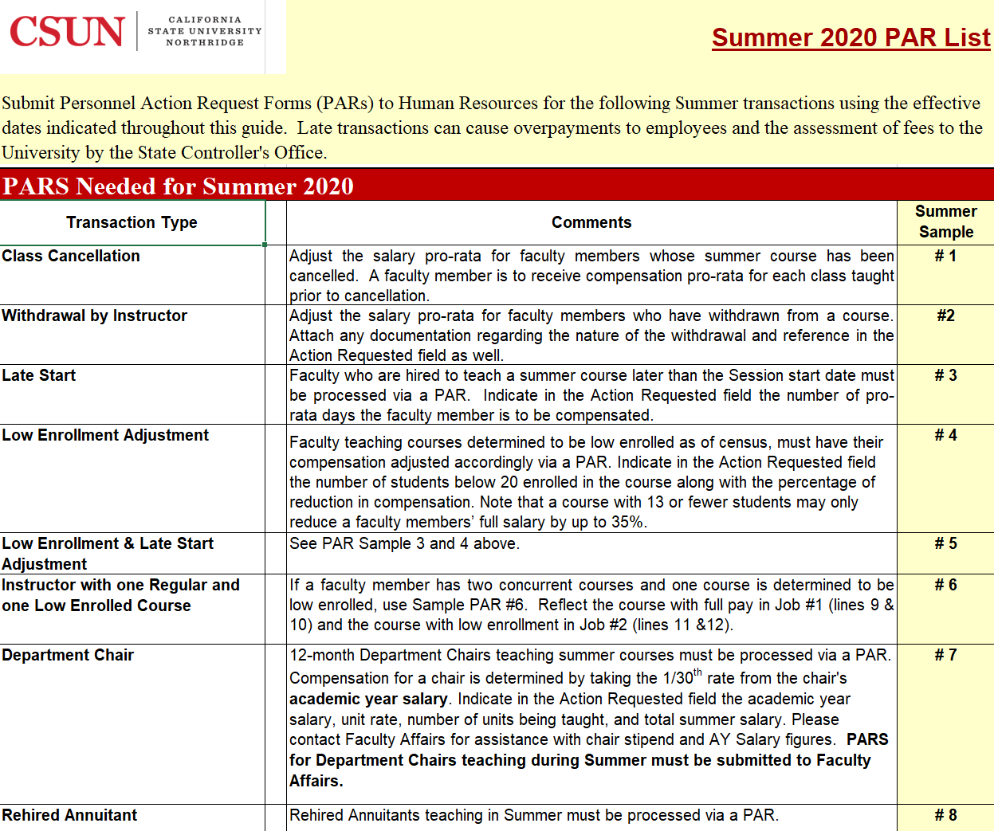
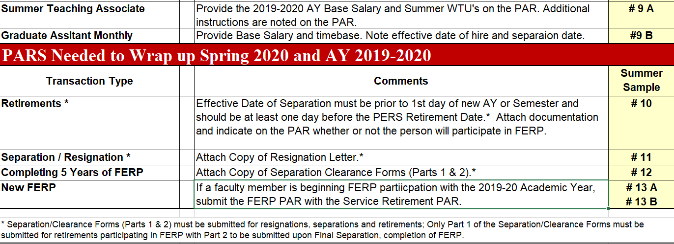

Summer Sample PAR #1 – Department Cancels Class after Start of Session
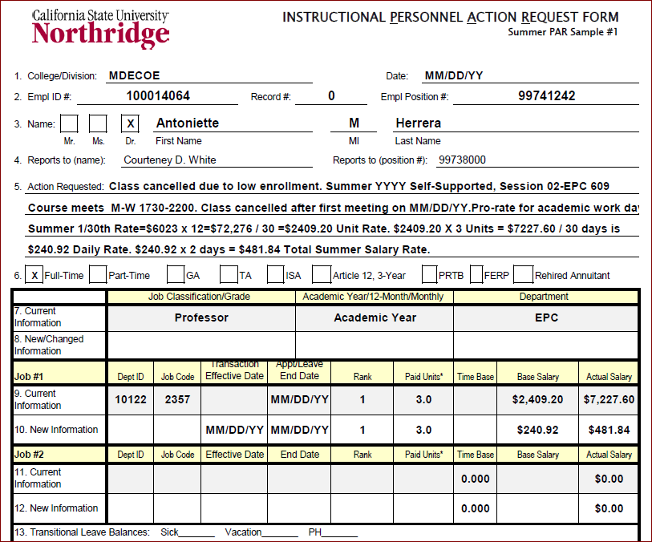

Summer Sample PAR #2 – Faculty Member Withdraws From Appointment
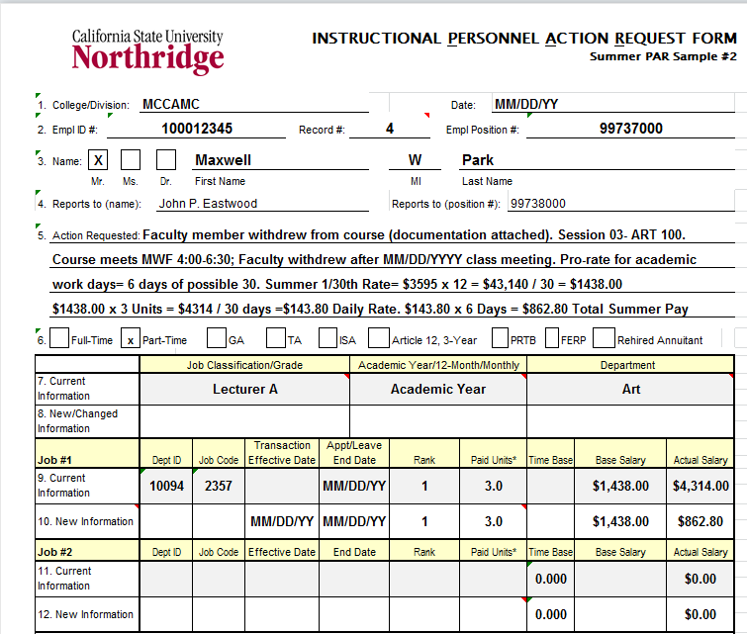

Summer Sample PAR #3 – Faculty Member Starts Appointment Late

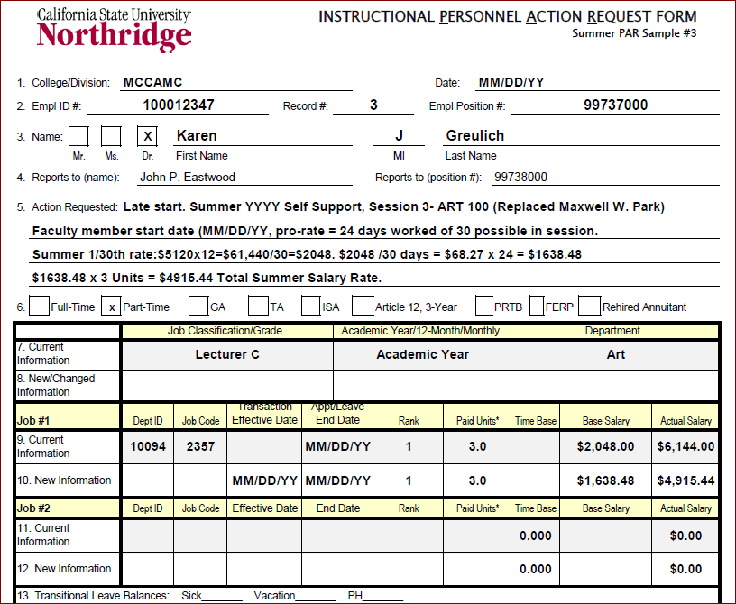

Summer Sample PAR #4 – Low Enrollment Salary Adjustment
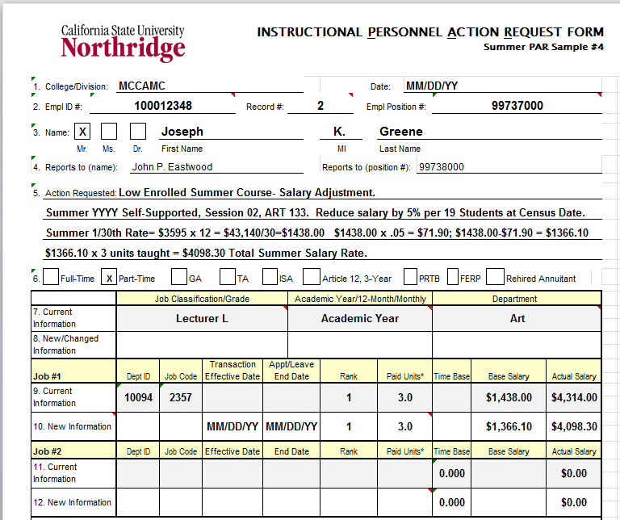

Summer Sample PAR #5 – Low Enrollment Class and Late Start

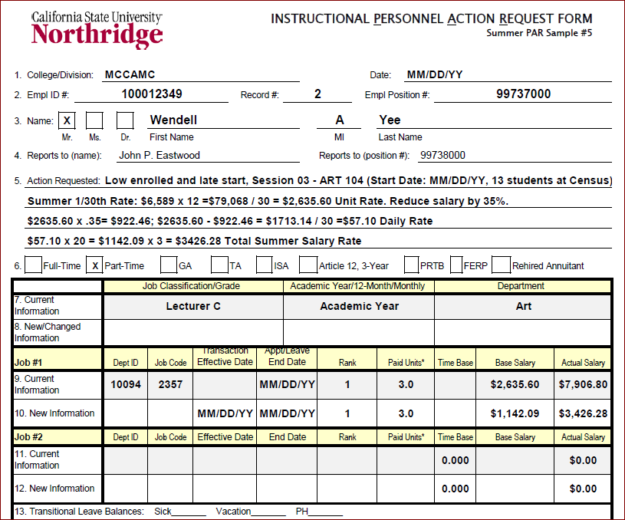

Summer Sample PAR #6 – Teaching One Regular & One Low Enrolled Class
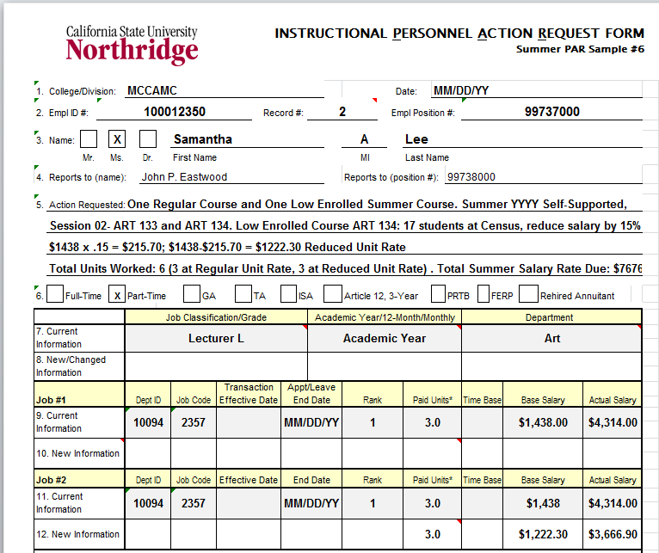

Summer Sample PAR #7 – Department Chair Teaching In Summer
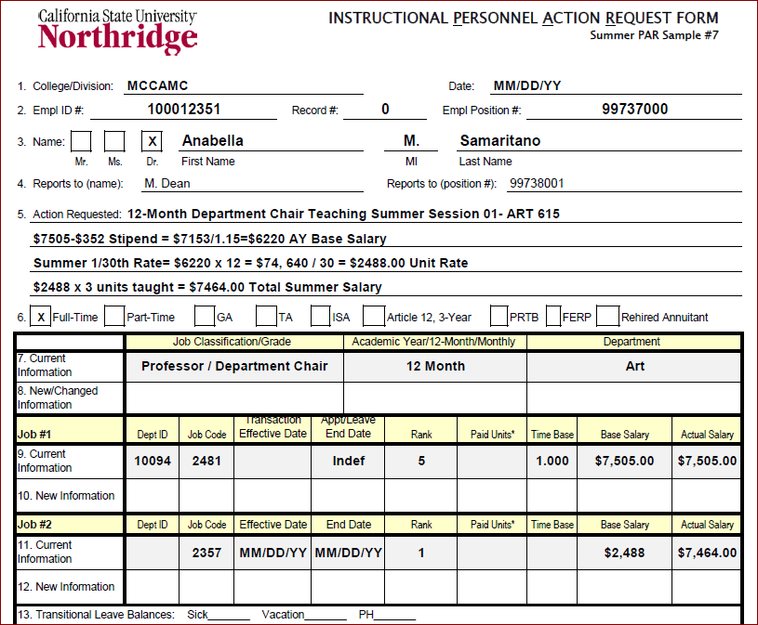

Summer Sample PAR #8 – Rehired Annuitant Teaching In Summer

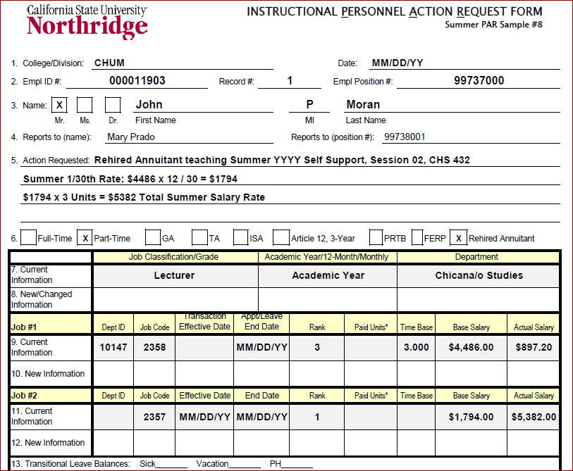

Summer Sample PAR #9 – Teaching Associate Teaching In Summer
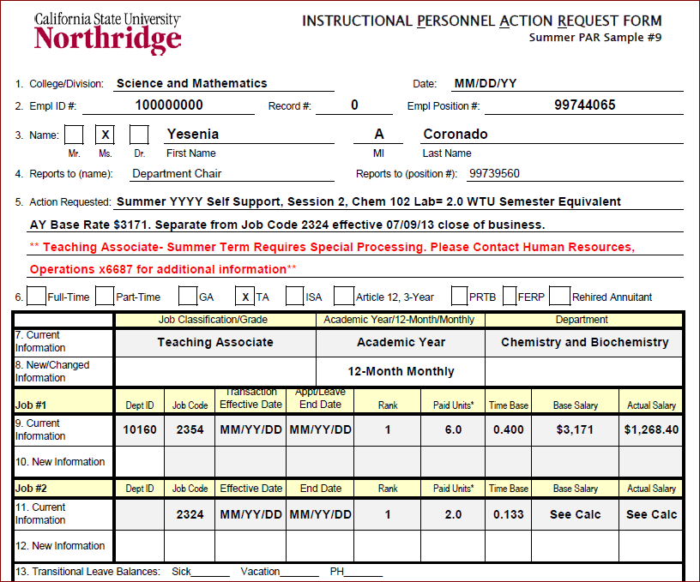

Summer Sample PAR #10 – Service Retirement PAR

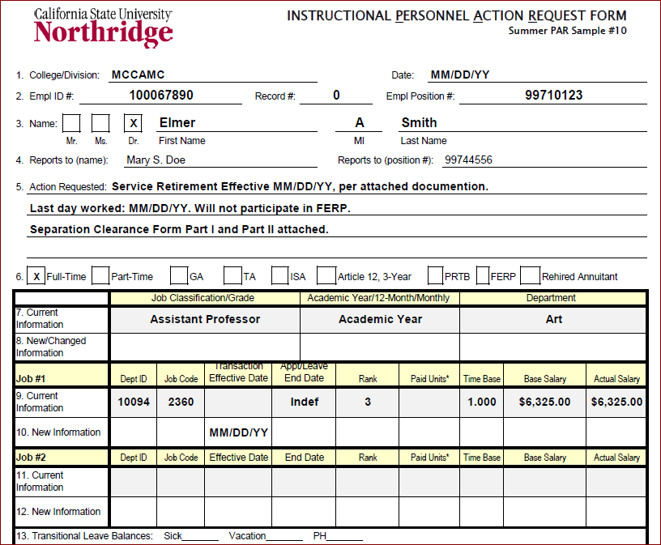

Summer Sample PAR #11 – Separation / Resignation
If the employee was hired to work Summer only, submit Separation/Clearance Forms.
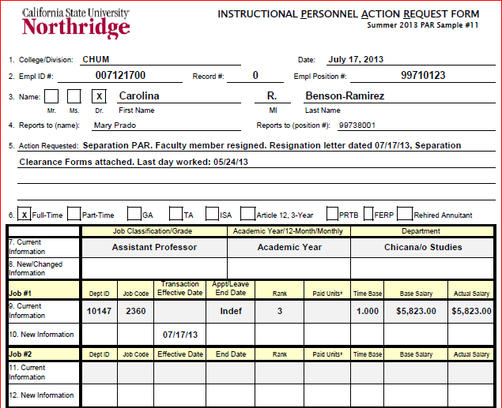

Summer Sample PAR #12 – Completion of 5 Years of FERP
Submit Section 2 of Separation Clearance Forms.
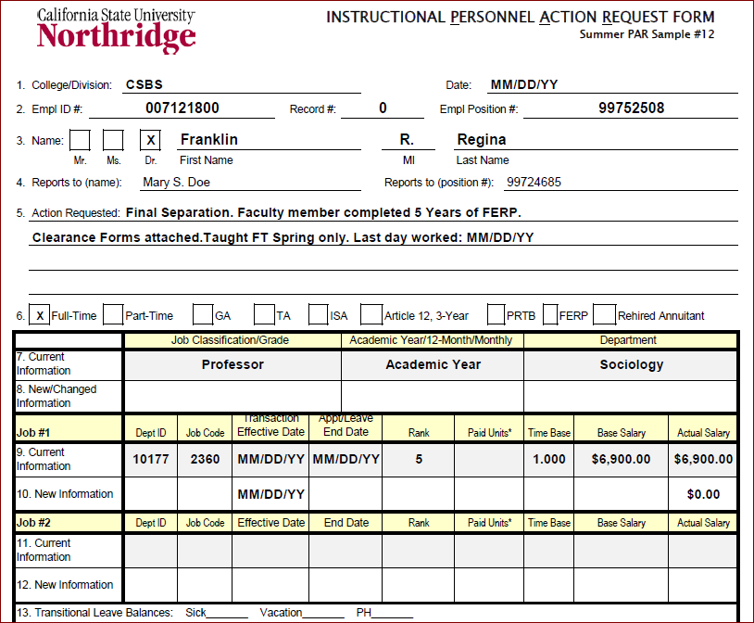

Summer Sample PAR #13A– Newly Retired Faculty Beginning FERP – 1 of 2
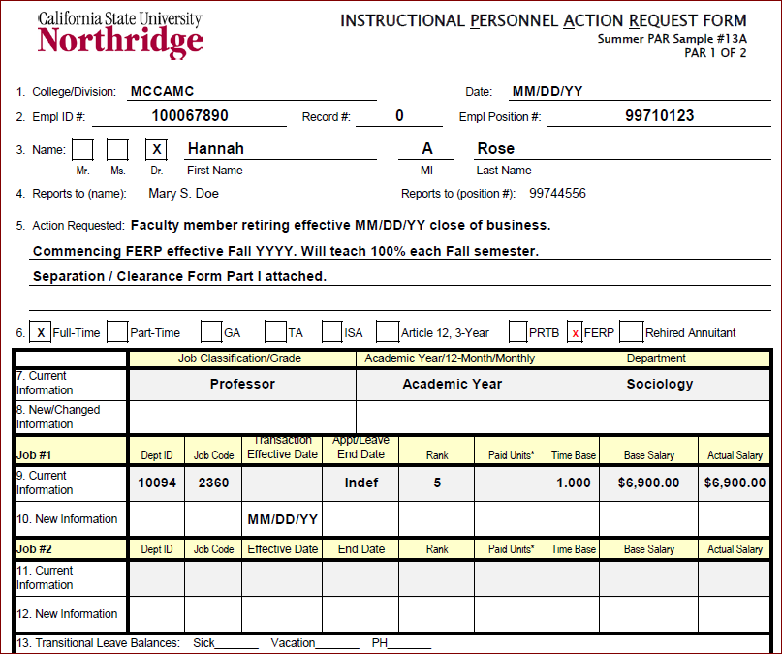

Summer Sample PAR #13B – Newly Retired Faculty Beginning FERP – 2 of 2

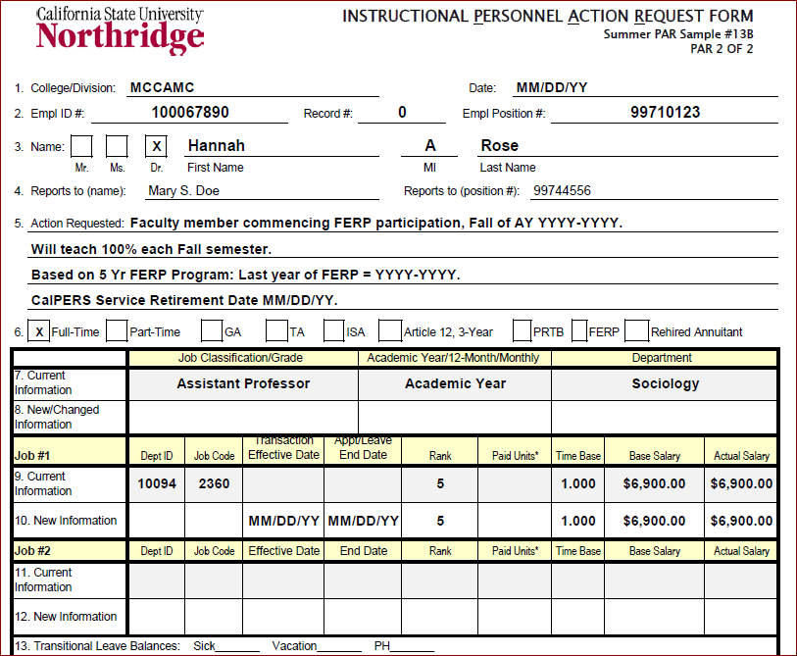

Stipends are not paid to any employee who is eligible for CalPERS health benefits during these pay periods.

