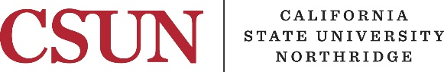

Full-Time Lecturer

Annual Summary of Achievements

Name:: |  |  |  | Date:
CSUN ID #: |  | Department:

The information requested on this form is to be prepared by each full-time Lecturer/Assistant Librarian/Counselor and submitted to the Department Chair/Director no later than April 27, 2018. The purpose of this form is to provide the faculty member with the opportunity to summarize the year's activities so that the personnel file contain an updated and accurate summary of activities related to the Lecturer, Assistant Librarian, or Counselor appointment.

A copy of this form shall be placed in the faculty member’s Personnel Action File.

Teaching Effectiveness

Teaching effectiveness refers to the competence of the instructor in classrooms, laboratories, and supervision of individual student projects, research and field work. Evaluation of teaching effectiveness shall be based upon student evaluations of teaching effectiveness and other sources of evidence of teaching effectiveness deemed appropriate by the Department. Although much of the evidence concerning teaching effectiveness will be obtained through approved Department procedures, the lecturer may provide additional evidence here of efforts to improve teaching competence and effectiveness.

List and describe activities during the past year intended to maintain or improve teaching
effectiveness:

Other (e.g., advising, curriculum):

