**2018-2019 Annual Program Assessment Report Guide**

Please submit report to your department chair or program coordinator, the Associate Dean of your College, and to [james.solomon@csun.edu](mailto:james.solomon@csun.edu), Director of the Office of Academic Assessment and Program Review, by **September 30, 2019**. You may, but are not required to, submit a separate report for each program, including graduate degree programs, which conducted assessment activities, or you may combine programs in a single report. **Please include this form with your report in the same file and identify your department/program in the file name.**

**College: Mike Curb College of Arts, Media, and Communication.**

**Department: Theatre**

**Program: BA, Theatre including GE**

**Assessment liaison:**

1. **Please check off whichever is applicable:**

**A. ____X___ Measured student work within program major/options.**

**B. ________ Analyzed results of measurement within program major/options.**

**C. ________ Applied results of analysis to program review/curriculum/review/revision major/options.**

**D. ____X____ Focused exclusively on the direct assessment measurement of General Education Arts and Humanities student learning outcomes**

1. **Overview of Annual Assessment Project(s).** On a separate sheet,provide a brief overview of this year’s assessment activities, including:

* an explanation for why your department chose the assessment activities (measurement, analysis, application, or GE assessment) that it enacted
* if your department implemented assessment **option A**, identify which program SLOs were assessed (please identify the SLOs in full), in which classes and/or contexts, what assessment instruments were used and the methodology employed, the resulting scores, and the relation between this year’s measure of student work and that of past years: (include as an appendix any and all relevant materials that you wish to include)
* if your department implemented assessment **option B**, identify what conclusions were drawn from the analysis of measured results, what changes to the program were planned in response, and the relation between this year’s analyses and past and future assessment activities
* if your department implemented **option C**, identify the program modifications that were adopted, and the relation between program modifications and past and future assessment activities
* if your program implemented **option D**, exclusively or simultaneously with **options** **A, B, and/or C**, identify the basic skill(s) assessed and the precise learning outcomes assessed, the assessment instruments and methodology employed, and the resulting scores
* in what way(s) your assessment activities may reflect the university’s commitment to diversity in all its dimensions but especially with respect to underrepresented groups
* any other assessment-related information you wish to include, including SLO revision (especially to ensure continuing alignment between program course offerings and both program and university student learning outcomes), and/or the creation and modification of new assessment instruments

**Overview of Annual Assessment – Theatre 2018-19**

*Identify the basic skill(s) assessed and the precise learning outcomes assessed.*

The rotation for General Education (GE) assessment in 2018-19 was the assessment of the **Arts and Humanities** curriculum. With this focus, the Theatre Department chose to review the 2009 General Education recertification documents and identify potential program (Theatre) student learning outcomes that focus on equivalent skills identified in the Arts and Humanities GE student learning outcomes.

The Theatre Department identified the following for review:

1.GE SLO 2 is matched with Theatre SLO 4.

2.GE SLO 6 is matched with Theatre SLO 3.

**1) GE Arts & Humanities SLOs**

***Critical Thinking****: SLO 2. Students will be able to analyze, interpret, and reflect critically upon ideas of value, meaning, discourse and expression from a variety of perspectives from the arts and/or humanities;*

***Theatre PSLOS***

***Critical Thinking****: PSLO 4. Students will formulate and articulate critical analyses and evaluations of theatrical works.*

**2) GEArts & Humanities *SLOs***

***Historical and Cultural Context****: SLO 6. Students will be able to describe and explain the historical and/or cultural context within which a body of work was created or a tradition emerged.*

***Theatre PSLOS***

***Historical and Cultural Context****: PSLO 3. Students will demonstrate an understanding of the relevant contexts in which theatre is created and presented.*

With these two groupings in mind, the department identified full and part-time instructors teaching in the Theatre GE program and asked them to identify student assignments within their courses that would be appropriate in the assessment the above SLOs. During Fall 2018, one section TH 110, seven sections of TH 111, and two sections of TH 310. One section of TH 333 was offered Spring 2019.

After reviewing assignment prompts for these courses, the department decided to proceed with assessing the **Critical Thinking SLOs** identified as *Theatre PSLO 4* and *Arts and Humanities SLO 2*. A draft rubric was created to use for the assessment of both SLOs. This rubric was reviewed by the entire faculty which resulted in an engaged conversation during a faculty meeting around the definitions of *value, meaning*, and *discourse* as specified in **Arts and Humanities SLO 2 and the Theatre PSLO 4.**

The students’ selected works were written assignments or critiques ranging from 1 – 3 pages. For the norming process 6 samples were chosen.

The rubric was subject to a norming process by a committee of four, full-time faculty. A set of student work samples was gathered from the courses listed above. After discussing the rubric with Director of the Office of Academic Assessment and Program Review, the department simplified the rubric from four levels to three levels:

Does not Meet Expectations (1 point)

Meets Expectations (2 points)

Exceeds Expectations (3) points

A Does Not Apply option was added only when an assignment did not reflect a given area of the SLO. This simplification helped with the norming process and resulted in no outliers in the final assessment.

After norming, using the single rubric, we assessed Arts & Humanities GE SLO -2 using student work from TH 110, TH 111, TH 310 & TH 333 and Theatre PSLO 4 using student work from TH 110. Note that TH 110 is a requirement in the theatre major, as well as being a general education course.

After consultation with Director of the Office of Academic Assessment and Program Review, a **20% sampling** figure was agreed on. Based on that figure, the following samples and assignments were determined.

TH 110

Population – 104

Sample Size – 20

TH 111

Population – 45

Sample Size – 9

TH 310

Population – 20

Sample Size – 4

TH 333

Population – 90

Sample Size – 18

**Final Assessment Results:** (see appendix including rubric and score sheets.)

*Theatre PSLO 4*

When reviewing the assessment results for Theatre PSLO4 using student work from the Fall 2018 course offering, the area of **communication “**meets expectation” of the reviewers. While the medium assessment score indicated a “meets expectation” for **interpretation** and **reflection**, the mean was shy of meets expectation and the mode was “does not meet expectation.” The area with the lowest scoring was **analysis** with a “does not meet expectations.” Since TH 110 is the introductory course for theatre majors in addition to being a GE, it is recommended that the department as a whole review the results to confirm the expectation level for the students and provide guidance for future instructors.

Theatre PSLO 4 Assessment Scoring (Using TH 110 student work)

*Student will formulate and articulate critical analyses and evaluations of theatrical works.*

**Communication** (def: info exchanged or conveyed between individuals through a common system of symbols, signs, or behavior)

The mean was 2.05. The median was 2.0. The mode was 3.0

**Interpretation** (def: explanation, clarification, exposition or illumination)

The mean was 1.65. The median was 2.0. The mode was 2.0.

**Analysis** (def: investigation, deconstruction, or examination)

The mean was 1.45. The median was 1.0. The mode was 1.0.

**Reflection** (def: serious thought or consideration)

The mean was 1.68. The median was 2.0. The mode was 1.0.

*Arts and Humanities GE SLO 2*

When reviewing the assessment results for Arts and Humanities GE SLO 2 using student work from the *lower division* Fall 2018 course offerings, the area of **communication “**meets expectation” of the reviewers. While the medium assessment score indicated a “meets expectation” for **interpretation** and **reflection**, the mean was shy of “meets expectation” and the mode was “does not meet expectation.” The area with the lowest scoring was **analysis** with a “does not meet the expectations.”

When reviewing the assessment results for Arts and Humanities GE SLO 2 using student work from the *upper division* Fall 2018 course offerings, the medium and the mode were all “meets expectations” which indicates that a simple majority met the expectation.

When these courses were recertified as GE courses in 2009, the Theatre Department indicated that all Arts and Humanities GE SLO were met by the theatre GE courses. It is recommended that the theatre department reanalyze the relevant GE courses and select two Arts & Humanities GE SLOs for which the department feels satisfies at the highest level. Once this is determined this should be communicated to the instructors of these courses so they can design the courses with these specific GE SLOs in mind rather than trying to design a course that meets all The Arts and Humanities GE SLOs as well as the Theatre PSLOs.

**Arts and Humanities GE SLO 2 Assessment Scoring (Using Lower Division student work – TH 110 & TH 111)**

*Students will be able to analyze, interpret, and reflect critically upon ideas of value, meaning, discourse and expression from a variety of perspectives from the arts and/or humanities;*

**Communication** (def: info exchanged or conveyed between individuals through a common system of symbols, signs, or behavior)

The mean was 2.00. The median was 2.0. The mode was 2.0.

**Interpretation** (def: explanation, clarification, exposition or illumination)

The mean was 1.62. The median was 2.0. The mode was 1.0.

**Analysis** (def: investigation, deconstruction, or examination)

The mean was 1.50. The median was 1.0. The mode was 1.0.

**Reflection** (def: serious thought or consideration)

The mean was 1.71. The median was 2.0. The mode was 1.0.

Arts and Humanities GE SLO 2 (Using Upper Division student work – TH 310 & TH 333)

*Students will be able to analyze, interpret, and reflect critically upon ideas of value, meaning, discourse and expression from a variety of perspectives from the arts and/or humanities;*

**Communication** (def: info exchanged or conveyed between individuals through a common system of symbols, signs, or behavior)

The mean was 1.91. The median was 2.0. The mode was 2.0.

**Interpretation** (def: explanation, clarification, exposition or illumination)

The mean was 1.64. The median was 2.0. The mode was 2.0.

**Analysis** (def: investigation, deconstruction, or examination)

The mean was 1.70. The median was 2.0. The mode was 2.0.

**Reflection** (def: serious thought or consideration)

The mean was 1.82. The median was 2.0. The mode was 2.0.

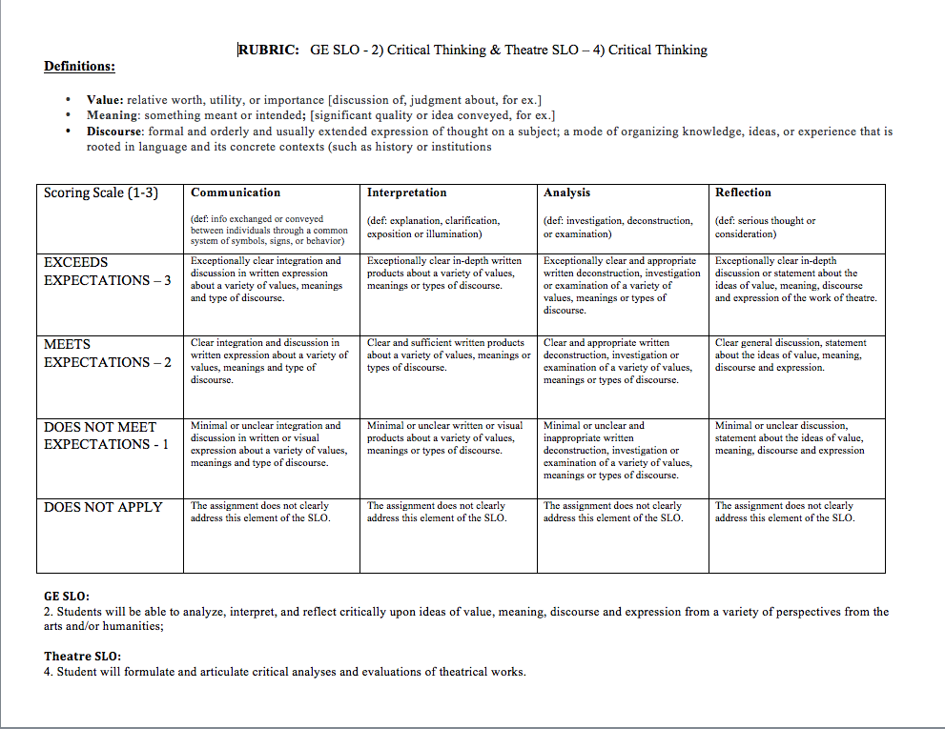 APPENDIX A

 **APPANDIAX B**

**APPENDIX C**



*In conclusion, in the lower division courses the assessment revealed a need for more focus on Analysis, Interpretation and Reflection in the area of Critical Thinking from both the PSLO and the GE SLO. This could take the form of clearer assignments in these areas or perhaps a series of embedded assignments that could incrementally allow students to gain an understanding through repeated practice of these concepts. There is an opportunity here for theatre faculty to discuss what the expectations are for the lower division GE introductory courses and how we might move the skill set involved in critical thinking towards “meets expectations” or even “exceeds expectations.” It could also be interesting to disaggregate the student work samples by theatre major/minor and the GE student population, and also to assess the work of Freshmen/Sophomore in relation to Junior/Senior. It would be interesting to note also if the separation of Freshmen in a discrete section of 110 from the larger OL version has led to a decrease in DFU’s in this course.

As for the upper division GE, according to the assessment done, there was room for improvement in all areas and the theatre faculty may wish to discuss ways to bring “meets expectations” to “exceeds expectations,” in these upper division courses. It would again be interesting to disaggregate for majors/minors and GE students. It would also be interesting to look at the grades given for the assignments assessed to determine if the assessment matches the grades given. But most of all the theatre faculty will want to review the results of the assessment with a view to improving student success. This may be through gathering all the faculty teaching these courses and affirming the areas that need improvement in the area of Critical Thinking, along with devising projects or assignments that will allow students to demonstrate their practice and mastery of these skills.

1. **Preview of planned assessment activities for 2019-20.** Include a brief description as reflective of a continuous program of ongoing assessment.

Assessment activities for 2019-20 will include discussions of the results of the 18-19 assessment, to see what changes may need to be implemented based on the results and an analysis of the results. Given that the assessment results indicate a need for increased attention to the area of analysis, interpretation and reflection in the consideration of a theatrical work, both a departmental and a GE SLO, the faculty will want to articulate and implement ways to increase student learning in these areas. Additionally, our assessment process for this coming year will begin with a discussion of what area needs to be assessed. After a brief discussion with the Chair it seems there may be benefit from an assessment in the area of Theatre History, under which the GE courses Theatre 110, 310, 325 and 333 fall. I believe it would be useful for the faculty to discuss what skills are being introduced, practiced and demonstrated in these courses and how they align with Department PSLOS and GE SLOS. Theatre 110 is a required course in the major and many theatre majors also take Theatre 333. I will also propose that one area that may be beneficial to review using the tool of assessment concerns the implementation of a capstone or culminating project, assignment or performance for our students. We have discussed this idea in the past, however it seems that using assessment to understand what our senior theatre majors have learned may be fruitful.