Time & Attendance® Version 8.0

Quick Reference Card for Hourly View Employees
The following instructions describe a typical employee persona configuration. The names and location of widgets and commands may differ in your configuration.

Opening Time & Attendance

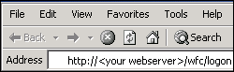

To open Time & Attendance, do the following:
- Click on the Time & Attendance link, favorite or Shortcut in your browser.

Logging On

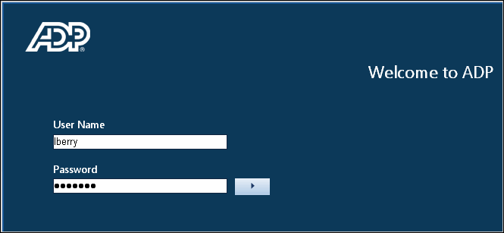

To log on, do the following:
- Type your User Name and Password (case sensitive). Click the blue arrow to login. After displaying a loading libraries message, 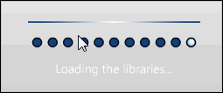
Time & Attendance opens your Navigator workspace, which contains the widgets that you need to do your job. The type and placement of widgets is based on your access rights.

Related Items pane ----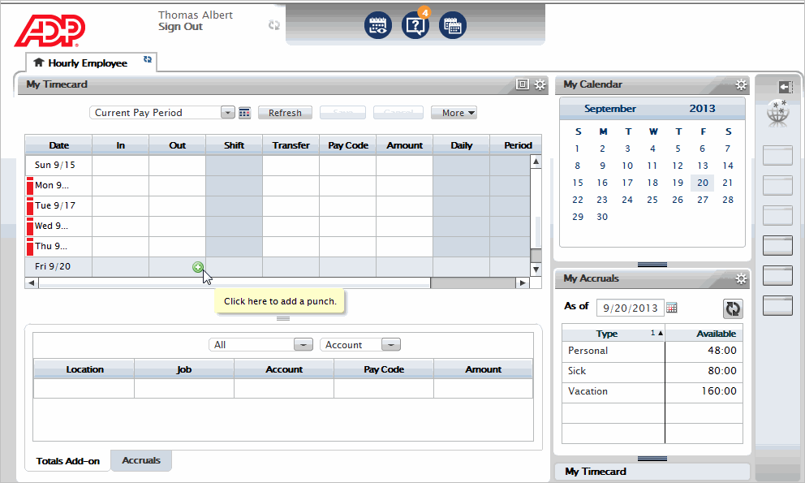
- From your Navigator workspace, you can perform functions such as punch in and out, view My Timecard, and sign out.

Signing Out

To sign out, do the following:
- Click Sign Out located in the upper-left portion of the view. The system signs you out and returns to the Logon screen.
Note: If you do not sign out before you close your browser, your connection to Time & Attendance may remain open and others may be able to view your information.

Changing Passwords
- Locate the Change Password widget (it may be in the Related Items pane), then click Change Password. The Change Password widget opens.
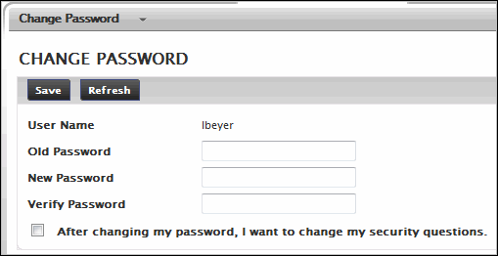
- Type your old password.
- Type a new password.
- Type the new password again in the Verify Password text box.
- Click Change Password.

Entering/Edit Worked Time (Punches)

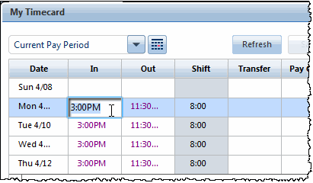

To enter IN or OUT punches, do the following:
- If the My Timecard widget is not already primary, make it primary by dragging or using the Pop-out option on the Gear icon .
- Click in the first In column and enter your starting time.
- Press the TAB key and move to the first Out column and enter your ending time.
- To add another set of In and Out punches for the same day, add a new row by clicking the + icon on the far left side of the screen on the line for that day
- Click Save.

To edit IN or OUT punches, do the following:
- If the My Timecard widget is not already primary, make it primary by dragging or using the Pop-out option on the Gear icon .
- Click in the cell you wish to edit.
- Enter the new IN or OUT time. The new time replaces the previous time.
- Press the TAB key and move to another cell, if desired, and repeat step 3.
- Click Save.

Saving and Refreshing the Timecard
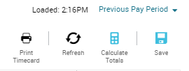

To save a timecard after editing, do the following:
- Click Save. The changes are saved.
- Click Refresh after saving to ensure that your screen displays the most recent changes.
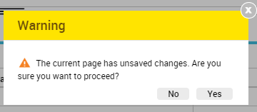
- To cancel edits, click Refresh or Cancel before clicking Save. A warning message opens reminding you that you will lose changes.

Refreshing the Workspace
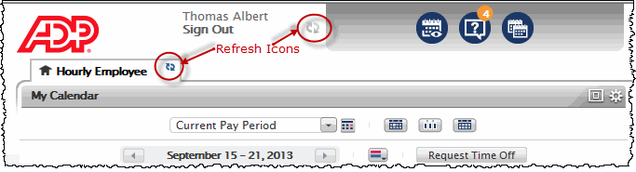

Entering/Editing Non-worked Hours
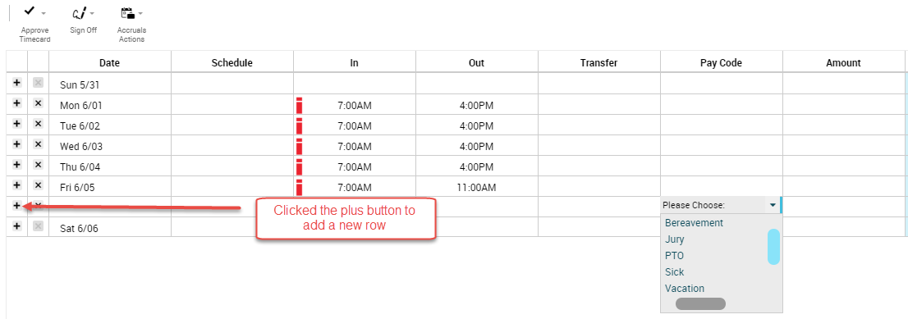
If your access rights permit, you may enter or edit non-worked time, such as sick time, vacation…

To enter non-worked hours, do the following:
- If the My Timecard widget is not already primary, make it primary by dragging or using the Pop-out option on the Gear icon .
- Click to select the day to which you want to add a pay code or amount.
Note: You cannot have an in/out punch and a pay code on the same line. If you already have a punch on a given day, you must add a new row before you enter a pay code.
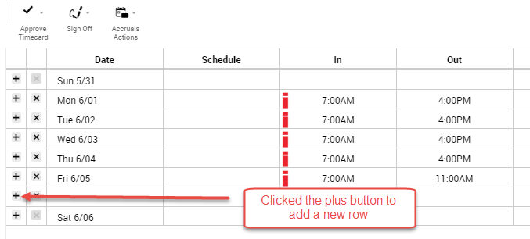
- If you already have a punch recorded for that day, click the plus + button next to the appropriate day to add a new row for the pay code or amount.
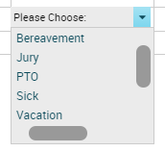
- Double Click in the pay code column. The Pay Code choice list opens.
- Select the desired pay code.
- Type the number of hours in the amount field.
- Click Save. The pay code appears on the appropriate day in the timecard and the Totals Details update to reflect the change.
Note: If you enter a partial hour, separate the hours and minutes with either a decimal point or a colon. For example, enter 8 and one half hours as either 8.5 or 8:30.

Approving Timecard
Note: If your manager has approved your timecard, you cannot remove their approval or make any changes until they have removed their approval.

To approve timecard, do the following:
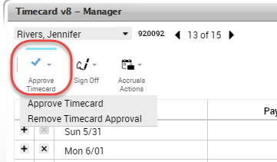
- Open the employee timecard.
- Select the The CORRECT Pay Period from the Time Period choice list.
- Click Approve Timecard.
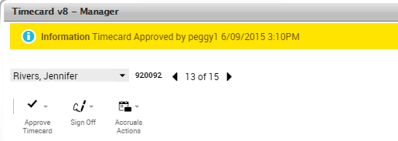

To remove approval, do the following:
- Select Approve Timecard ~ Remove Timecard Approval. A message briefly appears confirming the removal.

Transferring Labor Account
If your access rights permit, you can transfer time or a pay code to a different labor account.

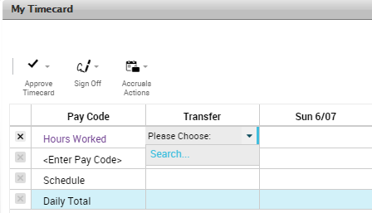

To open the Transfer dialog, do the following:
- If the My Timecard widget is not already primary, make it primary by dragging or using the Pop-out option on the Gear icon .
- Click a cell in the Transfer column.
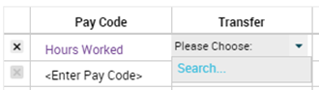
- If there is data in the cell, click the cell and select Search to open the Transfer dialog and select the appropriate labor account.

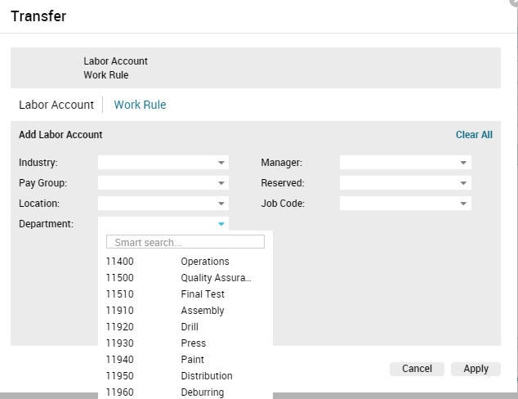

My Timecard Workspace Summary
To open your timecard, drag the My Timecard widget to the primary view. You might have access to only some of these features depending on how Navigator is configured for you.
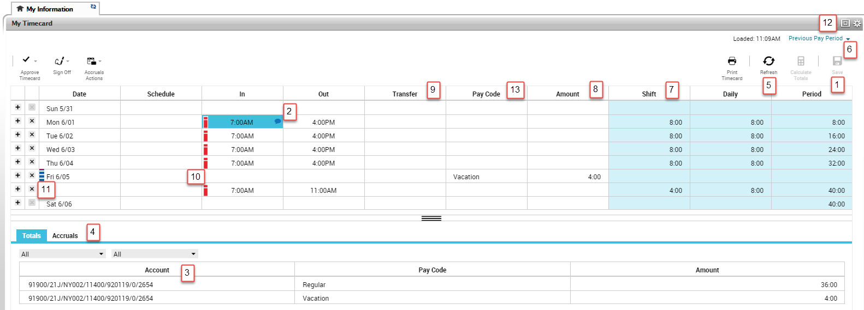
1. Save – Saves your changes | 8. Amount – Defines an amount in hours or money for the pay code or duration
2. Comment/Note Indicator – This blue balloon indicates that there is a comment associated with this punch. Mouse over to read the comment. | 9. Transfer – Defines a job or work rule transfer. If no account or work rules appears in the cell, your time is charged to your home account and calculated through your default work rule.
3. Primary Account – Area that lists your job information and what accounts are to be charged for your services | 10. Exception indicator— Red with white bar – Indicates a system generated exception Diagonal bars indicate that multiple exceptions have been made to this punch
4. Total Summary Area – This is a breakdown of your job summary, account summary, and pay code summary. | 11. Exception indicators—Blue with white bar – indicates excused absence
5. Refresh – Refreshes the timecard without saving any changes. | 12. Maximize/minimize and Gear icon – Enlarge or shrink widget workspace. Gear icon contains preferences, pop-out, and close.
6. Time Period – Defines the time period you are viewing. Use the drop-down list to select a different time period. | 13. Pay Code – Defines a category for specifying hours or money for worked and non-worked time.
7. Shift – Indicates hours worked in that shift

