Department of Gender and Women’s Studies

Assessment for 2018-2019: GWS 370 Women and Violence

Prepared by Tina Beyene, PhD

The Goal of the Assessment

In Spring 2020, the Department of Gender and Women’s Studies participated in the 2019-20 assessment of General Education Section D: Social Sciences and United States History and Local Government (Section D1-4). The SLOs for this section state:

Students will:
- Explain how social scientists conduct the systematic study of social relations, human experiences and patterns of change over time.
- Analyze and explain the multiple perspectives found in the social sciences that underlie debates on important historical and contemporary issues.
- Apply appropriate social scientific methods to collect data, analyze, evaluate, explain and/or solve problems in social relations and human behavior.
- Demonstrate an understanding of how social problems impact individuals, communities and societies.

What we assessed
GWS 370 Women and Violence in Spring 2020 was selected because it was the only course listed in Section D that semester. The focus was on SLO # 4, "Demonstrate an understanding of how social problems impact individuals, communities and societies" for a number of reasons: First, most GWS courses are interdisciplinary and draw on social science and humanities material. Second, our classes are taught by faculty whose training could be in the humanities or social sciences and their respective trainings tend to shape the lens through which each class is taught. For instance, in Spring 2020, one professor who taught GWS 300 is trained as a political scientist while a second one is trained in humanities Hence, the first 3 SLOs were harder to control across sections.

Assessment Design
GWS 370, Women and Violence is an upper division GE course open to majors and non-majors and it directly addresses diversity and the impact of violence on underrepresented groups. The GWS department offers several units of this course a semester with enrollment of approximately 35 students per section. There are fully on-line, hybrid and fully in person sections of GWS 370 each semester and they are taught by tenure-track as well as adjunct faculty.

I worked with all 5 of the sections of GWS 370 (taught by 2 faculty). Of the five sections initially selected for the assessment, one was a fully online, and four sections were scheduled to meet in person. The enrollment in each section was about 36 students except one section which had 35. Initially, the online section was included to simultaneously assess if there were real differences for (on a smaller scale) if there are differences in the instructors’ ability to meet learning outcomes when a course is taught on-line vs. in person. Due to the coronavirus pandemic, however, all sections were fully online classes after spring break in March 2020.

Survey Questions
With input from the two faculty members teaching GWS 370, I designed a survey to assess learning pertaining to Section D’s SLO 4. The questions were:

- In 1-3 sentences, explain what you think is the relationship between gender and violence. (1 point)
- What kind of acts can constitute gender-based violence? Give 2 examples. (1 point; .5 points for each example)
- Give an example of who is a perpetrator of gender-based violence (1 point)
- How do you think violence against women or gender-based violence affects the following (give one example and explain in 2-3 sentences) (1 point)
- Individual (.25 points)
- Families (.25 points)
- Communities (.25 points)
- Society-at-large (.25 points)
- Name at least one solution to gender-based violence. (1 point)

Rubric and Grading Scale
For each answer, students could earn anywhere from 0 points to 1 point per question for a total of 5 points per test. The CSUN point to letter grade conversion system was used:

A=4.0+
A-= 3.7-3.99
B += 3.3-3.6
B= 3.0-3.2
B-== 2.7-2.9
C+-2.3-2.6
C= 2.0-2.2
C-=1.7-1.9
D =1.3
F-=0

Below is the specific rubric used to grade each question:
 | 0 pts | .25 pts | .5 pts | .75 pts | 1 pt
Q1 | Blank answer  OR  Wrong answer | Lists victims such as women or trans people or others but nothing else | Mentions terminology that suggests hierarchy and women’s subordinate status but does not connect how they inform violence. | Addresses as concepts of power hierarchy and attempts to connect them to gendered violence but does not fully finish the thought | Clearly identifies the relationship between gender hierarchy, power and gender-based violence.  Includes clear examples that illustrate how gender ideology underpin a specific violence. Articulates how many oppressions intersect in shaping experiences of gendered violence
Q2 | No answer or wrong examples | Answer hints at acts of violence by maybe names places of violence or perpetrators | Answer could be an example of gender-based violence but how it is an act of violence is not demonstrated | Gives one correct answer | 2 correct answers
Q3 | Gives no answer or wrong one | Vague descriptions  (media, society etc.) | Gives broad examples that need to be shown as perpetrators of GBV | Name people whose beliefs can lead to violence but not necessarily unless they commit specific acts of violence (e.g.: transphobic individuals) | Identifies perpetrators and their act
Q4 | No answer | Identifies at least one impact of GBV on one of the following: individual, family, community or society | Identifies at least one impact of GBV on two of the following: individual, family, community or society | Identifies at least one impact of GBV on three of the following: individual, family, community or society | Identifies at least one impact of GBV for each of the following: individual, family, community or society. Demonstrates an understanding of the difference between each category and names relevant impact.
Q5 | No solution | Vague solution | Unexplained solutions but has the right vocabulary (e.g. Advocacy) | Generalized solutions that don’t circle back to the violence they will eliminate like “eliminate toxic masculinity” or “raise boys differently” | Names a solution and connects it to a specific violence it is intended to solve and how.

Distribution of Survey

Pretest
A total of 126 anonymous and ungraded pre-tests were administered in hard copy form during the 2nd and 3rd weeks of classes. The section breakdown of pre-test questionnaires collected is as follows:

Section 1: Liz Phillipose M/W 11-12:15
Enrollment: 36
No. of pre-test surveys: 29

Section 2: Rana Sharif T/T 12:30-1:145
Enrollment 36
No. of pre-test surveys: 29

Section 3: Rana Sharif T/T 9:30-10:45
Enrollment: 36
No. of pre-test surveys: 30

Section 4: Rana Sharif T/T 11-12:15
Enrollment: 35
No. of pre-test surveys: 37

Section 5: Liz Phillipose (Online) M 7-9:45 pm
Enrollment: 35
No. of pre-test surveys: 30

Posttest
The post-tests included the same questions as the pre-tests to measure shifts in student knowledge based on their participation in the course. Because of the pandemic related switch to online classes, all post-course surveys were distributed in weeks 14 and 15 via Google Forms. We still managed to collect 111 total post-test surveys were.

Rana Sharif: Sections 2, 3, and 4
No. of post-test surveys: 79

Liz Phillipose: Section 5
No. of post-test surveys: 32

Data Gathering Problems
A number of problems plagued this data especially as we transition to online teaching during the post-midterm Covid-19 lockdown. The big problems was the discrepancy between pre and post survey data collection and coding process. At the beginning of the semester, we distributed the pre surveys in person in hard copy form in each section. Hence, each section’s survey total was clearly labeled. But after the Covid-19 lockdown, we had to collected the data online using Google Form. This switch created several headaches for us in part because we were not familiar with this software and did not clearly stipulate how to gather the data. For instance, I distributed the questions without creating separate surveys for each section and not realizing that without clearly separating the data, the recipients can distribute the survey to all their sections and there would be no way to determine the source of each survey. The result was that one professor sent the questionnaire to each section separately, while the second professor distributed unlabeled questionnaires to all her sections, which led to 76 undifferentiated posttest responses from Sections 2, 3 and 4 with no way to distinguish them. Since they also anonymous. we couldn’t match students to sections either.

While the post-test surveys for Sections 1 and 5 were gathered separately, those too posed a problem, albeit a different one. The professor for that class sent out the questionnaires on a software that was not Google Form, which saved the data in a way that rendered the student responses illegible. Unfortunately, only the data for section 5 was recovered and we had to discard section 1 from the assessment.

Method
In the end, we only had to work with limited data from Sections 2, 3 and 4, which we treated as one data set and section 5, which was treated as a separate assessment of on online class. While we had a total of 126 pretest and 111 post-test surveys. But in reality, this really meant that for sections 2, 3 and 4, we had 96 pre-tests that we can attribute to a section but 79 post-tests, which were lumped together. And for section 5, the online course, we had 30 pretest and 32 post-test results. The usable data was analyzed using Google Sheets along following matrix:
  - Average Total scores on pre and post tests
  - Average score per question on pre and post tests
  - Median scores of tests on pre and post tests

Results

Result for All Sections
Overall, 126 pretest and 111 post-test surveys were analyzed to gain a general idea of how all GWS 300 courses faired. As Table 1 and Figure 1 show, the total average score of all GWS 300 sections improved by + 1.03 points, moving from a B- to an A- by the end of the semester, a 35% improvement. The improvements also held across the board for each question’s average score, with question 2 and question 5 showing the most change, 62% and 66% respectively. The media score also went up by 36%.

Table 1 All Sections: Total Average Score, Median Score and Average Score per Question
All Sections
 | Q1 | Q2 | Q3 | Q4 | Q5 | Total-Avg | Total-Avg-Q1 | Median
Pretest Avg | 0.63 | 0.47 | 0.60 | 0.65 | 0.50 | 2.84 | 2.21 | 2.75
Posttest Avg | 0.69 | 0.76 | 0.80 | 0.75 | 0.82 | 3.84 | 3.15 | 3.75
% Change | 10% | 62% | 35% | 17% | 66% | 35% | 42% | 36%
Pretest Count | 126
Posttest Count | 111
Figure 1 All Sections: Pretest and Posttest Total Average and Averages by Question
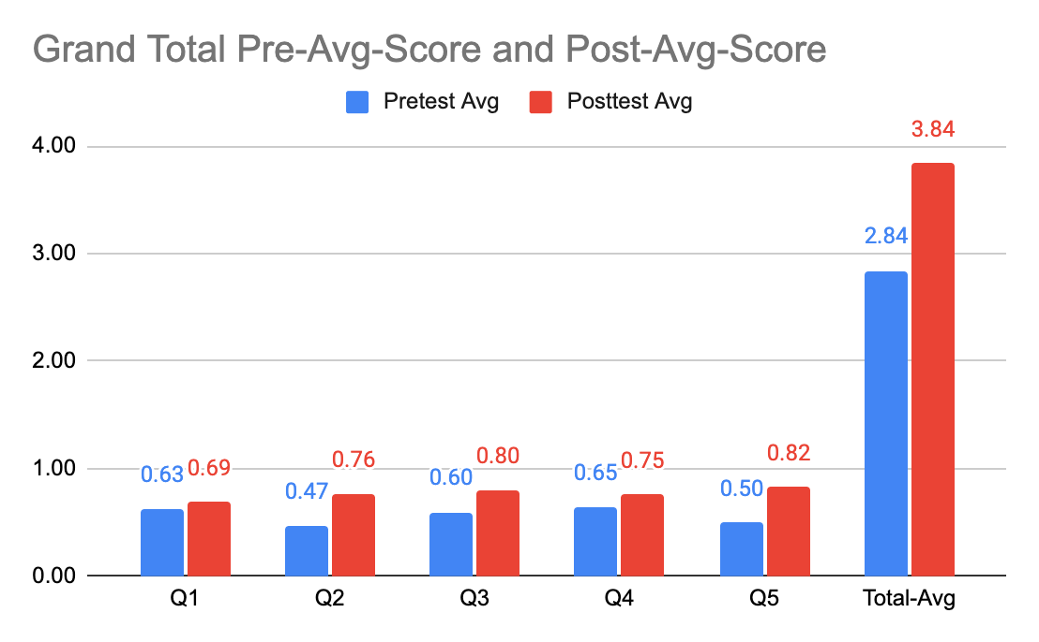

Result for Section 2, 3, 4 (Sharif)
Overall average score for Sections 2, 3, 4 (sharif) saw a gain of change: + 1.03 points, which meant that the average score for these 3 sections went from a B- in the pretest to an A- in the post test. As Table 2 shows, the pretest average score for the entire test was 2.81/5. By the end of the semester that average score was 3.84/5. Median score also improved by 36%.

All questions also showed improvement as seen in Table 2 and Figure 2. Question 2, 3 and 5 showed the biggest change with scores improving by +0.30 and +0.27 and +0.28 points respectively. Question 1 showed the least improvement with a fail of only +0.01.
Table 2 Section 2, 3, 4 (Sharif): Total Average Score, Median Score and Average Score per Question
Section 2, 3 and 4 (Sharif)
Phase | Q1 | Q2 | Q3 | Q4 | Q5 | Total-Avg | Median
Pretest Avg | 0.65 | 0.45 | 0.55 | 0.60 | 0.55 | 2.14 | 2.75
Posttest Avg | 0.66 | 0.72 | 0.85 | 0.77 | 0.83 | 3.84 | 3.75
% Change | 1% | 60% | 55% | 28% | 50% | 79% | 36%
Pretest Count | 96
Posttest Count | 79

Figure 2 Section 2, 3, 4 (Sharif): Pretest and Posttest Total Average and Averages by Question
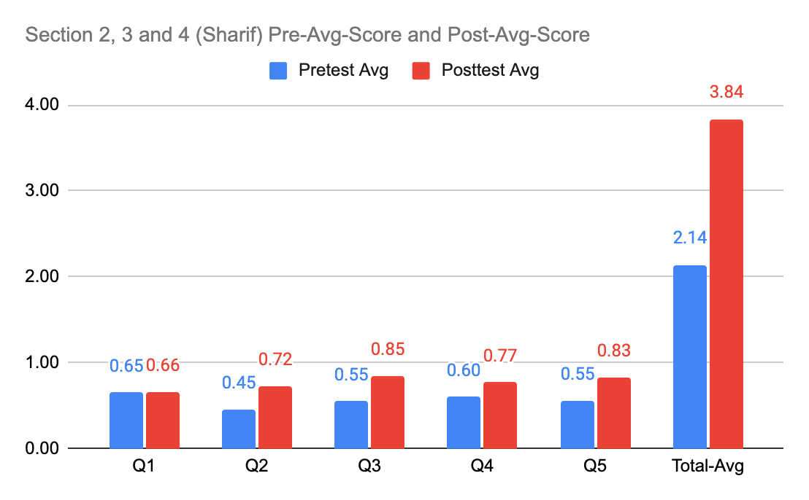

Results for Section 5 Online (Phillipose): Overall Average Results
The results for Section 5, the online version of GWS 370, was consistent with the findings of the overall data and the results from the other sections. As Table 3 and Figure 3 show, the pretest total average score was 2.93/5 and increased by +1.03 points in the Posttest to 3.83/5. That meant an improvement from a B- to an A-.

While the overall average score for section 5 went up, the data for each question showed interesting variation. For instance, question 5 answers went up by an average of 0.49 points, a 161% change. Question 2 also showed and average point gain of 0.33 points. Question 1 also saw a 0.21-point gain which is markedly higher that the 1point gain for the same question in Sharif’s sections. However, and most surprisingly, questions 3 and 4 showed average losses of 0.06 and 0.07 points in Section 5.

Table 3 Section 5 Online (Phillipose): Total Average Score, Median Score and Average Score per Question
Section 5 Online (Phillipose)
 | Q1 | Q2 | Q3 | Q4 | Q5 | Total-Avg | Median
Pretest Avg | 0.56 | 0.53 | 0.75 | 0.78 | 0.31 | 2.93 | 2.75
Posttest Avg | 0.77 | 0.86 | 0.69 | 0.71 | 0.80 | 3.83 | 4.00
% Change | 37% | 61% | -8% | -9% | 161% | 31% | 45%

Figure 3 Section 5 Online (Phillipose): Pretest and Posttest Total Average and Averages by Question
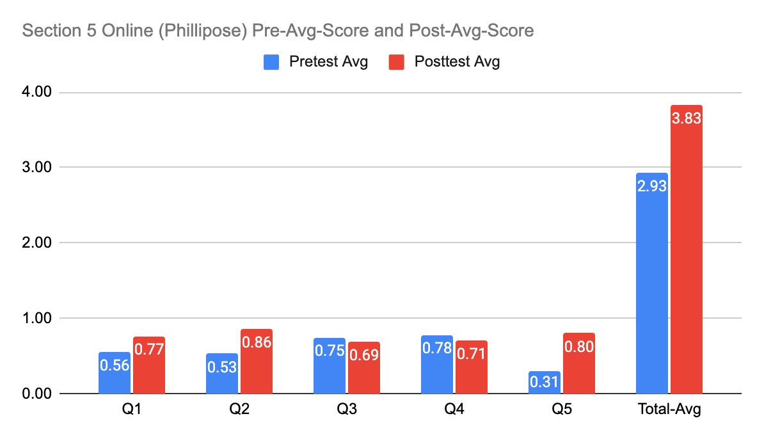

Analysis
- One problem that was clear from the outset is that despite the fact that GWS 370 is listed as a section D GE course, it is not necessarily designed to meet the GE SLOs. Moreover, as an interdisciplinary course, it is not clear how it should be listed in a discipline specific section such as Section D. While it is possible to align GWS 370 with Section D and its SLOs, I think the department needs to determine how to best fit our interdisciplinary courses across different sections. In the short term, the department could remind all instructors to include and reflect Section D’s SLOs in their syllabi, course design and assessment tools.
- Nonetheless, despite the mid semester disruption of Covid-19, many students responded to the post survey.
- Overall, by the end of the semester, students’ scores improved across the board, rising from a B- to an A -.
- Students entered the class with some prior knowledge that allowed them to answer questions 2 and 3 and 4a and 4b. They has some idea of what acts constitute gender-based violence (like rape and domestic violence), knew examples of perpetrators and their acts (e.g.” husbands who beat their wives and vice versa or how any gender can perpetrate gender motivated violence). They also had a fair amount of knowledge about the effect of violence on individuals (including post-traumatic stress disorder, fear, self-esteem issues, isolation, shame. Self-blame etc.) and on families (the multigenerational cycle of violence as a result of domestic violence or the break-up of families, the normalization of gendered violence for children who grow up witnessing such vinylene etc.)
- Most frequent examples of gender-based violence identified by students in the pre-tests were those of 1) rape/sexual assault and domestic violence. It is clear that at some level of their educational and/or personal lives, students are exposed to these two types of gender-based disparities. As a result, most students scored very high on questions 1 and 2.
- By far the question that students were least able to answer in the pre-test was #1, i.e. articulating the relationship between gender and violence. The scores in this category were exceptionally low. While the most coherent answers simply stated that men perpetrate violence against women, generally the answers were incomplete, nonsensical or a restatement of the question.
- The posttest results on question 1 were also curious. For instance, there was a lack of significant change on question 1 in Section 2, 3, 4 (Sharif). While this stagnation could be the result of a poorly constructed question that seemed to confuse students the most as seen in the pretest answers, it is not clear if the nature of the question was the problem, especially since the same question saw a 37% improvement in Section 5 online (Phillipose). Nevertheless, this is one question that could be better phrased in future assessments.
- Students showed most improvement in their responses to questions 2 and 5 in both sections.
- Most frequent example given for question 5 regarding solutions for GBV in the pretest was “education.” This might just reflect students’ own decision to learn about the topic by taking this class since there was no additional clarification about what type of education. The second most common answer raising boys to have respect. This answer suggest some exposure students to theories that link gender socialization, the naturalization of notions of male aggression and female weakness, and collective attitudes that view violence against women as inevitable. However, the links were not clearly articulated. By the posttest, though, these answers had become more nuanced.
“Education” was elaborated to include specific ideas such as self-defense classes or education on laws such as the Violence Against Women Act or education on community resources. Gender socialization has similarly become better articulated. Many answers noted raising boys that masculinity should not be equated with aggression or with raising children to embrace non heteronormative sexualities in order to reduce bullying of and hate crimes against LGBTQ people. Socialization answers also articulated a need to raise girls who do not associate femininity with silence. Other specific answers included the rejection of bystander culure, the elimination of law enforcement violence against communities of color and immigrant communities which double victimize those communities and keep those suffering from gender-based violence silent.
- The most surprising result was the decline in average score for questions 3 and 4 for Section 5 online (Phillipose). While question 4, which has four elements including specific questions about how gender-based violence affects individuals, families, communities and society-at-large is admittedly harder, question 3, which as who can be a perpetrator, should have been easy for these students. Indeed, in the other combined sections (2, 3 and 4 taught by Professor Sharif), there was a 55% improvement on the average score of question 3. It is not clear why this happened on these two questions in Section 5 especially since in this class, the average score for question 1, the vaguest question on the survey, improved the most overall. One possible explanation is that it could be a Covid-19-related fluke. With the disruption of the pandemic, it is feasible that students were simply not as focused on the surveys. However, it is hard to know what accounts for the net loss since the average score on other questions like question 5 improved.

Conclusion
Based on the results of this assessment, I return to the question of whether GWS 370 meets SLO 4 in Section D and the problem of the Covid-19 on post-test survey results. The results indicate a definite improvement in student knowledge across all three sections, but the course SLOs needs to be better aligned with the GE SLOs so that the assessment can directly determine the course’s accomplishment with regards to Section D. Although GES 370, a course on women and violence, integrates social science and humanities, perhaps the student survey was not the ideal was to assess the course’s alignment with Section D. Other instruments such as syllabus and assignment review would have offered a clearer picture in this regard. The Covid-19 related data collection mishap has also prevented a comparison of each sections, which makes this data limited.

future Recommendations
- Give clearly labeled surveys to each instructor reflecting the sections in the survey itself so that the data can be matched to a specific course.
- If online assessment tools are used in the future, use the same software.
- Ask students to provide their names for a pre and post assessment can be done per student
- Create questions that are more specific to minimize overlap in student responses
- Give clear instructions that students should draw on course materials to answer questions to the best of their abilities in the post test
- The GWS department would benefit from evaluating all Section D listed courses to ensure that a strong social science component is present. This may also involve using different or multiple assessment tools for evaluating interdisciplinary courses that cross list in disciplinary university offerings.

