RS 100: “Introduction to Religious Studies”
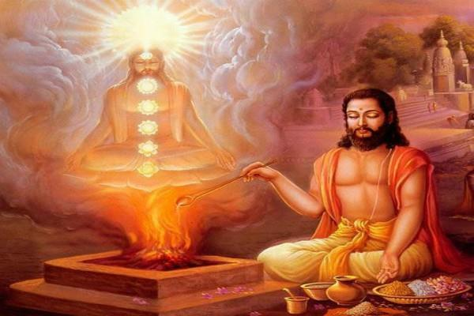
What is “Religion?” How can we study religions scientifically? What are myths and rituals? How do religious communities form and function? Why do some religions require sacrifices? Are religions going away? Does religion continue to influence people? What makes religions similar? What makes them different? How can we understand religious violence? What is the relationship between Religion and Science?

Earn G.E. credit while expanding your knowledge!

