CSUN
Course Syllabus Spring 2021 (Course 11188)
ART 112: World Arts: Africa, Oceania, and the Americas

Instructor: Juliet Moss
Format: Online (Mondays via Zoom 11:00 am – 12:15 pm)
Contact Info: juliet.moss@csun.edu
Office Hours:

- Online by appointment: Mondays 8:45 am – 10:45 am
Tuesdays 8:45 am – 10:45 am

Catalogue Description:
ART 112. World Arts: Africa, Oceania and the Americas (3)
Survey of the visual arts of Africa, Oceania, and the Americas emphasizing historical, religious and socio-cultural contexts. Discussion, research and writing on the visual arts, including painting, sculpture, architecture, book arts, ceramics, textiles, and body arts. (Available for General Education, F Comparative Cultural Studies)

Course Description Detail:
This course will explore and compare art-making practices among select African, Oceanic, and Native American cultures. The artistic expressions include art, architecture, painting, sculpture, festival arts, and body modifications and supplements. The relationship of art to the cultural context in which it was produced, including social status, gender, belief systems, the environment, globalization, and lifecycle stages will form the framework of this course. In addition, the course will critically address commonly held Western assumptions and stereotypes about the non-Western world and its arts.

Art Department Program Goals addressed in this Course:
- Students will acquire competent knowledge and skills in various art media, concepts and methodologies.
- Students will utilize and apply critical thinking skills to communicate ideas for their intended audience at a competent level in visual, oral, and written formats.
- Students will acquire historical and contemporary knowledge of diverse cultural and aesthetic contexts, including political, visual and material culture.

Learning Objectives:
Student will:
- be acquainted with the visual language of African, Oceanic, and Native American art.
- describe and illustrate the historical and/or cultural contexts in which specific African, Oceanic, and Native American art works are created and experienced.
- describe, analyze and write about how meaning is created through form and content in a work of non-Western art.
- recognize the basic principles and methodologies of non-Western art.
- examine the reception of non-Western art in the West.
- foster tolerance for and sensitivity to different cultures and value systems through the study of Non-Western art.

Canvas:
Welcome to Canvas, our learning management system! Canvas is accessible with the latest versions of Chrome and Firefox. It is also important that you access Canvas via the CSUN website instead of the mobile application in order to ensure full functionality. In addition, you must routinely log in and out of Canvas in order to ensure that you are working in the “live” environment. I cannot account for individual connectivity or internet issues so always submit assignments as early as possible and plan ahead to ensure that you have internet access.

Readings:
Class readings, images, and videos are all located in our ART 112 eText. This free eText can be found on our class Canvas site.

All readings are required and should be completed before our classroom meetings. You will be best prepared if you read each article three times and several days before assignments are due.

Assessment and Evaluation:
Research Paper/Creative Project - 40 points
Essays (5 @ 10 points each) - 50 points
Quizzes (11 @ 10 points each) - 110 points
***Quizzes cannot be retaken and 10 quizzes must be completed to pass this class***

Grades are based on a total of 200 points for research paper/creative project, essays, and quizzes. A maximum of 210 points are possible with 1 extra credit assignment.

A = 200-185 A- = 184-180
B+ = 179-173 B = 172-165 B- = 164-160
C+ = 159-153 C = 152-145 C- = 144-140
D+ = 139-133 D = 132-125 D- = 124-120
F = 119-0

In Canvas under “Grades,” make sure to deselect the box next to “Calculate based only on graded assignments.” This will then give you accurate totals based upon all assignments in this course.
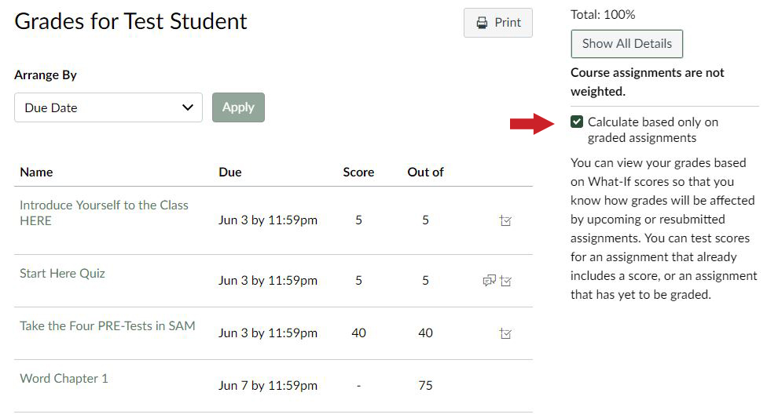
Attendance, Participation, and Zoom Etiquette:
Attendance is a vital component of this course. A great deal of information will be presented during Zoom sessions that will show up on the exams, so attendance is extremely important. Attendance will be taken at the beginning and end of each Zoom meeting. Unexcused absences will result in the loss of one point each. Late arrival or early departure can be also be disruptive. Two instances of unexcused tardiness or early departure will result in the loss of one point.

When you enter our classroom, please be ready to be seen and heard. Make sure that your name as it is listed in your academic record is updated in your Zoom profile. Keep your microphone off/muted when you’re not talking, but keep your video on so that you can be seen. Dress appropriately and avoid multitasking. Focus on the lecture material, take notes, and participate just as you would in a lecture hall by using the Zoom chat feature or “raise your hand” to speak.

Please treat everyone with respect. Students are expected to engage in responsible behaviors and to be civil to one another and to others in the classroom. Recording devices and photographs are not allowed. Please refer to the University Student Conduct Code: http://www.csun.edu/catalog/policies/student-conduct-code/

Office Hours:
You are required to meet with me at least once during the semester. I encourage you to meet with me more often than this. See office hours above and email me to make an appointment.

Research Paper/Creative Project:
See the “research paper/creative project” folder in Canvas for paper assignment. We will go over the paper assignment/creative project and expectations in class. The paper/project is due in the Canvas folder on May 19th by 8pm. NO LATE PAPERS/PROJECTS. A late assignment is only accepted under emergency situation if I am notified in advance and it will be graded down 10 points for each day it is late. Please submit in the Canvas folder in DOC or DOCX format. Please see Course Outline below for due dates.

Emergency Final Exam Contingency Plan: Department of Art
Our final assessment is the research paper/creative project which will be submitted digitally online in Canvas.

Essays:
You are required to write essays where you will be asked to verbalize your thoughts and ideas about lecture and reading material. There will be 5 essays this semester. Essays are due on designated Wednesdays by 8pm in Canvas. Essays are graded on content, organization, grammar, style, and spelling. Be sure that you answer the question asked in its entirety and be sure to proofread your answer.

Essay grades are based on a scale of 0-10 points:
9-10 is the equivalent of an A and represents a polished, well-written, thoughtful, and thorough response.
8 is the equivalent of a B and represents a good essay that demonstrates strong knowledge of the subject but has some minor flaws either in content and/or grammar.
7 is the equivalent of a C and represents an essay that displays weakness in several areas or only partially answers the question.
6 is the equivalent of a D and represents little understanding of the material or the assignment with major flaws in content and/or grammar.

Quizzes:
There will be 11 quizzes that will test your understanding of class material and your ability to interpret the material you have studied. The quizzes will consist of 10 multiple choice questions and you will have 15 minutes to answer them. Quizzes are available on designated weeks in Canvas between Wednesday 6am and Thursday 8pm. Be sure you can take ALL quizzes otherwise this course is NOT right for you. Your score will be posted after the quiz availability period has ended. You may miss one and only one quiz (and you will forfeit all points from this quiz). There are no quiz make-ups or substitutions.

Late Work:
Late work will NOT be graded. I cannot upload assignments to Canvas on your behalf. In addition, screen shots of submissions are not acceptable, emailed submissions are not acceptable, and submissions to the wrong assignment in Canvas will not be accepted. A late assignment is only accepted under emergency situations if I am notified in advance and it will be graded down 10 points for each day it is late.

Written Work:
Your written work should improve throughout the semester and your grades for discussion essays and the research paper will be based on the following:
- Responsiveness to the assignment, clearly demonstrating that you have read and understood the material
- Use of explanation and specific detail to support and clarify your claims
- Standard grammar, punctuation, spelling and English usage
- References cited properly using Chicago Style formatting
- Free of plagiarism. Plagiarism is defined as taking and using the thoughts and writings of another person as if they were your own. This includes plagiarizing another student from this or a previous semester, a website, museum brochure or any other written material. The copying of more than four or five words in a row without citing the source is considered plagiarism. If I discover ANY use of plagiarism, even if it is only one sentence, you will receive a zero for that essay. You will not be able to make up the essay. Further plagiarism will lead to an F for the course and notification to the University.

English as a Second Language:
All essays must be in good, standard English and free of grammatical issues. If English is not your first language, I suggest working closely with The Writing Center in SB408 (7-2033) and finding at least two outside proofreaders (whose command of the English language you admire) to look over your work before you submit it.

Students with Disabilities:

If you have a disability and need accommodations, please register with the Disability Resources and Educational Services (DRES) office or the National Center on Deafness (NCOD). The DRES office is located in Bayramian Hall, room 110 and can be reached at (818) 677-2684. NCOD is located on Bertrand Street in Jeanne Chisholm Hall and can be reached at (818) 677-2611. Students with disabilities who wish to request accommodations must be registered with DRES or NCOD, and should discuss these requests with the instructor as early as possible.

Student Conduct:

Students are expected to engage in responsible behaviors and to be civil to one another and to others in the classroom. Recording devices and photographs are not allowed. Cell phones and laptops are to be turned-off during class. Please refer to the University Student Conduct Code: http://www.csun.edu/catalog/policies/student-conduct-code/

Current e-mail address: You must communicate with me using your current CSUN email address and should include your first and last name, as well as the course name/number.

Academic Integrity:
All students are expected to comply with CSUN’s high standards of Academic Integrity and avoid instances of dishonesty at all times. Such acts of dishonesty include cheating, plagiarism, fraud, false citations or data, and the fraudulent use of Internet resources. Students are not to commit academic fraud. Cases of academic misconduct will be reported and may result in probation, suspension, or expulsion as outlined in Section 41301, Title 5, of the California Code of Regulations.
Academic Fraud includes, but is not limited to, the following situations:
*Plagiarism is using someone else’s ideas or work without proper or complete acknowledgement. Plagiarism encompasses many things, and is by far the most common manifestation of academic fraud. For example, copying a passage straight from a book into a paper without quoting or explicitly citing the author is plagiarism. In addition, completely rewording someone else’s work or ideas and using it as one’s own is also plagiarism. It is very important that students properly acknowledge all ideas, work, and even distinctive wording that are not their own. Students who are unsure of how or when to properly acknowledge sources are encouraged to contact me.
*Plagiarism via the Internet is occurring with more and more frequency, and takes a number of different forms. As should be obvious, purchasing research papers on the Internet and submitting them as a student’s own work constitutes a gross case of plagiarism. Cutting and pasting from a website without putting the text being used in quotation marks and/or without properly citing the source also constitutes plagiarism.
*Cheating is the copying of any test or quiz or essay or work done in a class that is not the student’s own work. It also includes giving or receiving unauthorized assistance during an examination whether it was intentional or not. Obtaining or distributing unauthorized information about an exam before it is given is also cheating, as is using inappropriate or unallowable sources of information during an exam. This includes posting images of exams or content from our course for others to use on the Internet as well.
*Multiple Submission is the use of work previously submitted at this or any other institution to fulfill academic requirements in another class. For example, using a paper from an English class for a Sociology class is Academic Fraud. Slightly altered work that has been resubmitted is also considered to be fraudulent. With prior permission, some professors may allow students to complete one assignment for two classes. In this case, prior permission from both instructors is absolutely necessary.
*False Citation is falsely citing a source or attributing work to a source from which the referenced material was not obtained. A simple example of this would be footnoting a paragraph and citing a work that was never utilized.
*Intentional Deception is the submission of false documentation (absence excuse, proof of attendance, volunteer hours, etc.) for falsifying any official college record. A student who misrepresents facts in order to obtain exemptions from course requirements has committed an act of intentional deception. It is best for a student to do the work as required in a course or speak to the instructor about circumstances that may cause problems in completing forms correctly or honestly.

Course Outline

Week 1 Course Introduction

Jan 25 (Zoom):

- Print out and read this syllabus. This syllabus will be your weekly map for the class so study it carefully. Look over the assignment’s dates and times, reading and writing requirements, and course material. Be sure that this course is right for you and that you will be able to successfully complete it. Online classes require a great deal of personal motivation, discipline, and time commitment. Do not allow yourself to fall behind.
Jan 27 (Canvas):
- Familiarize yourself with our course in Canvas, update your profile in Zoom as well as Canvas, and calendar all due dates for our assessments.

Week 2 Africa

Feb 1 (Zoom): Art and the Artist in the Non-West
Feb 3 (Canvas):

- Read Chapter 1: Art and the Artist in the Non-West

Week 3 Africa

Feb 8 (Zoom): Introduction to the Arts of Africa
Feb 10 (Canvas):
-Read Chapter 2: Introduction to the Arts of Africa

Week 4 Africa
Feb 15 (Zoom): The Royal Arts of the Asante
-Read Chapter 3: Art and Social Status, Asante, Ghana
Feb 17 (Canvas): Asante quiz #1

Week 5 Africa

Feb 22 (Zoom): Mural Art and Beadwork of the Ndebele
-Read Chapter 4: Art and Globalization: Ndebele, South Africa
Feb 24 (Canvas): Ndebele quiz #2

Week 6 Africa
Mar 1 (Zoom): Masking Amongst the Mende
-Read Chapter 5: Masquerade and Initiation: The Mende Sande Society, Sierra Leone
Mar 3 (Canvas): Mende quiz #3

-Essay #1 due

Week 7 Africa
Mar 8 (Zoom): Art and Kingship in Luba Culture
-Read Chapter 7: The Art of the Luba, Democratic Republic of Congo
Mar 10 (Canvas): Luba quiz #4

Week 8: Spring Recess

Week 9 Oceania
Mar 22 (Zoom): Introduction to Polynesian Art: Mana, Tapu, and Art Production
-Read Chapters 8 and 9: Introduction to the Arts of Polynesia and Art and the Belief System in Hawaii
Mar 24 (Canvas): Polynesia quiz #5
-Essay #2 due

Week 10 Oceania
Mar 29 (Zoom): Tatau in Samoan Art
-Read Chapter 10: Samoan Tatau
Mar 31 (Canvas): Samoa quiz #6

Week 11 Oceania
Apr 5 (Zoom): The Art of Carving Amongst the Maori
-Read Chapter 11: Carving Wood and Skin, Maori, New Zealand
Apr 7 (Canvas): Maori quiz #7
-Essay #3 due

Week 12 Oceania
Apr 12 (Zoom): Art and Environment on Easter Island
-Read Chapter 12: Art and the Environment, Rapanui, Easter Island
Apr 14 (Canvas): Rapanui quiz #8

Week 13 Native America
Apr 19 (Zoom): Architecture and the Cosmos: The Art of the Aztecs
-Read Chapters 13 and 14: Introduction to the Indigenous Arts of the Americas and Architecture and the Cosmos, Aztec, present-day Mexico
Apr 21 (Canvas): Aztec quiz #9
-Essay #4 due

Week 14 Native America
Apr 26 (Zoom): Stonework and State Control: The Art of the Inka

-Read Chapter 15: Art and State Control, Inka, South America
Apr 28 (Canvas): Inka quiz #10

Week 15 Native America
May 3 (Zoom): The Art of Giving in the Northwest Coast
-Read Chapter 16: Style, Form, and Meaning in the Northwest Coast, North America
May 5 (Canvas): Northwest Coast quiz #11
-Essay #5 due

Week 16 Native America
May 10 (Zoom): The Pueblo and Navajo of the Southwest
-Read Chapter 17: Art and Appropriation, The Pueblo and Navajo of the Southwest
May 12 (Canvas): Southwest quiz #12 – Extra Credit

Week 17 Finals Week
May 19 (Canvas): Research Paper/Creative Project due in Canvas folder by 8pm

Syllabus is subject to change

