California State University, Northridge
Middle Eastern and Islamic Studies

How Muslims Fight Back Islamic Extremism

A Book Talk by Karima Bennoune
Professor of international Law, University of California, Davis
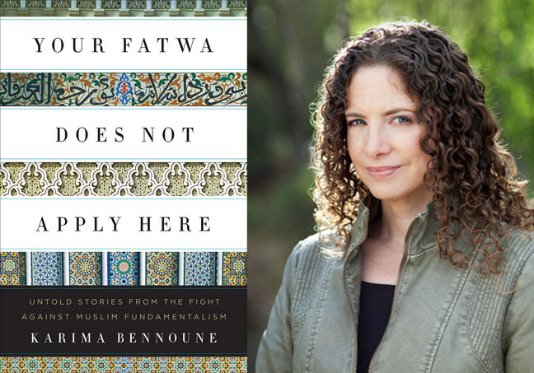
Date: February 27th, 2014

Location: Oviatt Library,
Jack and Florence Ferman Room, CSUN

Time: 12:15 pm
Reception & Refreshment

Karima Bennoune, an international human-rights lawyer, professor and activist, interviewed nearly 300 people from almost 30 countries, from Afghanistan to Mali to illuminate the inspiring stories of those who represent one of the best hopes for ending fundamentalist oppression worldwide. Her writing has appeared in many leading academic journals. She has also been a consultant for the International Council on Human Rights Policy, the Coalition to Stop the Use of Child Soldiers, and UNESCO.
The Middle Eastern and Islamic Studies (MEIS) Program at CSUN is an interdisciplinary minor offering courses in the languages, histories, religions, cultures, sociology and politics of the Middle East. It seeks to enhance students’ understanding of Islamic cultures and the Muslim communities both internationally and within the United States: www.csun.edu/meis
Contact:
MEIS, Office of Interdisciplinary Studies, CSU, Northridge, Sierra Hall 194, Telephone: (818) 677-6762 or 818-677-7218

