California State University Northridge
Middle Eastern and Islamic Studies & Gender and Women's Studies Department
Present:
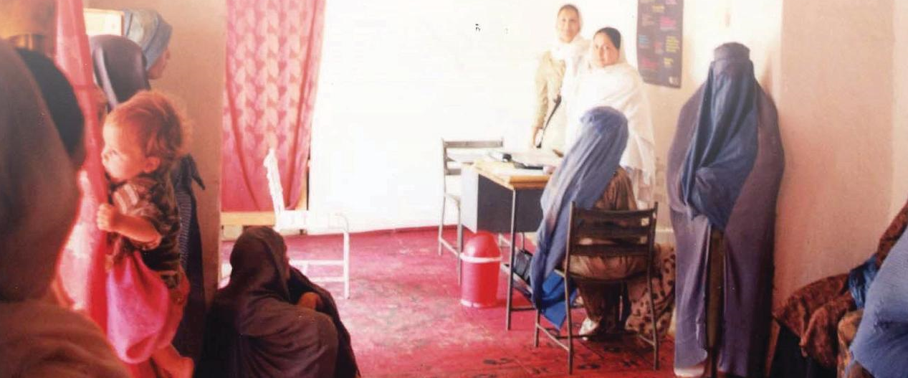

Family Planning and Reproductive Health in Afghanistan:
A Hands-on Case Study
A short film screening and discussion with Taraneh Salke
Date: November 14th, 2013
Time: 4:00 PM
Location: Room 221 Jerome Richfield Hall
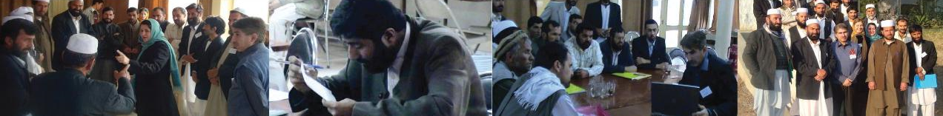
Taraneh Salke is the founder and executive director of Family Health Alliance (FHA), a nonprofit organization focused on advancement of women’s reproductive health and rights in resource poor environments (www.familyhealthalliance.org). An advocate of global women’s health and rights, she speaks extensively nationally and internationally (www.taranehsalke.com), about the importance of cultural sensitivity and relevance in implementing global development programs. Her award winning documentary “Where Are The Men?” depicts women’s health and status in Afghanistan and opportunities missed by the international community to advance women’s development in this male dominated society (www.wherearethemenmovie.com). In 2013, Taraneh was honored at the Women of The World Awards, sponsored by 50/50 Leadership and the United Nations Association. The award recognizes "women who are impacting lives throughout the world."

Contact:
MEIS, Office of Interdisciplinary Studies, CSUN, Sierra Hall 194, Tel: (818) 677-6762 or 818-677-7218
www.csun.edu/meis & www.csun.edu/gws

