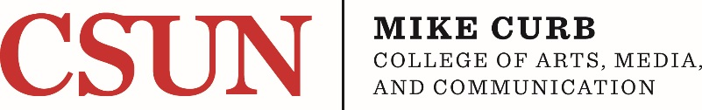

MCCAMC RESEARCH AND CREATIVE ACTIVITY AWARDS
FOR 2020-2021

APPLICATION

Application must be submitted via email to Rachel Valiensi at rachel.valiensi@csun.edu
by 5 pm on Monday, February 24, 2020.

(Note: Due date coincides with deadline for the University level RSCA Awards. All applicants for the Reassigned Time and Mini-Grant awards are encouraged to apply to both the college and university competitions to increase your chance of receiving an award. The same project can only receive one award.)

Files should be named 2021RSCA_Lastname_Firstname

NAME:

DEPARTMENT:

TITLE OF APPLICATION:

TYPE OF REQUEST:

___ Reassigned Time

___ Mini-Grant Amount $ (maximum $5000.00)

___ Travel Support Amount $ (maximum $2000.00)

- Proposal Abstract (Limited to 1800 characters including spaces)
provide an overview of the proposed project that: 1) provides background, 2) outlines the aims or outcomes and 3) describes the significance of the proposed project

- Project Narrative (5 double-spaced pages maximum)
Please keep in mind that the project should be written in such a fashion that it can be clearly understood by academics outside the applicant’s discipline

- Identify the Problem, Project or Subject

- Aim or Expected Outcome

- Research or Creative Process

- Potential Significance

- Timeline

- Plans for Dissemination

- Availability of Resources

- References Cited (1 page maximum, single-spaced)

- Detailed Budget (for mini-grants and travel support requests) OR Justification (for reassigned time requests) (1 page maximum)

- Prior Funding Information
List any University or College RSCA Awards received in the past 4 years. Please provide for each the title and year received.

- Curriculum Vitae (2 single-spaced pages maximum)

