Signing up with S4 Database to begin your Service Learning Experience

Step 1: Go to the Office of Community Engagement’s website where you can find the S4 Database. https://www.csun.edu/undergraduate-studies/community-engagement

Step 2: You will see information and upcoming events pertaining to our office. To access the S4 Database, you would look to the on the left column and click on S4 Service Learning Database

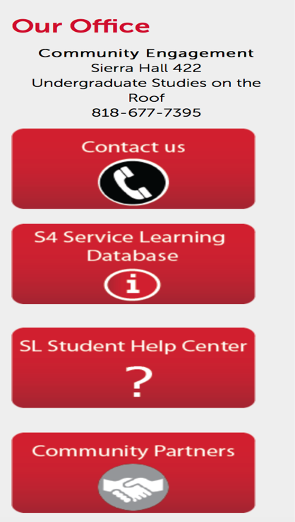

Step 3: After, your screen will open the Service Leaning site.

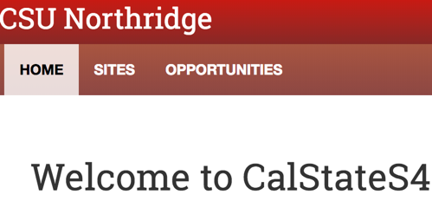

Step 4: You will be prompted to the sign in page where you will click on the Student/Faculty Log In.

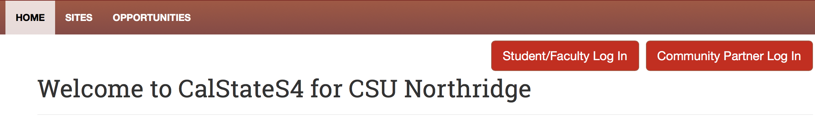

Step 5: Once you do that, you will be asked to choose your campus, California State University Northridge.

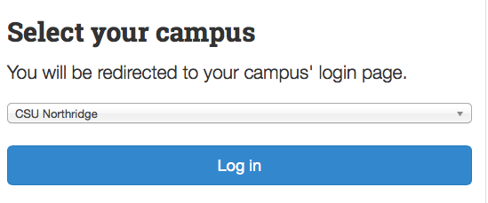

Step 6: Then you will sign in using your student ID credentials.

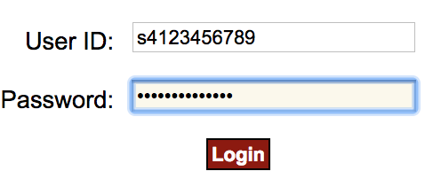

Step 7: You are in! Welcome to the start of your Service Learning adventure. Explore what sites we offer or search what might fit your skills best. If you connect with a site that is not in our database, then the OCE may be able to get them signed up with the S4 Database. Let us connect.

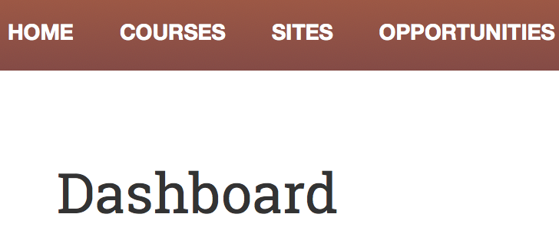

If you have any questions, please do not hesitate to contact, Dr. Svetlana Tyutina
styutina@csun.edu

