Women in the Jewish Experience

Fall Semester 2018 * JS 330

TTh 9:30 – 10:45 AM
Dr. Elaine Goodfriend
Course #14246
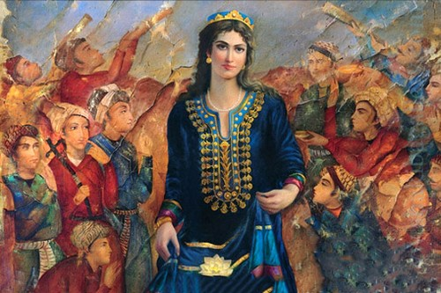

This course examines women in Jewish communities from antiquity to the present. The course perspective is international, with significant focus on Mediterranean, West Asian and African Jewish societies. Contemporary topics include sexuality, birth control, and body image.

Available for General Education, Subject Explorations: Comparative Cultural Studies/Gender, Race, Class, and Ethnicity Studies, and Foreign Languages

