College: Science and Mathematics
Department: Geological Sciences
Program: B.S.
Assessment liaison: Matthew d’Alessio
- Please check off whichever is applicable:
0. __X_____ Prepared assessment instruments for future measurement.
A. ________ Measured student work.
B. _______ Analyzed results of measurement.
C. __X_____ Applied results of analysis to program review/curriculum/review/revision.

Executive Summary

Geological Sciences worked to ‘close the loop’ on our action items from last year’s assessment of our SLO about effective communication. During last year’s assessment work, we realized gaps during the semesters between GEOL 303 (Communicating Geoscience, taken during the first year of the major) and GEOL 490 (Capstone, taken near graduation). There were opportunities for developing and practicing communication skills in many of the intervening courses, but there were gaps and existing assignments were scored using each faculty member’s individual preferences and not always aligned with the communications goals from GEOL 303. We developed a few department-wide resources to provide consistent messaging to students for each of their communications products. Instructors also added assignments to ensure that students get practice in poster and presentation skills more often during our program. This coming year, we will build on that progress by developing a few more resources and having more discussions to bring the faculty onto the same page.

In the past, we have assessed geologic problem-solving through a unique activity called ‘progressively revealed problem sessions.” We have not administered this tool since our massive curriculum overhaul was slowly phased in. All of our new classes have now been taught for three years, so we are ready to see the effect of the new curriculum on student performance. During this assessment cycle, we prepared to administer this tool again by importing items into Canvas and creating a new scenario based on an environmental justice theme. We will administer and analyze the results during the upcoming year.

SLO 4
Students will be able to present polished summaries, both written and oral, of their geological discoveries.

During the 2018-19 report, we identified several action items to ensure that all our faculty are supporting visual communication skills throughout the program and are on the same page about how to do that.

Action items for 2019-20 Assessment
We would like to ‘close the loop’ on our assessment results from 2018-19. This includes:

- Provide examples of successful student work to future gateway and capstone classes so that they can see models of low, medium, and high performing work. With almost no instructional time, these examples can dramatically improve overall product quality.
- Include more posters and visual communication at the “Tier 3” level. Our Tier 2 (gateway) and Tier 4 (capstone) courses all have an emphasis on visual communication products, but there is a gap where we are not really doing much with them in Tier 3. The lead instructor for GEOL 307 immediately offered to incorporate such a project and is considering how to frame the activity.
- Create a ‘visual communication strategies’ handout for faculty to post and distribute with their assignments as a ‘cheat sheet’.

Progress Report

COVID => Change of Plan from Posters to Presentations. In addition to writing for communication, geology places great emphasis on presentations and posters. Our action plan published in our last report called for steps to improve the skill of poster communication and we did make some changes to our program’s use of posters in the Fall semester, but in Spring we redirected towards presentations due to COVID. Posters are an ideal medium for communicating in person while student presentations work better during remote learning. At some point in the future, we need to return to make equivalent progress again with poster communications.

Here is our progress on each of the three action items we identified last year:

- We created Extreme Makeover, Powerpoint Edition (https://youtu.be/wS9JQPsyyJg) for instructors to embed in every GEOL class where students prepare presentations. The 5 minute YouTube video shows ‘before’ and ‘after’ a slide redesign using our department’s checklist for effective slides. The video has 136 views so far – an impressive number considering that we only have 55 majors in the department. We decided against a full ‘collection’ of student examples because we were worried that if there is too much, students won’t utilize the resources.
- Our GEOL 307 instructor followed through and designed a new communication activity using posters. The class had an exceptionally low enrollment last year, so we will archive the five student posters created in Fall 2019 and aggregate them with future semesters for analysis in future years. We plan to return to this SLO in 2 years.
- We created a Checklist for making effective slides for presentations (see attached). It comes with a companion example similar to the Extreme Makeover video except that it includes three levels of quality for the same basic slide. Faculty can pass this single sheet out in class to discuss before assigning presentations.

Action Items for 2020-21
- Continue to collect data on presentations and posters for analysis in 2021-2022.
- Continue to discuss the checklist as a faculty. Encourage our faculty to make revisions to their own slides to follow the checklist so that we give proper models to our students.

Checklist for making effective slides for presentations

Individual Slides:  Main Message |  | Every slide has ONE idea.
 |  | Main message for slide appears as a sentence at the top (a complete sentence, bold, left justified, sentence case, no period).
 |  | Simple graphics communicate the main message visually. They should be able to stand alone (without the sentence headline), but depict the same message as the sentence headline using pictures.
Graphics |  | Graphics are LARGE and clear.
 |  | Graphs and images have annotations like arrows and callouts, when appropriate, to draw attention to the key elements on the slide.
 |  | Graphics are not just random clip-art that distracts – they need to communicate the main message of the slide visually.
Text |  | Text blocks are no more than two lines
 |  | Lists have 2, 3, or 4 items max. NO BULLETS.
 |  | Font is a professional looking “Sans serif” font
 |  | Font is at least 18 points (except for references)
Layout |  | Background is solid color (dark background w/light text, or light background w/dark text)
 |  | There is GENEROUS use of white space.
Presentation |  | Presentation includes a visual roadmap slide that lays out the entire presentation graphically.
 |  | Presentation ends with the main message – NOT a ‘thank you’ slide.

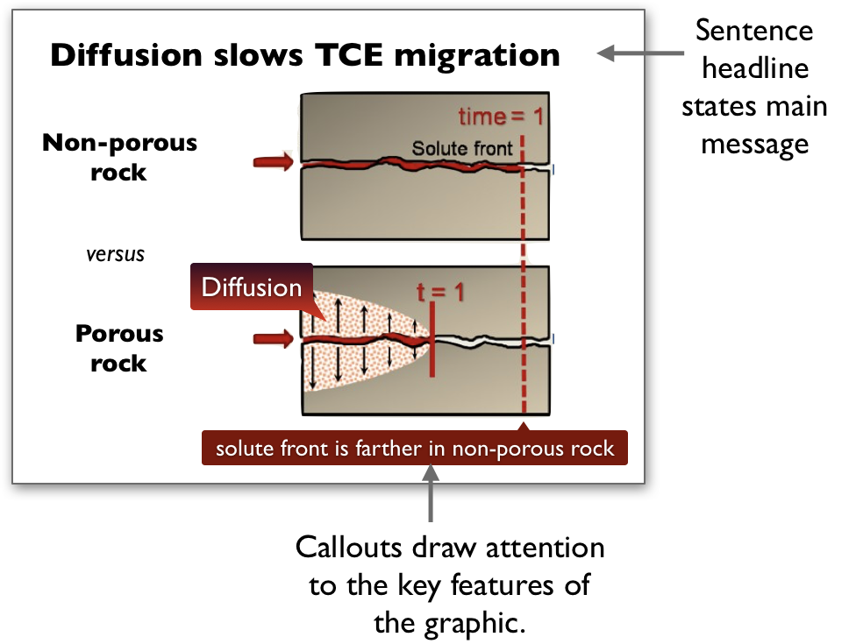
Companion handout to our checklist that narrates the evolution of a slide from a starting point to an effective slide following our presentation strategies.
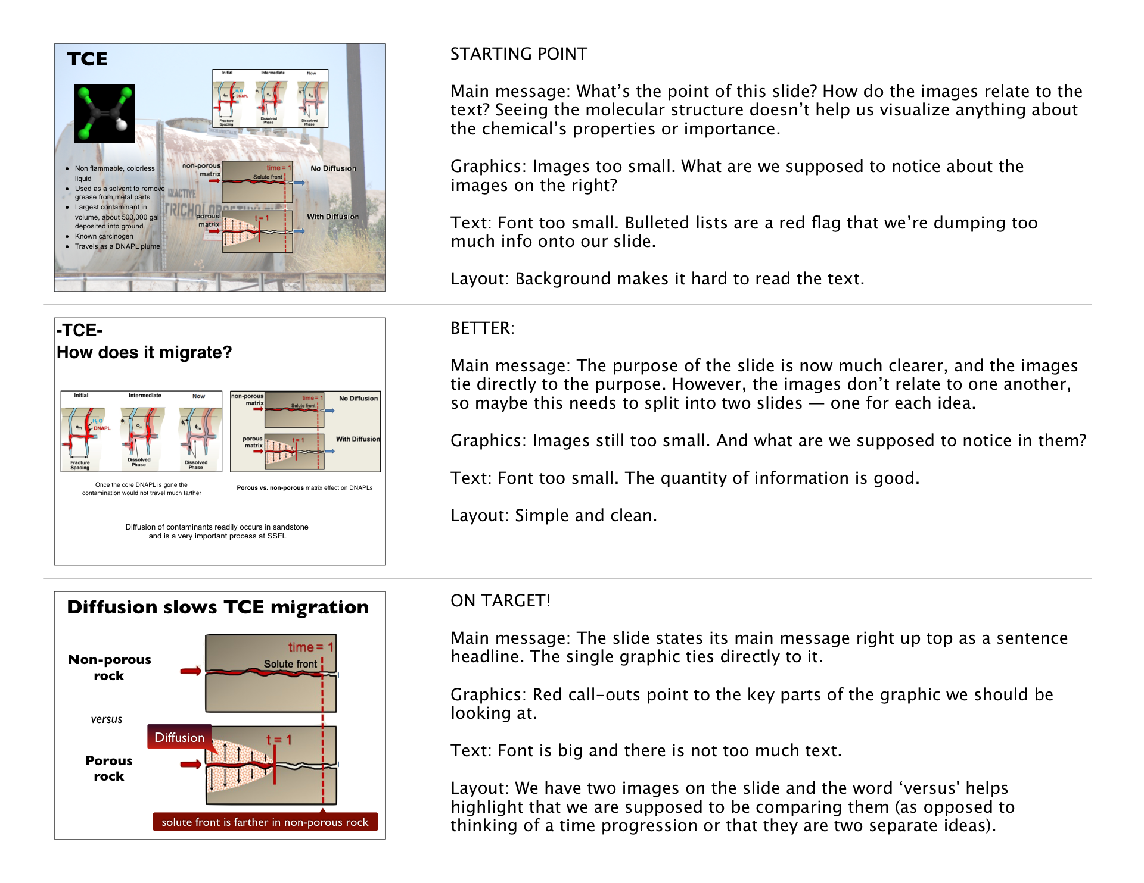

SLOs 2-3
2) Identify geologic problems, use scientific problem solving to aid in their solution, and reflect on the findings, both independently and in collaboration with others;

3) Demonstrate skills in standard data-collection and data-analysis methods in both lab and field settings;

Progress Report
In the past, we have assessed these SLO’s using a ‘progressively revealed problem’ administered in our campus LMS (see 2011-12 and 2012-13 reports). Most items in the assessment relate to SLO 2 with a few items probing the data-analysis portion of SLO 3. Here is a summary from our 2011-12 report:

We utilized a "progressively revealed problem-solving assessment." It is based on some of the case study assessments done by the Biology department at University of New Mexico (references available). The analysis tests 5 independent skills in scientific problem solving:
- Hypothesis generation
- Planning investigations
- Analyzing data (quantitative literacy)
- Evaluate Conclusions (critical thinking)
- Reflect on Conclusions and Formulate Next Steps
We present students with a single scenario ("The Case of the Muddy Fish" for this year's prompt). They respond to the 5 key skills listed above in a series of 5 prompts. With each new prompt, new information is revealed. While all building on a single scenario, the information required for each skill is provided within each skill's prompt. In other words, students are not penalized for "not-knowing how to answer a previous question" because a valid correct answer to the previous question is revealed each time the student moves forward. The situation is novel enough that no students have prior knowledge tackling this specific problem. Though they certainly do draw on some background knowledge in geology, we are hoping to test these independent scientific process skills.

We have not administered the scenarios since the campus migrated from Moodle to Canvas. During the 2019-20 report period, we adapted two existing scenarios to Canvas (The Case of the Muddy Fish and The Case of the Blooming Sakura). In addition, we began developing a new scenario with an environmental justice theme – The Case of the Smoggy City. Our previous items included data analysis of graphs, but this item is about spatial data analysis – a key skill in geoscience problem solving. This scenario also reflects our department’s new attention to equity and environmental justice in our community.

- Data analysis and interpretation (unscored). Students read a short introduction to the MATES IV air quality estimated risk maps that show elevated cancer risk from air pollution in Los Angeles County. The map shows blobs of color indicating the number of cancer cases that can be attributed to air pollution per million residents each year. Rather than giving them the true data for which they might have prior knowledge, we provide them similar data for a community called Matador City. The first question asks them to narrate what they see in the spatial data. This gives them familiarity with the problem and primes them for thinking about this natural system that they have probably never considered as geologists.
- Hypothesesis generation. Students generate 3 possible ideas that might explain the spatial patterns they see.
- Planning investigations. Upon submitting that response, they are posed two competing statements:
  - “Matador City’s bad air quality is dominated by natural factors such as its topography and wind patterns. Expensive environmental regulations should be relaxed because they just add cost without significant benefit.”
  - “Matador City’s bad air quality is dominated by human influences (factories, vehicles, etc…). Air quality regulations for factories and vehicles need to be strengthened to improve human health in the region.”
The students then list data sets they would need to help determine which of these statements applies most to this fictional city.
- Data analysis and interpretation. After hitting submit, they are presented with another layer of actual data chosen by the exam writers (it may not coincide with any of the data they requested in the previous step). Students then narrate an analysis of the spatial data, looking for trends and relationships between the different data layers. Which statement do the data support most strongly?
- Evaluate Conclusions. After hitting submit, they are contacted by a fictitious policy maker that wants input about where to invest in air quality mitigation measures. They receive additional spatial data about household income. They need to weigh the environmental justice factors alongside scientific ones. They reflect on how they would balance these considerations.
- Reflect on findings. The scenario ends with a link to real data for our community, searchable by address. They find their own home and reflect on the situation.

Responses to each prompt are relatively short paragraphs or bullet points.

Action Items for 2020-21
- Vet the new Case of the Smoggy City as a faculty.
- Administer the Case of the Muddy Fish and our new Case of the Smoggy City to students in GEOL 490 (capstone) and GEOL 314 (a gateway-level course)
- Preliminarily compare the gateway and capstone classes.
- Preliminarily compare 2020 to our previous results from before our major curriculum overhaul.
- Collaboratively score and analyze student submissions as a faculty.
- Discuss our findings as a faculty and develop ‘closing the loop action items’ for implementation in 2021-22.

The Case of the Smoggy City (draft)

- Air quality directly impacts human health. While most people know that air pollution triggers asthma, exhaust from burning fossil fuels sprays toxins into the air that trigger many types of cancer. Where there is more smog, there is more cancer. The map below shows the number of cancer cases per million residents that can be directly attributed to bad air quality for Matador City. These data are fictional, but at the end of this session we will show you real data from Los Angeles. Describe what you see in this spatial data set.
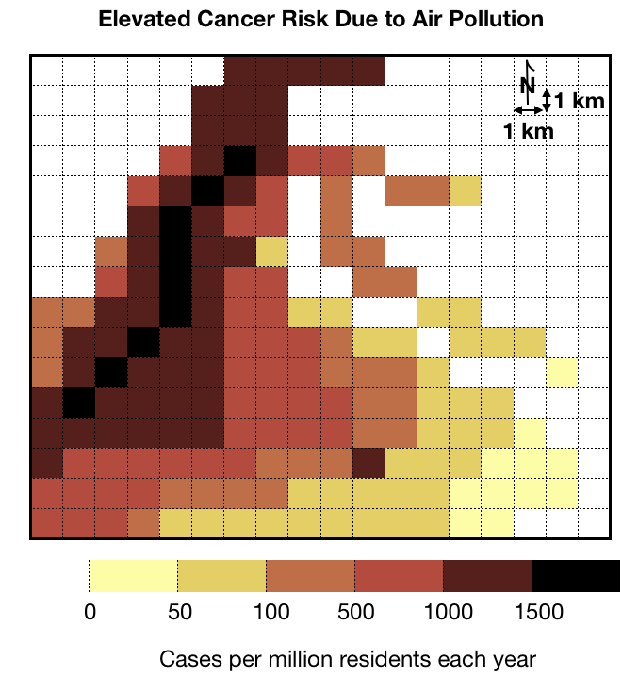

- Name 3 possible things that might cause the spatial patterns and differences you see in the map.
- Two scientists looked at this data set and noticed that air quality was much worse in some areas than others. Here is what they say.
  - “Matador City’s bad air quality is dominated by natural factors such as its topography and wind patterns. Expensive environmental regulations should be relaxed because they just add cost without significant benefit.”
  - “Matador City’s bad air quality is dominated by human influences (factories, vehicles, etc…). Air quality regulations for factories and vehicles need to be strengthened to improve human health in the region.”

List different data sets that you would need to determine if either of these two claims is correct. You can request maps, graphs, etc…

- Below is the original map of elevated cancer risk alongside a map showing topography, major population centers, and freeways. What relationships do you notice in the different data sets? Which of the two scientists’ claims does the data support?
  - “Matador City’s bad air quality is dominated by natural factors such as its topography and wind patterns. Expensive environmental regulations should be relaxed because they just add cost without significant benefit.”
  - “Matador City’s bad air quality is dominated by human influences (factories, vehicles, etc…). Air quality regulations for factories and vehicles need to be strengthened to improve human health in the region.”

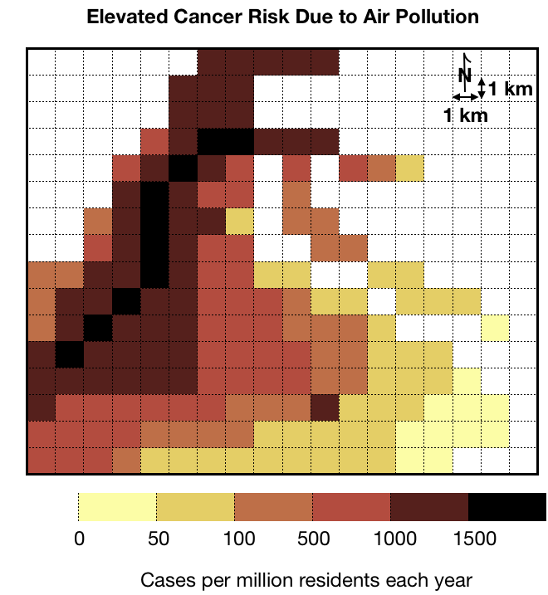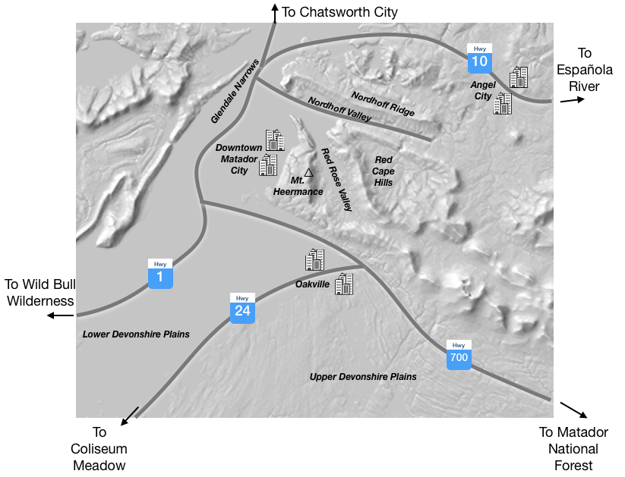

- The federal government has funding for measures to improve air quality. The residents of Nordhoff Valley note that their air quality is significantly worse than their neighbors in the Red Cape Hills. They feel that they should be the first to receive these funds. Do you agree with the residents of Nordhoff Valley? What factors would you weigh to decide where to allocate the funds?
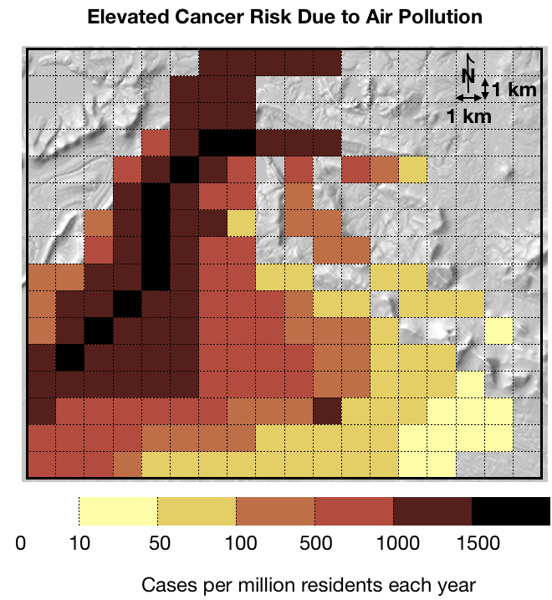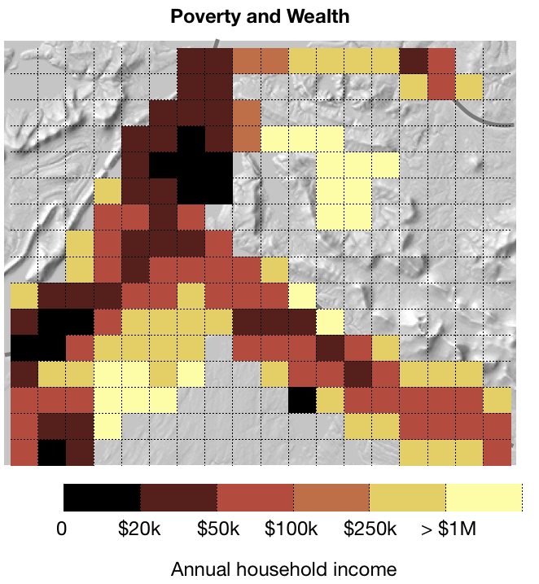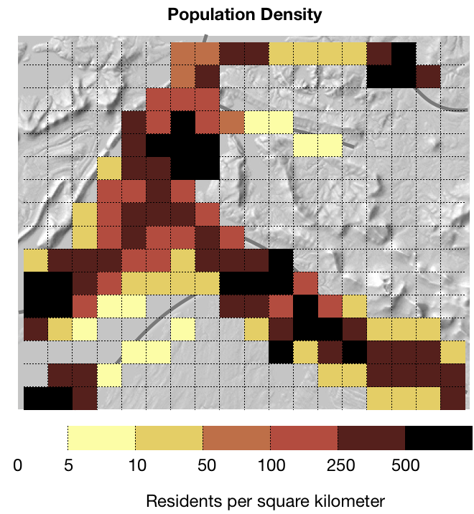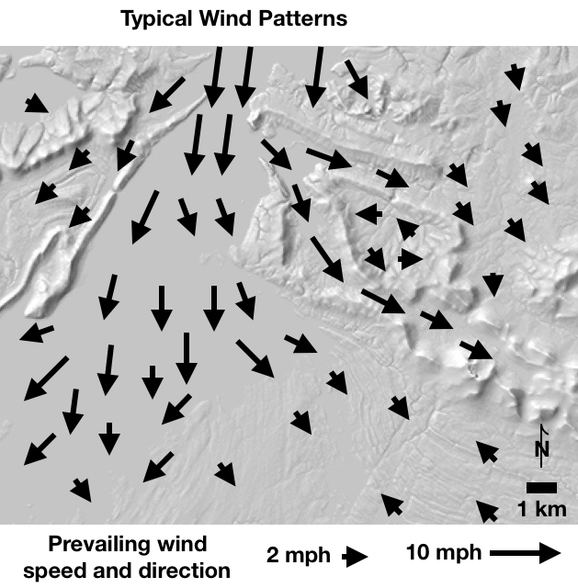
- Matador City is fictional but these scenarios are very real. Take a look at the real map of cancer caused by air pollution in Los Angeles County.
  - Write three things you notice in this map
  - Write three questions you have when you look at this data set.

