GWS 100 INTRODUCTION TO GENDER & WOMEN’S STUDIES

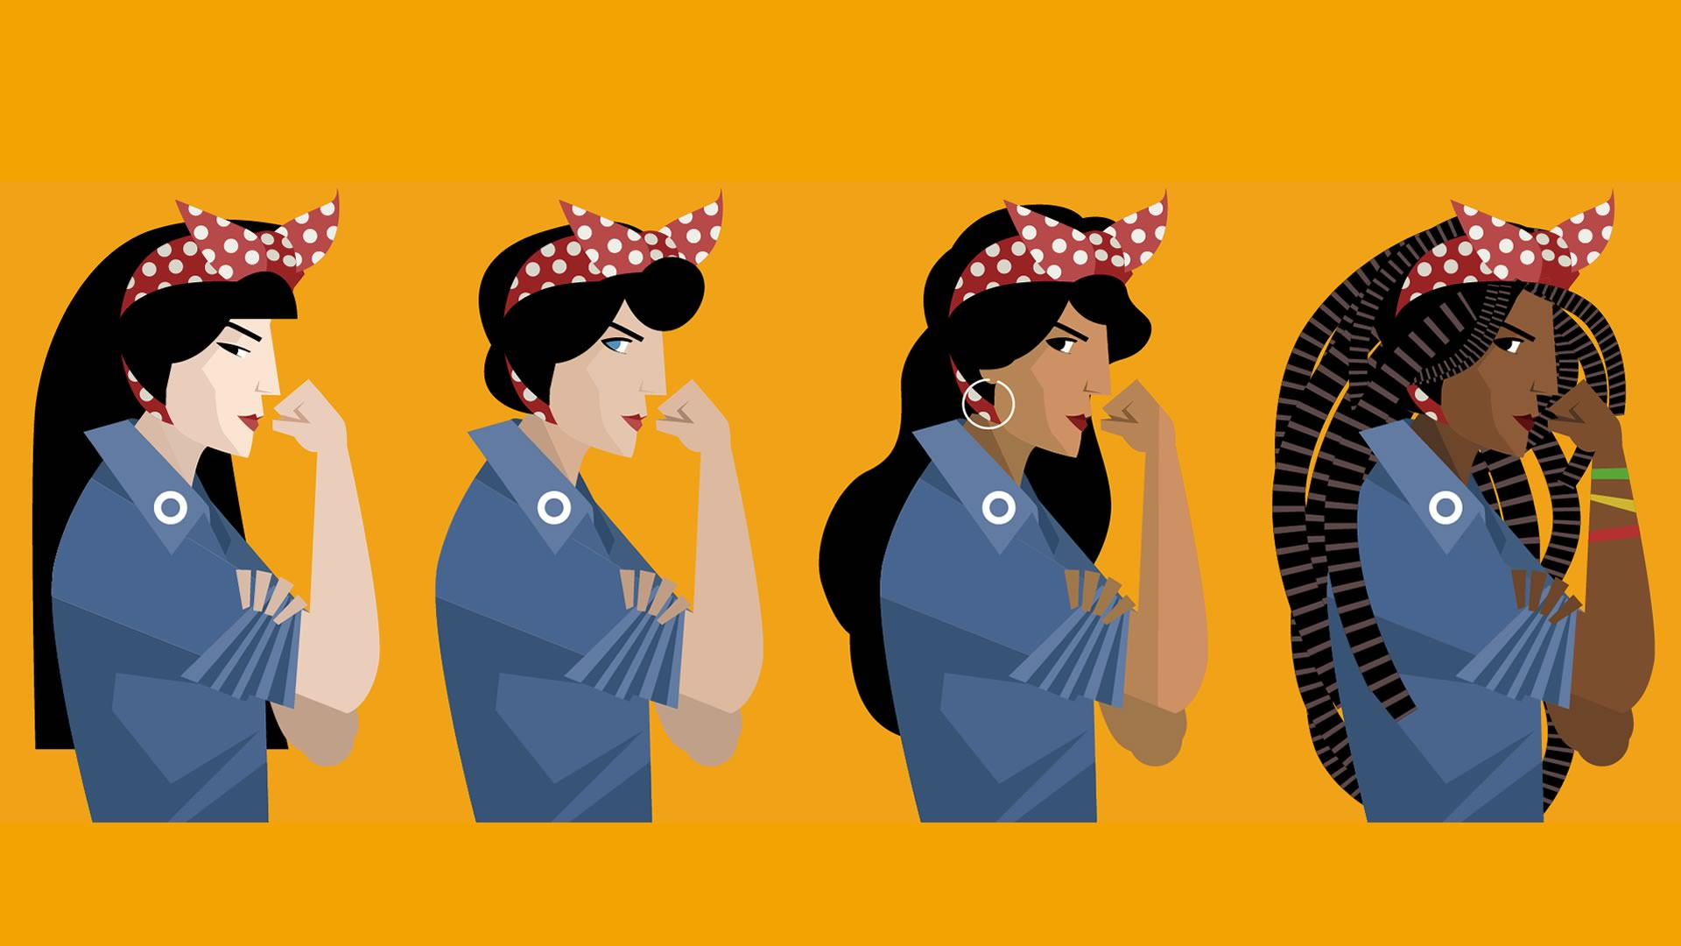

PROFESSOR BRENY MENDOZA

ONLINE CLASS MAY 28-JULY 9^{TH,} 2019

Tuesdays 4-6:45PM

KICK START THE SUMMER WITH A GWS INTRODUCTORY GE COURSE!!
THIS COURSE WILL BLOW YOUR MIND! BRING DOWN THE GENDER BINARY AND LEARN EVERYTHING YOU NEED TO KNOW ABOUT BODY POLITICS!
Sample of topics: gender, feminism, intersectionality, neoliberalism, gender wage gap, slut walks, FEMEN, sexting, rape culture, weight control, gender and the medical establishment, reproductive rights, celebrity feminism, media representation of women and much more!
ENROLL NOW!

