USER GUIDE
Version 6.1

Copyright information
Copyright © 2019 Cryptzone North America Inc. All rights reserved.
Information in this document is subject to change without notice and does not represent a commitment on the part of the vendor or its representatives. Permission to use, distribute, or copy not granted without written approval. No part of this document may be reproduced or transmitted in any form or by any means, electronic or mechanical, including photocopying, without the written permission of Cryptzone North America Inc. Complying with all applicable copyright laws in the US and other countries is the responsibility of the user.
The Cyxtera logo, Compliance Sheriff, and Compliance Deputy are trademarks of Cryptzone North America Inc. Microsoft is a registered trademark of Microsoft Corporation in the United States and/or other countries. All other product names mentioned herein are trademarks of their respective owners.
Technical support
For licensing or technical support information, please submit your requests via the Cyxtera Help Center at http://support.cyxtera.com/. For more information, visit Compliance Sheriff and Deputy Support Terms.

Table of contents
1 - Introduction 6
About Compliance Sheriff 6
Installing Compliance Sheriff 7
Getting Started 7
Logging In 9
2 - Defining and running scans 10
Creating and modifying scan definitions 10
Organizing Scans Into Groups 12
Creating Transaction Scripts 14
Running scans 25
Scanning Local Content 27
Scheduling Scans 28
Scanning the Current Browser Page 28
3 - Defining and running monitors 31
Creating and Modifying Monitors 31
Running Monitors 32
Scheduling Monitors 33
4 - Reviewing results 34
Viewing the results of scans and monitors 34
Showing instances on the web page 34
What happens to the results when you...? 36
Revising results 37
Purging results 41
5 - Managing checkpoints 42
Checkpoint modules and groups 42
Managing checkpoint groups 42
Customizing checkpoints 43
6 - Managing views and reports 45
View definitions 45
Dashboard 46
Scan Summary 47
Scorecard 49
Trend Report 52
Audit Reports 54
Exporting and printing Views and the Dashboard 56
Sending reports and notifications 57
7 - Managing users and groups 59
Creating and managing users 59
Creating and managing user groups 59
8 - Configuring the system 61
Reference Information 62
A. Understanding the user interface 63
Keyboard shortcuts 63
Dashboard tab 64
Scans tab 66
Alerts tab 76
Checkpoints tab 83
Reports tab 86
Settings 109
Admin tab 120
B. Checkpoint expression syntax 124
Checkpoint expression parser 124
Checkpoint variables 124
Checkpoint functions 125
Checkpoint tests and loops 127
Checkpoint properties 132
Checkpoint examples 133
C. Scan diagnostic tool 136
D. Installing and configuring Compliance Deputy 137
Installation requirements 137
Installing and configuring Compliance Deputy 138
Upgrading Compliance Deputy 145

1 - Introduction
Compliance SheriffTM is an enterprise management system that enables validation of content for compliance with organizational and standards-based policies. It provides a unified approach that will meet the demands of both your organization's business and technical constituencies by allowing your experts and policy managers to define your organization's standards. Compliance Sheriff allows users to validate the compliance of new and existing content with your organization's policies,and allows you to know exactly why content has passed or failed.
IN THIS SECTION:
- About Compliance Sheriff
- Installing Compliance Sheriff
- Getting started
- Logging in
- Cryptzone Support

About Compliance Sheriff
With Compliance Sheriff, you can create and manage web governance standards for accessibility, privacy, and custom checkpoint compliance. Effective web content and regulatory governance is an essential risk management strategy that will ensure your organization's online resources comply with federal and international regulatory guidelines for best practices and risk management. Compliance Sheriff helps you avoid the costly litigation settlements and loss of business associated with failure to comply with standards for accessibility and privacy.
Compliance Sheriff provides automated testing and reporting for standards-based Privacy and Accessibility policies based on the current standards outlined by HIPAA, FISMA, COPPA, Section 508, Section 208, WCAG 2.0, WCAG 2.1and other commonly observed US and International standards. In addition to these published standards, you can create site quality and custom tests and reports to suit your organization's specific policies and requirements. For more information, see Checkpoint modules and groups and Customizing checkpoints.
Compliance Sheriff features a web-based user interface that makes even the most complex task simple and intuitive. The Dashboard home page allows content managers and executives direct access to the customizable site status reports. Scans can be scheduled at any frequency, or run on-demand. Drill-downs on failed page elements ensure rapid identification and remediation of any non-compliance or warning. Comprehensive administrative tools are provided for managing users, groups and their access to reports and scans. The result is a comprehensive solution accessible by all personnel across the organization, including, but not limited to web development, content management, governance, and risk management.
The user interface presents a series of tabs with which you can view, edit and run the various features of Compliance Sheriff.

CHECKPOINTS AND CHECKPOINT GROUPS
A checkpoint is an instruction set that will check that a web page conforms to certain predetermined rules or guidelines that make up the accessibility, privacy, and custom compliance modules (see Checkpoint modules and groups). Related checkpoints can be grouped and sub-grouped for easy assignment to scans (see Managing checkpoint groups). Groups and subgroups are also a useful way of controlling and summarizing your reports and charts. Checkpoints can be customized to meet the specific compliance requirements of any organization (see Customizing checkpoints).

SCANS AND MONITORS
Scans and monitors are collections of checkpoints that are evaluated on a defined set of pages within a website. You can create multiple scans and monitors and schedule them to run at specific times (see Defining and running scans and Defining and running monitors) . The results of the scan are written to the scan results database, which can be viewed, analyzed, and summarized in a variety of ways (see Reviewing results). You can configure the scan to issue a notification to one or more e-mail addresses when the scan finishes (see Sending reports and notifications). Scans and monitors are run in the background, so you can log out and continue with other tasks.

VIEWS AND REPORTS
Information generated by scans and monitors can be displayed in the Dashboard and other dynamic views or as static reports (see Managing views and reports). The Dashboard and reports are fully customizable, using predefined graphical and tabulated views. A view can show the result from an individual scan or combine the results from multiple scans or filter the results by URL or checkpoint groups.
Views can be customized to display data in a variety of formats including summary statistics, tables, and charts. From these views, you can drill-down to any desired level of detail, including the address and nature of each detected non- compliance and warning. Reports can be generated from any of these defined Views.
Views and Reports provide visibility into how your organization is performing with respect to compliance goals and allows you to compare compliance performance among individuals and groups.

ADMINISTRATION
From the Settings and Admin tabs, you can define user group privileges, manage users, change passwords, set user preferences, view user activity (see Managing users and groups), and other administration functions (see Configuring the system).

Installing Compliance Sheriff
To install and configure Compliance Sheriff, refer to the Compliance Sheriff Installation Guide. The main topics covered by the installation guide include:
- Architecture and components
- System requirements and recommendations
Installation, licensing, upgrades and uninstall
- Optional configurations
- Active Directory integration
- Adding proxy servers
- Enabling features when installed behind an SSL

Getting Started
To get a quick overview of Compliance Sheriff and produce immediate results:
- Log in to Compliance Sheriff (see Logging in).
Tip: If you are the first user, log in with the username "Administrator," and the password supplied to you when your installation was created. Otherwise, ensure that you belong to a group that has been given edit permission for scans, monitors, and views before proceeding with the next steps (see Creating and managing user groups).
- On the Dashboard, if no views have been added, the Quick Start is displayed. In the Start URL box, type the address of the web page where you want the scan to start
Tip: Make sure you type in the full address, e.g. http://cryptzone.com/company/about.
- Click the Compliance mode box and select a compliance standard, e.g. Section 508 or WCAG 2.0 AA.

- In the Maximum pages box, type the maximum number of pages you want to scan from the start page.
Tip: Initially keep this number small (up to 20 pages), so you get a quick result. You can always edit later.
- Click Scan. A status message is displayed while the scan runs. You can navigate away from the Dashboard without interrupting the scan.
Tip: You can stop the scan at any time, just click Abort. You can view the status by going to the Scans tab and sorting by the Status column. The Scan name is labelled “QuickStart” with the Start URL appended.
- When the scan is completed, you can Save it or run a new scan.
  - Click New Scan to run a new scan
  - Click Save under Save Options to save the scan. Quick Start scans are temporarily stored by the system. You must Save or it will be over written.
  - To Add the results view to the Dashboard, Check this option first and then click Save.
  - Click View Result to view the results without saving the scan. You can also save the scan from there. For more information about viewing scan summaries, see Working with scan summaries.
Tip: Save option will save both the scan definition and the view definition used to display the results of the scan. If you choose to add the view to the Dashboard, it will be displayed immediately.
- You can View and Edit the saved scan definition from the Scans tab and View/Edit the saved results view from the View tab. For information on modifying these definitions, see Creating and modifying scan definitions and Managing view definitions.
NOTE. Pending, running and aborted Quick Start scans are displayed in the scan list. However, completed scans are not displayed in the default view of the scan list. Completed Quick Start scans can be displayed in the Scan list by selecting the <Temporary Scans> group (or the scan group Quick Start is configured to use) in the Scan Group filter. For information on how to configure Quick Start to use a scan group, see Quick Start configuration.
Tip: Use Quick Start to quickly create and run a shallow scan, and then customize the saved definition to run a fully optioned, deeper scan.
- Access the full range of privacy, accessibility and site quality standards supplied with Compliance Sheriff, such as HIPAA, COPPA, FISMA, SOC, and more (see Checkpoint modules and groups).
NOTE. The checkpoint groups available in a Quick Start scan are set by your administrator. See Quick Start configuration for more information.
- Scan the contents of pages under development or in your corporate intranet (see Scanning local content).
- Create scripts to access secure sites and pages with dynamic content (see Creating transaction scripts).
- Customize views and reports (see Managing view definitions) and add them to the Dashboard (see Managing the Dashboard).
- View non-compliances in-place on the web page (see Showing instances on the web page).
- Revise scan results when a checkpoint produces a false positive (see Revising results).
- Summarize and report the health of the website (see Working with scan summaries, Working with scorecards, and Sending reports and notifications).
As you navigate around the interface, click the Help button at the top-right of the page to display information about the options available on that page.

Logging In
To use Compliance Sheriff, you will need a valid username and password. Contact your Compliance Sheriff administrator if you do not have one. If multiple users require concurrent access, each user requires a user account (see Managing users and groups).
Initially, when the software is first installed, you can log in as <Adminstrator> without a password (leave blank). After logging in for the first time, it is important that you set this password.
To log in:
- In the Username box, type in your username.
- In the Password box, type in your password, which is case sensitive.
Password policy is configurable. Refer to System configuration on the Settings tab for the current password requirements and how to configure your password policy.
- Select the Remember me check box so that in the future you will be logged in automatically.
NOTE. If you choose the Remember me option, your log-in details might be visible to other users on this computer.
If you access the login.aspx page or if you clicked Sign Out previously, you will always be prompted to log in, regardless of the Remember me option.
To change your password:
NOTE. This function is not available if Active Directory integration is enabled.
- Select the Settings tab.
- Click Change password.
- In the Current password box, type in your current password.
- In the New password box, type in your new password.
- In the Confirm password box, type in your new password again.
- Click Save.
Depending on how the password policy is configured, you may also be asked to change your password regularly at log- in,, e.g.,
To change your preferences:
- Select the Settings tab.
- Click User preferences.
- Review and edit your User preferences as required.

2 - Defining and running scans
Scans allow you to run multi-level checks on your site for compliance issues. Related scans can be grouped so that they can be run or scheduled as a unit and the results combined into a single view or report. You can also scan local content and web pages under development before they are published.
To view the results of a scan, see Reviewing results.

Creating and modifying scan definitions
A scan is a collection of checkpoints that will be executed on a defined set of pages within a website. You can view, create, edit, and delete scan definitions from the Scans tab. If you have multiple sites that need to be scanned, you can create a scan for each individual site. NOTE that you can combined the results of a collection of scans into one report view.
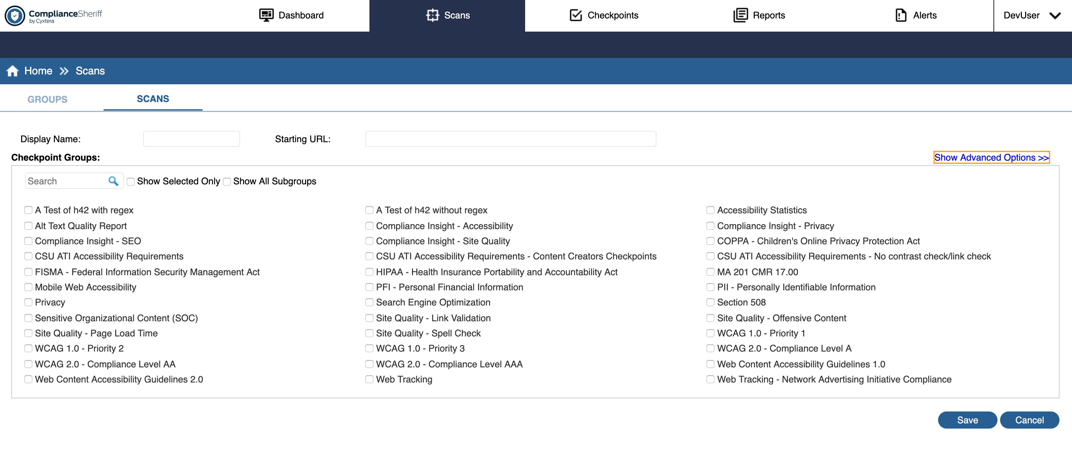

Figure 2 – Screenshot of where you would create a scan within Compliance Sheriff.

You can either create the scan definition on the Scans tab or run a Quick Start scan (with restricted options) from the Dashboard and then save it. For information on running a Quick Start scan, see Getting started.

NOTE: New scans cannot be created with multiple start pages. However, legacy scans with multiple start pages are supported, identified by an orange play button instead of normal green button. Expand the scan definition to view the list of start pages. A new Start Pages tab is created when the scan has multiple start pages. This table is read-only.

To view existing scan definitions:
Select the Scans tab. The Scans sub-tab displays all existing scan definitions in a table.
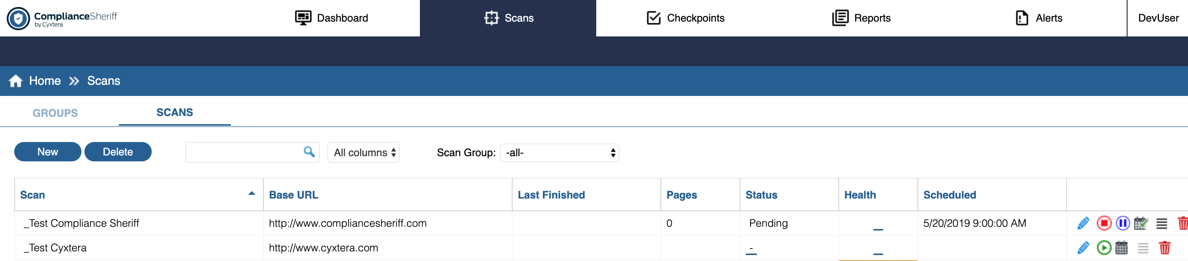
Figure 3 – Screenshot of scan list table.
- Each record in the table represents one scan. The columns show selected properties of each scan definition and the results of the last-run scan.
  - To see Scan Results, Click on an item in the Health column
  - To view the Scan Properties, Click on item in the Scan column
  - To view the Log files related to that scan run, Click an item in the Status column
- Filter the list by clicking in the Search box and typing a search string. The list updates as you type. You can also filter on one or more columns listed in the provided dropdown. Click the Cancel icon in the search box to clear the filter and display all scans.
- To display scans belonging to a particular scan group, select the group from the Scan Group dropdown provided.
  - To display the scans that are existing within a Scan Group, Click the Groups subtab. For more information about scan groups, see Organizing scans into groups.

To create a new scan definition:
You must define at least the Starting URL and one checkpoint group.
- Select the Scans tab, and then click the Scans subtab.
- Click New. You can also edit an existing scan definition and save as a new scan definition (see instructions on editing below).
- In the Display Name field, type a name for the scan. You can use long descriptive names.
- In the Starting URL field, type the full path name of the site to be scanned.
Not all pages in the domain are scanned. The depth of the scan is controlled by the Level and Page limit options (under Show advanced options) and by which pages can be reached by crawling through links.
- In the Checkpoint groups box, select the compliance checkpoint groups to be used by the scan.
  - You must select at least one checkpoint group.
  - A subgroup is any checkpoint group that is contained by another checkpoint group.
  - By default, subgroups are not listed in the table. T
  - o list the available subgroups, select the Show all subgroups check box.
6. To specify other properties (see Scan properties for more details), click Show advanced options. These options enable you:
• To control the depth of the scan, in the Levels field, select a level from 0 (start page only) to 20.
NOTE. Deep scans (with a high level value) can take a long time to run, potentially several hours, and require considerable network resources.
- To limit the total number of pages scanned (default is 20), in the Page limit box, type the maximum number of pages to be scanned.
- To specify the username and password required for the scanner to access the site, type the Username and Password for that Domain.
- To define user interactions required to access parts of a site, paste the script into the Transaction script box For example, to scan pages in a shopping cart site, you will need to log in, select an item, and check out. Refer to Creating transaction scripts for instructions on recording, modifying and replaying your scripts.
- To include or exclude page addresses, type a regular expression in the Include/Exclude URLs matching box that matches the names to be included or excluded. For example, typing \.txt in the Exclude URLs matching box excludes all pages with URLs ending with .txt.
- To specify additional or alternate domains to be included in the scan, type the URL in the Additional domains box. For example, if the base URL is http://www.mycompany.com/, a search link might point to http:// search.mycompany.com/, which will not be scanned unless specified in the scan.
- To retest all pages when a scan is rerun, select Retest all pages. Select this option to force the scan to retest all pages and update the results. When the results returned from a scan are manually updated (see Revising results), the page is not rescanned unless this option is turned on, to preserve the updated results of the last scan.
- To scan content on a local machine, the local intranet, or a secure location that can only be accessed from a local machine, select Scan local content. This will start the local scan agent. For more information, see Scanning local content.
- To select additional, non-HTML file types to be included in the scan, select Include PDF files and/or Scan Office documents. When scanned, the files are converted to HTML and then processed against the checkpoints defined in the scan.
- To change the default user-agent string, click the User-agent box and select from the available user-agent strings. In addition to the standard browsers (Internet Explorer, Chrome, Safari and Firefox), user-agent strings for a variety of screen sizes for mobile devices are also available. See Scan properties for more information on this option.

7. Click Save.

To edit a scan definition:
NOTE. For information about what happens to scan results when an existing scan is modified, see What happens to the results when you...?.
- Select the Scans tab, and then click the Scans subtab.
- Locate the scan you want to edit, and click the name in the Scan column or click Edit.
- Modify the scan properties as needed. See Scans subtab for details.
Click Save to save your changes. Y
- ou can also save as a new scan definition, but you must change the Display
Name before clicking Save As New.

To delete a scan definition:
- Select the Scans tab, and then click the Scans subtab.
- Locate the scan you want to delete. If the scan is running, click Stop.
- Click Delete.
- A confirmation is displayed. Select OK to delete the scan definition. If the scan has an associated view, a confirmation is displayed. Choose OK to continue deleting the scan.
Important. Any results for the scan will be permanently deleted.

Organizing Scans Into Groups
If you have a large number of scans, scan groups can help you stay organized. By creating scan groups, you can easily run related scans and combine the results of multiple scans into a single view or report. If your organization uses different versions of its website in different regions, you can create a scan group for each region. Similarly, you can group scans by department or business unit.
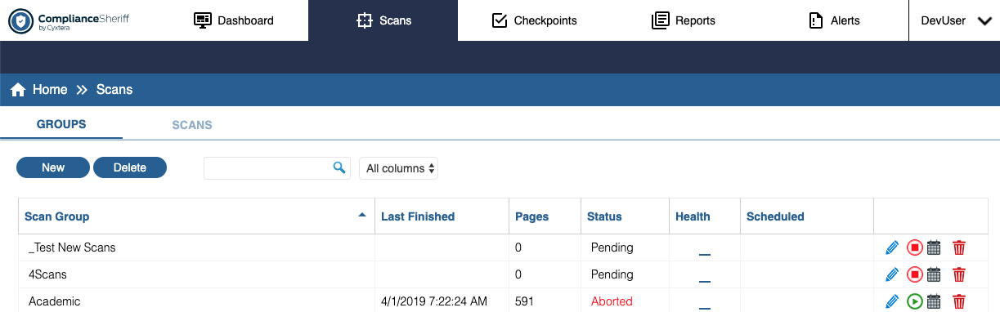

Figure 4 – Screenshot of table that includes the listing of Scans Groups.

To view existing scan groups:
- Select the Scans tab, and then click the Groups subtab.
- To filter the list, click in the Search box and type a search string. The list updates as you type. You can filter on one or more columns. Click the Cancel button to clear the filter and display all scans.
- Select the Scans tab, and then click the Groups subtab.
- Click New.
- In the Display Name box, type a name for the scan group. You can use long descriptive names.
- In the Scan group contains box, select whether the scan group will contain scans or subgroups (other scan groups). The available scans or subgroups are displayed. A scan group cannot include both scans and subgroups.
- In the Scans box, select the scans or subgroups you want to include in the scan group.
- Click Save.

To edit a scan group:
- Select the Scans tab, and then click the Groups subtab.
- Locate the scan group you want to edit, and click the name in the Scan Group column or click NOTE. A scan group cannot include both scans and subgroups.
- In the Scans box, add or remove scans or subgroups. To restrict the list to only the scans or subgroups selected in the scan group, select Show selected only.
- Click Save to save your changes. If you are saving as a new scan group, you must change the Display Name before clicking Save as new.

To delete a scan group:
- Select the Scans tab, and then click the Groups subtab.
- Select the scan group. You can select more than one scan group at a time. To select or clear all scan groups, select
or clear the check box in the header cell.
- Click Delete.
- A confirmation is displayed. Select OK to continue with the deletion. If you delete a scan group that has a view associated to it, a confirmation is displayed. Choose OK to continue deleting the scan group.

Creating Transaction Scripts

Transaction scripts tell a scan to take specific actions or navigations when scanning a site. This allows you to capture a typical user interaction and incorporate it into a scan definition. User Interactions might be as simple as entering login credentials or filling out a complex multi-stage form. Compliance Sheriff uses a proprietary WebDriver that supports specific commands for playback in a scan definition. These commands are largely a subset of Selenium IDE-based commands with additional Compliance Sheriff commands that enables a higher level of control of your scan results.

To manually create and edit a script:
- Open or create a Scan definition (see Defining and running scans).
- Click Show Advanced options.
- In the Transaction Script box, type or edit the script in the script box (see Selenium IDE script commands).
- Click Save.
NOTE. The Cryptzone toolbar in the Internet Explorer browser is not supported in version 5.0 or later. However, legacy sites that contain scans created with the Cryptzone toolbar can still be run by pasting the script into the Transaction Script box.
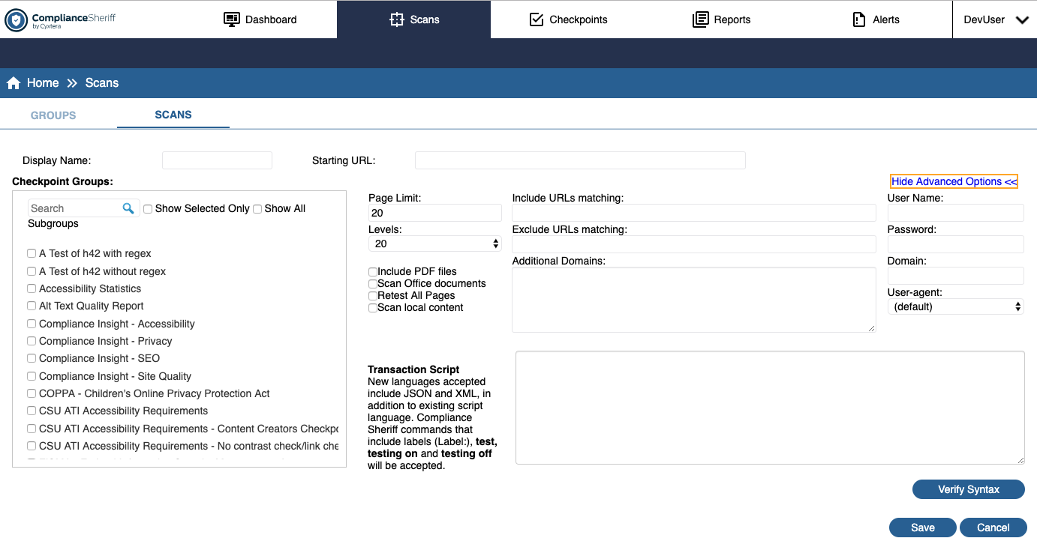
Figure 5: Screenshot of the Scan definition properties which includes a text box for entering a Transaction script.

To Record a Script using JSON Format

Installing the Selenium IDE Chrome Extension

- Download the Selenium IDE Extension for Chrome from the following location:
https://chrome.google.com/webstore/detail/selenium-ide/mooikfkahbdckldjjndioackbalphokd?utm_source=chrome-ntp-icon
- Click the Add to Chrome button, and the Add Extension popup choice.

Using Selenium IDE

- Click Selenium IDE icon in the toolbar. A Welcome pop-up window will appear with options to select under a “what would you like to do?”
- Click Record a new test in a new project.
- You will be asked to provide a name for your new project. Enter a project name in the Project Name field. Click OK button.
- You will need to set your project’s base URL before you can start recording. You must enter a valid base URL in the text box provided. Your tests will start by navigating to this URL.
- Once you enter your Base URL, then Click on Start Recording button.
- In the window that pops up, perform the actions you want Compliance Sheriff to replicate
- When the activity is complete, navigate back to the Selenium IDE Window.
- Click the Stop Recording button in the toolbar or use Ctrl+u.
- You will be brought to a screen that indicates a list of all the Commands you entered as well as the Target and Value for each command.
- Optional: At this point, we recommend that you review each of the commands to confirm they are supported by Compliance Sheriff.
- Click Save Project using the Save icon in the page toolbar. This saves the file as a *.side file.
- Close Selenium IDE.
- Find the *.side file that you saved
- Open the *.side file in NOTEpad, NOTEpad++ or something similar. The file that. You exported is in JSON format.
- Go to the Scan definition in Compliance Sheriff. Find the Transaction script text box in the Advanced section.
- Paste the JSON content into the text field.

To Record a Script using XML Format
Installing the Katalon Recorder

- Download the Katalon recorder browser extension from one of these locations:
  - Chrome store - https://chrome.google.com/webstore/detail/katalon-recorder/ljdobmomdgdljniojadhoplhkpialdid?hl=en-US
  - Firefox Add-Ons - https://addons.mozilla.org/en-US/firefox/addon/katalon-automation-record/
- Open the Katalon Recorder. Click the Start Recording button in the navigation bar.
- Browse to the website you want record, and walk through the steps that a user would walk through.
- When you complete your task, Click on the Stop Recording button. The Katalon Recorder should now list out all the Commands used to execute your steps, along with a corresponding column of a Target and Value for each Command.
- Click the Export button. The Export Test Case as a Script page will appear.
- In the Format field, select XML from the dropdown provided.
- Click the Copy to Clipboard button on the page.
- Go to the scan definition in compliance Sheriff. Find the Transaction Script text field in the Advanced section.
- Paste the XML content into the Transaction Scrip Text field.

Supported Commands for Transaction Scripts

Transaction scripts tell a scan to take specific actions or navigations when scanning a site. Below is a complete list of commands supported by transaction scripts. Each of the commands have the basic format of command "target" "value".

NOTE: The examples and syntax provided below uses Compliance Sheriff's proprietary WebDriver syntax. A transaction script can be manually created using the syntax below. Refer to articles on using the JSON or XML formats for alternate formats that enable the use of automated recording tools.

Commands (Unique to Compliance Sheriff)

The following commands are unique to Compliance Sheriff. You can insert them into a Transaction Script for finer control over how and when pages are scanned, and insert useful tags used in scan results.

testing
Description: Allows automated testing to be enabled or disabled. Default state is on.
Syntax: testing on|off
Examples:
testing on
testing off

test
Description: Explicitly triggers testing the current page in its current state. This triggers a test even when automated testing is disabled with testing off.
Syntax: test
Examples:
test

Labels
Description: Labels are used so that, when reviewing the scan results, the records have an informative reference.
Syntax: LabelToBeSeen:
Examples:
Scan Analysis 1:
MyOtherLabel:

Commands (Selenium IDE Supported)

The following list of commands are the subset of Selenium IDE commands supported by Compliance Sheriff for playback in a scan. Not all Selenium IDE commands recorded using external recording tools are supported by Compliance Sheriff, and commands outside of the list below are ignored if used in a scan definition.

open
Description: Open is used to navigate the browser to a new URL. If testing is on (default state), a scan is triggered before additional actions are taken.
Syntax: open "Complete URL" ""
Examples:
​open "http://www.google.com" ""
open "http://www.contoso.com/myPage.aspx?importantParameter=42" ""

addSelection
Description: Add a selection to the set of selected options in a multi-select element.
Syntax: addSelection "target selector" "option selector"
Examples:
addSelection "id=MySelector" "label=OptionsText1"
addSelection "id=MySelector" "index=2"

answerOnNextPrompt
Description: Provide the specified answer string in response to the next JavaScript prompt [window.prompt()].
Syntax: answerOnNextPrompt "response value" ""
Examples:
answerOnNextPrompt "MyResponseText" ""

chooseCancelOnNextConfirmation
Description: By default, window.confirm() function returns true, as if the user manually clicked OK. After running this command, the next call to confirm() returns false, as if the user clicked Cancel. Then it resumes using the default behavior for future confirmations, automatically returning true (OK) unless/until you explicitly call this command for each confirmation.
Syntax: chooseCancelOnNextConfirmation
Examples:
chooseCancelOnNextConfirmation

chooseOKOnNextConfirmation
Description: By default, window.confirm() function returns true, as if the user manually clicked OK. However, if chooseCancelOnNextConfirmation is called, the next confirm() returns false, to undo this or otherwise ensure it returns true this command can be used.
Syntax: chooseOKOnNextConfirmation
Examples:
chooseOKOnNextConfirmation

click
Description: A click on a link, button, or radio button.
Syntax: click "target selector" ""
Examples:
click "id=MyButtonId" ""
click "//div[4]/div/div/a[1]" ""

clickAndWait
Description: A click that is expected to load a new page. This also triggers an automatic scan if testing is enabled (default state).
Syntax: click "target selector" ""
Examples:
clickAndWait "id=MyButtonId" ""
clickAndWait "//div[4]/div/div/a[1]" ""

goBack
Description: Simulates the user clicking the Back button on their browser.
Syntax: goBack "" ""
Examples:
goBack "" ""

pause
Description: Wait for the specified amount of time (in milliseconds).
Syntax: pause "milliseconds" ""
Examples:
pause "1000" ""
pause "60000" ""

removeSelection
Description: Remove a selection from the set of selected options in a multi-select element using an option locator.
Syntax: removeSelection "target selector" "option selector"
Examples:
removeSelection "id=MySelector" "label=OptionsText1"
removeSelection "id=MySelector" "index=2"

runScript
Description: Executes provided command(s) within the current browser context during a scan. Beware that JS exceptions thrown are not managed, so it is advised to wrap your script in try/catch blocks if there is any chance that the script will throw an exception.
Syntax: runScript "script block" ""
Examples:
runScript "javascript{ JAVASCRIPT_HERE }" ""
runScript "javascript{ e = document.createElement('div'); t = document.createTextNode('temp text'); e.appendChild(t); document.body.appendChild(e);}" ""

select
Description: Select an option from a drop-down field using an option locator. Option locators provide different ways of specifying options of an HTML Select element (e.g., for selecting a specific option, or for asserting that the selected option satisfies a specification). TselectFrame
Syntax: select "selector" ""
Examples:

selectFrame
Description: Selects a frame within the current window. You can invoke this command multiple times to select nested frames. To select the parent frame, use “relative= parent” as a locator. To select the top frame, use “relative=top”. You can also select a frame by its 0-based index number--select the first frame with “index=0”, or the third frame with “index=2”.
Syntax: selectFrame "selector" ""
Examples:
selectFrame "id=myIFrame1" ""

selectWindow
Description: Selects a popup window using a window locator. After a popup window is selected, all commands go to that window. To select the main window again, use null as the target. Window locators provide different ways of specifying the window object: by title, by internal JavaScript "name," or by JavaScript variable.
Syntax: selectWindow "selector" ""
Examples:
selectWindow "name=MyPopUp"
selectWindow "title=Main Home Page"

type
Description: Used for entering text.
Syntax: type "selector" "value"
Examples:
type "id=MyInputBox" "This text would be entered"
type "//div[4]/div/div/input[1]" "Entering this text"

waitForElementPresent
Description: Pause execution until an expected UI element, as defined by its HTML tag, is present on the page. Default 30-second timeout based on Settings: System Configuration: Scanner Settings: Timeout.
Syntax: waitForElementPresent "selector" ""
Examples:
waitForElementPresent "id=MyDiagBox" "

waitForFrameToLoad
Description: Pause execution until an expected new frame loads. Default 30-second timeout based on Settings: System Configuration: Scanner Settings: Timeout.
Syntax: waitForFrameToLoad "selector" ""
Examples:
waitForFrameToLoad "id=MyFrame1" ""

waitForLocation
Description: Wait for URL. Will timeout after 30 seconds.
Syntax: waitForLocation "absolute_url" ""
Examples:
waitForLocation "http://www.mytestSite.com/lib/page3.html" ""

waitForPopup
Description: Waits a designated amount of time for the designated popup window to open. If none is specified, it waits for any window to be opened.
Syntax: waitForPopup "windowName" "millisecond_timespan"
Examples:
waitForPopup "MyPopupWindow" "30000"
waitForPopup "" "30000"

Validating the Format of Transaction Scripts
1. After creating or recording a transaction script using a third party tool, copy and paste the script into the Transaction Script field of a scan definition.
2. Click Verify Syntax button following the transaction script text field.
3. If your transaction script doesn't have the correct syntax, Compliance Sheriff displays a descriptive error explaining the reasons for the error.
5. If you entered a properly formatted transaction script, when you click Verify Syntax, you see a Syntax Verified message. You are free to run your scan.
NOTE: A properly formatted transaction script does not guarantee that the script plays back successfully when running the scan. Additional troubleshooting may be required to resolve any issues with the transaction script playback.

Supported XML Format Rules

1. Root node name does not matter.

2. Child node name does not matter.

3. Root node must have at least one child node.

4. There can be only one level of child nodes under the Root node.

5. Each child node, in this case “selenese,” requires a child node with each of the following names: command, target, value.

6. The comment node is an optional node under the child node, and can be added to any or all child nodes.

7. No quotes or colons are required.

8. What is placed in the command, target, and value nodes are taken as is--there is no transformation.

Sample XML Output Code
NOTE: NOT ALL COMMANDS ARE COMPATIBLE WITH ComplianceSheriff.

<?xml version="1.0" encoding="UTF-8"?> [Symbol] Not Required, but can be used
<TestCase> [Symbol] Root node, Required, Name does not matter
<selenese> [Symbol] Child Node, Name does not matter
<command>open</command> [Symbol] Required, Node Name must be “command”
<target><http://www.compliancesheriff.com/></target> [Symbol] Required, Node Name must be “target”
<value></value> [Symbol] Required, Node Name must be “value”
</selenese>
<selenese>
<comment>Test comments</comment> [Symbol]Not Required, but can be used in any child node to add a comment, no colon required.
<command>click</command>
<target>link=Test Your Site Now</target>
<value></value>
</selenese>
<selenese>
<command>selectWindow</command>
<target>id=win_ser_1</target>
<value></value>
</selenese>
<selenese>
<command>click</command>
<target>id=shellmenu_0</target>
<value></value>
</selenese>
<selenese>
<command>click</command>
<target>id=resources</target>
<value></value>
</selenese>
<selenese>
<command>click</command>
<target></target>
<value></value>
</selenese>
</TestCase>

Required JSON Format Rules

While the Selenium IDE is used to auto-generate the JSON that is used, it may be helpful to understand the formatting. Additionally, we have two (2) custom commands that can be added by hand. More information on this is found below.

Inside the script, we focus on the list of commands, and each command is comprised of three (3) parts:
command – Provides the type of action that is taken
target – Identifies the element
value – Value to provide, if applicable (i.e., text to type)

The following is a basic example of the JSON transaction script that performs two actions/commands:
open a website
type a name in an input field.

{"commands":[
{
"command":"open" ,
"target":"http://www.compliancesheriff.com" ,
"value":
}
{
"command": "type" ,
"target": "id=username" ,
"value": "user1"
}
]}
*NOTE: When there is more than one command, each must be separated by a comma, as are each of the key/value pairs.

Sample JSON Output Code

NOTE: NOT ALL SELENIUM COMMANDS ARE COMPATIBLE WITH Compliance Sheriff. Review this list of accepted commands.

In the sample below, the highlighted code is only what Compliance Sheriff is using. No other lines of this JSON script is used by our software.

{
"id": "5dbdaf41-1326-48a6-a3ae-c3efeb114c49",
"name": "Untitled Project",
"url": "https://pathways.studentaffairs.csun.edu/",
"tests": [{
"id": "5ab5eb23-5c21-45b3-aceb-3498d749ec89",
"name": "Untitled",
"commands": []
}, {
"id": "0c9d515e-cf80-4431-a533-d19cb4c6c9f6",
"name": "Dev Complaince Sheriff",
"commands": [{
"id": "2139a1bd-596c-4a7c-a5f4-a05c34197d00",
"comment": "",
"command": "open",
"target": "https://auth.csun.edu/cas/login?service=https%3A//pathways.studentaffairs.csun.edu/auth/cas/service&amp;amp;languageCd=ENG&amp;amp;embedform=true",
"value": ""
}, {
"id": "529577b0-368e-4640-85d5-6e4198960761",
"comment": "",
"command": "type",
"target": "id=username",
"value": "capguest5"
}, {
"id": "f467d8c1-0abe-4a11-8f0b-9a1c972dd70c",
"comment": "",
"command": "type",
"target": "id=password",
"value": "pathways5"
}, {
"id": "dcde4ca1-ef41-4984-b676-f27246c8e911",
"comment": "",
"command": "clickAndWait",
"target": "name=submit",
"value": ""
}, {
"id": "2fcd444c-c3ee-42d9-adf0-7a18d9e9cd1c",
"comment": "",
"command": "clickAndWait",
"target": "link=YOURSELF",
"value": ""
}]
}],
"suites": [{
"id": "cead4a4c-fd1e-43e6-8ea3-2ff61ba2399a",
"name": "Default Suite",
"parallel": false,
"timeout": 300,
"tests": ["5ab5eb23-5c21-45b3-aceb-3498d749ec89"]
}],
"urls": ["https://pathways.studentaffairs.csun.edu/"],
"plugins": [],
"version": "1.0"
}

Using the Firefox Selenium IDE script recorder
Selenium IDE is a powerful scripting engine that allows you to record your interactions with dynamic, client-based sites. It has the ability to handle web applications in which user actions trigger client-side scripting (via AJAX, for example) in order to update the displayed page. The scripts recorded by Selenium IDE emulate the actions of the user, and can reproduce button clicks, drop-down menu selections, field value entries, and many other actions. When Selenium- generated scripts are copied into a Compliance Sheriff scan, they enable faster and more reliable results.
Before using the Selenium IDE script recorder, review the Prerequisites for running Selenium IDE scripts.
Record the script
- Selenium IDE should begin recording automatically. The record button appears in the upper right of the Selenium IDE user interface, and is signified by a red dot.
- In the Base URL field, type the URL of the site you wish to record scripts on, and click the globe icon. Navigate the site in Firefox as you normally would: select different links, open menus, press buttons, and enter information as needed.
- When you have finished interacting with the site, return to the Selenium IDE user interface, and click Record to stop the recording. Click File>Save Test Case As, type a name for the recording, and click Save.
- Delete any items you created, and sign out.
Tip. It is good practice to leave the site you interacted with in the same state it was in when you started the recording.
- In the upper left of the Selenium IDE user interface, slow down the playback speed by dragging the slider. Click Play entire test suite (this is the play button, adjacent to the Fast-Slow slider control). Watch the sequence of commands and confirm that the movements through the site are accurate. If they are, the script has recorded correctly.
Review and edit the script
Select and delete any commands recorded by Selenium IDE that you do not want copied into your scan in Compliance Sheriff. For more information, see Selenium IDE script commands. If you delete any commands, be sure to confirm that the script can still play back correctly. If it cannot, either record a new session, or enter the missing commands manually.
To manually enter a Selenium IDE command, right-click in the command sequence and select Insert New Command, and then type the command in the Command field. Drag the command to the correct place in the sequence.
To manually enter a comment or Compliance Sheriff command, right-click in the command sequence and select Insert New Comment, and then type the command in the Command field. Drag the comment or command to the required position in the sequence. For more information, see Adding labels and Test commands.
Save and paste script into the scan definition
- Click File>Save Test Case As, type a name for the recording, and then click Save.
- Click Copy to display the formatted script in the default text editor. Copy the contents and paste it into the
Transaction Script box of the scan definition (see Creating and modifying scan definitions).
- Save the scan and run it.

Prerequisites for running Selenium IDE scripts
To record and run Selenium IDE scripts, you need the following components, installed in the order shown:
- Mozilla Firefox
Mozilla Firefox must be installed on the client machine. The scanning engine replays the script using Internet Explorer, so Firefox does not need to be installed on any servers.
- Selenium IDE
Selenium IDE is the script recorder and only works with Mozilla Firefox. To configure Selenium IDE in Firefox:
  - Download Selenium IDE from https://addons.mozilla.org/en-US/firefox/addon/selenium-ide/ and install on the client machine.
  - Start Firefox.
  - Press ALT to display the top menu, and then click Tools>Selenium IDE.
  - Click Options and select Record absolute URL.
  - Click OK.
NOTE. You might need to enlarge the Options dialog to see the OK button.
Compliance Sheriff Selenium IDE add-in
The add-in installs the Compliance Sheriff Selenium IDE toolbar, from which you can record scripts in Firefox. To install the Compliance Sheriff Selenium add-in:
• Download and run the Compliance Sheriff Selenium IDE add-in installer (csseleniumaddin.xpi) from the plugins folder where Compliance Sheriff is installed.
To start recording scripts from the toolbar, see Using the Firefox Selenium IDE script recorder. Related topics
...Using the Firefox Selenium IDE script recorder ...Compliance Sheriff Selenium IDE toolbar ...Selenium IDE script commands

Compliance Sheriff Selenium IDE toolbar
Open URL
Opens the address entered in Firefox.
Copy
Opens the current script in the default text editor, formatted for Compliance Sheriff. This can then be copied and pasted into the scan definition. Alternatively, from the File menu, point to Export Test Case, and click Transaction Script. This will export the formatted transaction script to a text file, which you can then copy and paste into the scan definition.
Insert test command
See Selenium IDE script commands for more information.

Selenium IDE script commands
- Supported commands
- Unsupported commands
- Command buffering
- Test commands
- Adding labels
- Actions not recorded

UNSUPPORTED COMMANDS
Many commands in Selenium IDE, such as assertAlert, are not recognized by Compliance Sheriff, but they should not disrupt your scan. You can delete these commands.
COMMAND BUFFERING
At the beginning of a recording session, no commands will appear in the command sequence until a click or clickAndWait action is made. As soon you perform one of these click actions, the action will appear in the command sequence, preceded by the buffered actions. For example, if you open a site and log in, no commands will appear in the sequence until you click the login button. Once you did so, the command sequence would look similar to this:
open "http://www.mycompanywebsite.com" " " type "id=username" "Administrator"
type "id=password" "TopSecret" clickAndWait "id=LoginButton" " "
This buffering only occurs once. If you open a different site page, your actions would not be recorded, and you will need to manually add the action to the command sequence (see “Review and edit the script” step in Using the Firefox Selenium IDE script recorder).
TEST COMMANDS
If you are creating a scan for a site with partial page updating—for example, a site containing subtabs that do not load a new page when you select them—you may need to insert a test command. Doing so indicates that an important action took place during the script recording session, but was not registered by the browser, and this action needs to be tested against Checkpoints in Compliance Sheriff. For example, a click command won't trigger a test to validate a page against your checkpoints—you need a clickAndWait command for that—so you would add a test command immediately after the click command in the sequence:
click "id=ContentPlaceHolder1_CompanySitePageList_btnDelete" " " test
The testing off/on commands are available for cases in which particular site interactions are required as part of the transaction, but the pages that are returned do not need automatically testing.
To add test commands:
NOTE. Test and testing on/off are Compliance Sheriff commands, so Selenium IDE will not recognize them as commands and must be entered as comments.
- In Selenium IDE, after a script has been recorded, select the command you want to test.
- Right-click and select Insert New Comment.
- Type the command and then drag it into the sequence in the position required.
ADDING LABELS
Adding labels to Selenium IDE commands makes a scan report easier to navigate because the comments will appear in the report and you will know exactly what the passes, failures, warnings, and visual checks refer to.
To create a label:
- In Selenium IDE, after a script has been recorded, select the command you want to label.
- Right-click and select Insert New Comment.
- Type the label in the Command field ending with a colon. For example, if you wanted to label a command "After Login", and the command is clickAndWait "id=loginButton", the command sequence should look like this:
After Login:
clickAndWait "id=loginButton"
Be sure to label test commands you have inserted, so that it is clear what these actions refer to. For example:
click "id=login" After Login: test
ACTIONS NOT RECORDED
The actions listed below are not recorded by Selenium IDE:
Actions not recorded | Workaround
Pressing ENTER on a selected button. | Click with the pointer.
Clicking Back and Forward buttons in the browser. | Insert a goBack command manually, but there is not an equivalent forward command.
Using the Bookmarks menu to load a new page. | Insert an open command for the bookmarked page. Insert an open command for the page you have loaded.
Loading a new page by typing the address in the address bar. | For information on commonly recorded commands, see “Common commands” above.

Running scans
Scans can be run on demand from the Scans tab. To schedule a scan to run at regular intervals, see Scheduling scans. Before scanning local content, see Scanning local content. You can also use Compliance Deputy to quickly scan pages under development, before they are published (see Scanning the current browser page).
To run a scan:
- Select the Scans tab, and then click the Scans subtab or Groups subtab.
- Locate the scan or group you want to run and, on the scan record, click Run. The scan status changes to
“Pending” and then "Running”. Refer to Scan status for other status values.
To pause and resume a scan:
- Select the Scans tab, and then click the Scans subtab.
NOTE. Pause/Resume function is only available for scans—that is, you cannot pause a scan group. Also, scans with
multiple start pages cannot be paused.
- Locate the scan you want to pause and check that the scan status is “Running”. Refer to Scan status for other status values.
- On the scan record, click Pause. The scan status changes to "Pausing" and then “Paused”. While paused, the scan log and results can be viewed (see Viewing the scan log and Viewing the results of scans and monitors).
- To resume the scan, click Resume.
To stop a scan:
- Select the Scans tab, and then click the Scans subtab or Groups subtab.
- Locate the scan or group you want to stop and check that the scan status is “Running”. Refer to Scan status for
other status values.
- On the scan record, click Stop. The scan status changes to "Aborted."

Scan Status
The status of the scan indicates whether the scan has been run, is currently running, has completed running, or was stopped by a user.
Status | Description
None | The scan has not been run.
Pending | The scan has been launched, but is not able to run yet.
Running | The scan is currently in progress.
Pausing/Paused | The scan is currently paused and can be resumed or cancelled. The results of the incomplete scan can be viewed
Completed | The scan completed successfully, and a health value generated (see below).
Aborted | The scan failed to complete properly.
To view the scan log, click the status value (see Viewing the scan log). MARKING ABORTED SCANS AS COMPLETED
When a scan is aborted, the status can be changed to completed, by Viewing the scan log and selecting Mark as completed. The Health value (see below) is then calculated from the page content that was successfully scanned. This is useful when a long scan is aborted near completion and avoids the need to rerun the scan.
HEALTH VALUES OF COMPLETED SCANS
The results of completed scans are summarized by the Health value:
Health | Description
Passed | The scan completed successfully, and a health value generated.
Passed with warnings | The scan completed with some warnings, and a health value generated.
Failed | The scan completed, but one or more pages failed to pass all the checkpoints.

Click the Health value to display details of the scan results (see Viewing the results of scans and monitors).

Viewing the Scan Log
You can combine time-stamped log messages from multiple scan runs and filter the results by category:
- Debug: detailed information about scan progress, including an "Analyzing" message for every page processed.
- Info: information about the scan, including timings, IP address information, and redirections detected.
- Error: unexpected events, such as pages not being able to be downloaded or processed, or critical problems that prevent the scan from completing.
To view a scan log file:
  - Select the Scans tab, and then click the Scans subtab or Groups subtab.
  - Click the status value in the corresponding scan or scan group record.
  - The log file for the last run is displayed. Select or clear the Debug, Info, and Error check boxes to determine which results are displayed. Click a column heading (e.g. Type, Timestamp, Message, or Stack trace) to sort the results by that column.

Scanning Local Content
If you want scans to access content that is only accessible from the local machine, you must install the local scan agent. The local scan agent communicates with the Compliance Sheriff server and uploads content from the local machine for scanning. The local scan agent is required for content on:
- Your local machine
- The company intranet
- A secure site that requires special authentication from your local machine
If you want to run scans overnight, make sure that the machine hosting the local scan agent is not shut down or placed in hibernation mode.
NOTE. The local scan agent only supports a single instance of Compliance Sheriff.
To install the local scan agent:
- Download and run the local scan agent installer (ComplianceSheriffLocalScanAgentInstall.exe) from the plugins folder where Compliance Sheriff is installed.
- From the installer, when prompted, click Next.
- Click Next to accept the default folder path for the installation.
- When prompted, type the full URL path to Compliance Sheriff. Do not include the .aspx suffix in the address. Click Next.
NOTE. If this is a local host address, the local scan agent is not required.
- When prompted, type a user name and password of a local user that will allow the scan agent to access the local content. Click Next.
- Click Install.
- When the installation completes, click Finish. A confirmation page will then load in your default browser.
NOTE. Record the URL of the confirmation page for future reference. This page sets a cookie for the current browser. If the cookie is lost, or you want to use a different browser, you can restore the cookie by visiting this page with the new browser or rerunning the installer from the new browser.
You are now ready to scan local content.
To scan local content:
- Edit the scan or monitor.
- Click Show advanced options and select Scan local content.
- Click Save.
- Run the scan.

Scheduling Scans
A scan can be scheduled to run at predetermined intervals. Multiple schedules can be defined for a scan.
To schedule a scan:
- Select the Scans tab, and then click the Scans subtab or Groups subtab.
- Click the Schedule button of the scan or group you want to schedule.
- Click Add to define a schedule.
- Select or type the Scan schedule properties as required.
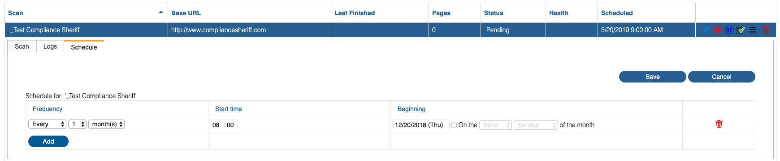
Figure 6 – Screenshot of scheduling scans page.
Schedules use the user’s time zone setting (see User preferences). The default time is based on the locale set on the server hosting Compliance Sheriff.
- Click Save.
NOTE. If a scan has not completed by the time the next run is scheduled to begin, then the next run will be skipped.
To change or remove a scan schedule:
- Select the Scans tab, and then click the Scans subtab.
- Click the Schedule button of the scan you want to reschedule.
- Select or type the Scan schedule properties as required. Click Add to set another schedule or click remove a schedule.
- Click Save.

Scanning the Current Browser Page
You can quickly scan the current browser page (e.g. a page that is under development on your local machine) by either running Quick Start scan (see Getting started) with the local scan agent installed (see Scanning local content) or by running a scan from Compliance Deputy. This topic describes how to use Compliance Deputy to scan the current page from a browser.
Compliance Deputy is an on-demand browser-based plug-in that allows developers and content providers to test and repair content prior to publishing in the production environment. It utilizes the checkpoints created in Compliance Sheriff.
Compliance Deputy toolbar (Google Chrome version shown)
Compliance Deputy is available for the following browsers:
- Microsoft Internet Explorer
- Google Chrome
- Apple Safari (Mac only)
- Mozilla Firefox
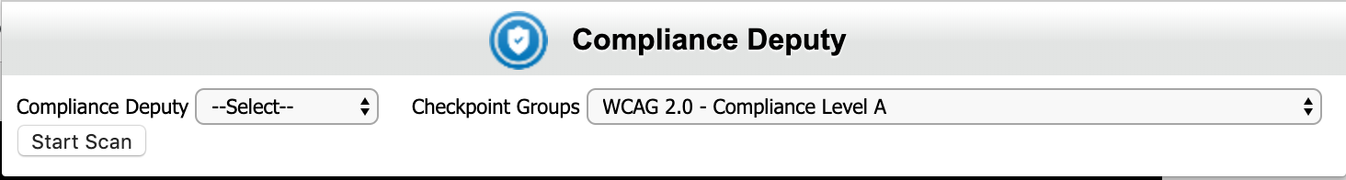
Figure 7 – Screenshot of Compliance Deputy toolbar
To scan a page with Compliance Deputy:
- In the browser address box, type the address of the page you want to scan.
- In the Compliance Deputy toolbar, select the Checkpoint groups you want to scan the page against.
- Click Start Scan. The scan status changes to "Scanning".
- When the scan is completed, a new tab is opened to display the scan result, and the status changes to "Complete":
  - To view details of issues detected by the scan, in the Scan Results tab, click the message link.
  - Select Source to view the page source or Rendered view to view the rendered web page.
- Modify the page source to resolve the issues reported by Compliance Deputy, and then rerun the scan to verify the issue has been resolved. If required, select another checkpoint group in the toolbar and scan the page again for a different set of compliance checkpoints (see below).
To view Compliance Deputy scans in Compliance Sheriff:
- Pending, running and aborted Compliance Deputy scans are displayed in the Compliance Sheriff scan list.
- Completed Compliance Deputy scans can be displayed in the Scan list by selecting the <Temporary Scans> group (or the scan group Compliance Deputy is configured to use) in the Scan Group filter. For information on how to configure Compliance Deputy to use a scan group, see Configuring and managing Compliance Deputy installations.
NOTE. The Temporary Scans group is also the default group for Quick Scans.
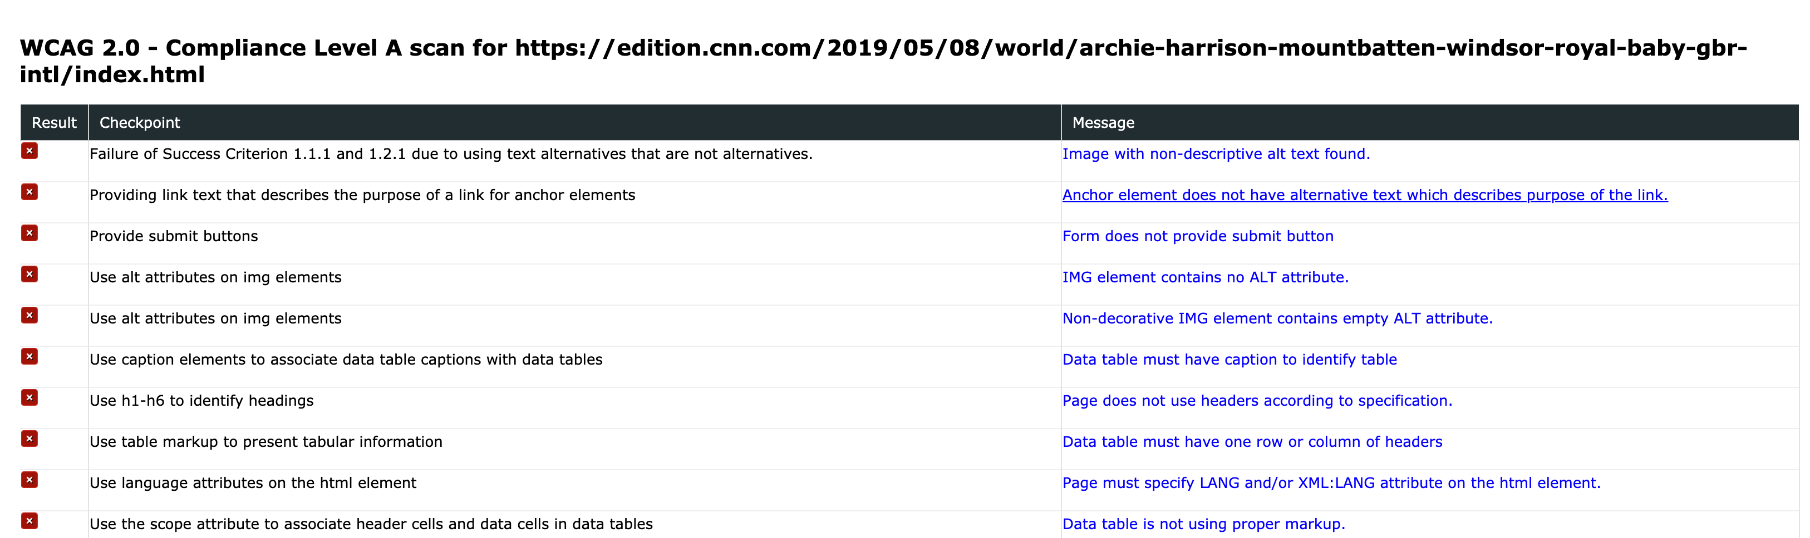
Figure 8 – Screenshot of Compliance Deputy results
To scan with a different checkpoint group or scan definition:
- From the Deputy toolbar dropdown list, select another checkpoint group to scan the page against.
NOTE. If the checkpoint group is not available in the list, notify your Compliance Sheriff administrator. The administrator will need to create or edit the Compliance Deputy configuration file to include the appropriate Checkpoints group(s). Once provided, use the Load configuration option in the Deputy toolbar to browse for and reload the configuration file.
- To use a different scan group or scan definition, you will need to create and deploy additional configuration files. For example, to check accessibility on mobile devices, you will need to create a configuration file that specifies mobile checkpoints and a scan group containing a scan definition for each user-agent string you want to test.
If there are no checkpoint groups available in Compliance Deputy:
- The checkpoint groups available in Compliance Deputy are defined in a configuration file. Compliance Deputy reloads the configuration each time the browser starts. If no checkpoint groups are available for selection in Compliance Deputy, the most likely cause is that the configuration file failed to load. You can load the configuration file manually (see below). Contact your administrator to find out how to access the required configuration file.
If a checkpoint group in Compliance Sheriff isn’t available in Compliance Deputy:
- The checkpoint groups available in Compliance Deputy are selected from the checkpoint groups available in Compliance Sheriff and defined in a local configuration file. To access other checkpoint groups, they must first be added to your configuration. Contact your administrator to find out how to access the required configuration file.
To manually load a configuration file:
- From the browser, on the Compliance Deputy toolbar, click the Compliance Deputy box and select Load Configuration.
- Browse for the required configuration file and click Open. Contact your administrator on how to access the configuration folder.
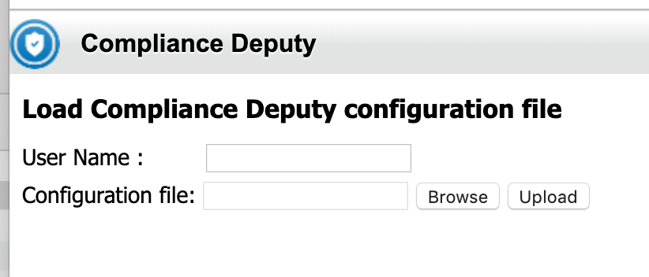

Figure 9 – Screenshot of compliance deputy once Load Configuration option is selected from the toolbar.

3 - Defining and running monitors
Monitors protect specific pages of your site from serious threats. They are run more frequently than scans and are ideal for targeting specific issues with single checkpoints, including security issues. If you want a site page to have thorough protection, you want a monitor.
IN THIS SECTION:
- Creating and modifying monitors
- Running monitors
- Scheduling monitors

Creating and Modifying Monitors
A monitor is a collection of checkpoints that will be executed on specific pages of a website. A monitor can use any Priority 1 checkpoint. You can view, create, edit, and delete monitors.
To view existing monitors:
- Select the Alerts tab. Then Select Monitors from the sub-tab. The Monitors sub- tab displays all existing monitor definitions in a table. Each record represents one scan. The columns show selected properties of each scan definition and the results of the last-run scan. The scan results can be interrogated by clicking hyperlinked values in selected columns.
- To view the monitor properties, click the name listed in the Monitor column.
- To filter the list, click in the Search box and type a search string. The list updates as you type. You can filter on
one or more columns. Click the Cancel button to clear the filter and display all scans.
To create a new monitor:
- Select the Alerts tab and then select the Monitors sub-tab
- Click New. You can also edit an existing monitor and save as a new monitor (see instructions on editing below).
- In the Display Name field, type a name for the monitor. You can use long descriptive names.
- In the URL field, type the full path name of the root directory containing the pages to be scanned. For example, to monitor the http://mysite.com/contact/ page, set the Base URL to http://mysite.com.
- In the Checkpoints box, select the checkpoints to be used by the monitor. You must select at least one checkpoint To filter the list, click in the Search box and type a search string. The list updates as you type. Click the
Cancel button to clear the filter and display all monitors. Select Show selected only to show only the selected checkpoints.
- Select the desired Send alerts option and type a valid e-mail address in the Send to box.
- Specify other properties as required (see Monitor properties for details), such as:
  - Create transaction script (see Creating transaction scripts).
  - Specify the username and password required for the scanner to access the site.
- Click Save.

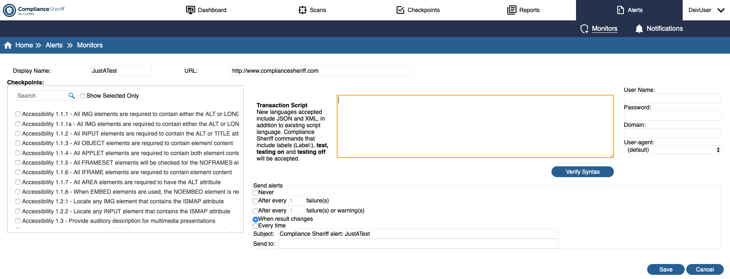
Figure 10 – Screenshot of creating a new monitor

To edit a monitor:
- Select the Alerts tab and then Monitors sub-tab.
- Locate the monitor you want to edit, and click the name in the Monitor column or click
- Modify the monitor properties as needed. See Monitor properties for details.
4. Click Save to save your changes. You can also save as a new scan definition, but you must change the Display
Name before clicking Save As New.
To delete a monitor:
- Select the Alerts tab and then Monitors sub-tab.
- Locate the monitor you want to delete. If the monitor is running, click Stop.
- Select the check box next to the monitor name. You can select more than one scan at a time. To select or clear all scans, select or clear the check box in the header.
- Click Delete.
- Click Delete.
- A confirmation is displayed. Select OK to delete the scan definition. If the scan has an associated view, a confirmation is displayed. Choose OK to continue deleting the scan.
Important. Any results for the monitor will be permanently deleted.

Running Monitors
Monitors can be run on demand from the Monitors tab. To schedule a monitor to run at regular intervals, see Scheduling monitors. Before scanning local content, see Scanning local content. You can also use Compliance Deputy to scan pages under development, before they are published (see Scanning the current browser page).
To run a monitor:
- Select the Alerts tab and then Monitors sub-tab.
- Locate the scan you want to run and, on the scan record, click Run. The scan status changes to “Pending” and then "Running”. Refer to Scan status for other status values. To view the scan log, click the status value (see Viewing the scan log).
To stop a monitor:
- Select the Alerts tab and then Monitors sub-tab.
- Locate the monitor you want to stop and check that the status is “Running”. Refer to Scan status for other status
- Select Stop. The scan status changes to "Aborted."

Scheduling Monitors
A monitor can be scheduled to run at predetermined intervals. Multiple schedules can be defined for a monitor.
To schedule a monitor:
- Select the Alerts tab and then Monitors sub-tab.
- Click the Schedule button of the scan you want to schedule.
- Click Add to define a schedule.
- Select or type the Monitor schedule properties as required.
Schedules use the user’s time zone setting (see User preferences). The default time is based on the locale set on the server hosting Compliance Sheriff.
- Click Save.
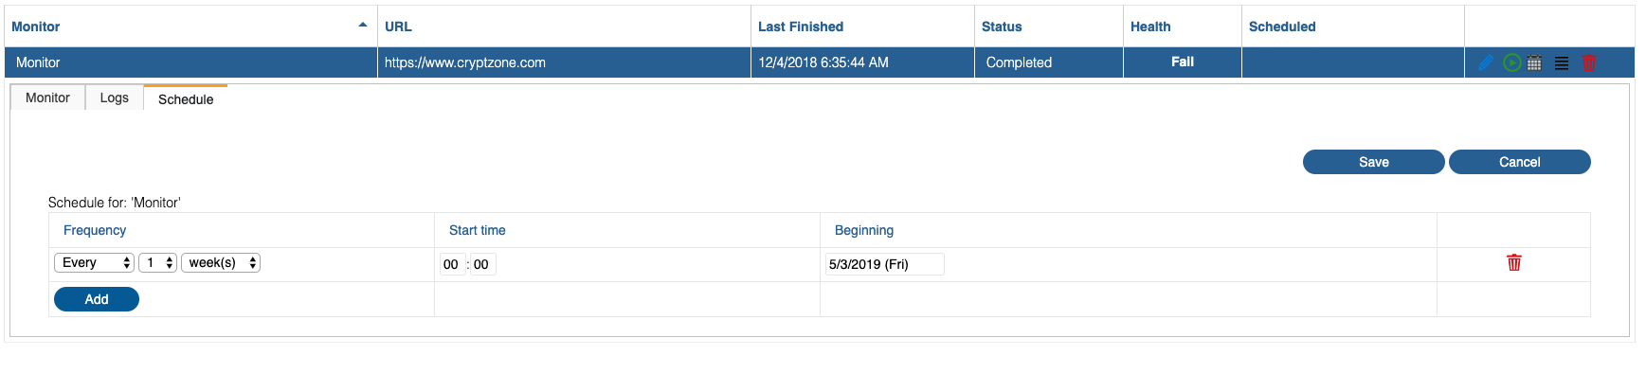
Figure 11 - Screenshot of scheduling a monitor
To change or remove a monitor schedule:
- Select the Alerts tab and then Monitors sub-tab.
- Click the Schedule button of the scan you want to reschedule.
- Select or type the Monitor schedule properties as required. Click Add to set another schedule or click remove a schedule.
- Click Save.

4 - Reviewing results
The results of completed scans and monitors are stored in the results database, which can be viewed, revised and purged. Detected instances of non-compliance can also be viewed in the web page.
IN THIS SECTION:
- Viewing the results of scans and monitors
- Showing instances on the web page
- What happens to the results when you...?
- Revising results
- Purging results

Viewing the results of scans and monitors
You can view results returned for individual checkpoints and checkpoint groups from the Scans and Monitor. To learn about using the views displayed, see Managing views and reports.
NOTE. All dates and times displayed are in the time zone specified in the user's preferences.
From the Scans tab:
  - After a scan has been run, select the Scans tab. You will be viewing a list of scans.
  - Click the More icon that directly ollows the Scheduler icon within in the scan row. Then click Show Results.
  - You will be brought to the Reports tab under the Views sub-tab.
  - You can modify the view settings (see Managing view definitions). To save the view (which can then be added to the Dashboard), click Save.
From the Alerts/ Monitors sub-tab:
  - After a scan has been run, click the Alerts tab and then the Monitors sub-tab.
  - Click the More icon (next to Scheduler icon) in the row corresponding to the monitor, and then click Show Results.
  - You will be brought to the Reports tab under the Views sub-tab.

Showing instances on the web page
You can view instances of violations detected by a scan or monitor (occurrences) as they appear on the page or in the source code. You can show occurrences by clicking links to scanned pages displayed in a variety of reports. For more information, see Show Instances FAQ.
To show occurrences from a scan summary:
- View the scan summary for a scan group, scan or monitor (see Working with scan summaries).
- In the scan summary, under Top Ten Pages, click a page to open the show instances feature for that page. The page opens in a new browser window. For information on using the show instances feature, see Navigating the show instances page.
To show occurrences from a table view:
The table must be of type “Issue identification” or “Occurrences”.
- Select the Views tab.
- In the list of views, click the Preview button for the view containing the table.
- In the Preview panel, in the table, expand the table records and locate the pages section.
- Click a page to open the show instances feature for that page. The page opens in a new browser window. For information on using the show instances feature, see Navigating the show instances page.

Navigating the show instances page
The first page containing an occurrence is displayed. The first occurrence is highlighted with a red outline. Use the controls on the toolbar to navigate through occurrences and pages:
- Use the Next Occurrence (ALT+[) and Previous Occurrence (ALT+]) controls (red arrows) to step through each occurrence.
- Use the Next Result (ALT+=) and Previous Result (ALT+-) controls (gray arrows on the far-left) to step through each page.

Figure 12 – Screenshot of toolbar to navigate through issue occurrences on the pages scanned.
- In the Occurrences box, select the occurrence number (1 is the first occurrence on the page). Or select -all- to view all occurrences on the page.
- Click Code source to display the source HTML of the page. Occurrences are highlighted with a red outline. Click Rendered view to return to the rendered page.
- Click How to fix? to display the checkpoint reference page, defined by the “URL for further information” property, if set, in the Checkpoint properties.
- Select or unselect Enable Javascript to view the page with or without Javascript enabled.
- Click the page URL at the top of the show instances page to open the page in the default browser or editor. KEYBOARD SHORTCUTS
Function | Shortcut
Next Result | ALT+=
Previous Result | ALT+-
Next Occurrence | ALT+[
Previous Occurrence | ALT+]

Show Instances FAQ
What types of content can be rendered?
The following web and Microsoft Office file types can be rendered:
DOC DOCX PDF PPT PPTX XLS XLSX HTML
Why does the content rendered not look exactly like it does on the original page?
Sometimes certain scripts or CSS files are not available and the content will not display exactly as it does on the web site. In these instances, the user can navigate using the URL on show instances to inspect the live site. For PDF and Office file formats, the content is converted into a HTML representation of the original content.
What is a result?
A result refers to the end product of a scan or monitor. Each checkpoint can produce multiple results. The two most common results for a checkpoint are PASS or FAIL. Labels in the checkpoint rule are displayed in the result message.

What is an occurrence?
An occurrence is a specific location within content where a compliance check was performed. If, for example, an error was found in two locations in the document, then two occurrences will be displayed.
Why do some occurrences display extra text?
For checkpoints that use %value% in the result message, the occurrences will populate with the string recorded in the value parameter. An example would be checking for the presence of e-mails in the content.
How do I customize where the How to fix button links to?
Clicking How to fix will load the reference page for the checkpoint, if set. To customize the reference page in a checkpoint, edit the URL for further information property of the checkpoint. See Customizing checkpoints.
I don't understand the terms used in the show instances interface. Where can I find definitions?
See Show Instances.
How do I remove the security pop-up in Internet Explorer?
If Compliance Sheriff is hosted on a secure site, and the show instances report links to a non-secure site, the Internet Explorer security settings for the internet zone will need to be adjusted as follows:
- From the Tools menu in Internet Explorer, click Internet options.
- Click the Security tab.
- Click Trusted sites.
- Click Sites and add the secure site to your list of trusted sites.
- On the Security tab, click Custom level.
- In the Miscellaneous group, under Display mixed content, select Enable.
- Click OK.

What happens to the results when you...?
After a scan is run, what happens when you:
Delete a scan definition?
- All results for the scan will be permanently deleted.
- Any views that show results for the scan might not behave as expected and might generate error messages.
Delete a scan group?
• Any views that show results for the scan group might not behave as expected.
Change the name of the scan?
• The name of the scan can be changed at any time. Changes are automatically updated in any views that refer to the modified scan.
Add or remove checkpoint groups in the scan?
- Checkpoint groups can be added to a scan at any time. The new checkpoints will not show up in the reports until the scan is rerun.
- If a checkpoint group is removed from a previously run scan, any views that show historical data might not behave as expected.
Add or remove checkpoints in a checkpoint group used by the scan?
- Checkpoints can be added to a checkpoint group at any time. The new checkpoints will not show up in the reports until the scan is rerun.
- If a checkpoint or checkpoint group is removed from a previously run scan, any views that show historical data might not behave as expected and might generate error messages.
Change the properties of a checkpoint or checkpoint group used by the scan?
  - Descriptions of checkpoints and checkpoint groups can be modified at any time. Changes are automatically updated in any views that refer to the modified checkpoint or checkpoint group.
  - The URL for further information property of a checkpoint can be modified at any time. Changes are automatically updated in any views that refer to the modified checkpoint or checkpoint group.
  - If the priority or rule of a checkpoint is changed, any existing scan results (which include a record of the priority) for that checkpoint will remain unchanged. To avoid confusion, either save as a new checkpoint or purge the existing results before rerunning the scan.

Revising results
Results of scans and monitors can be revised when checkpoints require a visual check or generate "false positives"— that is, a failure is recorded but manual inspection shows that the page or element in question should have passed the checkpoint. This typically occurs when the checkpoint rule does not explicitly cover all possible exceptions.
You can update the results of a scan recorded in the results database by either:
- Running the Result Revision Wizard (see Using the Result Revision Wizard).
- Importing a previously exported and amended CSV file (see Exporting and importing scan results).
When a result is changed, the corresponding message column will be automatically updated to reflect the new result and your username will be automatically appended to the message text so that anyone viewing the results will be able to confirm that the result has been manually adjusted, and by whom.
Before committing the changes to the database, you will be asked to confirm the operation, and you will be shown the number of records that will be updated.
Subsequent runs of the same scan might not preserve manual adjustments. This depends on whether the crawler can determine if the page has changed. When the records are updated through the Import facility, page results that were updated will be flagged accordingly. This flag is then used by the crawler to skip these pages during subsequent scans, preserving the result. If you want the scanner to re-scan the page, check on the "Retest all pages" option in the scan properties before you run the scan.

Using the Result Revision Wizard
The Result Revision Wizard allows you to manually modify the results generated by an automated scan.
To start the Result Revision Wizard:
- From the Scans or Monitors tab, locate the scan or monitor whose results you want to revise, and click the corresponding row.
- Under Results, click Revise Results.
You can also start the Result Revision Wizard from a Scan summary.
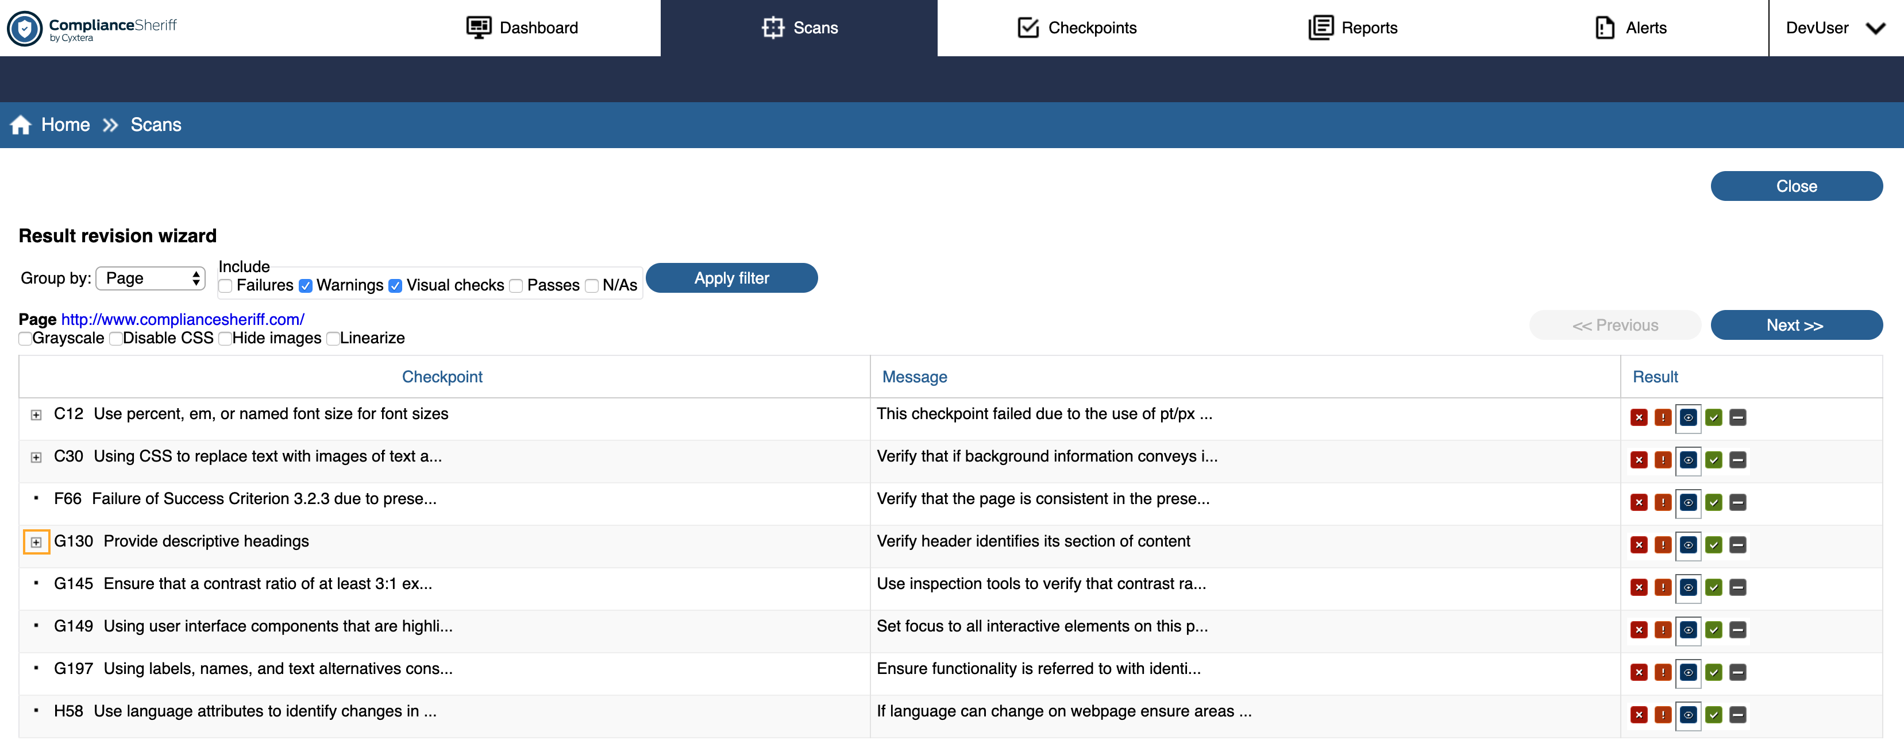

Figure 13 – Screenshot of result revision wizard page
The wizard displays all the results of a single scan, showing the message and result returned by a checkpoint. The following features are available when viewing results in the wizard:
In Group by, choose to group results by either page or checkpoint.
By page
Page mode is suitable for smaller scans. In this mode, the wizard steps through each page, showing the URL of the page, listing results for that page that match the current filter. To view the page in a new window, click the web page URL, and choose a display option:
- Grayscale: Check accessibility by people with limited color perception.
- Disable CSS: Check accessibility by users using browsers with limited capabilities.
- Hide images: Check accessibility by users using readers (information in images must also be provided in text).
- Linearize: Check accessibility by users using screen readers (tables are displayed with only one cell per row).

By Checkpoint
Checkpoint mode is suitable for large scans in which a single checkpoint is likely to fail in the same manner across a large range of pages.
For example, if pages are based on a template, problems with the template will be reported on every page. Instead of modifying each instance one by one, you can modify all instances with a single click. Also, if the checkpoint uses a user variable to list exceptions to the rule, the user variable can be updated for future scans.
In checkpoint mode, the wizard steps through each checkpoint in numerical order. For each checkpoint, the results are grouped by the result message and the key attribute values.
For example, if Checkpoint Accessibility 1.1.1 causes a warning "Non-decorative IMG element contains empty ALT attribute" for images "http://mysite.com/ logo.gif" and "http://mysite.com/blank.gif", two separate entries will be shown. When a result is changed for an entry with an associated key attribute value, then the checkpoint rule is checked to look for a test with the following form:
If has attribute {key-attribute}
If attribute value [as absolute url] equals any of %{uservarname}%
... Else
Mark {existing-result-value}, with '{message}'
where {key-attribute}, {existing-result-value} and {message} match the result being modified. The [as absolute url] part is optional.
If such a test is found, then the key attribute value for the current result record is added to the user variable {uservarname}. For results where no key-attribute value is present (e.g. page-based checkpoints), no user- variables will be automatically updated.
If you are using spell-checking checkpoints, you can use the wizard to add custom words, including proper nouns (such as company and product names), so that these words don't fail the checkpoints in the future. A revision will need to be made to each individual spell-checking checkpoint you are using. Be sure to capitalize proper nouns, so that future scans will identify uncapitalized instances of these words as errors.
For example, if you wanted "Firefox" to pass a spell-check, you use the Wizard to add "Firefox" only, because "firefox" is a spelling error. For more information on adding custom words, see User dictionaries.
- Under Include, select which results are shown: Failures, Warnings, Visual Checks, Passes, and N/As. Click Apply Filter to apply.
- Click an icon in the Result column to revise the result. The message is updated with the user’s name in brackets, so that results modified through the revision wizard can be identified when displaying views or reports. Click in the Message column to edit.
- Click Next to commit the changes to the database and continue to the next page. On the final page of results, click Finish button.
KEYBOARD SHORTCUTS
Key Action | Results
f | Mark the current result as "Failure" and step to the next result.
w | Mark the current result as "Warning" and step to the next result.
v | Mark the current result as "Visual check" and step to the next result.
p | Mark the current result as "Pass" and step to the next result.
n | Mark the current result as "N/A" and step to the next result.
To use these shortcut keys, ensure that the focus is on one of the result buttons—this is true when each screen is shown initially, but it won't be true if, for example, you modify any of the grouping or filtering options. This method is most appropriate when there is no need to enter extra comments for each modification. After modifying the last result on a particular screen, the focus jumps to either a numbered-button that brings up the next subset of results for the current page or checkpoint, or if none, to the Next button. You will need to hit the return or space key to activate the button.
EXAMPLES
Page-based visual accessibility check
- Run a Section 508 or WCAG 1.0 Priority 1 scan on a site containing an image.
- When the scan finishes, click More, and then click Revise results. All warnings and visual checks for the first page of the website are shown.
- Clear the Warnings check box and click Apply Filter. Only Visual check results are now shown.
- Click the page URL to open it in a new window.
- Select Grayscale to show the page in monochrome.
- Visually confirm that the page is readable without color. For the entry for Checkpoint 2.1 "Ensure that all information conveyed with color is also available without color", click Passed.
- Click Next to move to the next page and commit your change to the database.
- Repeat until you have visually checked all pages. Your website is now accessible to users with restricted color
perception.
Checkpoint-based false-positive revision
- Run a Section 508 or WCAG 1.0 Priority 1 scan on a site containing pages based on a template that contains a decorative image (e.g. a border or spacer image) with blank ALT text.
- When the scan finishes, click More, and then click Revise results.
- Select Group by Checkpoint, clear the Visual checks check box, and then click Apply Filter. All warnings generated by Checkpoint 1.1.1 are shown.
- For the first entry, NOTE of the full URL of the IMG SRC attribute, and click Passed.
- Click Next (or Finish if no other checkpoints generated warnings).
- Select the Settings tab, and click User agents, variables & key attributes.
- Confirm that in the entry field labeled "List of user variables", the variable %DecorativeImageList% now includes the URL you NOTEd in step 4.
- Rerun the scan on the same site with Retest all pages option selected.
- Repeat and NOTE that there is now no warning for the image URL that was added to the %DecorativeImageList% user-variable.

Exporting and importing scan results
The results of a scan or monitor can be exported and imported in CSV format. You can use any text editing tool to review and revise the results. A spreadsheet, for example, provides tools to quickly filter records by checkpoint and perform batch operations on multiple records.
NOTE. To export a scan report, see Exporting and printing reports. To export the results of a scan or monitor:
- From the Scans or Monitors tab, locate the scan or monitor you want to export and click More in the corresponding row.
- Click Quick Export Results to export all results. Alternatively, to customize the CSV, click Advanced Export. The CSV Exporter is displayed, from which you can specify:
  - Other result columns (default is the Result text/message)
  - Other result types (default is Failures and Warnings)
  - Specific scan runs (default is the latest run from the scan selected)
For additional export options, click More Options: The CSV Exporter – More Options is displayed, from which you can specify:
    - Export results for a scan group or a view
    - Filter results by specific checkpoints
    - Additional result fields for more detail
NOTE. Files created from the More Options page cannot be imported back to Compliance Sheriff. If you intend to modify and re-import the results, do not use More Options.
3. Click Submit to export the customized CSV file.
To import a revised, exported CSV results file:
- From the Scans or Monitors tab, locate the scan or monitor you want to update and click corresponding row.
- Click Import Results.
- Locate the CSV file you want to import, select the file, and click Open.
Important. This operation cannot be reversed and will permanently alter the database.
- A confirmation message is displayed in the status field.

Purging results
Important. Results are permanently deleted from the database.
To purge scan or monitor results:
- Select the Scans or Monitors tab, locate the scan or monitor whose results you want to purge, and click More in the corresponding row.
- Under Purge, select from the available options:
  - Purge all deletes all runs, including the one most recently completed.
  - Purge old deletes all runs except the one most recently completed.

5 - Managing checkpoints
A checkpoint is an instruction set that checks that a web page conforms to predetermined rules or guidelines. Modules contain standard checkpoints, but checkpoints can be customized to meet any requirement. A checkpoint group is a set of checkpoints or checkpoint subgroups. A checkpoint group can be created for any purpose.
IN THIS SECTION:
- Checkpoint modules and groups
- Managing checkpoint groups
- Customizing checkpoints

Checkpoint modules and groups
A checkpoint group is a set of related checkpoints. These are licensed for use as checkpoint modules, which contain a selection of checkpoint groups. The availability of checkpoint groups depends on what modules you have licensed. You will only see the checkpoint groups that you are licensed to use.
To obtain information about checkpoint modules and groups and the checkpoints they contain, refer to the latest Checkpoint Groups and Checkpoints Technical NOTE.

Managing checkpoint groups
A checkpoint group is a collection of checkpoints, or a collection of other checkpoint groups. A checkpoint group contained within another checkpoint group is called a subgroup. A checkpoint group cannot contain itself, and it cannot contain both checkpoints and subgroups.
Checkpoint groups allow you to collect related checkpoints for easy assignment to scans. Checkpoint groups are also useful when constructing views of results. Being able to report by checkpoint group and subgroup will allow you to more effectively present the results of a scan or monitor.
To view checkpoint groups:
- Select the Checkpoints tab. The Groups subtab displays all existing checkpoint groups in a table. Each record represents one checkpoint group. Checkpoint groups can be interrogated by clicking the Description.
- To filter the list, select a module from the Module drop-down box. Only checkpoints contained in the selected module are displayed.
- To filter the list, click in the Search box and type a search string. The list updates as you type. You can filter on one or more columns. Click the Cancel button to clear the filter and display all checkpoint groups.
To create a checkpoint group:
- Select the Checkpoints tab, and then click the Groups subtab.
- Click New.
- In the Short description box, type a short description. The Long description is optional.
- To group checkpoints:
NOTE. A checkpoint group cannot contain itself, and it cannot contain both checkpoints and subgroups.
  - In the Group contains box, select Checkpoints.
  - Select a module from the Module drop-down menu. The checkpoints contained in the module are displayed.
  - Select one or more checkpoints in the Checkpoints box. Or, to group subgroups:
  - In the Group contains box, select Subgroups.
- Select one or more checkpoint groups in the Checkpoint groups box.
5. Click Save.
To edit a checkpoint group:
- Select the Checkpoints tab, and then click the Groups subtab.
- Locate the checkpoint group you want to edit, and click the Description or click Edit
- Modify the Checkpoint group properties as needed.
- Click Save.
NOTE. Do not use Save As New unless you have changed the Description.
To delete a checkpoint group:
- Select the Checkpoints tab, and then click the Groups subtab.
- Locate the checkpoint group you want to delete and click Delete.
- A confirmation message is displayed. Select OK to confirm deletion.

Customizing checkpoints
You can create new checkpoints and edit existing checkpoints. In general, avoid editing standard checkpoints. Instead, copy the checkpoint and edit the duplicate. Before creating new checkpoints or customizing standard checkpoints, familiarize yourself with the checkpoints supplied with each of the available Checkpoint modules and groups. To obtain information about licensing additional modules, contact Compliance Sheriff support.
NOTE. When creating and editing a checkpoint rule, remove any unwanted spaces from search strings. For example, the function If page text contains any of [Adobe Reader ] (with a trailing space) will ignore “Adobe Reader,” and “Adobe Reader.”
To view checkpoints:
- Select the Checkpoints tab. The Checkpoints subtab displays all existing checkpoints in a table. Each record represents one checkpoint. Checkpoints can be interrogated by clicking hyperlinked values in selected columns.
- To filter the list, select a module from the Module drop-down box. Only checkpoints contained in the selected module are displayed.
- To filter the list, click in the Search box and type a search string. The list updates as you type. You can filter on one or more columns. Click the Cancel button to clear the filter and display all checkpoints.
To create a new checkpoint:
- Select the Checkpoints tab, and then click the Checkpoints subtab.
- Click New.
- From the Module drop-down box, select a module (see Checkpoint modules and groups).
- In the Number box, type a unique number for this module. The recommended format for the number is 9.9, 9.9.9 or 9.9a.
- From the Priority drop-down box, select the checkpoint priority. This categorizes the importance of a checkpoint result and can be used to group results in a view or report. It does not affect the order the checkpoints are performed within a scan or monitor.
- In the Short description box, type a short description. The Long description is optional.
- In the URL for further information box, enter a URL that will direct the user to a solution if this checkpoint fails.
- In the Rule box, define the rule that controls what your checkpoint will be testing for. For information, refer to Checkpoint expression syntax.
- Click Save.
To edit a checkpoint:
- Select the Checkpoints tab, and then click the Checkpoints subtab.
- Locate the checkpoint you want to edit, and click Edit.
- Modify the Checkpoint properties as needed.
- Click Save.
NOTE. Do not use Save As New unless you have changed both the Number and Short description.
To copy a checkpoint:
- Select the Checkpoints tab, and then click the Checkpoints subtab.
- Locate the checkpoint you want to edit, and click Edit.
- You must change the Number and Short description before creating a copy.
- Click Save As New.
To delete a checkpoint:
- Select the Checkpoints tab, and then click the Checkpoints subtab.
- Locate the checkpoint you want to delete and click Delete.
- A confirmation message is displayed. Select OK to confirm deletion.

6 - Managing views and reports
Results of scans and monitors stored in the results database can be displayed and summarized in a variety of dynamic views and static reports. Views can be customized with a variety of textual and graphical elements and displayed on the Dashboard. Scan summaries and scorecards are special types views created automatically by the system, which can be saved and modified by the user and added to the Dashboard.
IN THIS SECTION:
- View Definitions
- Dashboard
- Scan Summary
- Score Card
- Trend Report
- Exporting and printing reports
- Sending reports and notifications

View definitions
The results of scans and monitors are displayed using a variety of system- and user-defined view definitions. Views that have been saved or created by the user are displayed on the Views tab.
To display existing view definitions:
Select the Reports tab. The default selection will be the Custom Views tab. The available View definitions are displayed in a list.
- In the list,
- Click the name to view and edit the View properties.
- Click magnifying glass icon to display the View in the Preview panel
- Click document icon to display the View as an HTML page in a new window
- Click the pdf icon to display the View as a PDF page in a new window
- Click the .csv icon to export tabular View to a CSV file
To create a new view definition:
NOTE. To quickly create a scan summary or scorecard view, view the results using the system-generated view (see Working with scan summaries or Working with scorecards) and then save the view as a view definition. You can then modify the view definition and add it to the Dashboard.
- Select the Custom Views tab.
- Click New.
- In the Name box, type a name for the view.
- In the Show results for field, choose if you want to show the results of scans, scan groups, or monitors.
- Expand each category of view properties (e.g. Checkpoints, Pages, Chart, Summary, Tables) and make your selections. The view properties available depend on the type of result—see View properties for details. If the selected scans, scan groups, or monitors have been run (results exist in the database), the view is displayed in the preview pane as you make your selections. Select Disable auto-update to prevent the preview updating with each selection. Click Update to refresh the preview.
- Click Save.
To edit a view definition:
- Select the Custom Views tab. The available view definitions are displayed in a list.
- Locate the view you want to edit and click the name.
- Expand each category of view properties (e.g. Checkpoints, Pages, Chart, Summary, Tables) and make your selections. The view properties available depend on the type of result. If the selected scans, scan groups, or monitors have been run (results exist in the database), the view is displayed in the preview pane as you make your selections. Select Disable auto-update to prevent the preview updating with each selection. Click Update to refresh the preview.
- Click Save to save your changes or Save as new to create a new view—you must change the name of the view before saving as a new view.
To delete a view definition:
- Select the Custom Views tab. The available view definitions are displayed in a list.
- Locate the view you want to delete and select the corresponding check box. You can delete one or more views.
- Click Delete.
- A confirmation message is displayed. Click OK to confirm deletion.
To customize table views:
You can modify the order and contents of tables of type Issue Identification, Page Compliance, and Result History.
NOTE. You must have administrator privileges to access these settings.
- Click the Settings tab.
- Click Table groupings for views.
- Edit the groupings in each table type as required. Separate groupings with a comma. Only groupings that are valid for
- that table type can be used. For example, you cannot use "Group" in the Result History table. Groupings are case sensitive. For example,"page" instead of "Page" will result in error.
- Click Save.

Dashboard
The Dashboard is a user-defined display area for the results of scans and monitors. The Dashboard comprises one or more views, which can be any combination of text, tables and charts. Depending on the views available, the Dashboard can display summaries of multiple scans or scan groups and details of individual scans, checkpoints, or checkpoint groups.
NOTE. You must create a view definition before it can be added to the Dashboard (see Managing view definitions).
To add a view to the Dashboard:
- Click Add view and select a view from the list of available views.
To remove a view from the Dashboard:
- Click the Close button on the view title bar or tab.
To change the view mode:
NOTE. Vertical mode is recommended when using a screen reader, so the Dashboard can be read from top to bottom.
- Click Arrange as grid to arrange the views in a grid. For example, if you add 4 views to your dashboard, they will be displayed in a 2-by-2 format (two columns, two rows). If you have 6 views on your dashboard, they will be displayed in a 3-by-2 format (three columns, two rows).
- Click Display on tabs to display each view in a separate tab. Th view expands to occupy the entire window when active.

Scan Summary
A scan summary is a special type of view that is automatically generated by the system when viewing results. They provide the complete results of a scan or monitor. From the scan summary, you can find all the information you need on where to focus your future efforts at web compliance and get a clear sense of how well your organization is meeting its web governance standards.
NOTE. You must first run a scan before you can view its scan summary.
Scan summaries can be accessed by clicking a health value in the scan results or a scorecard. The scan summary displays a series of summary tables and charts. You can interrogate the results by clicking various links in the scan summary—see Scan summary for a complete list of features:
- Scan statistics: Displays the number of pages scanned, how long the scan took to run and the total occurrences returned by the scan.
- Priority 1 checkpoints: Displays the most important issues detected by the scan.
- Top 10 checkpoints: Displays the 10 checkpoints with the highest occurrence counts in that category.
- Top 10 checkpoints changed via results revision: Displays the results associated with checkpoints you've modified in the Results Revision Wizard.
- Top 10 issues: Displays a list of the ten results that Cryptzone recommends for immediate action.
- Top 10 pages: Displays the ten pages containing the highest number of checkpoint violations.
- Trend: Displays detailed statistics of a scan.
When viewing a scan summary, you can save the view, modify the view definition (see Managing view definitions), and add it to the Dashboard (see Managing the Dashboard).
To view a scan summary:
• Click the health value in the scan results or a scorecard.
To create a scan summary view and add it to the Dashboard:
- View the scan summary.
- Click Create View.
- In the Name box, type a unique name for the view.
- Modify the view definition as required (see Managing view definitions), and then click Save. The view is added to the list of view definitions on the Views tab. Click the Preview button to display in the Preview panel.
- Click the Dashboard tab and add the view (see Managing the Dashboard). You can modify the view again at any time by editing the view definition on the Views tab.
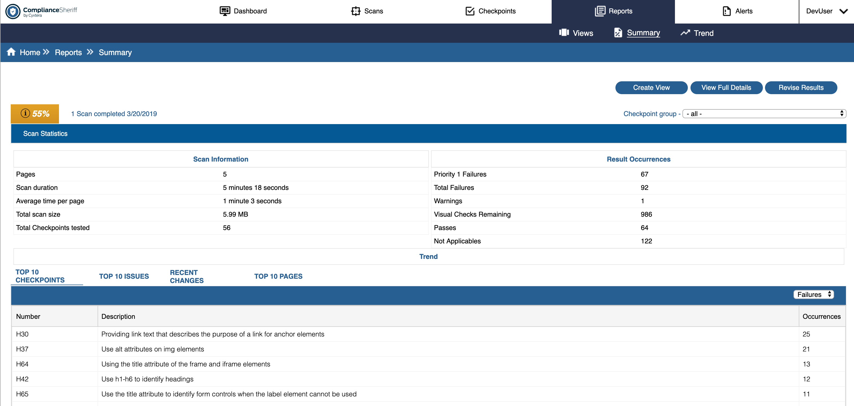

Figure 14 – Screenshot of the Summary report for a Scan
To display information about the health value is calculated:
- At the top-left of the scan summary, click the health value (this applies wherever an information symbol is displayed next to the health value).
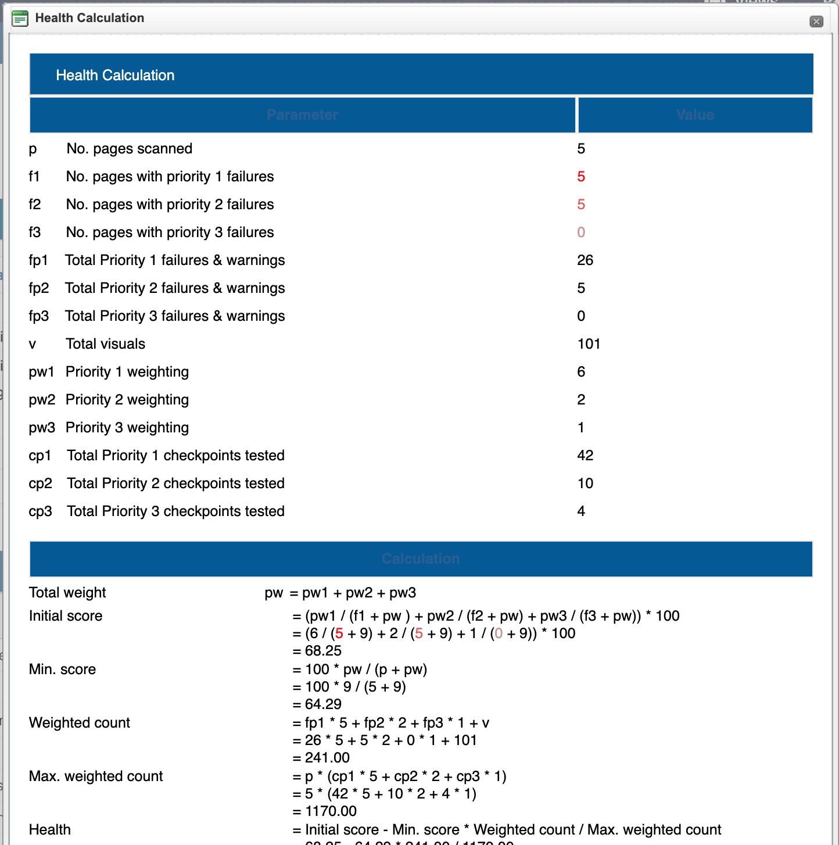

Figure 15 - Screenshot of health score calculation

Scorecard
A scorecard is a special type of view that is automatically generated by the system when viewing results. A scorecard provides a graphical summary of how well your organization is meeting its web compliance standards. By allowing you to make side-by-side comparisons of several sites or groups of sites across your network, a scorecard allows you to see which areas of your site network are exceeding your goals, which areas need further attention, and which areas have improved or declined.
- Viewing and interrogating scorecards
- Creating a custom scorecard
- Scorecard FAQ

Viewing and interrogating scorecards
NOTE. Scorecards will display results for up to the maximum limit of 50 scans.
To view a scorecard for a scan group:
- Select the Scan tab, click the Groups subtab, and then click the Health value of the scan group. The scorecard is displayed on the Summary tab.
To view a scorecard for all scan groups:
- Select the Reports tab followed by the Summary sub-tab.
INTERROGATING THE SCORECARD
- The rows in the scorecard are scan groups and scans. The columns in the scorecard show the results for each checkpoint group in those scans.
- To view details of individual scans, expand the scan group. Click the name of the scan to display the scan summary for the scan (see Working with scan summaries). Click a health value to display the scan summary for the checkpoint group. When you are finished viewing the results for that scan, click Back to scorecard.
- To view the scorecard for a checkpoint group, in the column heading of the main scorecard, click View Details. The scorecard for that checkpoint group is displayed. The columns now show the results for each checkpoint. Click a health value to display the scan summary for that checkpoint (see Working with scan summaries). Click View Details to display the scorecard for that checkpoint. When you are finished viewing the results for that checkpoint group, click the name of the main scorecard in the breadcrumbs at the top of the scorecard.
- If the scan group has been run more than once, the trend is shown in parenthesis. To hide trend values, click Options and select Hide trend values.
- To highlight areas that are performing well or badly, click Options and select an option from the Highlight box.
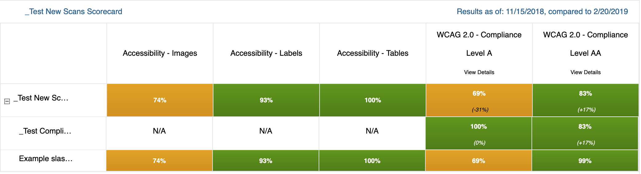
Figure 16 – Screenshot of score card

Creating a custom scorecard
Before setting up a scorecard, define your web compliance goals so that the scorecard reflects these goals:
- What are your governance strategies?
- What areas of compliance-accessibility, privacy, site quality, or other areas-are most important to you?
- What divisions within your organization are the most relevant? (When comparing different areas of a site network, many organizations, for example, choose to compare the performance of different geographical regions, while others choose to compare business departments.)
- What divisions would you make?
- What areas of compliance would you enforce most strictly?
To create a custom scorecard:
  - Determine which scans or scan groups you wish to compare. The Base URL of the scan determines which site pages are compared in the scorecard (see Creating and modifying scan definitions).
  - Review the checkpoints or checkpoint groups associated with the scans or scan groups you wish to compare. Determine whether these are the compliance issues that you consider most important for comparison purposes. If you're unsure where to start, Compliance Sheriff recommends using the Metrics checkpoint group for each scan in your scorecard. Metrics tests a site's adherence to common standards for accessibility, site quality, privacy, and search engine optimization. If you don't have access to the Metrics checkpoint group, you can create your own checkpoint group.
  - When you are satisfied that the most appropriate checkpoints and checkpoint groups have been assigned to the scans (i.e. site pages) that you want to compare, create a scan group (see Organizing scans into groups).
  - Run the new scan group (see Running scans).
  - When all scans are completed, view the scorecard (see below).
  - Click Create View and modify and save the scorecard as a view definition (see Managing view definitions).
  - Add the scorecard view to your Managing the Dashboard.

Scorecard FAQ
How do I create a scorecard to compare business departments?
A scan should be created for each business department—for example, Marketing, Contoso Product, Acme Product, HR, Operations,and Professional Services. These scans can then be placed in a scan group, and the scan group can then be used to schedule and run a series of compliance checks. This scan group could be titled "Business Departments." Each business department can contain multiple scans that contribute to an overall score.
How do I create a scorecard to compare geographical regions?
A scan should be created for each region—for example, EMEA, ASIA, and USA. These scans can then be placed in a scan group, and the scan group can then be used to schedule and run a series of compliance checks. This scan group could be titled "Regions." Each region can contain multiple scans that contribute to an overall score.
Do all scans within my scan group need to have the same checkpoint groups?
No, but it’s recommended. This will make the scorecard's comparisons more helpful.
Can I put a scorecard on my dashboard?
Yes, but you will first need to Create a View for a Scorecard. When adding a scorecard to your dashboard, it is recommended that you display the scorecard in either "Vertical" mode or "Tabs" mode, so that the entire scorecard is visible in the UI.
How do I access the default scorecard for my scan group?
Navigate to the Scans tab and make sure the Groups subtab is selected. Click the Health percent value to open the default scorecard for the scan group.
How do I change which checkpoint groups are displayed within the scorecard?
Click the Configure button on the scorecard you've opened. This will take you to the Views tab, where a scorecard can be configured. The checkpoint groups list allows you to select which checkpoint groups will be displayed. Only checkpoint groups contained within the scan on your scorecard will be available as options.
What happens if I view a scorecard for a scan group that has not been run?
The scorecard will display N/A for all checkpoint groups.
What happens if I view a scorecard and one of the scans did not run a particular checkpoint group?
The scorecard will display N/A in the column of the checkpoint group(s) that were not run. You may go back and add in the relevant checkpoint group, and re-run the scan to fully complete the scorecard.
How is the score calculated for a checkpoint group column on scorecard?
The scan group will display the lowest compliance score of all the scans within the group. If three scans have a compliance score of 93, and one has a score of 78, then the scan group will have a score of 78.
How is the compliance score calculated for a particular checkpoint group and scan?
= 6 / ({# pages failing a Priority 1 checkpoint} + 9) + 2 / ({# pages failing a Priority 2 checkpoint} + 9) + 1 / ({# pages failing a Priority 3 checkpoint} + 9)

How many checkpoints should I use for KPI?
We recommend using no more than 10 checkpoints per checkpoint group.
How do I educate teams on performance measurements?
- Give each team documentation on what they're assessed on and compared with.
- Give training workshops to all teams.
- Explain past, present, and future performance indicators.
How do I export a scorecard to Excel, CSV, or PDF?
Once a scorecard has been saved as a view, it can be exported to any of these formats from the views tab. If the icons for these file formats do not appear in the views tab, additional installation steps may be required.
Can I shorten the names of checkpoints or checkpoint groups?
If you add the same prefix to several checkpoints or checkpoint groups contained within a larger checkpoint group, the scorecard will remove the prefix when you drill down from the larger checkpoint group. For example, the checkpoint group "Metrics" contains four checkpoint groups: Metrics - Accessibility, Metrics - Site Quality, Metrics - Privacy, and Metrics - SEO. In a scorecard, if you drill down from the "Metrics" Checkpoint Group, the contents will appear as Accessibility, Site Quality, Privacy, and SEO -- the "Metrics" prefix is removed.

Trend Report
The Trend Report was created to demonstrate a trend in progress for addressing compliance issues. The Trend Report is based on a selection of a Scheduled Scan Group. Running the same scans over a set period of time will allow for a most consistent view of how your organization is trending against your goals.

To view a report,
- Select a Scheduled Scan Group from dropdown.
- Click Update button.

Note: The date of the last scan run for that Scan Group is indicated.

The Trend report includes the following features:

- Page and checkpoint performance
- Performance History
- Top 10 Page failures
- Top 10 Checkpoint failures
- Performance by Scan

Page and Checkpoint Performance
- Page performance includes the total number of pages scanned as well as the number of pages that passed and failed the checkpoint tests that were run.
- Checkpoint performance includes the total number of checkpoint tests that were run during the scan. The number of checkpoints passed and failed are indicated, along with related percentages.

Note: If the page failed one checkpoint than the page is indicated as failed.

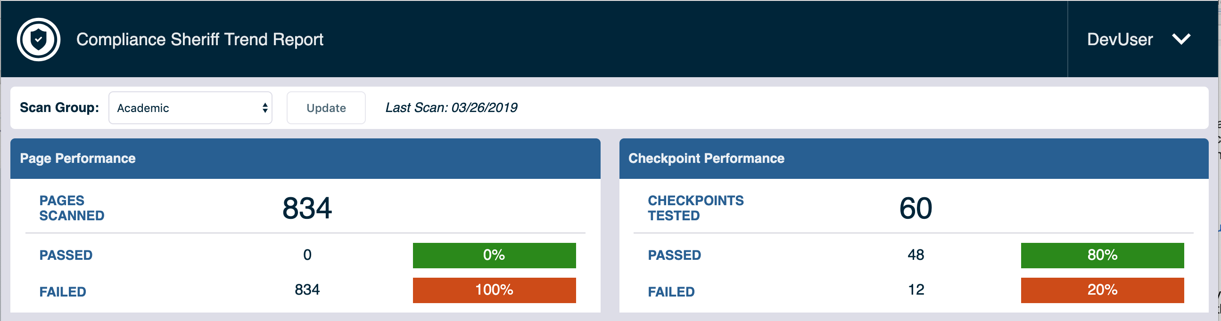

Performance History
- The Performance History tracks the performance of last 12 Scheduled Scan Group runs for the selected Scan Group.
  - E.g., if the Scan Group is scheduled to run monthly, then you will see the last 12 months reflected.
  - If the Scan Group is scheduled to run weekly, then you will see the last 12 weeks reflected.
- There are two chart options:
- Pages – Failed. (default)
  - The bar graph represents the total number of pages that were scanned for that Scan Group.
  - The trendline indicates the total number of pages that failed the checkpoints when the scan was run.
- Checkpoints – Failed
  - The bar graph represents the total number of Checkpoint tests that were run against the pages.
  - The trendline indicates the total number of Checkpoint tests that failed.
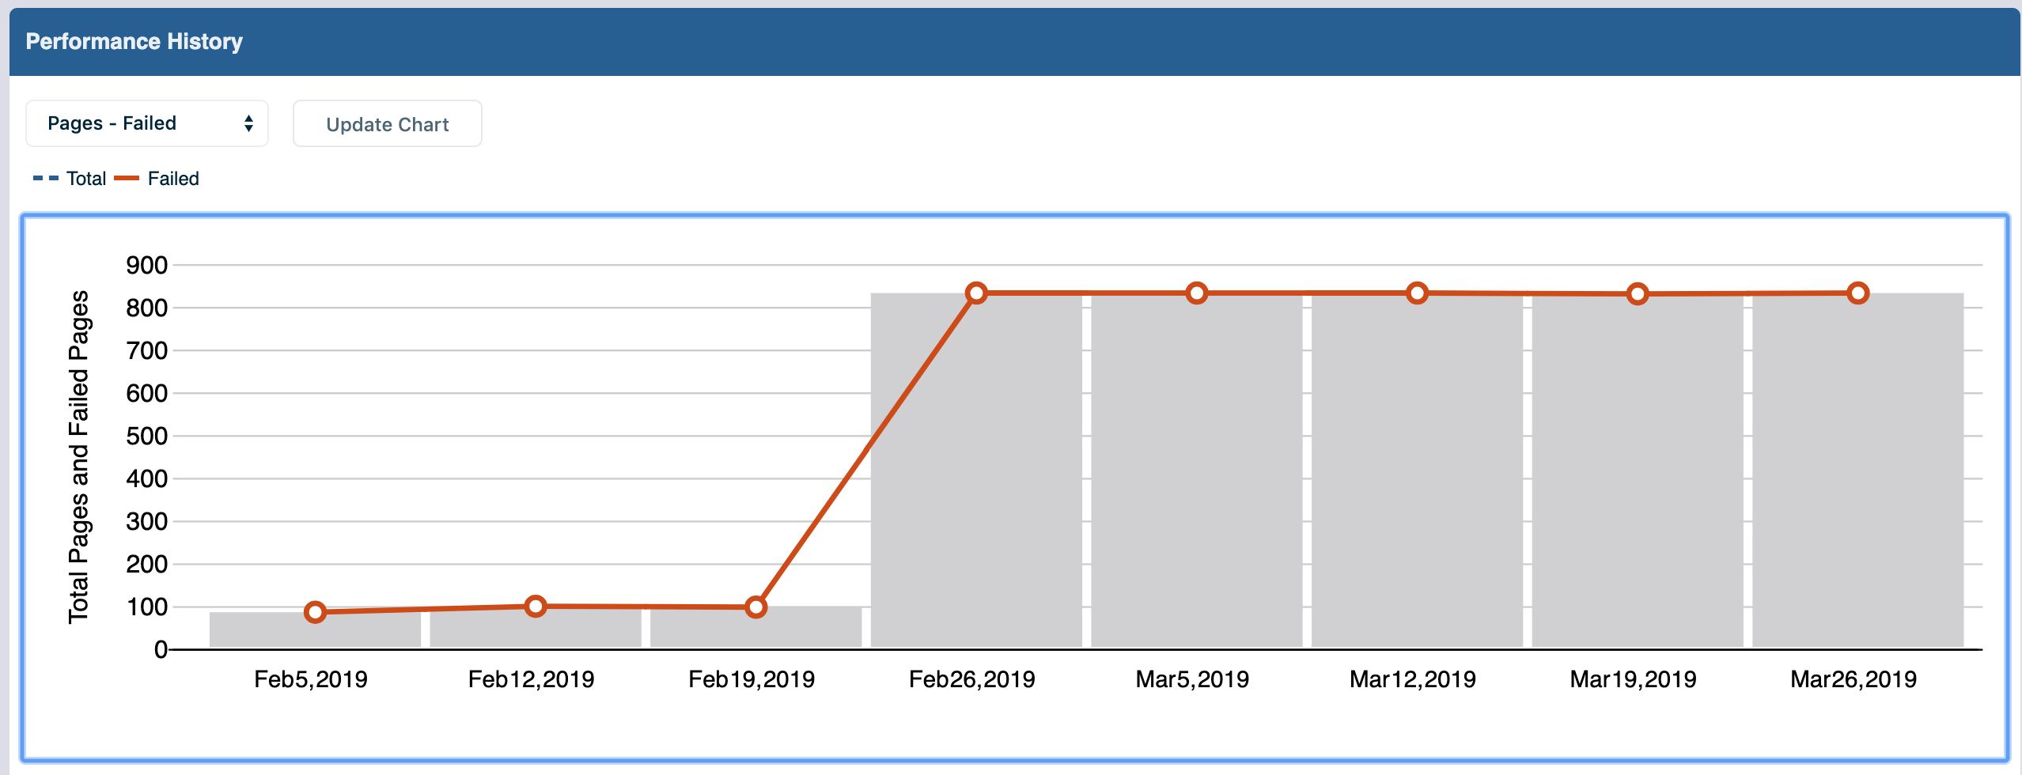

Top 10 Page Failures
The Top 10 page failures is a list of the pages that were included in the last run of the Scheduled Scan Group that failed the most Checkpoint tests. A breakdown by priority level is also provided.

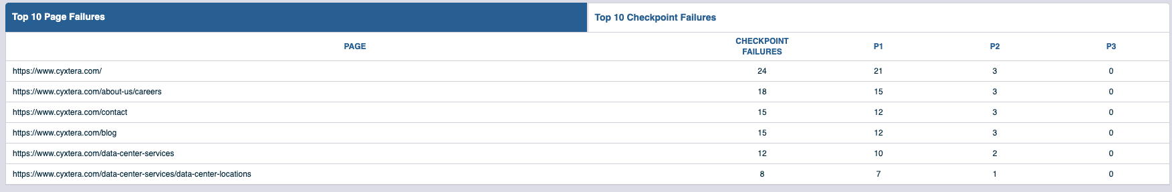

Top 10 Checkpoint Failures
The Top 10 checkpoint failures is a list of the Checkpoints that were included in the last run of the Scheduled Scan Group that had the most failures. Also indicated are P1 failures and number of pages where that particular failure occurred.

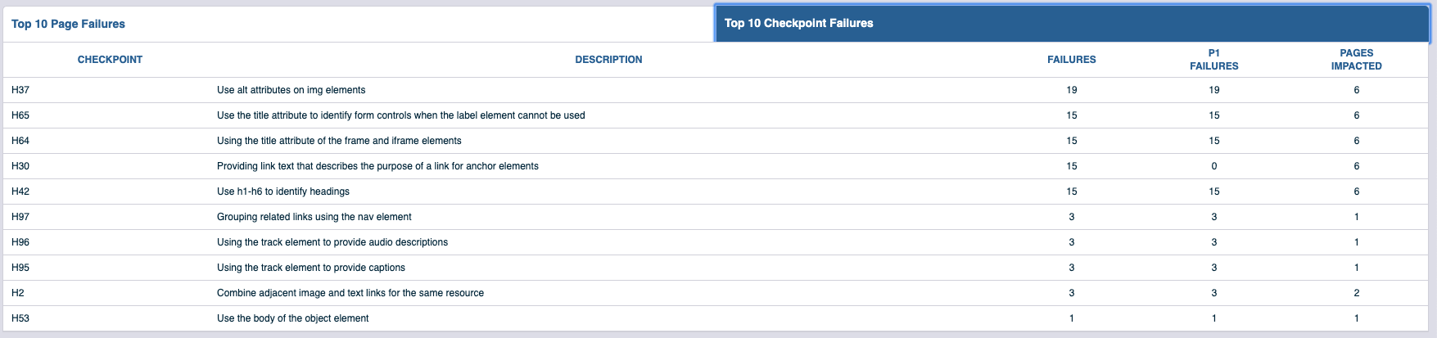

Performance by Scan
The Performance by Scan lists out all the Scans that were included in the last Scheduled Scan Group run. These are sorted by Total number of checkpoint failures. This will give you an understanding of your performance by scan.

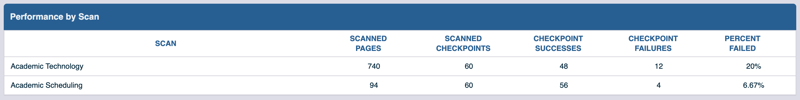

Audits Report
The Audits sub-tab under Reports allows for users to access Compliance Sheriff reports that were manually created, such as Baseline Audit, VPATs or Regression Reports.

The Audit Report will become visible when View, Create or Edit permissions are associated with a User Group in Admin. Only when this permission is granted will the Audit link show up beneath the Reports tab.

The Compliance Sheriff Support Team will have Create and Edit permissions for any organizations who have purchased these Service products so that they may upload, edit or remove these documents. Therefore, if you subscribe to these products, you will find them in this section.

To access the Audit Reports,

- Click on Reports tab in the top navigation
- Click on Audits sub-tab
- Table presented will include the following columns:
  - Report name
  - Comments
  - Report Type
  - Update Date
  - File Size
  - File Format
  - Actions

If you have Create/Edit access, then you will be presented with the table along with the following features:

- Add Report (only for Create access)
- Edit
- Download
- Delete

View Report
If you have View-only access, then you will be presented with the table and any reports listed that have been uploaded for you.

If you want to download a report,
- Click on the Download icon under the Actions column at the end of the row for the report you want.

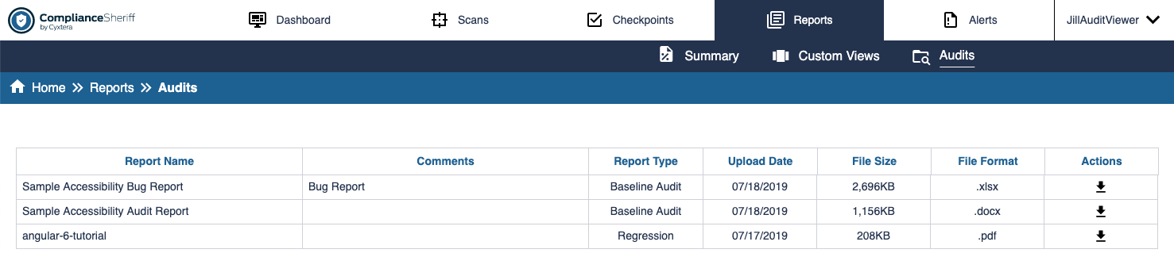

Add Report

Permissions required: Create

If you have Create permissions than there will be a button entitled “Add Report” above the Audit Reports table. The Add Report feature will allow a user to upload a document to the Audit Reports table. This is primarily used by the Compliance Sheriff Service Team to post manual accessibility testing reports and documents.

If you want to Add a report,
- Click on Add Report button
- A modal will pop up entitled “Add Audit Report”
- Click on Browse button which will allow you to browse your computer to select a file for uploading
- Enter a Name for your report that will display in the table
- Select a report Type from the selections provided
- You can enter a message into an optional Comments field if needed
- Select Add to upload your file into the table
- You may select Close to close out the modal at any time.

Note:
- The Maximum file size to upload is 100 MB
- Accepted file types to upload include: .doc, .docx, .xls, .xlsx, .pdf
- Report type options include: Baseline Audit, VPAT, Regression and Other

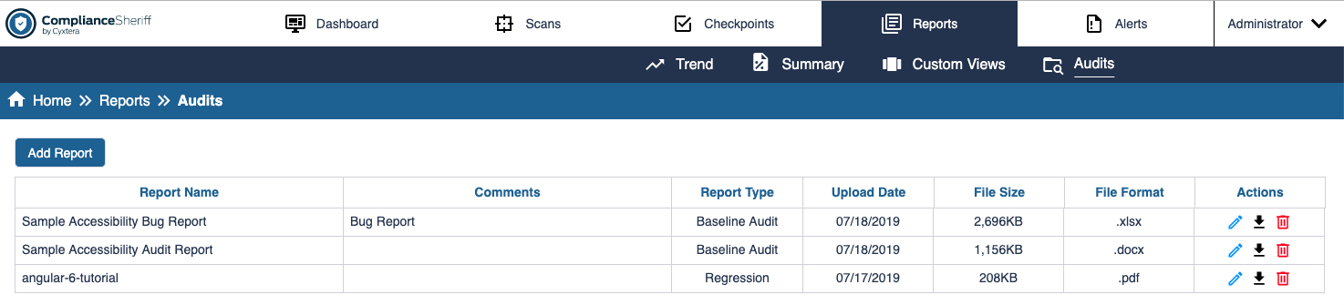

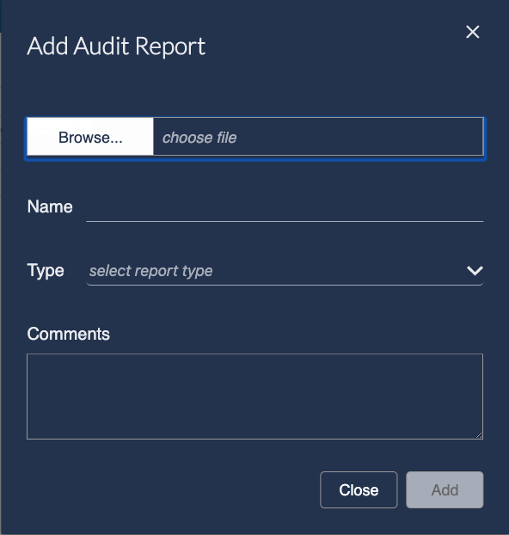

Edit Report
Permission required: Edit

If you have Edit permissions then there will be an Edit icon under the Actions column in each row that has a report listed. The Edit icon will be the first of three icons presented in this Actions column.

If you want to Edit a report,
- Click on the Edit icon under the Actions column for any report listed in the Audit reports table
- A modal will pop up entitled, “Edit Audit Report”
- You may change the Name, Type, or Comments field.
- Select Save button to save your edits
- You may select Close button to close out the modal at any time.

Note: This feature allows you to change any of the description data for the report in the table but does not allow you to change the report itself in any way.

Delete Report
Permission required: Edit

If you want to delete a report,
- Click on the Delete icon under the Actions column at the end of the row for the report you want.
- Confirm deletion by selecting Delete on the confirmation modal pop-up
- You may select Close on the modal to cancel your delete action.

Exporting and printing Views and the Dashboard
Static reports suitable for e-mailing, printing, or archiving can be generated from view definitions. The Dashboard can also be printed. You can also create notifications (see Sending reports and notifications) that automatically send reports to e-mail addresses.
  - Generating a report from a view definition
  - Printing the Dashboard
NOTE. To export scan results, see Exporting and importing scan results.

Generating a report from a view definition
    - Select the Reports tab and the Views sub-tab.
    - Locate the view you want to generate a report from.
    - To customize the report before it is generated, click the view name and modify the view settings (see Managing view definitions). For example, you can filter the report by issue priority or change the way the report is grouped. Click Save to return to the Views list.
    - Choose the file type:
• Click the Report button to open the view as an HTML page in a new window. Use the browser print tools to send or print the page.
Click the PDF button to open the view as a PDF report in a new window. Use the PDF reader tools to print or save the file to a local folder.
Click the Export as CSV button to export tabular reports in CSV format.
NOTE that only tables can be exported as a CSV (see Exporting and importing scan results).
NOTE. You can also export the scan results in CSV format (see

Printing the Dashboard
When printed, all table views are shown collapsed.
To print the Dashboard:
- Select the Dashboard tab.
- Select the print-friendly view mode.
- From the browser, set the page size, orientation, margins, headers and footers, and font.
- From the browser, print the page.

Sending reports and notifications
A notification is an e-mail message that is automatically sent at the end of a scan or monitor or at scheduled intervals. For example, if you have a report that combines the results of two scans, where one is run weekly and the other is run monthly, you can send a notification after the weekly scan, each month after the monthly scan, or just once a quarter.
To configure the system to send notifications:
- Select the down arrow beneath your user name in the top navigation bar. From here select Settings.
- Click System configuration.
- Review and modify the settings under Notification/alert settings (see System configuration).
To create a notification:
- Select the Alerts tab followed by the Notifications sub-tab.
- Click New.
- In the Send report based on view drop-down, select from the available views (see Managing view definitions).
- In the Send to box, type one or more e-mail addresses separated by commas or semicolons.
- In the Subject box, type the subject line of the e-mail.
- Choose what is sent. If none selected, the full HTML report is sent:
  - Send as a link or as a PDF or as a table summary only
- Choose when the notification is sent:
  - Send after each run of scan/monitor: Select a scan or monitor from the drop-down menu.
  - Send at scheduled intervals: Click Add and define frequency, time (24-hour clock) and start date for sending notifications. Multiple schedules can be defined.
- Click Save.
To edit a notification:
- Select the Alerts tab followed by the Notifications sub-tab.
- In the list of notifications, click the notification you want to edit.
- Modify the settings as required. See Notification properties for details.
- Click Save to save your changes or Save as new to create a new notification—you must change the subject of the notification before saving as a new notification.
To delete a notification:
- Select the Alerts tab followed by the Notifications sub-tab..
- In the list of notifications, select the notification you want to delete by clicking the check box. You can select one or
more notifications.
- Click Delete.
- A confirmation message is displayed. Click OK to confirm deletion.

7 - Managing users and groups
Users and user groups are managed from the Admin tab, which is only available to administrators. For information on logging in, changing your password, and setting user preferences, see Logging in.
NOTE. You can also manage user permissions from Windows Active Directory.
IN THIS SECTION:
- Creating and managing users
- Creating and managing user groups

Creating and managing users
To create a user:
- Select Admin from the dropdown associated with your Username. This will be the last item in the top navigation bar.
- The default page will be the Users subtab.
- Click New.
- Type a Username and Password.
- Select a user group that matches the permissions you want to give this user (see Creating and managing user groups).
- Click Save.
To edit a user:
- Select Admin from the dropdown associated with your Username. This will be the last item in the top navigation bar.
- The default page will be the Users subtab.
- Click on the name of the user you want to edit.
- Modify the User properties as needed.
- Click Save.
To delete a user:
- Select Admin from the dropdown associated with your Username. This will be the last item in the top navigation bar.
- The default page will be the Users subtab.
- Select the user you want to delete (check box in the far-left column). You can select more than one user at a time.
- Click Delete.
- A confirmation dialog box is displayed. Click OK to confirm deletion.
NOTE. If a user is logged in, deleting that user will not end the user's current session.

Creating and managing user groups
To create a user group:
- Select Admin from the dropdown associated with your Username. This will be the last item in the top navigation bar.
- The default page will be the Users subtab. Select the Groups sub-tab.
- Click New.
- In the Name field, type a name for the group. The group name can include any characters, and is case-sensitive.
- In the Permissions field, define the permissions for this group (see User group properties).
- Click Save.
To edit a user group:
- Select Admin from the dropdown associated with your Username. This will be the last item in the top navigation bar.
- The default page will be the Users subtab. Select the Groups sub-tab.
- Click the name of the group you want to edit.
- Edit the User group properties as needed.
- Click Save.
To delete a user group:
Important. You cannot delete the Administrators group.
If you delete a group that contains members, the members will not belong to a group. The user can still log in, but without a group, the user can only access their user preferences but will not have permission to view or edit scans, results, or views.
- Select Admin from the dropdown associated with your Username. This will be the last item in the top navigation bar.
- The default page will be the Users subtab. Select the Groups sub-tab.
- Select the group you wish to delete by clicking in the corresponding check box. You can select one or more groups.
- Click Delete.
- A confirmation message is displayed. Click OK to confirm deletion.

8 - Configuring the system
Compliance Sheriff and Compliance Deputy are configured from Settings, which can be found in the dropdown for the Username in navigation bar. To access the Settings tab, you will need to log in as a member of a Compliance Sheriff group with the option for Editing of custom dictionaries, user variables etc. permitted enabled.
Installing and configuring Compliance Sheriff
For information on installing and configuring Compliance Sheriff, refer to the Compliance Sheriff Installation Guide. Additional information is available in the help topics under the Settings.
Installing and configuring Compliance Deputy
Compliance Deputy is an add-on module to Compliance Sheriff (version 4.3.0 or above) that allows content developers to quickly scan and correct pages under development, prior to the pages being published. Compliance Deputy is a browser-based application, which is installed on the user's local machine. For information on how to obtain Compliance Deputy, contact Compliance Sheriff Support.
Compliance Deputy is installed as a toolbar on the user's browser, from which scans can be run on the content of the current browser tab. Toolbars are available for Internet Explorer, Google Chrome, Mozilla Firefox and Apple Safari (Mac) browsers. For information on installing Compliance Deputy, refer to Installing and configuring Compliance Deputy.
Compliance Deputy uses the same checkpoint groups as Compliance Sheriff, ensuring the same governance standards are applied pre and post publication of web page content. Each installation can be customized to meet the specific needs of the developer. For details of how to configure Compliance Deputy, see Installing and configuring Compliance Deputy (this topic is intended for administrators).
For information on using Compliance Deputy, see Scanning the current browser page.

Reference Information
This section contains descriptions of the user interface, which are displayed in context-sensitive help; the syntax of expressions used in Sheriff policies, rules and checkpoints; and other useful reference information.
IN THIS SECTION:
- Understanding the user interface
- Checkpoint expression syntax
- Scan diagnostic tool
- Installing and configuring Compliance Deputy

Understanding the user interface
If you are new to Compliance Sheriff, start by reading the Getting started topic, which will guide you through running your first scan and point you at other topics in this guide that will step you through your introduction to compliance monitoring.
This section describes the tabs, tools, and pages displayed by Compliance Sheriff. These topics are displayed when you click Help or press the F1 key from a particular part of the user interface. These context-sensitive topics are intentionally brief and do not explain the concepts or the task that the user is performing.
- Dashboard tab
- Scans tab
- Alerts tab
- Checkpoints tab
- Reports tab
- Settings
- Admin

Keyboard shortcuts
The following keyboard shortcuts are available when working in the tabs and pages of the Compliance Sheriff user interface:
Function | Shortcut
Help  New  Delete  Filter  Scan Group / Checkpoint Group  Run  Purge All  Purge Old  Purge Latest  Close  Save  Save As New  Cancel  File  Import  Export  No Refresh  Module  Add  Remove  Select All Rows | ALT+H  ALT+N  ALT+X  ALT+F  ALT+G  ALT+R  ALT+A  ALT+O  ALT+L  ALT+C  ALT+S  ALT+N  ALT+X  ALT+F  ALT+I  ALT+E  ALT+R  ALT+M  ALT+A  ALT+R  ALT+L

Dashboard tab
The Dashboard is a user-defined display area for the results of scans and monitors. It also provides a Quick Start feature that will assist anyone new to Compliance Sheriff to quickly run their first compliance scan.
The Dashboard comprises one or more views, which can be any combination of tables and charts. Depending on the views available, the Dashboard can display summaries of multiple scans or scan groups and details of individual scans, checkpoints, or checkpoint groups.
NOTE. You must create a view definition before it can be added to the Dashboard. You can also create view definitions and add them to the Dashboard by running a Quick Start scan (see Getting started).

Dashboard
From this page you can run a Quick Start scan, add and remove views, rearrange views on the Dashboard, drill-down into views to see the detailed scan results, and print a report. All functions are available through icons on the navigation bar before the main page begins.
Show/Hide Quick Start
Hide and show the Quick Start.
Add View
Add a view to the Dashboard.
Display on tabs
When displaying multiple view, this option Displays each view on a single page on a separate tab.
Arrange as grid
When displaying multiple view, this option Arranges views in a grid on one page.
Print
Displays print-friendly view in new browser tab.
QUICK START
Quickly scan pages and view the results.
Start URL
Type the full path name of the site to be scanned.
Compliance mode
Select a compliance standard for the scan, e.g. Section 508 or WCAG 2.0 A+AA.
Maximum pages
Limit the total number of pages to be scanned when following links from the Start URL. Initially, keep this number small (20 pages, for example), so you get a quick result. You can always run a deeper scan later.
Scan
Run the scan. A status message is displayed while the scan runs. You can navigate away from the Dashboard without interrupting the scan.
Abort
[Displayed while scan is running] Cancel the current running scan.
View Result
[Displayed when scan is completed] View the results of the scan on the Summary tab.
Save Options
[Displayed when scan is completed] Save the Quick Start scan so that it can be edited and rerun from the Scans tab. Quick Start scans are temporarily stored by the system. If you want to keep the scan results, you must save the scan, otherwise it will be overwritten the next time a Quick Start scan is run.
Save scan and view with name
Displays the name the scan and view definitions will be saved as. Click the box to edit.
Add view to Dashboard
Select to automatically add the saved view to the Dashboard.
Save
Save the last-run Quick Start scan.
New Scan
Create a new Quick Start scan without saving the scan just run.
[VIEW CONTROLS]
Edit view
Click to edit the view definition in the Views tab (see Managing view definitions).
Close view
Click to remove the view from the Dashboard (it will still be listed on the Views tab).

Scans tab
The available scan definitions and scan groups are listed on this page. From here, you can view, create, edit, and delete scan definitions; organize scans into scan groups; run a scan or scan group; interrogate the results of completed scans; and more.

Scans subtab
The available scan definitions and details of the last-run scans are listed on this page. From here, you can view, create, edit, and delete scan definitions; run a scan or schedule it to run at specified times and intervals; interrogate the results of completed scans; and revise or purge results stored in the results database. For more information about using the features on this page, follow the links provided or refer to the related topics at the bottom of this help topic.
New
Creates a new scan definition. Opens Scan properties page.
Delete
Deletes the selected scan definitions.
Filters the scans list by a search text string. Choose which columns to search and then type the search text in the search box. The list will update automatically as you type. The search text is not case-sensitive. For example, select <Status> from the Column dropdown and then type “a” in the Search box to display all Aborted scans. Click the cancel button on the right of the Search box to display the unfiltered list of scans.
Scan Group
Filters the scans list by a scan group.
SCANS LIST
Click a column heading to sort by that column.
Scan
Displays the name of the scan definition. Click to edit the Scan properties.
Base URL
Displays the path name of the site to be scanned, e.g. the domain URL.
Last Finished
Displays the time and date of the last-run scan.
Pages
Displays the number of pages scanned by the last-run scan.
Status
Displays the run status of the scan (see Scan status for details). Click to view the scan log.
Health
Displays the health rating of the last-run scan. Click to view the scan summary (see Working with scan summaries). Scheduled
Displays the time and date of the next scheduled scan.
Edit
Click to edit the Scan properties.
Run / Stop
Click to immediately run or stop the scan. The value in the Status column shows the progress of the scan.
Pause / Resume
Click to pause a running scan and resume a paused scan. You can view the results of paused scans from the More menu (see below).
Click to display the Scan schedule properties and create and edit a schedule. If a schedule exists, a tick mark is displayed.
More
Click to expand the scan record and display options for showing, purging, exporting, and importing scan results:
- Show Results: Click to display the view definition of the default scan summary. The scan summary is displayed in the Preview panel. From the Views tab you can modify and save the view definition or view as a report (see Managing view definitions and Viewing the results of scans and monitors).
- Revise Results: Click to start the Result Revision Wizard. See Revising results for more information.
- Purge All: Click to delete results of all runs, including the last-run scan. See Purging results for more
information.
- Purge Old: Click to delete results of all runs except the last-run scan. See Purging results for more information.
- Purge Latest: Click to delete only the results of the last-run scan. See Purging results for more information.
- Quick Export Results: Click to immediately export results for the scan from the results database in CSV format. For more information, see Exporting and importing scan results.
- Advanced Export: Click to display the CSV Exporter, from which you can customize the exported CSV. For more information, see Exporting and importing scan results.
- Import Results: Click to import a CSV results file and update the results database. From the Open dialog box, browse and select the CSV file, and then click Open. For more information, see Exporting and importing scan results.
Delete
Click to permanently delete the selected scan definition and related scans.

Scan properties
Displays the properties of the selected scan. For information about using the features on this panel, see the related topics at the bottom of this topic.
Save
Saves your changes.
Save As New
Copies and saves as a new scan. You must change the Display name before saving as a new scan.
Cancel
Closes edit panel without saving your changes.
Display name
The descriptive name for a scan displayed on the list of scans. The scan list can be sorted by name by clicking the title bar above the Scan column.
Starting URL
This defines the start page of the scan. The URL must be a valid http:// or https:// or file:/// address. If you do not type the prefix, http:// will be added automatically. A starting URL must be defined for every scan.
NOTE. Not all pages in the domain are scanned. The depth of the scan is controlled by the Level and Page limit options (click Show Advanced Options to display) and by which pages can be reached by crawling through links.
Checkpoint groups
Displays the checkpoint groups available and which have been selected for the scan. To add or remove a checkpoint group, select or clear the corresponding check box.
- Search: Type a search string to filter the list. The list of checkpoint groups updates as you type.
- Show selected only: Select to display only the checkpoint groups selected for the scan.
- Show all subgroups: Select to display checkpoint subgroups (checkpoint groups containing other groups). By default, only checkpoint groups are listed.
Show/hide advanced options
Click to show and hide more scan properties.
Page limit
Limit the maximum number of pages returned. NOTE that the page limit is ignored for Site Quality checkpoint groups, such as Link Validation.
Levels
You can specify how many levels the scan will track down. A scan will include any pages referenced by the current page, provided it does not exceed the number of levels defined or the maximum number of pages. Initially, set the level to 1 (the start page is level 0) when you create a new scan. This will reduce the number of pages that will be scanned while you are refining the scan properties. Later, when you are ready to scan all the pages of a website, you can increase the levels.
NOTE. Deep scans (maximum 20 levels) can take a long time to run, potentially several hours, and require considerable network resources.
Include URLs matching
This regular expression determines what pages are included for testing. The filter is a regular expression. If specified, pages will only be included in the scan if the URL matches the expression. For example, /Shop/ will only test pages with URLs that include the value /Shop/.
Exclude URLs matching
This is a regular expression for excluding all pages with names that conform to the expression. For example, \.txt excludes all pages with URLs ending with .txt.
Additional domains
Specify additional or alternate domains to be included in the scan. For example, if the base URL is http:// www.mycompany.com/, a search link might point to http://search.mycompany.com/, which will not be scanned unless specified in the scan.
Include PDF files
Include Adobe PDF files in the scan. When scanned, the files are converted to HTML and then processed against the checkpoints defined in the scan. As much of the CSS is removed in this process, it has limited capabilities to test accessibility.
Scan Office documents
Include Microsoft Office (Word, Excel and PowerPoint) documents in the scan. When scanned, the files are converted to HTML and then processed against the checkpoints defined in the scan:
Retest all pages
Select this option to force the scan to retest all pages and update the results. Previous scan results can be manually modified by importing a CSV file with updated results. When an update is detected, the page is not rescanned (unless this option is turned on) and preserves the results of the last scan.
Scan local content
Select to scan content on your local machine or intranet. The local scan agent uploads local content to the Compliance Sheriff server for scanning. For more information, see Scanning local content.
Transaction script
Defines user interactions required to access parts of a site using the Firefox browser. For example, to scan pages in a shopping cart site, you will need to log in, select an item, and check out. Refer to Creating transaction scripts for instructions on recording, modifying and replaying your scripts. When you have completed creating your script, paste it into the Transaction script box.
NOTE. Each page that is returned by the transaction script is tested to the number of levels specified for the scan. If you only want the start page tested, set Levels to 0.
Username/Password/Domain
Use these options for sites requiring HTTP authentication (for example, when the browser displays a login dialog).
User-agent
Use this option to change the default user-agent string.
Mozilla/5.0 (Windows NT 10.0; Win64; x64) AppleWebKit/537.36 (KHTML, like Gecko) Chrome/60.0.3112.113 Safari/537.36 HiScan

Click to select from the available user-agent strings. For more information refer to the article at the MSDN library: http://msdn2.microsoft.com/en-us/library/ms537503.aspx.

Scan schedule properties
Displays the properties of the selected scan schedule. See Scheduling scans for information about using the features on this panel.
Save
Saves your changes.
Cancel
Closes the Schedule panel without saving your changes.
SCHEDULES
Frequency
Set the interval between runs:
- Every: Set the number of minutes, hours, days, weeks, or months between each run.
- Run once: Run a single scan.
Start time
Set the time of day the scan starts. The default start time is midnight on the following day.
Beginning
Set the date the scan will commence. If the frequency is months, the start date must not be later than the 28th day of the month.
• On the ... of the month (for monthly scans only): Select to set the time and day of the month when a monthly scan runs—for example, the third Tuesday of every month.
Remove
Deletes the schedule.
Add
Adds a new schedule.

CSV Exporter
Specify additional columns, result types, result priorities, page URLs, checkpoint IDs, and runs to be exported. See Exporting and importing scan results for information about using the features on this page.
Select scan
Click to select the scan to export.
Optional columns
Select additional columns from results database to be exported. Current selections are shown with a gray background. Hold the CTRL key to select and unselect multiple columns.
Result filter
Select the types of results to be exported. Current selections are shown with a gray background. Hold the CTRL key to select and unselect multiple types.
Priority filter
Select the priority of results to be exported. Current selections are shown with a gray background. Hold the CTRL key to select and unselect multiple values.
URL filter
Type one or more URLs to restrict results to those sites or pages. Press ENTER to type additional addresses.
Checkpoint ID filter
Type one or more checkpoint IDs (e.g. H57) to restrict results to those checkpoints. Press ENTER to type additional IDs.
Runs (finish time)
Select which runs you want to export. Hold the CTRL key to select and unselect multiple runs.
More options
Opens CSV Exporter – More Options page, from which you can;
- Export results for a scan group or a view.
- Filter results by specific checkpoints.
- Select additional result fields for more detail.
Submit
Click to apply and export results.
NOTE. The export selections will revert to the default settings next time you use the CSV exporter.

CSV Exporter – More Options
Specify additional columns, specify scan group or view, and filter by checkpoint. See Exporting and importing scan results for information about using the features on this page.
Select scan group
Click to select a scan group.
Select view
Click to select a view.
Select scan
Click to select the scan to export.
Select checkpoints
Filter by checkpoint. Current selections are shown with a gray background. Hold the CTRL key to select and unselect checkpoints.
Optional columns
Select additional columns from results database to be exported. Current selections are shown with a gray background. Hold the CTRL key to select and unselect multiple columns.
Result filter
Select the types of results to be exported. Current selections are shown with a gray background. Hold the CTRL key to select and unselect multiple types.
Priority filter
Select the priority of results to be exported. Current selections are shown with a gray background. Hold the CTRL key to select and unselect multiple values.
URL filter
Type one or more URLs to restrict results to those sites or pages. Press ENTER to type additional addresses.
Runs (finish time)
Select which runs you want to export. Hold the CTRL key to select and unselect multiple runs.
Submit
Click to apply and export results.
NOTE. The export selections will revert to the default settings next time you use the CSV exporter.

Result Revision Wizard
Review and revise the scan result for each instance or each checkpoint. See Using the Result Revision Wizard for more information on using the features on this page.
Close
Closes the wizard.
Group by
- Page: Steps through each page, showing the URL of the page, listing results for that page that match the current filter.
- Checkpoint: Steps through each checkpoint in numerical order. For each checkpoint, the results are grouped by the result message and the key attribute values.
Include
Controls the types of results shown in the list. Select and clear as required.
Apply filter
Click to apply changes to Include or Group by options.
[BY PAGE]
Previous/Next/Finish
Commits revisions to the results database and displays next or previous page.
Page
Shows the page URL. Click to view the page in a new window, and choose a display mode:
  - Grayscale: Check accessibility of users with limited color perception.
  - Disable CSS: Check accessibility of users using readers or browsers with limited capabilities.
  - Hide images: Check that information in images is also provided in text.
  - Linearize: Check accessibility of users using screen readers (tables are displayed with one cell per row).
Checkpoint
Click the checkpoint number to display information about the checkpoint (“URL for further information” checkpoint property).
Message
Displays the message based on the scan result for the checkpoint. The message can be edited if the Result is changed by selecting one of the options displayed in the Result column.
Result
Click an icon to revise the result. The message is updated with the user’s name in brackets, so that results modified through the revision wizard can be identified when displaying views or reports.
[BY CHECKPOINT]
Previous/Next/Finish
Commits revisions to the results database and displays next or previous page.
[Checkpoint]
Checkpoint number and description.
Element
Displays the element found by the scan based on the Checkpoint specified, and the pages where the element exists. Click the page to display it in a new window.
Message
Displays the default message associated with the checkpoint result. Editable once the result is changed from the Result column.
Result
Click an icon to revise the result. The message is updated with the user’s name in brackets, so that results modified through the revision wizard can be identified when displaying views or reports.

Groups subtab
Displays the available scan groups and details of the last-run scan group. See Organizing scans into groups for more information on using the features on this page.

New
Creates a new scan group. Opens Scan group properties page.
Delete
Deletes the selected scan groups.
[
Search][Column]
Filters the list by a search text string. Choose which columns to search and then type the search text in the search box. The list will update automatically as you type. The search text is not case-sensitive. For example, select <Status> from the Column dropdown and then type “a” in the Search box to display all Aborted scans. Click the cancel button on the right of the Search box to display the unfiltered list of scans.
SCAN GROUPS LIST
Click a column heading to sort by that column.
Scan Group
Descriptive name.
Last Finished
Displays the time and date of the last-run scan.
Pages
Displays the number of pages scanned by the last-run scan.
Status
Displays the run status of the scan (see Scan status for details). Click to view the scan log.
Health
Displays the health rating of the last-run scan (and percentage change on previous scan). Click to view the scorecard (see Working with scorecards).
Scheduled
Displays the time and date of the next scheduled scan.
Edit
Click to edit the Scan group properties. Run / Stop
Click to immediately run or stop the scan. The value in the Status column shows the progress of the scan.
NOTE. Pause/Resume function is only available for scans—that is, you cannot pause a scan grouo.

Schedule
Click to display the Scan schedule properties and create and edit a schedule. If a schedule exists, a tick mark is displayed.
Delete
Click to permanently delete the selected scan group definition and related scans.

Scan group properties
Displays the properties of the selected scan group. See Organizing scans into groups for information about using the features on this page.
Save
Saves your changes.
Save As New
Copies and saves as a new scan group. You must change the Display name before saving as a new scan group.
Cancel
Returns to Groups subtab without saving your changes.
Display name
The descriptive name for the scan group displayed on the list of scan groups.
Scan group contains
Scan groups can contain scans -or- other groups, but not both scans and groups together. A scan group cannot contain itself.
• Scans
• Subgroups
Scans
Displays the scans available and which have been selected for the scan group. To add or remove a scan, select or clear the corresponding check box.
- Search: Type a search string to filter the list. The list of checkpoint groups updates as you type.
- Show selected only: Select to display only the checkpoint groups selected for the scan.

Alerts tab
The Alerts tab allows for access to Monitors and Notifications

Monitors sub-tab
The available monitor definitions and details of the last-run scan are listed on this page. From here, you can view, create, edit, and delete monitor definitions; run a monitor or schedule it to run at specified times and intervals; interrogate the results of completed scans; and revise or purge results stored in the results database.

Monitors list
The available monitor definitions and details of the last-run scan are listed on this page. From here, you can view, create, edit, and delete monitor definitions; run a monitor or schedule it to run at specified times and intervals; interrogate the results of completed scans; and revise or purge results stored in the results database.
New
Creates a new monitor definition. Opens Monitor properties page.
Delete
Deletes the selected monitor definitions.
[Search][Column]
Filters the list by a search text string. Choose which columns to search and then type the search text in the search box. The list will update automatically as you type. The search text is not case-sensitive. For example, select <Status> from the Column dropdown and then type “a” in the Search box to display all Aborted scans. Click the cancel button on the right of the Search box to display the unfiltered list of scans.
MONITORS LIST
Click a column heading to sort by that column.
Scan
Displays the name of the monitor definition. Click to edit the Monitor properties.
URL
Displays the full path name of the site to be scanned. Page addresses are relative to this URL.
Last Finished
Displays the time and date of the last-run scan.
Status
Displays the run status of the scan (see Scan status for details). Click to view the scan log.
Health
Displays the health rating of the last-run scan (and percentage change on previous scan). Click to view the scan summary (see Working with scan summaries).
Edit
Click to edit the Scan properties.
Run / Stop
Click to immediately run or stop the scan. The value in the Status column shows the progress of the scan. Schedule
Click to display the Scan schedule properties and create and edit a schedule. If a schedule exists, a tick mark is displayed.
More
Click to expand the scan record and display options for showing, purging, exporting, and importing scan results:
- Show Results: Click to display the view definition of the default scan summary. The scan summary is displayed in the Preview panel. From the Views sub tab you can modify and save the view definition or view as a report (see Managing view definitions and Viewing the results of scans and monitors).
- Revise Results: Click to start the Result Revision Wizard. See Revising results for more information.
- Purge All: Click to delete results of all runs, including the last-run scan. See Purging results for more
information.
- Purge Old: Click to delete results of all runs except the last-run scan. See Purging results for more information.
- Purge Latest: Click to delete only the results of the last-run scan. See Purging results for more information.
- Quick Export Results: Click to immediately export results for the scan from the results database in CSV format. For more information, see Exporting and importing scan results.
- Advanced Export: Click to display the CSV Exporter, from which you can customize the exported CSV. For more information, see Exporting and importing scan results.
- Import Results: Click to import a CSV results file and update the results database. From the Open dialog box, browse and select the CSV file, and then click Open. For more information, see Exporting and importing scan results.
Delete
Click to permanently delete the selected scan definition and related scans.

Monitor properties
Displays the properties of the selected monitor. See Creating and modifying monitors for information about using the features on this panel.
Save
Saves your changes.
Cancel
Closes the panel without saving your changes.
Display name
The descriptive name for a monitor displayed on the list of scans. The monitor list can be sorted by name by clicking the title bar above the Monitor column.
URL
This defines the potential scope and limit of the monitor. A valid http:// or https:// URL should be entered. If you do not type http://, it will be added automatically. A URL must be defined for a monitor.
We recommend that you do not define sub-pages in the base URL. For example, use "http://mysite.com/" instead of "http://mysite.com/en/", and use the "Page" field to specify the "/en/" sub-page.
Checkpoints
Displays the checkpoints available and which have been selected for the scan. To add or remove a checkpoint, select or clear the corresponding check box.
- Search: Type a search string to filter the list. The list of checkpoint groups updates as you type.
- Show selected only: Select to display only the checkpoint groups selected for the scan.
Transaction script
Defines user interactions required to access parts of a site using the Firefox browser. For example, to scan pages in a shopping cart site, you will need to log in, select an item, and check out. Refer to Creating transaction scripts for instructions on recording, modifying and replaying your scripts. When you have completed creating your script, paste it into the Transaction script box.
Username/Password/Domain
Use these options for sites requiring HTTP authentication (for example, when the browser displays a login dialog).
User-agent
Use this option to change the default user-agent string.
Mozilla/5.0 (Windows NT 10.0; Win64; x64) AppleWebKit/537.36 (KHTML, like Gecko) Chrome/60.0.3112.113 Safari/537.36 HiScan

Click to select from the available user-agent strings. For more information refer to the article at the MSDN library: http:/ /msdn2.microsoft.com/en-us/library/ms537503.aspx.

Send alerts
Alerts are text-only e-mail messages, sent when a Checkpoint returns a particular result. They contain only the information specified by the Checkpoint result message, rather than a full report.
There are several options for how often a Monitor should send alerts:
- Never
- After every n failure(s)
If n is 1, an alert is sent every time a checkpoint returns a "Failed" result. For higher values of n, then at least n consecutive runs of the monitor must produce a "Failed' result before an alert is sent. For example, if a Monitor checks your website every 5 minutes to determine that the site is available, but you only wish to be alerted if the site is down for 15 minutes or greater, you would use an n value of '3'.
- After every n failure(s) or warning(s)
This is similar to the above, except that both "Failed" and "Warning" results are considered. For example, if you are using the default "Verify that page is available" Checkpoint for a Monitor that checks your website every 5 minutes, and you specify a value of '3', then you would be alerted if the first and second run determined that the site could not be accessed ("Failed"), and the third run determined that the site was available, but took longer than 10 seconds to download ("Warning").
- When a result changes
This option causes alerts to be sent only when the result is different from the previous run. No alert will be sent the very first time the monitor runs.
- Every time

- Subject
Customize the subject field of the notification e-mails you will receive.
- Send to
Required setting that specifies the e-mail address to send the alert to. Separate multiple addresses with a semicolon.

Monitor schedule properties
Displays the properties of the selected schedule. See Scheduling monitors for information about using the features on this panel.
Save
Saves your changes.
Cancel
Closes the panel without saving your changes.
SCHEDULES
Frequency
Set the interval between runs:
  - Every: Set the number of minutes, hours, days, weeks, or months between each run.
  - Run once: Run a single scan.
Start time
Set the time of day the scan starts. The default start time is midnight on the following day.
Beginning
Set the date the scan will commence. If the frequency is months, the start date must not be later than the 28th day of the month.
• On the ... of the month (for monthly scans only): Select to set the time and day of the month when a monthly scan runs—for example, the third Tuesday of every month.
Remove
Deletes the schedule.
Add
Adds a new schedule.

Notifications sub-tab
Displays the available notifications, which define when report summaries of completed scans are sent and to whom. A notification is an e-mail message that is automatically sent at the end of a scan or monitor or at scheduled intervals. For example, if a report combines the results of two scans, where one is run weekly and the other is run monthly, you can send a notification after the weekly scan, each month after the monthly scan, or just once a quarter.

Notifications list
Displays the available notifications. From this page, you can create, edit and delete notifications.
New
Create a new notification.
Delete
Delete the selected notifications.
NOTIFICATIONS LIST
Click a column heading to sort by that column. Click the notification to view and edit the Notification properties. Subject
Displays the subject line of the notification email.
Send to
Displays the email addresses where the notification is sent to.
Schedule
Displays the frequency at which notifications are sent.
Send
Click to immediately send the notification.
Related Topics
...Sending reports and notifications ...System configuration

Notification properties
Displays the properties of the selected notification. For information on using the features on this page, see Sending reports and notifications.
Save
Saves your changes.
Cancel
Return to the Notifications list without saving your changes.
Send report based on view
Click to select from the available views. The report or summary contained in the email notification or linked view is based on the selected view.
Send to
Type the email address where the notification will be sent to. For multiple recipients, separate the email addresses with commas or semicolons.
Subject
The subject line of the notification email. Click to edit.
[TYPE OF NOTIFICATION]
Send as link
Select to include a link to the current version of report in the body of the email. The recipient must have access to the Compliance Sheriff server to view the report.
Send as PDF
Select to attach a PDF of the report to the email. Use this option to ensure that that the report is archived or if the recipient does not have access to the Compliance Sheriff server.
Table summary only
Select to send only a non-expandable table summary report.
[TIMING OF NOTIFICATION]
Send after each run of scan/monitor
Select to send a notification after the scan or monitor associated with the selected view is run. If a view has multiple scans or monitors associated with it, choose which scan or monitor will determine when the notification is sent—for example, select the scan or monitor that you expect will be the last to complete. Alternatively, the notification can be sent at scheduled intervals (see below).
Send at scheduled intervals
Select to send notifications according to a defined schedule.
[NOTIFICATION SCHEDULE]
Add
Click to add a schedule. Multiple schedules can be defined for a notification.
Frequency
Select to <send once> or <every> <number> of <days, weeks, or months>.
Start time
Define the time of the day that the notification will be sent. Clock time is 24-hour UTC+0:00. The default start-time is midnight on the following day.
Beginning
Define the date that the first notification will be sent. If the frequency is months, the day of the month should not exceed 28. If the frequency is months, the weekday of the month (e.g. on the second Friday of every month) can also be selected.
Remove
Click to remove a schedule.
Related Topics
...Sending reports and notifications ...System configuration

Checkpoints tab
Displays the available checkpoints and checkpoint groups. From this tab, you can manage checkpoint groups and create or customize checkpoints.

Checkpoints subtab
Displays the available checkpoints. For information on the checkpoints supplied with Compliance Sheriff, see Checkpoint modules and groups. For information about using the features on this page, see Managing checkpoints.
New
Creates a new checkpoint. Opens the Checkpoint properties page. Delete
Deletes the selected checkpoints. Click a checkpoint row to select. Hold down SHIFT select a contiguous group of checkpoints or hold down CTRL to select multiple checkpoints.
[Search][Column]
Dynamically filters the checkpoints list as you type. Use the adjacent box to restrict the filter to a selected column or all columns.
Module
Filter the checkpoints list to display checkpoints in a selected module or all modules.
CHECKPOINTS LIST
Click a column heading to sort by that column.
Module
Displays the compliance module the checkpoint belongs to.
Number
Displays the checkpoint number. Click to open the Checkpoint properties.
Description
Displays a short description of the purpose of the checkpoint. Click to open the Checkpoint properties.
Date modified
Displays the date the checkpoint was last edited.
Edit
Click to edit the Checkpoint properties.
Delete
Deletes the checkpoint.
Checkpoint properties
Displays the properties of the selected checkpoint. See Customizing checkpoints for information about using the features on this panel.
Save
Saves your changes.
Save As New
Copies and saves as a new checkpoint. You must change the Number or Module or both before saving as a new checkpoint.
Cancel
Closes the panel without saving your changes.
Module
A checkpoint is uniquely identified by its module and number. For information on the modules and groups available, see Checkpoint modules and groups. You cannot change the module for existing checkpoints.
Number
A checkpoint is uniquely identified by its module and number. Any text can be used; however, the format 9.9, 9.9.9 or 9.9a is recommended.
Priority
This is a value that allows the importance of a checkpoint result to be categorized, and can be used to group results in a view or report. It does not affect the order the checkpoints are performed within a scan or monitor. For Accessibility, the priority of a checkpoint is governed by WCAG 1.0 (http://www.w3.org/TR/WCAG10/). A checkpoint's priority is also used when calculating the usage points for each scan or monitor.
Short description
A brief description of the checkpoint.
Long description
A more detailed description of what the checkpoint does.
URL for further information
Use the URL for further information option in the checkpoint editor to set a reference page that a user can access when a scan or monitor fails this particular checkpoint.
Rule
The rule contains the logic by which the checkpoint result is determined. For more information, refer to Checkpoint expression syntax.
Use script editor
Select to edit the checkpoint rule with a regular text editor. This is suitable for advanced or visually-impaired users.

Groups subtab
Displays the available checkpoint groups. For information on the checkpoint groups supplied with Compliance Sheriff, see Checkpoint modules and groups. For information about using the features on this page, see Managing checkpoint groups.
New
Creates a new checkpoint group. Opens Checkpoint group properties page.
Delete
Deletes the selected checkpoint groups. Click a checkpoint row to select. Hold down the SHIFT or CTRL key to select multiple checkpoints.
[Search][Column]
Dynamically filters the checkpoint groups list as you type. Use the adjacent box to restrict the filter to a selected column or all columns.
Module
Filter the checkpoint groups list to display checkpoint groups in a selected module or all modules.
CHECKPOINT GROUPS LIST
Click a column heading to sort by that column.
Description
A brief description of the checkpoint group. This is the name displayed when selecting a checkpoint group for a scan, selecting a subgroup, and when displaying results in views. Click to open the Checkpoint group properties.
Date modified
Displays the date the checkpoint group was last edited.
Checkpoint group properties
Displays the properties of the selected checkpoint group. See Managing checkpoint groups for information about using the features on this page.
Save
Saves your changes.
Save As New
Copies and saves as a new checkpoint group. You must change the Short Description before saving as a new checkpoint group.
Cancel
Closes the panel without saving your changes.
Short description
Displays a brief description of the checkpoint group. This is the name displayed when selecting a checkpoint group for a scan, selecting a subgroup, and when displaying results in views. Click to edit.
Long description
Displays a detailed description of the purpose of the checkpoint group. Click to edit.
Checkpoint group contains
Select Checkpoints if the checkpoint group defines a set of checkpoints. Select Subgroups if your checkpoint group is a parent group containing subgroups. A checkpoiont group cannot contain both checkpoints and subgroups.
Checkpoints
Displays the checkpoints available and which have been selected in the group. To add or remove a checkpoint, select or clear the corresponding check box.
- Search: Type a search string to filter the list. The list of checkpoint groups updates as you type.
- Show selected only: Select to display only the checkpoint groups selected for the scan.
- Module: Filter the checkpoints list to display checkpoints in a selected module or all modules.

Reports tab
Allows access to Views and Reporting features.

Views sub-tab
The Views sub-tab allows for the creation of customized reports or different ‘views’ into the data. Once a custom report is created, you can view and edit the definitions. These views allow for graphical and tabulated summaries of scan results, which can be displayed on the Dashboard, in the Scan summary, in HTML, PDF or through exportable CSV.

Views list
Displays the available view definitions. From this page you can create, preview, edit and delete views.
New
Creates a new view. Opens View properties page.
Delete
Deletes the selected views.
[Search]
Dynamically filters the Views list as you type.
VIEWS LIST
Click a column heading to sort by that column.
Name
Displays the view name (defaults to the scan name). Click name to open View properties.
Date modified
Displays the date the view definition was last edited.
[Tools]
- Preview: display the view in the Preview panel.
- Report: open the view as an HTML page in a new window.
- PDF: open the view as a PDF report in a new window.
- Export to CSV: export tabular views to a CSV format file.

Preview
Selected a view title and then click

View properties
Displays the properties of the selected view.
Save
Saves your changes.

Save As New
Copies and saves as a new view. You must change the Name before saving as a new view.
Cancel
Return to the Views list without saving your changes.
Name
The name used as a title when the view is displayed on the Dashboard, Summary tab or in reports.
Show results for
Select if the view is used for displaying results of scans, scan groups, or monitors. This determines which of the view settings are displayed below.

VIEW SETTINGS
NOTE. Not all options are displayed. The options shown depend on other selections and the definitions of the associated scans, scan groups or monitors.
Scans
Select the scans associated with the view. To select multiple scans, hold down the CTRL key as you make your selection. If the selected scans have already run and have results, a preview of the view will be displayed in the preview pane as you make your selections. Select Disable auto-update to prevent the preview pane refreshing each time you make a change, and then click Update to refresh the preview.
Scan groups
Select the scan groups associated with the view. To select multiple scan groups, hold down the CTRL key as you make your selection. If the selected scan groups have already run and have results, a preview of the view will be displayed in the preview pane as you make your selections. Select Disable auto-update to prevent the preview pane refreshing each time you make a change, and then click Update to refresh the preview.
Monitors
Select the monitors associated with the view. To select multiple monitors, hold down the CTRL key as you make your selection. If the selected monitors have already run and have results, a preview of the view will be displayed in the preview pane as you make your selections. Select Disable auto-update to prevent the preview pane refreshing each time you make a change, and then click Update to refresh the preview.
Checkpoint Groups
[if Scans or Scan groups selected] Select the checkpoint groups displayed in the view. To select multiple checkpoint groups, hold down the CTRL key as you make your selection. By default, all checkpoint groups in the associated scan definitions are included in the view. Change the selection to report on specific groups. For example, if both privacy and accessibility checkpoint groups are included in the scan, you can restrict the view to display only the privacy checkpoint groups.
Checkpoints
[if Monitors selected] Select the checkpoints displayed in the view. To select multiple checkpoints, hold down the CTRL key as you make your selection. By default, all checkpoints in the associated scan definitions are included in the view. Change the selection to report on specific checkpoints. For example, you can restrict the view to display only the link validation checkpoints.
Chart
Select the chart type and chart options to display the results for the selected scans, scan groups, checkpoint groups and pages. The options displayed depend on the chart type selected and can include:
- Chart type: Select from the available Chart types.
- Show as: Select from the available Chart display options.
- Use ALT text: Select to display the ALT text. Hovering over the chart displays the full text.
Table
Select the table type to display the results for the selected scans, scan groups, checkpoint groups and pages. For more information on table types, see Table types.
Pages
[if Scans or Scan groups selected] Select the page URLs displayed in the view. To select multiple pages, hold down the CTRL key as you make your selection. By default, all pages in the associated scan definitions are included in the view. Change the selection to report on specific pages.
Summary
Enable or disable the display of information in the scan summary. The options displayed depend on your previous selections and may include:
- Date/Time scan started
- Date/Time scan completed
- Number of pages scanned
- Number of checkpoints tested
- Accessibility statistics
- Monitor reporting period start Date/Time
- Monitor reporting period end Date/Time
- Number of pages monitored
Reporting Period
[if Monitors selected] Select the length of time and the ending time for display of results. For example, if a monitor runs every hour, to view the results for a 12-hour period excluding the two most recent scans, set the length to 12 hours and the time to 2 hours ago.
Preview
• Disable auto-update
Select to prevent the preview pane refreshing each time you make a change.
• Update
When auto-update is disabled, click to refresh the preview pane.

Chart types
The Chart display options available depend on the selected chart type and result type (scan, scan group or monitor).
HEALTH
A health chart shows the percentage of pages that passed the scan or an index of failures and warnings detected over a monitoring period.
PAGE COMPLIANCE
The page compliance chart shows the number of pages that pass or fail.
RESULT METRICS
For scan and scan group results, result metrics charts show the total number of failures and passes, but, unlike the page compliance chart, the results are not grouped by page. For monitor results, result metrics charts show all possible results as a pie chart.
FAILURES BY PRIORITY
Failures by priority charts show the percentage of priority 1 and priority 2 failures. See Checkpoint properties for information on priority settings.
FAILURES BY GROUP
Failures by group charts show the percentage of failures associated with each checkpoint group. Results can be filtered by checkpoint priority.
NONE
Chart is not displayed in the view.

Chart display options
The display options available depend on the chart type and chart style selected and can include:
GAUGE
Shows the percentage of pages that passed all checkpoints. Warnings are not included.
LINE CHART
Results are displayed in time sequence along the X-axis.
Step by
Each bar represents a single run, or the last run in the month (including the last run in the current month), or the last run in the quarter (not including the last run in the current quarter).
Show last
Select the number of bars (runs, months or quarters).
PIE CHART
Shows the percentages for Passed and Failed as a pie chart.
Show warnings
Select to show warnings slice (otherwise included in Passed).
Show visual checks
Select to show visual checks slice (otherwise included in Passed).
BAR CHART
Shows page compliance against a secondary (X) axis.
X-axis
- Scan: The names of each scan are displayed as labels on the X-axis. Long scan names are unsuitable for display.
- Group: The names of each checkpoint group are displayed as labels on the X-axis. The full checkpoint group is not necessarily displayed. If multiple groups are selected, and they start with the same text followed by a "-", that part from the chart (or the table) will be truncated. For example, “WCAG 1.0 - SubGroup1” and “WCAG 1.0 - SubGroup2” will be displayed as “SubGroup1” and “SubGroup2”.
- Time: Results are displayed in time sequence along the X-axis.
Step by
[Time option only] Each bar represents a single run, or the last run in the month (including the last run in the current month), or the last run in the quarter (not including the last run in the current quarter).
Show last
[Time option only] Select the number of bars (runs, months or quarters). For example, if the scan is scheduled to run on the first and 15th day of each month, and Step by is <Runs> and Show last is <3>, on the 2-Mar-2015, the results for 15-Jan-2015, 15-Feb-2015, and 1-Mar-2015 will be shown. On the 16-Mar-2015, the third bar will show the result for 15-Mar-2015.
Bars
- Clustered: Results are displayed as a cluster of side-by-side bars at each chart point.
- Stacked: Results are displayed as a single stacked bar at each chart point where the height of each bar is the
total occurrences.
- Fully stacked: Results are displayed as a single stacked bar at each chart point where the height of each bar is 100%.

Table types
PAGE COMPLIANCE
The page compliance table shows the individual checkpoint results in an expandable tree and includes a page count and percentage for each result type (Failed, Warning, Visual, Passed and N/A).
Group by
Results can be grouped by:
- Result value, then page, then checkpoint group, then checkpoint
- Result value, then page, then checkpoint
- Result value, then scan, then page, then checkpoint group, then checkpoint.
These groupings can be customized with the Table groupings for views option on the Settings tab. NOTE that the first level of the Page compliance table should always be Result. The results are sorted at each level as follows:
- All entries are first sorted by the associated result value.
- Scans and pages are sorted by the order in which they were processed.
- Checkpoints are sorted by their checkpoint number.
- Checkpoint groups are sorted according to the order they are defined within a scan.
Show only differences to previous run
This option (not available for Links Analysis) causes the tree to reflect only results that have changed since the previous runs of the scans involved. For example, if page index.html failed checkpoints Accessibility 1.1.1 but passed Accessibility 1.1.2 on run 1, but on run 2 it passed both checkpoints, then only the fact that it passed 1.1.1 would be taken into consideration. Hence, only this checkpoint would be included in the report for that page. If, however, on run 2, it failed both checkpoints, only the fact that Accessibility 1.1.2 has failed would be shown in the report, as the result had not changed for Accessibility 1.1.1.
Include
Select or clear the result types you want in the table. For page compliance tables, this only affects which top-level entries are expandable to see the full details. For links analysis tables, "Failures" refers to links that could not be successfully accessed (i.e. did not return an HTTP 200 success code), "Passes" refers to links that were successfully accessed, and "N/A" refers to link types that cannot be tested (e.g. mailto: links).
Priority
Select the priority of the results to be exported.
Use relative URLs
Select to show page URLs relative to the start page of the first scan selected.
Keep checkpoints in order
Select to order checkpoints by their checkpoint number.
Fully expand initial item
Select expand the first table group.
Maximum list length
This option controls the maximum number of entries shown in any table group. This prevents the table from becoming too unwieldy when dealing with large result sets, but some of the reports may be truncated. If the length is above 2000, a warning message about the file size is displayed. Different list lengths can be set for each level by separating values with commas, for example
"50,5" means that the top level list should only be truncated if there are more than 50 entries, while each sub- list (and sub-sub-list below that) is kept to a maximum of 5 entries.
"1,2,5,1" when grouping by "Page, Group, Checkpoint, Result" will display 1 scanned page showing 2 checkpoint group, where each group can have up to 5 checkpoints, and each checkpoint will show 1 instance/ result.
ISSUE IDENTIFICATION
The Issue Identification table shows the individual checkpoint results in an expandable tree with columns for showing the number of failures in each top-level group.
Group by
Results can be grouped by:
- Checkpoint group, then by checkpoint, then page
- Checkpoint group, then priority, then checkpoint, then page
- Scan, then by checkpoint group, then checkpoint, then page
- Scan, then page, then group, then checkpoint
- Checkpoint group, then priority, then page, then checkpoint
- Page, then checkpoint group, then checkpoint.
These groupings can be customized with the Table groupings for views option on the Settings tab. NOTE that the first level of the Page compliance table should always be Result. The results are sorted at each level as follows:
- All entries are first sorted by the associated result value.
- Scans and pages are sorted by the order in which they were processed.
- Checkpoints are sorted by their checkpoint number.
- Checkpoint groups are sorted according to the order they are defined within a scan.
Show column for priority 1 issues
Clear to hide the column that counts priority 1 failures for each top-level group.
Show only differences to previous run
This option (not available for Links Analysis) causes the tree to reflect only results that have changed since the previous runs of the scans involved. For example, if page index.html failed checkpoints Accessibility 1.1.1 but passed Accessibility 1.1.2 on run 1, but on run 2 it passed both checkpoints, then only the fact that it passed 1.1.1 would be taken into consideration. Hence, only this checkpoint would be included in the report for that page. If, however, on run 2, it failed both checkpoints, only the fact that Accessibility 1.1.2 has failed would be shown in the report, as the result had not changed for Accessibility 1.1.1.
Include
Select or clear the result types you want in the table. For page compliance tables, this only affects which top-level entries are expandable to see the full details. For links analysis tables, "Failures" refers to links that could not be successfully accessed (i.e. did not return an HTTP 200 success code), "Passes" refers to links that were successfully accessed, and "N/A" refers to link types that cannot be tested (e.g. mailto: links).
Priority
Select the priority of the results to be exported.
Use relative URLs
Select to show page URLs relative to the start page of the first scan selected.
Keep checkpoints in order
Select to order checkpoints by their checkpoint number.
Fully expand initial item
Select expand the first table group.
Maximum list length
This option controls the maximum number of entries shown in any table group. This prevents the table from becoming too unwieldy when dealing with large result sets, but some of the reports may be truncated. If the length is above 2000, a warning message about the file size is displayed. Different list lengths can be set for each level by separating values with commas, for example
"50,5" means that the top level list should only be truncated if there are more than 50 entries, while each sub- list (and sub-sub-list below that) is kept to a maximum of 5 entries.
"1,2,5,1" when grouping by "Page, Group, Checkpoint, Result" will display 1 scanned page showing 2 checkpoint group, where each group can have up to 5 checkpoints, and each checkpoint will show 1 instance/ result.
OCCURRENCES
The Occurrences report is designed to help track issues that recur across a large number of pages on a website. Many modern websites use scripts and templates to generate the final output. If there are compliance issues in the templates themselves, the issues will appear across large sections of the website, potentially on every page. For more information, see Occurrences tables.
Include
Select or clear the result types you want in the table. For page compliance tables, this only affects which top-level entries are expandable to see the full details. For links analysis tables, "Failures" refers to links that could not be successfully accessed (i.e. did not return an HTTP 200 success code), "Passes" refers to links that were successfully accessed, and "N/A" refers to link types that cannot be tested (e.g. mailto: links).
Priority
Select the priority of the results to be exported.
Use relative URLs
Select to show page URLs relative to the start page of the first scan selected.
Show key attribute column
This option determines whether top-level entries of the table are based on key attribute information. See the Occurrences Table topic for more information.
Show container ID column
This option determines whether top-level entries of the table are based on container ID information. See the Occurrences Table topic for more information.
Fully expand initial item
Select expand the first table group.
Maximum list length
This option controls the maximum number of entries shown in any table group. This prevents the table from becoming too unwieldy when dealing with large result sets, but some of the reports may be truncated. If the length is above 2000, a warning message about the file size is displayed. Different list lengths can be set for each level by separating values with commas, for example
"50,5" means that the top level list should only be truncated if there are more than 50 entries, while each sub- list (and sub-sub-list below that) is kept to a maximum of 5 entries.
"1,2,5,1" when grouping by "Page, Group, Checkpoint, Result" will display 1 scanned page showing 2 checkpoint group, where each group can have up to 5 checkpoints, and each checkpoint will show 1 instance/ result.
LINKS ANALYSIS
The links analysis table is designed to assist you in finding broken links, and to generate a basic site map of the link structure of your site. For every page or resource found by the scan, you can view the status (typically an HTTP status code such as 404), the content-type, the size in bytes, the number of links in and out, and the last modified date/time.
Group by
Results can be grouped by None, File type, Status, Content type, or Last modified date.
Show only differences to previous run
This option (not available for Links Analysis) causes the tree to reflect only results that have changed since the previous runs of the scans involved. For example, if page index.html failed checkpoints Accessibility 1.1.1 but passed Accessibility 1.1.2 on run 1, but on run 2 it passed both checkpoints, then only the fact that it passed 1.1.1 would be taken into consideration. Hence, only this checkpoint would be included in the report for that page. If, however, on run 2, it failed both checkpoints, only the fact that Accessibility 1.1.2 has failed would be shown in the report, as the result had not changed for Accessibility 1.1.1.
Include
Select or clear the result types you want in the table. For page compliance tables, this only affects which top-level entries are expandable to see the full details. For links analysis tables, "Failures" refers to links that could not be successfully accessed (i.e. did not return an HTTP 200 success code), "Passes" refers to links that were successfully accessed, and "N/A" refers to link types that cannot be tested (e.g. mailto: links).
Priority
Select the priority of the results to be exported.
Use relative URLs
Select to show page URLs relative to the start page of the first scan selected. For each page, a list of other pages that link to it is shown.
Show 'links to' details
For each page, a list of pages and resources that are linked to it is shown. Broken links are shown in red.
Maximum list length
This option controls the maximum number of entries shown in any table group. This prevents the table from becoming too unwieldy when dealing with large result sets, but some of the reports may be truncated. If the length is above 2000, a warning message about the file size is displayed. Different list lengths can be set for each level by separating values with commas, for example
"50,5" means that the top level list should only be truncated if there are more than 50 entries, while each sub- list (and sub-sub-list below that) is kept to a maximum of 5 entries.
"1,2,5,1" when grouping by "Page, Group, Checkpoint, Result" will display 1 scanned page showing 2 checkpoint group, where each group can have up to 5 checkpoints, and each checkpoint will show 1 instance/ result.
Show external file type
[Group by File Type only] This adds an extra file type category, "External Files", which includes all pages that are not at the same base URL of the scan, or part of the Additional Domains list.
Edit file types
[Group by File Type only] This allows you to modify the file type map used to categorize pages into various file types. Each file type is specified by an entry enclosed with square brackets. You can then use either Url= or Content-Type= to specify a pattern, or comma-separated list of patterns, against which the pages are matched. Use '*' as a wildcard. NOTE that all spaces are ignored.
For example, the default file type "Web Pages" is specified as follows:
[Web Pages]
Url = *.htm,*.html Content-Type = *html*
In this case, any page whose URL ends with .htm or .html, or whose HTTP Content-Type header value includes html, will be included in this file type. NOTE that each page is tested against the file types in the order they are specified, and is included in the first type it matches.
An empty header can be used to exclude pages and content type, for example:
[PDF]
Url = *.pdf []
Url = *
will exclude links to all file types except those ending with a PDF extension.
FILE TYPES
This is a variation of the links analysis table that simply lists information about the files successfully accessed while crawling your website.
Use relative URLs
Select to show page URLs relative to the start page of the first scan selected.
Maximum list length
This option controls the maximum number of entries shown in any table group. This prevents the table from becoming too unwieldy when dealing with large result sets, but some of the reports may be truncated. If the length is above 2000, a warning message about the file size is displayed. Different list lengths can be set for each level by separating values with commas, for example
"50,5" means that the top level list should only be truncated if there are more than 50 entries, while each sub- list (and sub-sub-list below that) is kept to a maximum of 5 entries.
"1,2,5,1" when grouping by "Page, Group, Checkpoint, Result" will display 1 scanned page showing 2 checkpoint group, where each group can have up to 5 checkpoints, and each checkpoint will show 1 instance/ result.
Show external file type
[Group by File Type only] This adds an extra file type category, "External Files", which includes all pages that are not at the same base URL of the scan, or part of the Additional Domains list.
Edit file types
[Group by File Type only] This allows you to modify the file type map used to categorize pages into various file types. Each file type is specified by an entry enclosed with square brackets. You can then use either Url= or Content-Type= to specify a pattern, or comma-separated list of patterns, against which the pages are matched. Use '*' as a wildcard. NOTE that all spaces are ignored.
For example, the default file type "Web Pages" is specified as follows:
[Web Pages]
Url = *.htm,*.html Content-Type = *html*
In this case, any page whose URL ends with .htm or .html, or whose HTTP Content-Type header value includes html, will be included in this file type. NOTE that each page is tested against the file types in the order they are specified, and is included in the first type it matches.
An empty header can be used to exclude pages and content type, for example:
[PDF]
Url = *.pdf []
Url = *
will exclude links to all file types except those ending with a PDF extension.
SCORECARD
A scorecard provides a graphical summary of how well your organization is meeting its web compliance standards. For more information, see Working with scorecards.
Hide trend values
Select to hide trend values.
Highlight
Select from the available options.
SCAN SUMMARY
A scan summary provides the complete results of a scan or monitor. For more information, see Working with scan summaries.
NONE
No table will be displayed in the view.
HISTORY
[Monitors only] The History table is an expandable tree that shows all results as recorded over the reporting period, in chronological order.
Group by
Results can be grouped by:
- Checkpoint, then page
- Page, then checkpoint
- Monitor, then page, then checkpoint
These groupings can be customized with the Table groupings for views option on the Settings tab. Include
Select or clear the result types you want in the table. For page compliance tables, this only affects which top-level entries are expandable to see the full details. For links analysis tables, "Failures" refers to links that could not be successfully accessed (i.e. did not return an HTTP 200 success code), "Passes" refers to links that were successfully accessed, and "N/A" refers to link types that cannot be tested (e.g. mailto: links).
Show changes only
Use this option so that consecutive entries with the same result are compressed into a single entry. The timestamps in the table can be used to determine how long a particular result was relevant for.
Maximum list length
This option controls the maximum number of entries shown in any table group. This prevents the table from becoming too unwieldy when dealing with large result sets, but some of the reports may be truncated. If the length is above 2000, a warning message about the file size is displayed. Different list lengths can be set for each level by separating values with commas, for example
"50,5" means that the top level list should only be truncated if there are more than 50 entries, while each sub- list (and sub-sub-list below that) is kept to a maximum of 5 entries.
"1,2,5,1" when grouping by "Page, Group, Checkpoint, Result" will display 1 scanned page showing 2 checkpoint group, where each group can have up to 5 checkpoints, and each checkpoint will show 1 instance/ result.
Occurrences tables
Occurrences reports allow the user to group together issues based on key attribute values, and also (optionally) by the internal ID of the DIV blocks that contain the elements triggering particular checkpoint results. Because the report is sorted by how many times the issue occurs, it allows the user to focus on frequently occurring errors first.
For example, it may be that every page on a website includes an IMG element with a SRC attribute of "companylogo.png", where the ALT tag is missing. In this case, the error "IMG element has no ALT text" will occur at least once on every page, making it a high-recurrence error that will most likely appear near the top of the report. Grouped under each entry, a list of occurrences for every page is available.
Depending on whether the key attribute column is shown or not, the top-level items on the report can be based on this key attribute value. If the column is hidden, then all errors with the message "IMG element has no ALT text" are grouped together with a single count, and the key attribute values are only visible as sub-groups under each entry.
If the column is shown, then a separate entry for each key attribute value is created. For example, "IMG element has no ALT text" might occur 10,000 times with the src attribute value of "companylogo.png", but only 10 times with the SRC attribute value of "home.png". Depending on the report options, the latter entry might not even appear in the report.
There is an optional form of additional grouping, available for websites that make use of the ID attribute on DIV elements. For each element-based checkpoint result recorded, the ID of the containing DIV is also recorded. This is called the "container ID". If, for example, your website was constructed from two or three different templates, all of which had the company logo image with no ALT text, but each template used a different ID for the DIV that contained the IMG element, then if you turned on the "container ID" column, you would see several entries for the error "IMG element has no ALT text"—one for each container ID. However, NOTE that when this column is turned off, no information regarding container IDs is preserved in the report. This is not the case for key attribute values, where turning off the column simply pushes the grouping one level down.
NOTE that by default the occurrences report shows only failures and warnings. However, visual checks can be included. It is not recommended that "Passes" and "N/A" results are included, as no detailed occurrence information is available for such results. Also NOTE that the sort order is primarily based on occurrence counts; hence, if the most common result message is a warning, it will be placed at the top, potentially above the other result messages for failures. If two entries have the same occurrence count, then failures will be sorted before warnings and visual check results. For the actual list of occurrences under each entry, the primary sort order is by source code line number.
The occurrences report will also show checkpoint results for elements that have no key attribute values (e.g. table elements), and even for results that are page-based rather than element-based, but this is typically less useful.
To get the most from an occurrences report, it may be necessary to customize the key attributes for each element type. The default list is designed to work specifically with the checkpoints that are shipped with the product and should prove generally useful. An example of a possible customization is to add the CLASS attribute as a key attribute of the TABLE element. If the website programming guidelines dictate use of the CLASS attribute to distinguish different types of tables (for example, data vs. layout tables), then being able to group together checkpoint results for tables of different classes will assist in determining the best way to fix any reported compliance issues. For information on editing key attributes, see User agents, variables and key attributes on the Settings tab.
EXAMPLES
Scenario 1: Accessibility
- Scan a site with at least 10 pages based off the same template for WCAG 1.0 or Section 508 compliance, where the template includes an image with no ALT text.
- Once the scan is finished, click on the "Failed" status, then click the "View results" link.
3. Change the table type to "Occurrences".
- One of the top entries should be "IMG element contains no ALT attribute." In the key attribute, the URL of the image that is missing an ALT tag will be shown. The number in the right-hand column indicates how many times on your site an image using this URL was found without an ALT attribute.
- Uncheck the "Show container ID column" option if your site does not use div IDs, or this does not provide a useful means of identifying recurring issues.
- Uncheck the "Show key attribute column" option if you wish to see all cases of image elements not using ALT attributes grouped together with a single count.
- You can now expand this entry to see a list of all the different URLs for which there are IMG elements with no ALT attributes.
- Expand any one of those sub-entries to see a list of the pages and line/column positions where those IMG elements occur in the source. You can view the occurrences as they appear on a given page by clicking on the URL. When the HTML document opens, click on the "rendered page" link in the frame at the top of the page. Occurrences will be highlighted.
- If you can see the same column number and very similar line numbers occur across a number of pages, the error is most likely in a template file on the web server.
Scenario 2: Site Quality
- Scan a site with at least 10 pages all based off the same template for links analysis compliance, where that template includes a link to a non-existent file.
- Once the scan is finished, click on the "Failed" status, then click the "View results" link.
- Change the table type to "Occurrences".
- One of the top entries should be "One or more broken links found: (404) Not Found ". In the key attribute, the URL of the link that is broken will be shown. The number in the right-hand column indicates how many times a link to this URL was found on your site.
- Uncheck the "Show container ID column" option if your site does not use div IDs, or this does not provide a useful means of identifying recurring issues.
- Uncheck the "Show key attribute column" option if you wish to see all cases of 404 errors grouped together with a single count.
- You can now expand this entry to see a list of all the different URLs that caused 404 errors.
- Expand any one of those sub-entries to see a list of the pages and line/column positions where those links elements occur in the source. You can view the occurrences as they appear on a given page by clicking on the URL. When the HTML document opens, click on the "rendered page" link in the frame at the top of the page. Occurrences will be highlighted.
- If you can see the same column number and very similar line numbers occur across a number of pages, the error is most likely in a template file on the web server.

Summary sub-tab
Clicking the Health result for a scan on the Scan or Scan Groups tab will display a summary of the scan or scan group on this tab. Otherwise, if you select the Summary sub-tab (without clicking a Health result), a summary of the last-run scan group is displayed, if available.

Scan summary
Scan summaries can be accessed by clicking a health value in the scan results or a scorecard. The scan summary displays a series of summary tables and charts. For more information about scan summaries, see Working with scan summaries.
Back to scorecard
If you viewed the scan summary from a scorecard, click to return to the scorecard.
Create view
Click to create a view definition for this scan summary, which can then be added to the Dashboard. For information on creating the view, see Managing view definitions.
View full details
Displays every occurrence detected by the scan. This can take some time to generate.
Revise results
Starts the Results Revision Wizard. For more information, see Using the Result Revision Wizard.
Checkpoint group
Select a checkpoint group to summarize the results for that group. Select -all- to summarize all checkpoint groups in the scan or scan group.
SUMMARY TABLES AND CHARTS
Scan group statistics
- Not applicables: issues that don't refer to a specific checkpoint category.
- Priority 1 checkpoints: Priority-1 checkpoints test for the issues that are considered most important—for example, checkpoints that locate social security numbers on a non-confidential part of the site would be considered priority-1 checkpoints. To change the priority of a checkpoint, see Customizing checkpoints.
Trend
Displays detailed statistics of a scan. You can see how many pages were scanned, how long the scan took to run, the average time per page, and the number of checkpoints tested. You can also see the numerical totals for each item in the pie chart, along with the total Priority 1 Failures and Not Applicables. If this scan has been run two or more times, a trend line graph is displayed.
Top 10 checkpoints
From the pull-down menu, select Failures, Warnings, Visuals, Passed, or N/A. The ten checkpoints with the highest occurrence counts in that category are displayed. Click on the Description to open the list of occurrences in the Results Revision Wizard. If desired, you can change the title associated with any given violation. In the Number column, click a checkpoint number to open the checkpoint in the Checkpoint editor.
If you are viewing the results of a scan group summary, the same checkpoint can be listed more than once in the Top 10 Checkpoints table. This is because the table makes distinctions between the individual scans that comprise the scan group. Repetition of a checkpoint means that multiple scans within the scan group found violations for this checkpoint.
Top 10 issues
Displays a list of the ten results that Cryptzone recommends for immediate action. The icons in the left margin tell you what type of checkpoint each item refers to: Failure, Warning, or Visual. To view checkpoint violations as they appear on a site page, click the result field to open the Show Instances feature.
Top 10 checkpoints changed via results revision
Displays the results associated with checkpoints you've modified in the Results Revision Wizard. This allows you to monitor the RRW changes you've made and make sure that these changes are appropriate.
Top 10 pages
Displays the ten pages containing the highest number of checkpoint violations. While Top 10 Checkpoints reveals which checkpoints are consistently violated across your site collection, Top 10 Pages reveals which site pages consistently violate any number of checkpoints. Use the pull-down menu to view the top-10 pages for Failures, Warnings, or Visuals.
Related Topics
...Working with scan summaries ...Managing views and reports

Scorecard
A scorecard allows you to make side-by-side comparisons of several sites or groups of sites. The rows in the scorecard are scan groups and scans. The columns in the scorecard show the results for each checkpoint group in those scans. A scorecard displays the results for up to a maximum limit of 50 scans.
- To view details of individual scans, expand the scan group. Click the name of the scan to display the scan summary for the scan (see Scan summary). Click a health value to display the scan summary for the checkpoint group. When you are finished viewing the results for that scan, click Back to scorecard.
- To view the scorecard for a checkpoint group, in the column heading of the main scorecard, click View Details. The scorecard for that checkpoint group is displayed. The columns now show the results for each checkpoint. Click a health value to display the scan summary for that checkpoint (see Scan summary). Click View Details to display the scorecard for that checkpoint. When you are finished viewing the results for that checkpoint group, click the name of the main scorecard in the breadcrumbs at the top of the scorecard.
Options
Click to show and hide the display options:
- To view the results for a single scan group or all scan groups, click Scan Group.
- If the scan group has been run more than once, the trend is shown in parenthesis. To hide trend values, click the Hide trend values box and select from the available options.
- To highlight areas that are performing well or badly, select from the Highlight box.
Create view
Click to create a view definition for this scorecard, which can then be added to the Dashboard. For information on creating the view, see Managing view definitions.

Show Instances
You can view instances of non-compliances detected by a scan or monitor (occurrences) as they appear on the page or in the source code by clicking links to scanned pages displayed in a variety of reports.
Code source
Click to view where the violations occur in the HTML.
How to fix?
Load the reference page that has been set for the checkpoint, if a reference page has been set. To customize the reference page in a checkpoint, edit the URL for further information field in the checkpoint editor. For more information on checkpoints, visit the Checkpoints chapter.
Enable Javascript
Select or unselect o view the page with or without Javascript enabled.
Next occurrence
Scroll through the individual violations on a page, in the order they appear in the HTML.
Next page
Scroll to the next page on which one or more violations occurred.
Occurrences
View the individual violations by number. Select All to view all the violations on a page at once. (If more than one violation occurs on a page, show instances will default to All when opened.)
Previous page
Scroll to the previous page on which one or more violations occurred.
Previous occurrence
Scroll backwards through the individual violations on a page.
Rendered view
If you clicked Code source and wish to see the rendered page again, click Rendered view, located where the Code source button was previously displayed.
Result
A result refers to the end product of a scan or monitor. Each checkpoint in Compliance Sheriff has the ability to produce multiple results. The most common two results for a checkpoint will be a PASS result or a FAIL result. When building a checkpoint in Compliance Sheriff the text that is placed in to the rule will be displayed as a message to the user.

Trend Report Sub-tab
The Trend Report allows for a view of accessibility conformance over time. Allowing users to see the current status of their pages, the trend of conformance and a highlight of the areas with the highest failures will allow them to immediately communicate across the organization on where to focus efforts.

Using the Scan Group dropdown, select a Scheduled Scan Group. Then Click Update. The information in the report will update to reflect that data set.

NOTE: Only Scheduled Scan Groups are included as they allow for a consistent trendline over time. See Scheduling Scans in Section 2 for how to set up a Scheduled scan group.

Page and Checkpoint Performance
Figure 17 – Screenshot of top portion of Trend report

Scan Group
The Scan Group dropdown will include ONLY Scheduled Scan Groups. Select one to view the related data. If you have no scheduled scan groups than a message will appear to indicate that one is required.
Last Scan
The date when this Scan Group was run as a Scheduled Scan Group. This will NOT include any manual runs of the Scan Group.
Pages Scanned
This number will reflect the total number of pages scanned.
[Pages] Failed
This number will reflect the total number of pages that failed all checkpoints tested.
[Pages] Passed
This number will reflect the total number of pages that passed all checkpoints tested.
[Pages Percentage] Failed
This number will reflect the percent of the total number of pages that failed all checkpoints tested.
[Pages Percentage] Passed
This number will reflect the percent of the total number of pages that passed all checkpoints tested.
Checkpoints Tested
This number will reflect the total number of checkpoints tested.
[Checkpoints] Failed
This number will reflect the total number of checkpoints that failed.
[Checkpoints] Passed
This number will reflect the total number of checkpoints that passed.
[Checkpoints Percentage] Failed
This number will reflect the percent of the total number of checkpoints that failed.
[Checkpoints Percentage] Passed
This number will reflect the percent of the total number of checkpoints that passed.

Performance History
Figure 18 – Screenshot of performance history graph
Pages Failed
Selection to view the last 12 scheduled scan runs of Total Pages (bar graph) against Total Failed Pages (trendline).

Top 10 Page Failures
Figure 19 – Screenshot of top 10 page failures table
Page
Lists the full URL of the page that failed the checkpoints.
Checkpoint Failures
The number of checkpoints that failed for the given page.
P1
The number of Priority 1 checkpoints that failed for the given page.
P2
The number of Priority 2 checkpoints that failed for the given page.
P3
The number of Priority 3 checkpoints that failed for the given page.

Top 10 Checkpoint Failures
Figure 20 – Screenshot of top 10 checkpoint failures table
Checkpoint
The Checkpoint that was tested when the Scan Group was run.
Description
The description of the checkpoint that was tested when the Scan Group was run
Failures
The total number of checkpoints that failed during the last Scan Group run
P1 Failures
The total number of Priority 1 checkpoints that failed during the last Scan Group run
Pages Impacted
The total number of pages impacted when the last Scan Group was run.

Performance by Scan
Figure 21 – Screenshot of performance by scan table
Scan
The name of the scan in the order of checkpoint failures descending.
Scanned Pages
The total number of pages scanned within the last Scheduled Scan run.
Scanned Checkpoints
The total number of checkpoints tested during the last Scheduled Scan Group run.
Checkpoint successes
The total number of checkpoints that passed the tests during the last Scheduled Scan Group run.
Checkpoint failures
The total number of checkpoints that failed the tests during the last Scheduled Scan Group run.
Percent failed
The total percent of the total checkpoints that failed during the last Scan Group was run.

Audit Report
Audit Report allows one to receive any of the Compliance Sheriff Service products, such as Baseline Audit, VPATs or Regression Reports, through the Compliance Sheriff product. This allows for an organization to maintain their automated accessibility testing and their manual testing results all in one place. This feature is only available to organizations that have hosted Compliance Sheriff software.

The Audit Report will become visible when View, Create or Edit permissions are associated with a User Group in Admin. Only when this permission is granted will the Audit link show up beneath the Reports tab. This feature will be available to Admins but will be off by default.

NOTE: This feature should be used for maintaining only Compliance Sheriff reports. We recommend that only the Administrator of the account have Create or Edit access permissions.

The Report includes a table with the following fields:
Report Name, Comments, Report Type, Upload Date, File Size, File Format, Actions.

The Actions column includes links to:
- Edit an Audit report record
  - Only available with Create/Edit permissions
- Download an Audit report
  - Available for Create/Edit/View permissions
- Delete an Audit report
  - Only available with Create/Edit permissions

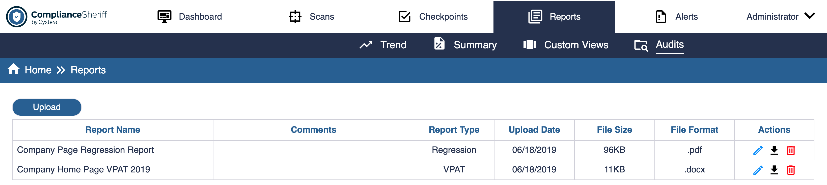

Uploading Reports

Permissions required: Create

If you have Create permissions than you will see a button “Upload” above the Audit Reports table. The Upload feature will allow a user to upload a document to the Audit Reports table. This is primarily used by the Compliance Sheriff Service Team to post manual accessibility testing reports and documents.

To upload a report:
- Click on the Upload button provided
- A modal will pop up on the screen
- On the modal, Select “Choose File” button.
- Browse your file system and select the file to upload.
- The name of the file will populate the Report Name field. This field can be edited. This is a required field.
- Select a Report type. The options include: Baseline Audit, Regression, VPAT and Other. This is a required field.
- Enter Comments as needed. This is an optional field.
- Select “Upload” button.
- Or Select “Close” to cancel the action.

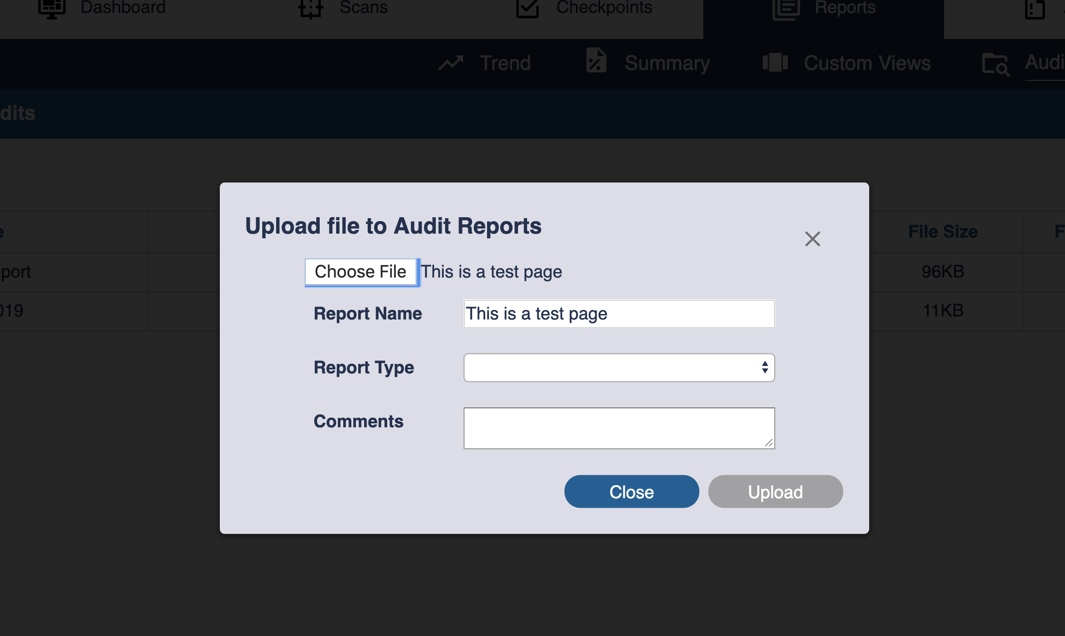

Note:
- The Maximum file size to upload is 100 MB
- Accepted file types to upload include: .doc, .docx, .xls, .xlsx, .pdf
- Report type options include: Baseline Audit, VPAT, Regression and Other

Downloading Reports

Permissions required: Create, Edit or View
.
Any user with permissions for View, Create or Edit will have the option to Download a report from the Audits tab.
There is no limit to how many times it can be downloaded.

- Click on the Download icon in the last column of the table, labelled “Actions”.
  - This would be the only Action for a user with View permissions and the second of three Actions for a user with Edit permissions.

Editing Report Record

Permissions required: Edit

A user with Edit permissions can edit Report records. This permission does not have any impact on the document itself, only the descriptive information. The following fields can be edited: Report Name, Report Type and Comments.

- Click on Edit icon in the last column of the table, labelled “Actions”.
  - This would be the first of three Actions for a user with Edit permissions.

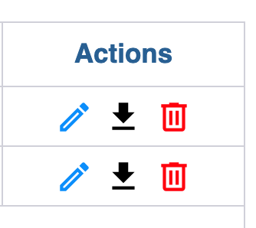

Deleting Reports

Permissions required: Edit

A user with Edit permissions can Delete a report from the table.
- Click on Delete icon in the last column of the table, labelled “Actions”.
  - This would be the last of three Actions for a user with Edit permissions.
- A confirmation note will pop up asking you to confirm if you want to delete the report indicated. You must either select “Cancel” or “Delete”

Settings
Settings to configure Compliance Sheriff and Compliance Deputy can be found when you select Settings within the Username dropdown in the top navigation toolbar. To access all settings on this tab, you will need to log in as a member of a Compliance Sheriff group with the option for Editing of custom dictionaries, user variables etc. permitted enabled.

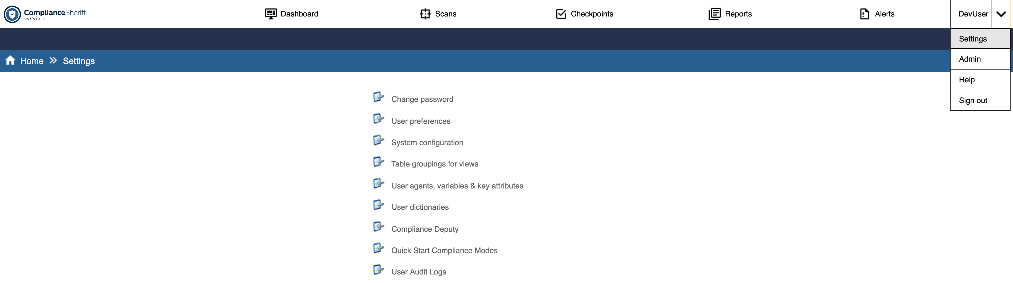
Figure 22 – Screenshot of settings page

Features include:
- Change password
- User preferences
- System configuration
- Table groupings for views
- User agents, variables and key attributes
- User dictionaries
- User Audit Logs
- Quick Start Configuration

Change password
NOTE. Not available if Active Directory integration is enabled.
NOTE. Password policy is configurable. The default password settings for new installations are that passwords must contain at least eight characters containing at least one lowercase text character, one uppercase text character, one numeric character, and one non-alphanumeric character. New users are required to reset their password when they first log in. Refer to System configuration on the Settings tab for the current password requirements and how to configure your password policy.
A user’s password can be changed by the user or an administrator from the Settings tab, or by the user from the log-in page (below) when their password expires.
Save
Saves your changes.
Cancel
Return without saving your changes.
Current password
Type the current password.
New password
Type the new password.
Confirm password
Retype the new password.

User preferences
Save
Saves your changes.
Cancel
Return without saving your changes.
Time zone
Select the local time zone.
Maximum text length for long descriptions and URLs
Determines how long a browser string or description can be before it's truncated. Adjust to suit your screen resolution.
Auto-update scans tab and view editor preview
Select to automatically refresh the Scans tab and previews when editing view definitions. This can be useful for users with accessibility concerns.
Auto-update interval for scans tab
Specifies the number of seconds between refreshes of the Scans tab. The minimum refresh interval is 3 seconds.
UI theme
Specify which UI theme you prefer: default or high contrast.

System configuration
NOTE. To change these settings, you will need to log in as a member of a Compliance Sheriff group with the option for Editing of custom dictionaries, user variables etc. permitted enabled.
Save
Saves your changes.
Cancel
Return without saving your changes.
WEB APPLICATION SETTINGS
NOTE. The Password Expiry Period default is 90 days.
To change the expiry period, add the PasswordExpiryPeriod key to the ComplianceSheriff.config file. The expiry period for all users is initially from the date of user creation or, if upgrading from an earlier version, the date of the version 5.1.2 upgrade.
Force users to change password
Forces new users to change password when they first log in.
Ignore list limits in reports
This will ignore list limits in reports.
Include instance detail in report
Determines whether or not a report should include a list of individual instances and state the line number and column number for each. If this detail is not required, un-check this box to generate smaller reports.
Max report size
This specifies the maximum size in bytes for generated reports - reports larger than this value are truncated, and an alert message is added to the bottom of the report. You may use the suffixes "MB" or "KB" as appropriate. A maximum size must be specified; there is no way to specify an unlimited size.
Minimum password length
Minimum number of characters.
Report header link URL
Will create a URL link in the header of a report.
Require digits for password
Require numeric characters.
Require mixed case for password
Require uppercase and lowercase characters.
Require non-alphanumeric characters for password
Require non-alphanumeric characters.
Result Logging
If checked, every SQL query used to generate the charts and result tables is logged into Trace.log, located on the host server under the ...\Log directory.
Review wizard max image width
Determines the maximum image width in pixels for images shown in the review wizard. Images wider than the specified limit will be truncated.
Implied Permissions
Turns on and off the implied permissions feature. See User group properties for details.
SCANNER SETTINGS
Allow invalid SSL certificates
This option is checked by default, and users can access these sites if they choose to do so. When unchecked, sites using invalid SSL certificates (for example, sites with expired or non-trusted root certificates) will not be crawled.
Browser load retries
This value provides additional control over how long to wait for Internet Explorer to become responsive when executing client scripts or transaction scripts.
Browser load timeout
This sets the maximum time in milliseconds to wait for pages to load when "Execute client scripts" is used, or when the loading is part of a transaction. Setting this too long can cause scans to run very slowly; however, setting it too low can cause pages to be processed before all content has been processed and all scripts have finished running.
Cache all pages
Uncheck this to prevent the contents of scanned pages being saved on the Compliance Sheriff server, meaning that they must be re-downloaded when viewing source code highlighted with result detail information. Not suitable for scanning dynamic sites.
Dynamic content scanning option
Select option:
- Never – Scans use old scanning engine. Universal engine is not used to scan the pages
- First page only – Universal engine is used to scan the first page and rest of the pages are scanned with old scanning engine
- All pages – Universal web engine is used to scan all the pages.
A warning message is displayed when the option 'All pages' selected HTTP user agent
User agent string to use for scans that specify "default" for this setting. Link check exclude filter
Pages containing "logout" in the URL will not be scanned, because users may be unexpectedly logged out of a site whenever the scan runs. If you want to add additional filters to this field, use a regular expression. For a complete description of regular expressions, please visit the following page:
http://www.regular-expressions.info/reference.html
Max page size
The maximum number of bytes that will be downloaded for any one page. Pages over the specified size will either be truncated (for text-based formats like HTML), or ignored (for binary formats like Office and PDF documents). The default is 1 MB (1048576).
Max threads
Maximum number of additional threads used to perform simultaneous downloads. Default is 10, the maximum recommended value is 20.
Purge after
Number of months after which to delete old database records.
Record all instances
Ensures that results from a scan are stored in the instances table. By default, the scanner only stores instances with a Failed/Warning or Visual result.
Record instance details
Record details of instances in instances table.
Resolve host aliases
Ensures that the crawler will cross over to the alias hosts if they've been configured.
Retries
Number of times to retry accessing any page after a failure. Default number of times is 3. The time between retries is given by the Timeout parameter. Certain failures will not cause retries, for example, 404 page not found.
Roll-up after
Number of months after which to 'roll-up' old database records. It purges all except the last run for each month.
Scan default page limit
Default maximum number of pages scanned.
Timeout
Minimum number of milliseconds to wait before giving up on downloading a file. The default is 30000 (one half- minute).
It may wait longer than the specified time if simultaneous downloads are occurring.
Verbose
Check for detailed logging (default), uncheck for errors and warnings only. A log file is created per scan or monitor, which is displayed when the scan/monitor status is opened. The log filename is based on the Scan ID, for example 2001.log, and is located in one of 2 areas:
For normal scans/monitors - the host server's "logs" directory (the default location is C:\Program Files (x86)\Cryptzone\Compliance Sheriff\logs)
For Scans run locally, in the user's default directory on the machine where the scan was started:
%USERPROFILE%\Local Settings\Application Data\Compliance Sheriff\Toolbar\<Web location of Compliance Sheriff instance>\<Scan ID.log>
For example:
C:\Documents and Settings\Administrator\ Local Settings\Application Data\Compliance Sheriff\Toolbar\demo.cryptzone.com_HiCS\2001.log
NOTIFICATION/ALERT SETTINGS
From
The 'from' address for all notifications. Default is no-reply@Cryptzone.com.
Link notification text
This can be used to add additional text to the end of messages sent for notifications where Send as link is checked.
Retry delay
Number of milliseconds before retrying if initial attempt to send notification fails.
Send password
The password to use for SMTP authentication.
Send user name
The user name to use for SMTP authentication.
SMTP authenticate
Set to '1' if the SMTP server requires authentication.
SMTP server
The domain name or IP address of the SMTP server to use. The default is blank, which means to use the local server hosting Compliance Sheriff.
SMTP server port
The TCP/IP port used by the SMTP server.
SMTP use SSL
Check this box if the SMTP server requires authentication.
Web location
The web address of the Compliance Sheriff application. This is set dynamically by the web application and should not be edited.

Table groupings for views
NOTE. To change these settings, you will need to log in as a member of a Compliance Sheriff group with the option for Editing of custom dictionaries, user variables etc. permitted enabled.
Save
Saves your changes.
Cancel
Return without saving your changes.
AVAILABLE GROUPINGS FOR...
Shows the order of results for various types of tables. Groupings must be separated by a comma. Groupings must be valid for the selected table type. Groupings are case sensitive. See Managing view definitions for information on how to modify table groupings.

User agents, variables and key attributes
NOTE. To change these settings, you will need to log in as a member of a Compliance Sheriff group with the option for Editing of custom dictionaries, user variables etc. permitted enabled.
Save
Saves your changes.
Cancel
Return without saving your changes.
USER AGENTS
Custom user agent strings can be used if your web server is configured to respond differently to different user agent strings. For example, it might require that the string includes "IE" or "Firefox". Compliance Sheriff is configured with sample user agent strings, and you can add additional ones by typing them in the field provided. You can find more information on user-agent strings at the MSDN library:
http://msdn2.microsoft.com/en-us/library/ms537503.aspx
The default user agent string is not shown in this list but is defined internally as: Mozilla/4.0 (compatible; MSIE 6.0; Windows NT 5.1; HiScan);
In addition to the standard browsers (Internet Explorer, Chrome, Safari and Firefox), user-agent strings for a variety of screen sizes for mobile devices are also available.
USER VARIABLES
User variables provide a way to customize the behavior of checkpoints without having to edit the checkpoint rule directly. They can also be used to share complex expressions between checkpoints, such as when a specific list of information is needed for use in more than one checkpoint.
A user variable can be referred to anywhere in a checkpoint rule by using the syntax %{variable-name}%.
To create a user variable, go to Settings>User agents, variables & key attributes, and scroll down to the List of user variables field. On a new line, enter a variable (for example: CompanyEmailList=support@Cryptzone.com,sales@Cryptzone.com). Items should be separate by a comma, and each new variable should go on a new line. Once you've finished, checkpoint rules can be created or edited to include the variable you've just created, as per the example below:
By default, the product is shipped with these variables:
DecorativeImageList
This is used by Checkpoint Accessibility 1.1.1 as a list of absolute URLs, separated by commas, that specify which images should be considered decorative and carry no textual meaning. It is updated automatically by the Results Revision wizard, but can it be manually edited here, and should be carefully maintained to ensure the list is accurate.
NonDescriptiveLinkText
This is a comma-separated list of common phrases used for links that are poorly accessible, because they don't describe the purpose of the link.
AreaHrefsWithRedundantText
This is used for server side image maps that have text link equivalents. This is used to comply with Section 508 - 1194.22(e).
[Links=http://mysite.com/areamap.png]
AudioExtensionsRegex
This is used to identify pages that contain audio files. Certain accessibility regulations require these to be listened to by a person to determine if an associated transcript provides equivalent access.
[=\.(au|mp3|wav|aif[fc]?|wma|m3u|ogg|ram?)\b]
VideoExtensionsRegex
This is used to identify pages that contain video miles. Certain accessibility regulations require these to be viewed by a person to determine if an equivalent alternative is provided.
[=\.(avi|divx|flv|m4v|mov|mpg|mp4|ogm|ogv|swf|wmv)\b]
NonDescriptiveAltTextRegex
This is a regular expression that is used by the Alt Text Quality module to determine whether appropriate alternate text has been specified by a user.
[=(^(image|picture|graphic|logo))|\.(jpg|jpeg|gif|png)|[a-z][0-9]|[0-9][a- z]|^[^\p{L}]*$]
InteractiveElements
This is used by multiple Web Content Accessibility Guidelines 2.0 checkpoints to flag work that will require visual verification. Examples of these are WCAG2 requirements around verification of keyboard focus and keyboard interaction.
[=(//INPUT|//A|//SELECT|//TEXTAREA|//BUTTON)|(//DIV|//UL|//OL)[@aria- activedescendant|@tabindex]|(//SPAN|//LI)[@tabindex]]
SharePointScreenReaderText
This is a list of alternate text values that are set within the SharePoint environment to make it easier to use for screen reader users. Because this text is included on decorative graphics a user variable is necessary to ensure that this helpful information is not flagged as a failure in compliance reports.
[=Use SHIFT+ENTER to open the menu (new window).,Presence enabled for this column,No presence information,Filter]
SharePointDecorativeImageList
This is a list of URLs for standard SharePoint installations that have been verified to be used for purely decorative purposes.
[(=/_layouts/images/blank.gif,/_layouts/images/menudark.gif,/_layouts/images/ whitearrow.gif,/_layouts/images/blank.gif,/_layouts/images/tvblank.gif,/_layouts/images/ rect.gif,/_layouts/images/checkout,verlay.gif,/_layouts/images/titlegraphic.gif,/ _layouts/images/exclaim.gif,/_layouts/images/trans.gif,/_layouts/images/ downarrw.gif,_layouts/images/fgimg.png)]
KEY ATTRIBUTES
This list is used by the scanner to determine what key attribute information to store for each element that triggers or generates a checkpoint result. This attribute information is shown in the issue identification, page compliance, and occurrences tables for views and reports, and is critical for identifying exactly where problems are being detected, and for grouping occurrences across a large site.
There is one line for each element name, and commas are used to separate the list of possible attribute names to check for. Where multiple attribute names are listed, the scanner will check each attribute name in turn and record the first value it finds. For example, if the key attributes for the a (anchor) element are listed as href,name, then every time a checkpoint result is recorded against an anchor element, if the href attribute is present, its value will be recorded in the database, and if not, the name attribute will be checked, and its value (if any) will be recorded instead. If neither attribute is present, no key attribute information will be stored for that element - just the element name.
The key attributes can be overridden for individual checkpoints by starting a new section with the internal ID of the Checkpoint. For example, Accessibility 11.2.2 is designed to recognize deprecated attributes, so there is a section [Accessibility_1122] that specifies for each element the names of deprecated attributes, ensuring that this is what gets recorded in the database. This is less helpful for the occurrences report, where it may be more useful to group, for example, img elements by the src attribute. However, this would result in a report that contained no information about which deprecated attributes were actually used.

User dictionaries
NOTE. To change these settings, you will need to log in as a member of a Compliance Sheriff group with the option for Editing of custom dictionaries, user variables etc. permitted enabled.
Dictionaries are used by spell-checking checkpoints, and are part of the Site Quality module. By default, a spell check uses two dictionaries: the primary dictionary, and its corresponding user-defined or secondary dictionary. For example, If a checkpoint is set to use English (US), the dictionaries used will be
en-US.dic (primary) user-en-US.dic (secondary)
Custom words, including proper nouns (such as company and product names), can be added to user dictionaries so they don't fail spell-checking checkpoints. Be sure to capitalize proper nouns when adding them, so that future scans will identify uncapitalized instances of these words as errors. For example, if you wanted to add "Firefox" to a user dictionary, you would enter it as "Firefox", ensuring that "firefox" is picked up as a spelling error.
Custom words can also be added to spell-checking checkpoints, by Using the Result Revision Wizard.
All available dictionaries are located in the data directory on the host server.
To download language dictionaries:
- Open the following page in your browser and select the language you want to download.
http://www.obout.com/editor_new/download_dictionaries.aspx
- Move or copy the dictionary file (e.g. de-DE.dic) to the worker folder on the server running the Compliance Sheriff worker. This is the primary dictionary.
C:\Program Files (x86)\Cryptzone\Compliance Sheriff\worker
- In the C:\ProgramData\Cryptzone\ComplianceSheriff\customers\Cryptzone\data folder, copy the existing user dictionary and rename it with the appropriate language (e.g. user-de-DE.dic). This is the secondary (user-defined) dictionary.
- From the Settings tab, click User Dictionaries and verify that the new user dictionary is displayed.
To customize user dictionaries:
- From the Settings tab, click User Dictionaries.
- Type the word you want to add in the appropriate language box.
- Click Save.
- To add another word, repeat steps 2 and 3. Only add one word at a time.
To specify a dictionary in a spell-check checkpoint:
• By default, the spell-check checkpoint uses the language of the web page source while scanning. This is achieved by setting the dictionary name in the ForEachUnknownWord checkpoint function to “*”. In this default case, if the page source language is German, Compliance Sheriff applies the de-DE.dic dictionary (located in the worker folder). If you have purchased supplemental dictionaries, they may be specified by using commas, e.g. “ForEachUnknownWord en-us,user-en-us,medical-en-us”. Any additional language dictionaries must be licensed and installed as previously described.
NOTE. It is recommended that users do not modify standard Compliance Sheriff checkpoints. Instead, create a new custom checkpoint. For more information, see Customizing checkpoints.

Quick Start configuration
NOTE. To change these settings, you will need to log in as a member of a Compliance Sheriff group with the option for Editing of custom dictionaries, user variables etc. permitted enabled.
From this page you can set the checkpoint groups available in the Quick Start (see Getting started) and the scan group that Quick Start scans are assigned to. The default settings are:
- Checkpoint groups: Section 508 and WCAG 2.0 A/AA/AAA.
- Scan group: Temporary Scans
NOTE. Completed scans in this group can only be displayed in the Scan list by selecting the <Temporary Scan> group in the Scan Group filter.
To change the Quick Start settings:
- From the Settings tab, click Quick Start Compliance Modes.
- On the Configuration tab, under Checkpoint Groups, select or clear the checkpoint groups that users will be able
to select in a Quick Start scan.
  - Use the Search tool to filter the list. The list updates as you type.
  - Select Show selected only to show only the selected checkpoint groups.
  - Select Show all subgroups to show subgroups containing checkpoint groups.
- In the Scan group box, select the scan group that scans from Quick Start scans will be assigned to in Compliance Sheriff. If there are no scan groups available, create one on the Scan tab.
- In the Default page limit box, type the default maximum number of pages (between 0 and 20) in a Quick Start scan.
- Click Save.

User Audit Logs
NOTE. The User Audit Logs feature is enabled on any new version 5.1.2 installation. Refer to the Installation Guide for instructions on implementing this feature when upgrading from an earlier version.
The User Audit Log records all user actions. The log records the user’s name, details of the action, and the date and time the action was taken. You can search, sort, filter, and export the log. Records in the User Audit Log can only be deleted directly from the User Audit Log database.
NOTE. You must belong to an Administrator group with full permissions to view User Audit Logs.
To view the User Audit Log
1. From the Settings tab, click User Audit Logs.
2. All user actions in the last 7 days are displayed in the list, including changes to the User Audit Log. Click a column heading to sort by that column. If an expand symbol is displayed to the left of a change record, click the record to display details of the change (as shown below). To show earlier actions, use the filter controls to set an earlier From Date (see next).
To filter the list, under User Audit Filter, type or select the values you want to filter on (User Name, Object Name, Type, Action, From Date, To Date), and then click Search. To clear the current filter, click Clear Filters.
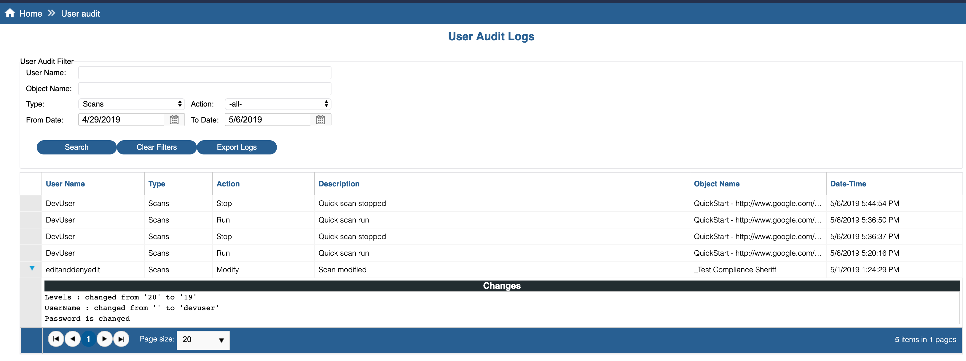
Figure 22 – Screenshot of user audit logs page
To export the User Audit Log
- From the Settings tab, click User Audit Logs.
- If required, filter the list before exporting (see instructions above).
- Under User Audit Filter, click Export Logs.
- The list is exported in CSV format.

Compliance Deputy
For information on running scans from the Compliance Deputy toolbar and how to load a local configuration file,
Scanning the current browser page.
For information on installing and configuring Compliance Deputy, see Installing and configuring Compliance Deputy.

Admin tab
New
Click to create a new user.
Delete
Click to delete the selected user.
Show usage
Click to display the usage history of the selected user (see Show usage). USERS LIST
Click a column heading to sort by that column.
Name
Displays the user’s username. Click to view and edit User properties. Group
Displays the user group the user belongs to.

User properties
Save
Saves your changes.
Cancel
Return without saving your changes.
Username
This is the log-in name for the user, and it is a required field. Usernames are case insensitive and may contain any character except double quotes (").
Password
The password is case sensitive. When resetting the password of an existing user, be sure to clear the password field. The dots that appear in the password field are placeholders, but they may become part of a new password if left undeleted.
NOTE. Refer to System configuration on the Settings tab for the current password requirements and how to configure your password policy.
Confirm password
If a password has been typed, it must be re-entered in this field.
Group
Every user must belong to a group which determines their permissions.

Show usage
The usage table displays a history of all completed scans, including scans that have been deleted. You can sort the list by clicking on the column headings. Totals are shown at the bottom of the table. Use the END, HOME, PG UP and PG DN keys to quickly move down and up the table.
The User column displays the username of scans that were launched manually. No user information is displayed for scheduled scans, which are launched by the system.

Groups subtab
New
Click to create a new user group.
Delete
Click to delete the selected user group.
Show usage
Click to display the usage history of the selected group
USER GROUPS LIST
Click a column heading to sort by that column.
Name
Displays the user group name. Click to view and edit User group properties.

User group properties
Save
Saves your changes.
Cancel
Return without saving your changes.
Name
This is the name of the group. All characters can be used, including spaces.
Scanning local content permitted
If selected, members of this group will be allowed to run the scans locally. Otherwise, the Run button on scans that have been defined to run locally will not be available to members of this group. The user group requires edit permissions for scan objects. Running local scans requires the Compliance Sheriff toolbar to be installed on the user's computer.
Editing of custom dictionaries, user variables etc. permitted
If selected, this option allows the user to edit these settings and the Compliance Deputy configuration on the Settings tab. This option is available by default for the Administrator group.
Permissions
You can set different permissions for users and user groups and restrict their actions on specified functions.
- Click Add to create a new permission.
- Click Remove to delete an existing permission.
To modify an existing permission (see descriptions below),
- Select the Type (checkpoint, checkpoint group, notification, etc.).
- In the Name column, click Edit, and select which items the permission applies to.
- In the Action column, select the permission that applies to the selected items.
PERMISSIONS LIST
Type
This determines the type of object on which you are specifying a permissible action. The types are scan/monitor, checkpoint, checkpoint group, view, notification, and scan group.
Name
This is the name of the object that the user is allowed to act on. Click Edit to open the list, and then one or more objects (hold down the CTRL key to select multiple objects).
Action
Below are the permissible actions that can be performed on an object. To specify the action you wish to perform, use the pull-down menu in the Action field. To perform a specified action on multiple objects, click Edit in the Name field, and hold the CTRL button to select multiple objects.
Action | Description
edit | Allows users of this group to modify the type of item defined in the Type field. Edit permission is required for a user to run a scan.
create | Allows users of this group to create the type of item defined in the Type field. The group will be granted full edit and view permissions to the defined item type, but will only be able to view or edit items created by another user in the group.
deny edit | Sets Edit permissions to all items except those defined in the Name field.
deny view | Sets View permissions to all items except those defined in the Name field.
View | Allows users of this group to view the specified object only. Users granted edit permission on an object are automatically granted view permission, but users granted view permission are not automatically granted edit permission.

IMPLIED PERMISSIONS
Compliance Sheriff has an implied permissions feature, which means that If you give a user "edit" or "view" permissions to a specific scan group or checkpoint group, the user will automatically be granted "edit" or "view" permissions to the individual scans or checkpoints contained in that group. Additionally, if you give a user permission to create scans or checkpoints, and the user already has "edit" or "view" permissions for one or more scan groups or checkpoint groups, then when the user creates a new scan or checkpoint and adds it to one of the user's permissible groups, the user will automatically be granted "edit" or "view" permissions to it.
NOTE that a "deny" permission, such as "deny edit" or "deny view", does not override an existing implied permission. The reason for this is that a "deny" permission already grants an implied permission. If you define a group with a "deny view" permission for the scan "Top Secret Scan", you are, by implication, giving the user permission to view all scans except "Top Secret Scan".
NOTE that if you do not specify a permission for an object type, then the users of that group will not see those objects.
To activate the implied permissions feature:
- From the Settings tab, click System Configuration.
- Under Web application settings, enable Implied permissions.
Scans and monitors are almost identical from an administrator's perspective. You cannot have a scan and a monitor with different actions for -al- . If one is set to edit and the other to view, then when saved, both will be set to edit.

Checkpoint expression syntax

Checkpoint expression parser
The Sheriff checkpoint expression parser supports Visual Basic expressions. The VB expression can comprise any combination of Checkpoint functions and Checkpoint tests and loops. For example, the following script returns a Fail result with the message “This is false”:
The parser supports:
- Standard arithmetic and Boolean operators are supported (+, -, *, /, AND, OR etc.)
- String functions (from the .NET CLR system.string type (e.g. .Length)
- LINQ functions (e.g. .Sum)
- Reg-ex functions
- System.Math functions
IfExpressionIsTrue 1 + 1 = 3
Pass This is true
Else
Fail This is false
Any functions from any other CLR namespaces (e.g. System.IO!) are blocked (e.g. by stripping out occurrences of ‘System.’ from the expression first, or using an execution context that doesn’t have permission to access external resources).

Checkpoint variables
The variables (string type, case-insensitive) available from the content analyzer are:

Variable | Description
value | The value found by the most recent use of IfHasAttribute, IfHasProperty, IfPageText, IfPageSource (it contains the ‘matching’ text found), etc.
content | The text content of the element most recently found by IfHasElement, ForEachElement, IfHasChildElement, ForEachChildElement
pageText | The entire page text
pageSource | The entire page source
url | The URL of the current document

Checkpoint functions
Function | Description
Contains | if element contains
ContainsAnyOf | if element contains any of
Continue | continue
Else | else
Equals | equals
EqualsAnyOf | equals any of
Fail text | mark 'Fail', with text
ForEachChildElement | for each child element of type
ForEachElement | for each element of type
ForEachLink | for each link
ForEachResource | for each file referred to
ForEachResult | for each result
ForEachUnknownWord | for each word not in dictionary
IfAttributeValue | if attribute value
IfAttributeValueAbsolute | if attribute value as absolute URL
IfAttributeValueLength | if attribute value length
IfContent | if element content
IfContentLength | if element content length
IfContentsChanged | if contents have changed
IfExpressionIsTrue | if expression returns non-zero value
IfElementHasValidARIALabel | if element has valid ARIA label
IfFileExists | if page exists with URL
IfHasAttribute | if element has attribute
IfHasChildElement | if element has child element if page has element
IfHasElement | If page has element
IfHasElement IfHasHeader name | Checks the current asset for the existence of the name metadata column. This can be any metadata column in the list or library that the policy is deployed to
ifHasLinkedElement | If element has linked element
IfHasStyleProperty | if element has linked element if element has style property
IfHeaderValue condition value | checks value for the list item in metadata name in IfHasHeader.
IfLinkValid | If link is valid
IfPagePassesCompiledCheck | if page passes compiled check
IfPageSource | if page source
IfPageText | if page text
IfPageUnavailable | if page unavailable
IfPropertyValue | if property value
IfResultText | if result text
IfScriptText | if script text
IfSecondsToLoadPage | if seconds to load page
IfURL | if URL
IfValueHasRepeats  IsExternalDomain | if value has words repeated more than domain is external
MatchesRegEx reg-ex | matches reg-ex
NA text | mark 'NA', with text
Pass text | mark 'Pass', with text
Then | then
Visual text | mark 'Visual', with text
Warn text | mark 'Warn', with text
EXAMPLES
IfHasHeader ABC
Checks for ABC metadata field.

IfHasHeader %Column% IfHeaderValue Equals SPMD1
Fail 'SPMD1' value found else
Pass else
NA
The above checkpoint expression looks for metadata names defined in the user variable 'Column' and then checks if the item metadata contains 'SPMD1'. If found, then fail the checkpoint and display a message "'SPMD1' value found", else it is passed. If none of the names defined in the Column variable exist, it is ignored.
The checkpoint is then included in a checkpoint group, which is set to a Policy. Policy conditions can then be defined to map the result of the checkpoint, to a set of MD values defined in the Sheriff Metadata. The Sheriff Metadata can then be deployed to the Asset, to display the result—which can then be used for various Sheriff treatments (classification/ permissions/workflows etc).

Checkpoint tests and loops
GENERAL TESTS
if page text
if page text [contains|equals|contains any of|equals any of|matches reg-ex] text
Searches the page markup source for the text specified. For contains any of and equals any of, this is a comma
separated list.
if page source
if page source [contains|equals|etc.] text
Searches the page markup source for the text specified. For contains any of and equals any of, this is a comma
separated list.
if page has element
if page has element element-type
Searches the HTML structure for any element of the type specified. For example, set element-type to TITLE to look for the <TITLE> element. Don’t include the HTML separators < or >. Element-type is internally prefixed with '//' to form a case-insensitive X-Path expression. Using X- Path expressions, you can perform more sophisticated searches.
For more information, see tutorial http://www.w3schools.com/xpath/ and reference http://www.w3.org/TR/xpath.
if page unavailable
If page unavailable
This can be used to test that the page itself is available. Checkpoints with this test at the beginning of the rule are executed even on pages that can’t be loaded. The variable %error% can be used to include extra information in the result text.
if page exists with URL
if page exists with URL url
Determines whether a page or resource with the given URL can be accessed. The URL can be absolute or relative to the page being tested. NOTE that any given complete URL will only be tested once per scan, so if the URL specified is, for example, /robots.txt, and all pages in your scan are in the same domain, only a single network request will be made, and the result is re-used when executing the checkpoint on subsequent pages.
if seconds to load page
if seconds to load page 􏰈|􏰀|􏰉 numerical-value
This records the time it takes to fetch the page from the website. The subsequent parameter must begin with <, =, or
>, followed by an integer.
if HTTP headers contain
if HTTP headers contain header-field
This checks for an HTTP header matching the header-field specified.
if property value
if property value [contains|equals|contains any of|equals any of|matches reg-ex] pattern
To be used after “If Has Style Property” – allows you to match the value of the found CSS property against the pattern provided.
if result text
if result text [contains|equals|contains any of|equals any of|matches reg-ex] pattern
Following “for each result”, matches the returned result or error against the pattern provided.
if script text
if script text [contains|equals|contains any of|equals any of|matches reg-ex] pattern
Matches all JavaScript directly inside the page source or in any externally referred to JS files against the pattern provided.
if URL
if URL [contains|equals|contains any of|equals any of|matches reg-ex] pattern
This allows you to test against the absolute URL of the current page, or, if inside a for each file referred to loop, the
URL of the file referred to.
if contents have changed
if contents have changed
This determines whether the page contents have changed since the previous run of this scan or monitor.
LOOPS
for each element of type
for each element of type element-type
This relates to the if page has element test. This loops through all elements matching element-type and executes the contained rules. Once the loop is complete, if no rules have caused a result to be set ( Mark "Failed" etc.), the rule shown at the end of the loop is executed.
for each file referred to
for each file referred to
This loops through all images, style sheets, scripts, and iframes referred to by the current page; in other words, all the files that a browser will automatically load when you bring up a page. Once the loop is complete, if no result has been set, the rule at the end of the loop is executed.
for each link
for each link
This iterates through all links on the page, including hyperlinks and any external resources referred to (images and style sheets, for example). Once the loop is complete, if no result has been set, the rule at the end of the loop is executed.
for each result
for each result
This iterates through all results returned. Once the loop is complete, if no result, the rule at the end of the loop is executed.
for each word not in dictionary
for each word not in dictionary dictionary-name
This iterates though all words in the page text that are not found in any of the dictionaries specified in the subsequent parameter. If you use “*” as the parameter value, the dictionary corresponding to the default system language is used (typical “en-us”, or American English). If you specify a specific language (e.g. fr-FR), the user dictionary for that language will be included by default. If you have purchased supplemental dictionaries, they may be specified by using commas, e.g. “en-us,user-en- us,medical-en-us”.
WHEN “IF PAGE HAS ELEMENT” HAS RETURNED TRUE OR INSIDE A “FOR EACH ELEMENT OF TYPE” LOOP
if element content
if element content [contains|equals|...] text
Tests the content of the element; in other words, the text that occurs between the beginning and end tags.
if content length
if content length < | = | > numerical-value
Tests the content length; in other words, how many characters are between the beginning and end tags. You must type <, = or > as the first character in the text box that follows “If content length”.
if element has linked element
if element has linked element element
A “linked” element is either:
- A parent element (i.e., the element that contains this one)
- An element that is associated by known attributes. The only type of attribute association supported in this version is the LABEL element’s FOR attribute, which must matches another element’s ID attribute.
if element has attribute element-attribute
if element has attribute element-attribute
Determines whether the attribute element-attribute (case insensitive) is specified for the current element.
if element has child element
if element has child element child-element
Determines whether the element child-element is present as a contained element—it need not be a direct child. In the following example, the <A> element would be considered a contained element of <BODY>:
HTML <BODY><DIV><A NAME='anchor'></DIV></BODY>
if element has style property
if element has style element style-property
Determines whether the calculated or “used” CSS style for a particular element specifies a particular CSS property.
if element has valid ARIA label
if element has valid ARIA label
Determines whether there is aria-label, aria-labelledby or aria-describedby attribute that correctly provides a non-blank label for an element.
for each child element of type
for each child element of type element-type
Loops through all contained elements of type element-type, behaving otherwise identically to the for each element of
type loop.
WHEN “IF ELEMENT HAS ATTRIBUTE” HAS RETURNED TRUE if attribute value
if attribute value [contains|equals|...] attribute-value
if attribute value length
if attribute value length >|=|< numerical-value
if attribute value as absolute URL
if attribute value as absolute URL [contains|equals|...|is external domain]
This attempts to convert the attribute value to an absolute URL, for cases where the attribute value can logically be a relative URL. For example:
The SRC attribute of an IMG element. A further test “is external domain” is made available to determine if the URL does actually refer to a resource that is part of the current website (as determined by the Base URL and the “additional domain” list specified in the scan).
if value has words repeated more than
if value has words repeated more than numerical-value
This test determines the number of times any words are repeated within an attribute value, and compares this number
with the original number entered.
INSIDE A "FOR EACH LINK" LOOP
If link is valid
if link is valid
This tests if the resource referred to by a link found by the “For each link” loop is available. The variable %error% can be used to include extra information in the result text.
WHEN “IF HTTP HEADERS CONTAIN” HAS RETURNED TRUE
if header value
if header value [contains|equals|...] header-field
Use this to test the HTTP header value returned by the server. Available only once you have selected a particular
starting test
INSIDE A “FOR EACH” LOOP
continue
continue
When inside a “for each” loop, continue (instead of mark) will ignore the element, marking no result. The rule specified
at the end of a "for each" loop is only executed if every element has caused a continue to execute.
mark <value> with text
mark N/A|Passed|Visual|Warning|Failed with text text
Marks the result of an “if-then-else” chain. The text text is included in the report as an explanation of why the checkpoint was given that result. The text may include a special token %url% which is expanded to be the URL of either the current page, or (more usefully) the current file in a "for each file of type" loop. The possible result values are :
Result Description
Fail = The page did not pass the checkpoint and must be fixed
Warn = The page passed the checkpoint but could be improved
Result Description
Visual = A visual check is required to determine whether this page passed this checkpoint
Pass = The page passed the checkpoint
NA = The checkpoint is not relevant for this page
NOTE:
- The final result is the "most severe"—that is, if the first element in the loop causes a "mark passed", but the second element causes a "mark failed", the final result is "Fail".
- If the final result is "Fail", "Warn", or "Visual", then the line number and position number of each element that caused this result is recorded to assist in locating the problem.
- If some elements cause a warning, but others cause a failure, only those causing a failure will be listed.

Checkpoint properties
Number
This is a unique identifier for the checkpoint. Any text can be entered; however, we recommended using numbers in the format N.N, N.N.N or N.NA, i.e. 9.9, 9.9.9 or 9.9a.
Description
A brief description of the checkpoint.
Rule
The rule returns a value for the result. For more information, refer to the Checkpoint Rule Tables page.
Regular expression
A regular expression is a pattern describing a certain amount of text.
Example | Description
\.asp$ | Pages ending in .asp
\.aspx?$ | Pages ending in .asp or .aspx
\.asp$|\.aspx$ | Pages ending in .asp or .aspx
^http://www\.cynthiasays\.com/ | Pages whose address begins with www.cynthiasays.com
/Help | Pages which contain the string /Help

You can use the pipe character to separate matching expressions.
For more examples and a complete description of regular expressions, visit the following page:
http://www.regular-expressions.info/reference.html

Checkpoint examples
ZERO DIVIDE TEST
The result should be “abort”, with an error message explaining that a divide by zero occurred.
NOTE. Expressions should be written to cope with any input.
LUHN VALIDATION TEST
The credit card detecting checkpoint, which performs the Luhn validation, contains the expression:
IfExpressionIsTrue 1 / 0 Fail
Else Pass
IfPageText MatchesRegEx \b\d{4}[-]y a + \d{4}[-]+\d{4}\b
IfExpressionIsTrue value.Replace(" ", "").Replace("-",""}.Select(Function(c, i)(AscW©-48)<<((value.Replace(“ “,””).Replace(“-“,””).Length-i-1)And 1)).Sum(Function(n)If(n>9,n-9,n))Mod 10-0
Fail A valid credit card number was found
else
Visual A number in credit-card format was found that is not valid
else
Pass No credit card numbers found
Using the Luhn validation checkpoint, test on a page containing 4012-8888-8888-1881, and somewhere else, 16 zeros in a row: 0000000000000000. These are valid according to most variations of the Luhn rule, so the result should be “Fail, A valid credit card number was found” with two instances highlighted. Then test on a page containing 0000 0000 0000 0001. This is not valid so the checkpoint result should be “Visual, A number in credit card format was found that is not valid”.
REG-EX EXAMPLE
This next example tests if the first CEO name found in the content is within 30 characters of the first expletive.
IfExpressionIsTrue Abs(Regex.Match(pageText, "%ListOfCEOS%".Replace(",","|")).Index - Regex.Match(pageText, "%BadWordsRegex%").Index) < 30
Fail CEO name found within 20 characters of a bad word Else
Pass
NOTE. User variables are treated exactly as they are for all other checkpoint rule actions—a simple text substitution is performed before execution.
Set user variables ListOfCEOs to “Gordon Gekko,Montgomery Burns” and BadWordsRegex to ”meanie”. Execute on a page containing “Homer Simpson thinks Montgomery Burns is a meanie!”. This should Fail.
Using the same checkpoint, execute on a page containing “Homer Simpson thinks Montogomery Burns is cool, but his workmates are meanies”. This should Pass.
X-PATH EXAMPLE
If the script text searches through JavaScript files on the page, then to be able to write more compact checkpoints, it is good to combine X-Path and reg-ex. Using the matches function from X-Path will allow verifications to be made on the values of various attributes supported by elements.
For example, for the form:
<form action>"/searchresults" name="SearchForm" onsubmit="return validate_theme_search_form(this)”>
<label class=”no scriptdisplay” for=”query”>Enter Search</label>
<input class=”hdInptSearch” type=”text” name=”ssn” id=”Name”/>
<input class=”hdInptSearch” type=”text” name=”query” id=”query”/>
<input class=”hdInptSearch” type=”text” name=”age” id=”Hi”/>
<input class=”hdInptSearch” type=”text” name=”email” id=”Email”/>
<input class=”hdButtonSearch” type=”submit” value=”” title=”Search”/>

Consider the following expressions:
FORM[(.//*[matches(text(),"HI")])]
Select all FORM elements that had a child element with the text “HI”
.//IMG[matches(@SRC,”\.jpe?g$”)]
Find all IMG elements where the SRC value ended in .jpg or .jpeg
.//A[matches(text(),”\s”)]
Find all A elements whose element content (link text) contains a space

Scan diagnostic tool
The Scan Diagnostic tool is useful when debugging transaction scripts that use screen rendering. The Scan Diagnostic tool can only be run on the Worker Server. To run the tool, open the command prompt, navigate to the Worker folder using command prompt, and then type the following command:
HiScan -urn urn:local:ComplianceSheriff:MachineName -enablescreenshotrendering true -cust CustomerName ScanID
where,
- Machinename is where the controller is installed.
- CustomerName is the web application name under IIS, which is used to create the URL (e.g. “Cryptzone” is the CusterName in the URL http://localhost/ComplianceSheriff_Cryptzone/login.aspx). There can be multiple instances under IIS, so the name of the specific instance is required.
- ScanID is the unique scan ID that has the transaction script which the user wants to diagnose. For example:
The screen rendering is displayed and is updated as each step in the transaction script is executed.

Installing and configuring Compliance Deputy
Compliance Deputy is installed as a toolbar on the client browser, from which scans can be run on the content of the current browser tab. Compliance Deputy is available for Internet Explorer, Google Chrome, Firefox and Apple Safari (Mac) browsers. Installation files for these browsers are available in the plug-ins directory of the Web-Front-End (WFE) server where Compliance Sheriff is installed. You can also download a zip file containing the installation files from http://support.cryptzone.com. The Google Chrome extension is also available from the Chrome Web Store.
NOTE. Information in this section is reproduced from the Compliance Deputy Installation and User Guide, which can be downloaded from http://support.cryptzone.com.
IN THIS SECTION:
- Installation requirements
- Installing and configuring Compliance Deputy
- Upgrading Compliance Deputy

Installation requirements
GENERAL
- Compliance Sheriff 5.2 and above
- Compliance Deputy CAL license
- Operating system required for browser
- .Net Framework v4.0 and above.
NOTE. Net Framework v4.5 is required if web server does not allow clients to connect using TLS (Transport Layer Security) protocol 1.0. i.e. connection can only be established through TLS 1.1 and/or 1.2.
SUPPORTED BROWSERS
- Internet Explorer 9.0 and above
- Google Chrome 40.0 and above
- Safari 7.0 (Mac OS X 10.9) and above
- Mozilla Firefox 54.0 and above
BROWSER REQUIREMENTS
Internet Explorer
- Installed with MSI installer.
- Turn off Enhanced Security Configuration (ESC).
Google Chrome
- Installed through Chrome Web Store. Alternatively, for developers, the extension is also provided in the Compliance Deputy install zip file.
- If Compliance Sheriff is installed and configured on a non-HTTPS environment, attempting to scan secure/HTTPS sites with Deputy may be aborted (timeout). For more information. refer to post installation section under 2.4.2 Google Chrome.
Safari (Mac)
  - Extension is provided in zip file for manual installation.
  - Support for Safari (Mac) is limited to scanning pages that are accessible by the Compliance Sheriff worker agent. Unlike the IE and Chrome versions, the Local Scan Agent is currently NOT available for Safari (Mac). Local content, such as CSS files referenced by the page being scanned, are not available to the remote worker server for processing.
Mozilla Firefox
• Extension is provided in the zip file for manual installation.

Installing and configuring Compliance Deputy
NOTE. If a previous version of Compliance Deputy is already installed, uninstall this version before proceeding.
To install and configure Compliance Deputy:
- Ensure that the Compliance Sheriff license includes CAL licenses for Compliance Deputy.
- Create a Compliance Deputy configuration file. For details, see Creating, editing and deploying configuration files.
- Install Compliance Deputy on each client for the browsers supported. NOTE that this process varies for each browser type. For details, refer to Installing Compliance Deputy.
- Configure each installation. For details, refer to Configuring and managing Compliance Deputy installations.

Installing Compliance Deputy
Refer to the sections below on how to installation and configure Compliance Deputy on different browsers:
- Internet Explorer
- Google Chrome
- Safari (Mac OS)
- Mozilla Firefox
The installers and extensions for these four browsers are included in the Compliance Deputy v5.1 zip file. This can be downloaded by logging into Cryptzone's distribution server (http://support.cryptzone.com) or from the Installer tab in the Compliance Deputy Configuration page in Compliance Sheriff. The Google Chrome extension is also available from the Chrome Web Store.
Internet Explorer
The Compliance Deputy installer for Internet Explorer is provided as a Windows installer (msi) which can be run interactively through the install wizard or in silent mode via the command line.
NOTE. For both install options, the Compliance Sheriff local scan agent, which allows local content (such as the local CSS file referenced by a web page) to be scanned by the remote Worker server, is installed automatically with Compliance Deputy.
To install using the install wizard:
  - Close all Internet Explorer sessions.
  - From the downloaded zip file, extract the installer ComplianceDeputySetup.msi into your local directory.
  - Copy the configuration file previously created e.g. ComplianceDeputy.config (see Creating, editing and deploying configuration files).
  - Run the installer and follow the on-screen prompts.
  - When completed, start Internet Explorer.
  - The user may be prompted to allow the add-on to be enabled. When prompted, enable the add-on.
  - Compliance Deputy will then be displayed in the toolbar.
Figure 23 – Screenshot of compliance deputy in Internet explorer
NOTE. If the Checkpoint Groups dropdown list is empty, the installer may have failed to copy the configuration file into the install directory selected during the install process (for example, you may have executed the installer from a network share). You can manually browse for and load the configuration file using the dropdown list provided in the toolbar by clicking on the Compliance Deputy icon.
To install in silent mode:
Using the msi parameters, Compliance Deputy can be installed from a command line using msiexec. For more information on using msiexec, in a command prompt, type in c:/>msiexec /?
- Close all Internet Explorer sessions.
- From the downloaded zip file, extract the installer ComplianceDeputySetup.msi into your local directory.
- Copy the configuration file previously created e.g. ComplainceDeputy.config (see Creating, editing and deploying configuration files).
- Open a command prompt and set it to the directory containing the Compliance Deputy installer and configuration file.
- Run the following command
c:/> msiexec /i ComplianceDeputySetup.msi /q
where:
/q = quiet mode (suppresses all install windows) and uses the default install options (installation directory). The default directory is C:/> Program files (x86)\Cryptzone\Compliance Deputy. To install Compliance Deputy into a different directory, use
c:/> msiexec TARGETDIR="C:\<mytargetdir>" /i ComplianceDeputySetup.msi /q
- During the install process, Deputy will automatically load the configuration file ComplianceDeputy.config
found in the same location as the msi installer.
- When completed, start Internet Explorer.
- The user may be prompted to allow the add-on to be enabled. When prompted, enable the add-on.
- Compliance Deputy will then be displayed in the toolbar.
NOTE. If the Checkpoint group dropdown list is empty, the installer may have failed to copy the configuration file into the install directory selected during the install process (for example, you may have executed the installer from a network share). You can manually browse for and load the configuration file using the dropdown list provided in the toolbar by clicking on the Compliance Deputy icon .
To disable:
- On the Tools menu, select Manage Add-ons.
- From the list of Toolbars and Extensions, locate and select one of the Compliance Deputy entries in the list.
- Click Disable and when prompted, click Disable again, ensuring that Compliance Deputy is selected.
To uninstall:
- Open the Windows Control Panel, and select Programs and Features.
- From the Uninstall or change a program list, double click on Compliance Deputy and follow the prompts.
Google Chrome
Google Chrome extensions can be loaded directly in the Extensions window when the Developer mode session is checked. However, the current version of Chrome enforces the policy that extensions must be downloaded and installed from the Chrome Web Store (CWS). If you manually add the extension into Chrome using the Developer mode option, the extension will be disabled when you next start a browser session, requiring you to repeatedly remove and add the extension each time. To ensure that the extension is retained, you need to add it from the Chrome Web Store.
NOTE. The Compliance Sheriff local scan agent, which allows local content (such as the local CSS file referenced by a web page) to be scanned by the remote Worker server, is installed automatically with Compliance Deputy.
To install from the Chrome Web Store:
- Open a Chrome browser session.
- Go to the Chrome Web Store by clicking on the Show Apps toolbar( ) or enter the URL
https://chrome.google.com/webstore/category/apps?utm_source=chrome-ntp-icon.
- Search the Web Store for "Compliance Deputy" or enter the URL
https://chrome.google.com/webstore/detail/compliance-deputy-toolbar/ lefgkkpbepgkeffnfmjahndmdlfdjmka?utm_source=chrome-ntp-icon
- Click Add to Chrome.
- When prompted to confirm, click Add to continue.
- Compliance Deputy should now be available in the toolbar.
- Click on the toolbar icon to display the options and configuration menus.
- From the Compliance Deputy dropdown list, select Load configuration.
- A new browser tab is displayed to allow you to load the configuration file and to enter the user name displayed under show usage.
- Click Browse and select the Compliance Deputy configuration file e.g. ComplianceDeputy.config. This is the configuration file created from Compliance Sheriff and made available to the users.
- Once selected, click Upload. Compliance Deputy is now configured and you can start scanning any public pages.
To disable or remove the extension
- Under More tools, select Extensions.
- Locate Compliance Deputy in the list of extensions.
- Clear the Enabled check box or click on the Trash icon to remove the extension.
SCANNING A SECURE (HTTPS) SITE
If Compliance Sheriff is installed and configured on a non-HTTPS environment, attempting to scan a secure (HTTPS) page with Deputy may be aborted (timeout). This is because by default, Chrome will block insecure content on secure pages. In order for Compliance Deputy to scan secure pages, ensure that Chrome does not block such content. This can be resolved by using one of the following options:
Ensure that the Compliance Sheriff instance (that Deputy is configured with) is set up in a secure/HTTPS (SSL) environment, OR
Allow the Chrome browser to always load insecure content (not recommended). This can be done by starting Chrome with the switch: "--allow-running-insecure-content" or add this to Chrome's shortcut to load insecure content automatically:
...\application\chrome.exe -allow-running-insecure-content
For more information, refer to https://support.google.com/chrome/answer/1342714?hl=en.
Safari (Mac OS)
Compliance Deputy is available as an extension to Safari on the Mac OS X platform.
To add the extension:
- Ensure you have access to the location where the Compliance Deputy configuration file and the zip file containing the Deputy extension (see Creating, editing and deploying configuration files).
- Close all Safari sessions.
- From the Compliance Deputy installer zip file, extract the Safari extension
Safari_ComplianceDeputy.safariextz into a folder in your Mac client.
- Start Safari and drag-and-drop the extension into the browser window.
- When prompted, click Install. The Compliance Deputy extension will now be available in Safari as a grey shield toolbar button:
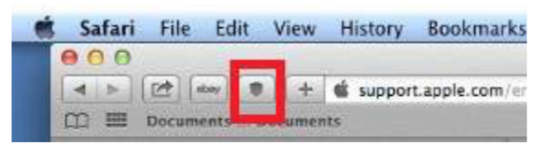
Figure 24 – Screenshot of Safari with Compliance Deputy toolbar icon
- Click on the toolbar button to display the options and configuration menus.
- From the Compliance Deputy dropdown list, select Load configuration.
- A new browser tab will be displayed to allow you to load the configuration file.
- Click Browse and select the configuration file e.g. ComplianceDeputy.config, that was created from Compliance Sheriff and made available to the users.
- Cick Upload.
- After the installation completes, the following changes need to be made to the IIS settings before a scan can be
run:
  - Open IIS.
  - Select ComplianceSheriff website.
  - Open Request Filtering and click HTTP Verbs.
  - Add new Verb "OPTIONS" by clicking Allow Verb.
  - Open Handler Mapping.
  - Click View Ordered List.
  - Find and select "OPTIONSVerbHandler".
  - In Actions pane, click Move UP until "OPTIONSVerbHandler" is at the top.
  - Restart Server.
- Compliance Deputy is now configured and you can start scanning public pages.
NOTE. In Safari, under Preferences>Security, the option to Block pop-up windows must be turned off (clear the check box) to display the scan results.
LOCAL SCAN AGENT
The Compliance Sheriff Local Scan Agent is not available for Safari. Support for the Local Scan Agent on Safari will be reviewed in future releases. As a consequence, the following features are not available for Deputy on Safari:
- Scanning of content required by the loaded page that is inaccessible from the remote worker server, such as CSS files stored on the local machine that is referenced by the loaded page.
- Display of <client machine>\<username> in the Show Usage screen in the Compliance Sheriff Admin tab.
Mozilla Firefox
Compliance Deputy is available as an extension to Firefox.
To add the extension:
- Ensure you have access to the location where the Compliance Deputy configuration file and the zip file containing the Deputy extension (see Creating, editing and deploying configuration files).
- Close all Firefox sessions.
- From the Compliance Deputy installers zip file, extract the Firefox extension "Firefox_ComplianceDeputy.xpi" into a folder in your PC client.
- Start Firefox and install the Compliance Deputy extension file (Open Menu>Add Ons>Extensions>Tools>Install Add-on From File).
- Compliance Deputy should now be available in the toolbar.
- Click on the toolbar icon to display the options and configuration menus.
- From the Compliance Deputy drop down list, select "Load configuration".
- A new browser tab is displayed to allow you to load the configuration file. In this browser tab, along with the option to load a config file, one more option is given to enter the username which will be displayed under show usage.
- Click on Browse and select the configuration file eg "ComplianceDeputy.config" that was created from Compliance Sheriff and made available to the users.
- Once selected, click Upload.
- After the installation completes, the following changes need to be made to the IIS settings before a scan can be run:
  - Open IIS.
  - Select ComplianceSheriff website.
  - Open "Request Filtering" and click "HTTP Verbs".
  - Add new Verb "OPTIONS" by clicking on "Allow Verb".
- Open Handler Mapping.
- Click "View Ordered List".
- Find and select "OPTIONSVerbHandler".
- Click "Move UP" in Actions pane until "OPTIONSVerbHandler" is at the top.
- Restart Server.
12. Compliance Deputy is now configured and you can start scanning public pages.

Configuring and managing Compliance Deputy installations
This topic is intended for department administrators. You must be a member of a group authorized for "Editing of custom dictionaries, user variables etc. permitted" to configure Compliance Deputy (see Groups subtab). For information on using Compliance Deputy, see Scanning the current browser page.
Related topics
...Installing and configuring Compliance Deputy ...Scanning the current browser page

Creating, editing and deploying configuration files
The Compliance Deputy configuration file contains the required settings for:
- Connection to the Compliance Sheriff instance.
- Checkpoint groups that can be selected when performing a scan.
- The default Scan Group that the scan belongs to.
You can either upload and edit an existing configuration file or create a new configuration file. To deploy, save or copy the configuration file to a network share location accessible to users.
You can create one or multiple configuration files, which can be loaded as required by users. If only one configuration is required, use the default file name ComplianceDeputy.config. If this file is found in the installation folder where the installer is run, it is loaded automatically.
If multiple configurations are required, create a different configuration file for each type of content, user or audience. For example, you might create different configurations for internal and public audiences, named ComplianceDeputyInternal.config and ComplianceDeputyPublic.config. When working on public pages, users can load the public configuration, and then switch back to the internal configuration for corporate intranet pages.
For more information on how users load a configuration file, see Scanning the current browser page.
NOTE. If the default configuration file ComplianceDeputy.config is found in the installation folder, it is automatically loaded. Compliance Deputy can be installed without a configuration file and then loaded later from the toolbar.

To create a new configuration file:
NOTE. To perform this task, the logged-in user must be a member of a Compliance Sheriff group with the option Editing of custom dictionaries, user variables etc. permitted selected.
- Log in to Compliance Sheriff.
- From the Settings tab, click Compliance Deputy.
- On the Configuration tab, under Checkpoint Groups, select or clear the checkpoint groups that users will be able to select in a Quick Start scan.
  - Use the Search tool to filter the list. The list updates as you type.
  - Select Show selected only to show only the selected checkpoint groups.
  - Select Show all subgroups to show subgroups containing checkpoint groups.
- In the Scan Group box, select the scan group the scans will belong to. If a scan group is not selected, the scans will not be associated with the <Temporary Scans> group. The Temporary Scans group is also the default group for Quick Scans.
NOTE. Deputy scans are considered "Temporary scans". By default, they will not be displayed in the scan list (even when selecting "--All--" in the Scan group filter). To display the Deputy scans, change the scan group filter.
- Click Save. When prompted, select Save As, navigate to the folder where the configuration file will be stored, edit the file name if required, and click Save on the Save As dialog box.
To upload and edit an existing configuration file:
- From the Settings tab, click Compliance Deputy.
- Select the Configuration tab.
- Next to the Config file box, click Choose File, navigate to the location where the configuration file is stored, select the file, and click Open.
- On the Configuration tab, click Load. The configuration details are displayed.
- To add and remove checkpoint groups, make your selections in the Checkpoint Groups box.
- To change the scan group the scans belong to, click the Scan Group box and select a different scan group.
- Click Save. When prompted, select Save As, navigate to the folder where the configuration file will be stored, edit the file name if required, and click Save on the Save As dialog box.
To deploy the application (installer and configuration file) to a network share:
- From the Settings tab, click Compliance Deputy.
- Select the Installer tab.
- Click Download and select the network share location where the installer will be copied to, and save the file to that folder.
- Copy the required configuration file or files to the same location where the installer file was downloaded to in the previous step (see Creating, editing and deploying configuration files).
5. Users can then download the installation files and install on their local machine.

Managing Compliance Deputy installations
Scans submitted by Compliance Deputy are ad hoc and managed with a subset of the tools used to manage Compliance Sheriff scans, including:
NOTE. Compliance Deputy users do not need to be registered as Compliance Sheriff users.
- The scan group (see Organizing scans into groups) is set in the configuration file (see Creating, editing and deploying configuration files). If a scan group is not specified in the configuration file, the scans can be viewed by selecting <Temporary Scans> in the Scan Group filter on the Scans tab.
- Timeout, retries, page size and other scan settings are set from System Configuration on the Settings tab. NOTE that these are systemwide settings and not specific to Compliance Deputy.
- To change the scan result deletion age, see the “Scanner settings” topic under System configuration.
- Usage data (scans performed, base URL, start and finish date/time, pages scanned, checkpoints used, user that
submitted the scan) can be viewed from Show usage on the Admin tab (see below).
- If Compliance Sheriff has been upgraded from an earlier version, the user may be prompted to log in to Compliance Sheriff when attempting to open the scan results. To allow anonymous users to run ad hoc scans and view the results, you will need to modify the Compliance Sheriff web.config file (see below).
- When a page scan is submitted by Compliance Deputy, Compliance Sheriff will scan the page against the checkpoint group(s) selected. Compliance Sheriff will then wait for a set period for the scan to be completed before submitting the result back to Compliance Deputy. This timeout period ensures that Compliance Deputy does not wait indefinitely should a delay occur in Compliance Sheriff. By default, this timeout period is set to 180 seconds. This can be increased or reduced (see below).
- By default, temporary scans (Deputy and Quick Start scans) older than 10 minutes from the time of the new scan, will be deleted. This default can be changed (see below).
To allow anonymous access to scan results:
  - Go to the Compliance Sheriff Web Front End (WFE) installation directory e.g. C:\Program Files (x86)\Cryptzone\Compliance Sheriff\web.
  - Edit Web.config and insert the following after </system.web>:
<location path="ShowResults.aspx"> <system.web>
<authorization>
<allow users="*" /> </authorization>
</system.web> </location>
To change the scan timeout:
- In the server where the Controller for Compliance Sheriff is installed, locate and edit the Compliance Sheriff configuration file C:\programdata\Cryptzonee\ComplianceSheriff\Customers\<Customername>\ ComplianceSheriff.config.xml.
- Under the <appSettings> group, insert the following:
<add key="SinglePageScanMaxSecondsToWait" value="x" />
Where x = timeout in seconds (default is 180 seconds)
Once entered, the field will be available in Compliance Sheriff under Settings>System Configuration>Web
Application Settings.
To change the retention period of Deputy scans:
NOTE. Deputy scans are temporary. To preserve these scans, ensure that the configuration file specifies a scan group.
- In the server where the Controller for Compliance Sheriff is installed, locate and edit the Compliance Sheriff configuration file C:\programdata\Cryptzone\ComplianceSheriff\Customers\<Customername>\ ComplianceSheriff.config.xml.
- Under the <appSettings> group, insert the following:
<add key="DeleteAdhocScansOlderThan" value="x" />
Where x = scan age in seconds (default is 600 seconds), 0 = Do not delete
Once entered, the field will be available in Compliance Sheriff under Settings>System Configuration>Web
Application Settings.
Tip. For troubleshooting purposes, if a Deputy scan is aborted, use the above setting to preserve the scan and its results while working with Cryptzone support to identify the issue. Alternatively, when a scan is aborted, click on its status then "Export files" to package up the scan definition, which will include the scan log file and resources used by the scan.
Related topics
...Creating, editing and deploying configuration files ...Installing and configuring Compliance Deputy ...Installation requirements
...Scanning the current browser page

Upgrading Compliance Deputy
If you are currently using an older version of Compliance Deputy, this version needs to be disabled or removed prior to downloading and installing a later version.
INTERNET EXPLORER
The installer for Compliance Deputy will automatically check the version currently installed. If found, it will automatically uninstall it, then proceed with installing the new version. NOTE that in version Compliance Deputy 4.2, the default install directory was "...\HiSoftware". This has been change to make the default directory to "Cryptzone".
These browsers were not supported in Compliance Deputy v4.2.
CHROME, SAFARI AND FIREFOX

