CSUN Pollinator Habitat Plan
March 2020

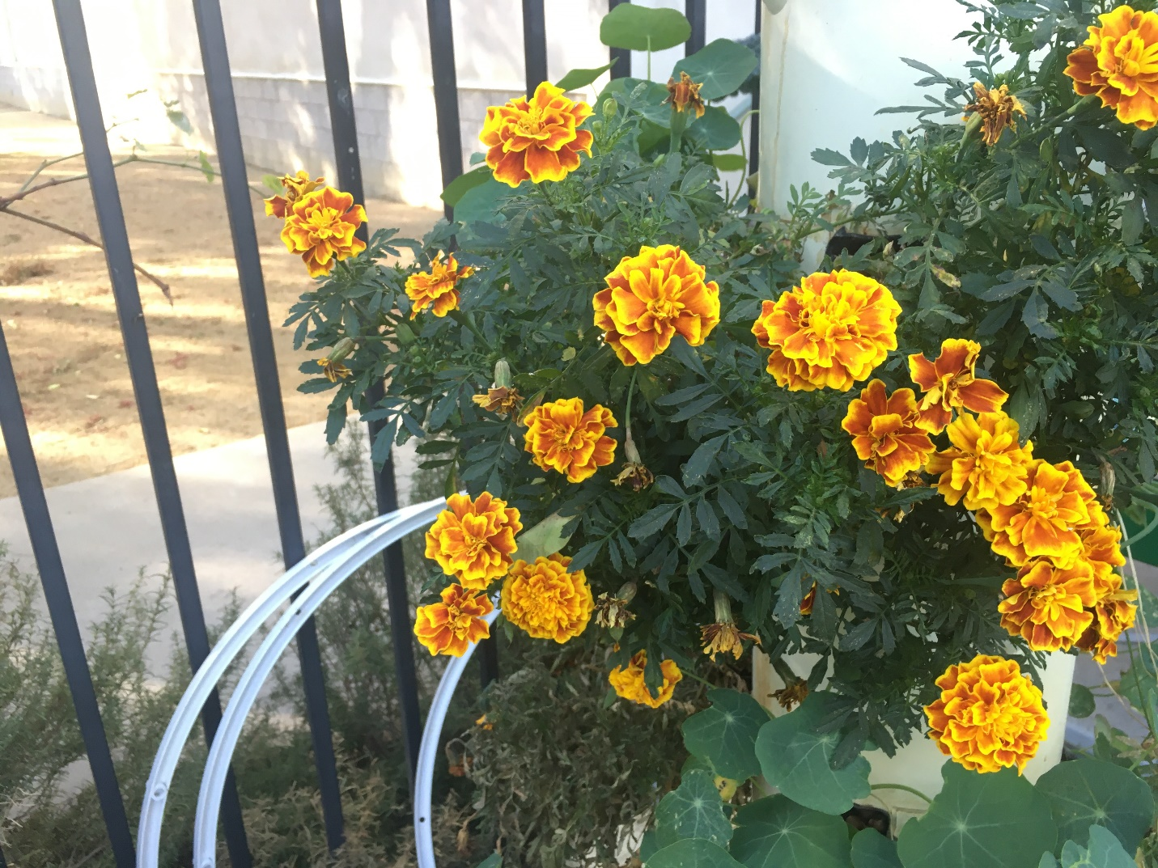
Part of any University’s responsibility to adapt to a changing climate includes keeping its environmental impact to a minimum and contributing to a balanced local ecosystem however possible. The cultivation of a landscape that supports pollinators and preserves local biodiversity is an essential part of that process. Pollinators are a vital element of ecosystems worldwide, as they are necessary for the reproduction of 75% to 95% of the earth’s flowering plants¹. This means that pollinators are instrumental in agricultural productivity, contributing to the growth of about a third of the food we eat daily². Yet, pollinator populations are declining worldwide, largely due to habitat loss and pesticide use².
California State University Northridge is committed to improving the health and habitat of local pollinator populations. Since 2013, CSUN has replanted over 400,000 square feet of landscaping throughout the campus, making much of CSUN’s grounds more attractive to pollinators and more drought resistant. CSUN is located in a dry, mild climate, with much less rainfall than the United States average, and native plant species are more likely to thrive in drought conditions and use less water overall. These plants are also often the best sources of nectar and pollen for local pollinators³. Many insects and birds have evolved alongside their native plants, creating dependent relationships between certain species, where the livelihood of one becomes reliant on the other. Therefore, incorporating native plants into CSUN’s landscape promotes a healthy ecosystem and helps to preserve local biodiversity. Additionally, they require less water, fertilizer, and overall maintenance, as they are already adapted to the Southern California climate and will thrive on the University grounds.
CSUN’s plans to continue expanding its pollinator habitats by increasing the number and diversity of flowering plants across campus. Cultivating a variety of plants that flower during different times of the year will ensure that pollinators can find food year-round. These efforts will also help CSUN continue to save water by reducing the amount of water-intensive plants on
campus. Additionally, areas designated as pollinator habitats will be identified as such, and protected from pesticide applications.
A list of plants has been created below that includes information about their blooming season and what wildlife they support. Most of the plants listed are native to the Southern California area and all are pollinator-friendly. If they are present on the CSUN campus, their location is indicated. In addition to the plants listed here, there is a pollinator and a food garden on campus that both contain a plethora of flowering plants that require pollination. Some are listed here, indicated by point 26, but due to the density and high volume of species in the relatively small area, not every species could be included. Some examples are milkweed, lavender, lime, basil, and mint. Overall, this list can be utilized by gardeners at any scale in order to create a valuable habitat that supports local pollinators.

Common Name | Scientific Name | Currently On Campus  Y/N | Location | Bloom | Wildlife Value
Fiddleneck | Amsinckia menziesii | No |  | Late spring/early summer | Birds
Chia | Salvia columbariae | No |  | Spring/summer | Birds
Yarrow | Achillea millefolium | Yes | 10, 11, 27 | Spring, summer, and early fall | Birds and butterflies
Creeping barberry | Berberis aquifolium var. repens | No |  | Spring/summer | Birds
Strawberry | Fragaria | No |  | Spring/early summer | Birds
Quail bush | Atriplex lentiformis ssp. breweri | No |  | Summer/fall | Birds
Nevin’s barberry | Berberis nevinii | No |  | Spring | Birds
Redberry and coffeeberry | Frangula and rhamnus | No |  | Spring | Birds
Toyon | Heteromeles arbutifolia | No |  | Summer/fall | Birds
Laurel Sumac | Malosma laurina | Yes | 5 | Late spring/summer | Insects, butterflies, and birds
Cherry | Prunus | No |  | Spring | Birds
Currant, gooseberry | Ribes | No |  | Spring/summer | Birds
Wild rose | Rosa | No |  | Summer | Birds
Sage | Salvia variations | Yes | 14, 26, 17, 15, 16, 13, 8, 4, 2, 3 | Spring | Birds, hummingbirds, bees, and butterflies
Snowberry | Symphoricarpos | No |  | Summer | Birds
Twinberry honeysuckle | Lonicera | No |  | Spring/summer | Birds
Blackberry, salmonberry, and thimbleberry | Rubus | No |  | Summer | Birds
Wild grape | Vitis | No |  | Summer | Birds
Southern California black walnut | Juglans californica | No |  | Spring | Birds
Oak | Quercus agrifolia | Yes | 10 | Spring | Insects, birds, and butterflies
Elderberry | Sambucus nigra spp. caerulea | No |  | Late spring/early summer | Insects and birds
Western columbine | Aquilegia formosa | No |  | Spring | Hummingbirds
Mahonia | Berberis | No |  | Spring | Hummingbirds
Red fairyduster | Calliandra californica | No |  | Year round | Hummingbirds and butterflies
California thistle | Cirsium occidentale | No |  | Spring | Hummingbirds
Summer holly | Comarostaphylis diversifolia | No |  | Late spring/early summer | Hummingbirds
Live forever | Dudleya | No |  | Late spring/early summer | Hummingbirds
Galvezia | Gambelia | No |  | Spring/summer/fall | Hummingbirds
Coral bells, alum root | Heuchera | No |  | Spring | Hummingbirds
Bladderpod | Peritoma (Isomeria) arborea | No |  | Spring/summer | Hummingbirds
Heart-leaf penstemon | Keckiella cordifolia | No |  | Late spring/early summer | Hummingbirds
Honeysuckle | Lonicera hispidula, L. subspicata | No |  | Spring | Hummingbirds
Sticky monkeyflower | Mimulus aurantiacus | No |  | Spring | Hummingbirds and butterflies
 | Penstemon | Yes | 27 | Spring | Hummingbirds
Currant and gooseberry | Ribes | No |  | Spring/Winter | Hummingbirds
Woolly blue curls | Trichostema lanatum | No |  | Spring | Hummingbirds
Chaparral snapdragon | Antirrhinum multiflorum | No |  | Summer | Hummingbirds
Zauschneria | Epilobium | No |  | Late summer/fall | Hummingbirds
Desert willow | Chilopsis linearis | Yes | 10, 26 | Summer | Hummingbirds
Hedge nettle | Stachys | No |  | Summer | Hummingbirds
Manzanita | Arctostaphylos | No |  | Early fall/winter/spring | Birds, hummingbirds, bees, and butterflies
Deerweed | Acmispon glaber | No |  | Spring/summer | Butterflies
Chamise, redshanks | Adenostoma | No |  | Summer | Butterflies
California buckeye | Aesculus californica | No |  | Late spring/early summer | Butterflies
Agave | Agave | No |  | Summer | Butterflies
White alder | Alnus rhombifolia | No |  | Fall | Butterflies
False indigo | Amorpha californica | No |  | Late spring/early summer | Butterflies
Madrone | Arbutus menziesii | No |  | Spring | Butterflies
Milkweed | Asclepias | Yes | 27 | Spring/ summer | Butterflies
Locoweed | Astragalus | No |  | Summer/fall | Butterflies
Desert marigold | Baileya multiradiata | No |  | Spring, summer, and fall | Butterflies
Coyote brush | Baccharis pilularis | No |  | Summer/early fall | Butterflies
California Lilac | Ceanothus | No |  | Spring | Butterflies, birds, and bees
Mountain mahogany | Cerocarpus betuloides | No |  | Spring/summer | Butterflies
Cobweb thistle | Cirsium occidentale | No |  | Late winter, spring, summer, and fall | Butterflies
Sacred datura, jimson weed | Datura wrightii | No |  | Summer/fall | Butterflies
California bush sunflower | Encelia californica | No |  | Spring/summer | Butterflies, insects, and bees
Seaside daisy | Erigeron | No |  | Late spring, summer, and early fall | Butterflies
California fuchsia | Epilobium | Yes | 13, 16, 5, 10 | Late summer/fall | Butterflies
 | Ericameria | No |  | Summer/fall | Butterflies
Yerba santa | Eriodictyon | No |  | Spring | Butterflies
California buckwheat | Eriogonum fasciculatum | Yes | 14, 26, 13, 8 | Spring, summer, and fall | Butterflies and bees
Coast buckwheat | Eriogonum parvifolium | No |  | Year round | Butterflies and bees
Coffeeberry | Frangula californica | No |  | Spring | Butterflies and birds
Common sunflower | Helianthus annuus | No |  | Summer/fall | Butterflies and bees
Chaparral yucca | Hesperoyucca whipplei | No |  | Early summer | Butterflies
Lupine | Lupinus | No |  | Spring/summer | Butterflies
Four o’clock | Mirabilis | No |  | Summer | Butterflies
Coyote mint | Monardella | No |  | Summer | Butterflies and bees
Evening primrose | Oenothera | Yes | 4 | Summer | Butterflies
Western sycamore | Platanus racemosa | No |  | Spring | Butterflies and hummingbirds
Grass family | Poaceae | No |  |  | Butterflies
Willow | Salix | Yes | 26 | Spring | Butterflies
Goldenrod | Solidago | No |  | Fall | Butterflies
Lilac verbena | Verbena lilacina | No |  | Spring/summer | Butterflies
Stinging nettle | Urtica dioica | No |  | Summer/early fall | Butterflies
Elegant clarkia | Clarkia unguiculata | No |  | Early summer | Bees
California poppy | Eschscholzia californica | No |  | Late winter, spring, summer, fall | Bees
Globe gilia | Gilia capitata | No |  | Late spring | Bees
Tidy tips | Layia platyglossa | No |  | Spring/early summer | Bees
Arroyo lupine | Lupinus succulentus | No |  | Late winter, spring, early summer | Bees
Lindley’s blazing star | Mentzelia lindleyi | No |  | Late spring/early summer | Bees
Baby blue eyes | Nemophila menziesii | No |  | Late winter, spring, early summer | Bees
Tansy-leaved phacelia | Phacelia tanacetifolia | No |  | Spring | Bees
Morning glory | Calystegia macrostegia | No |  | Spring/summer | Bees
Showy penstemon | Penstemon spectabilis | No |  | Spring/early summer | Bees
Blue witch | Solanum xanti | No |  | Late winter, spring, early summer | Bees
Apricot mallow | Sphaeralcea ambigua | No |  | Late winter, spring, summer, fall | Bees
Barberry | Berberis aquifolium, b. nevinii | No |  | Spring | Bees and birds
California flannelbush | Fremontodendron californicum | Yes | 13, 12, 9, 14 | Early summer | Bees, birds, butterflies
Toyon | Heteromeles arbutifolia | No |  | Summer/early fall | Bees and birds
Western redbud | Cercis occidentalis | No |  | Spring | Bees
Palo verde | Parkinsonia florida, p. microphylla | Yes | 25, 28, 17, 19, 16, 10 | Spring | Bees
Santa Cruz Island ironwood | Lyonothamnus floribundus ssp. aspleniifolius | No |  | Early summer | Birds
Holly-leaf cherry, catalina cherry | Prunus ilicifolia ssp. Ilicifolia, p. Ilicifolia ssp. lyonii | No |  | Spring | Birds
Hot lips sage | Salvia microphylla | Yes | 1, 5, 6, 10, 23, 15, 27 | Summer/fall | Butterflies and hummingbirds
Jerusalem sage | Phlomis fruticosa | Yes | 1, 10, 13, 11, 23, 18 | Spring | Bees and insects
Red yucca | Hesperaloe parviflora | Yes | 1, 11 | Spring/summer | Hummingbirds and insects
Salvia clevelandii | Blue sage | Yes | 1, 27, 22, 13 | Spring/summer | Bees
Little John bottlebrush | Dwarf callistemon | Yes | 2, 3, 4 | Year round | Bees, birds, hummingbirds, and butterflies
California sundrop | Calylophus drummondii | Yes | 2, 3 | Spring/summer | Bees
St. Catherine’s lace | Eriogonum giganteum | Yes | 26, 9, 8, 4 | Summer/early fall | Bees and butterflies
Germander sage | Salvia chamaedryoides | Yes | 10, 11, 13 | Year round | Bees
Pink dawn | Chitalpa tashkentensis | Yes | 1, 2, 24, 27, 12 | Spring/summer | Hummingbirds, birds, bees, and butterflies
Rosemary | Rosmarinus officinalis | Yes | 1, 4, 28, 27, 19, 22, 8 | Winter/spring | Bees
Crapemyrtle | Lagerstroemia indica | Yes | 16, 22, 13, 9, 10, 7, 5, 8, 18 | Summer | Bees and birds
Bird of paradise | Strelitzia reginae | Yes | 8, 23, 19, 18 | Fall, winter, and spring | Birds
Butterfly bush | Buddleia | Yes | 6, 19 | Late spring/summer | Butterflies
 | Lantana | Yes | 17, 27, 28, 16, 4, 2, 3, 23 | Year round | Butterflies and hummingbirds
Lion’s tails | Leonotis leonurus | Yes | 15, 16, 1 | Late spring, summer, and fall | Birds, butterflies, and hummingbirds
 | Bougainvillea | Yes | 23, 21 | Spring and fall | Butterflies, insects, and hummingbirds
Jacaranda tree | Jacaranda mimosifolia | Yes | 2, 3, 26 | Late spring/early summer | Bees
Natal plum | Carissa macrocarpa | Yes | 2, 3, 18 | Year round | Bees and birds
 | Hibiscus | Yes | 1, 18 | Summer | Bees, birds, and hummingbirds
Black and blue salvia | Salvia guaranitica | Yes | 4 | Summer/fall | Bees and hummingbirds
Yellow bells/Bells of fire | Tecoma stans | Yes | 19, 11, 16, 6, 15 | Spring, summer, fall | Butterflies, bees, and hummingbirds
California pepper tree | Schinus molle | Yes | 16, 13 | Summer | Bees
Autumn sage | Salvia greggii | Yes | 13 | Spring, summer, and fall | Bees, butterflies, and hummingbirds
California white sage | Salvia apiana | Yes | 5 | Spring/early summer | Bees
Orchid tree | Bauhinia variegata | Yes | 22 | Late winter, spring, and early summer | Bees
Sapphire showers | Duranta erecta | Yes | 6 | Summer | Butterflies, bees, and birds
American century plant | Agave americana | Yes | 10, 11, 1, 4, 15, 28 | Summer | Hummingbirds, insects, and birds
Blue flame agave | Agave shawii x attenuata | Yes | 11 | Summer | Hummingbirds
 | Rosa ‘red ribbons’ | Yes | 13, 22, 10, 11, 23, 16, 17 | Spring, summer, and fall | Bees
Rock rose | Cistus palhinhae | Yes | 15, 4, 2, 3 | Spring/summer | Bees and butterflies
Sweet acacia | Vachellia farnesiana | Yes | 17 | Late winter/spring | Bees, insects, and birds
Orange | Citrus X sinensis | Yes | 20 | Winter and spring | Bees
 | Echium | Yes | 19 | Spring/summer | Bees and butterflies
 | Magnolia | Yes | 16 | Spring/early summer | Bees and insects
Passion flower | Passiflora edulis | Yes | 24 | Spring/summer | Bees
Kangaroo paw | Anigozanthos | Yes | 15 | Spring/summer | Birds
 | Myoporum | Yes | 9 | Spring/summer | Bees
Society garlic | Tulbaghia violacea | Yes | 13 | Summer/fall | Butterflies and bees
Yankee point California lilac | Ceanothus griseus var. horizontalis | Yes | 10 | Spring | Bees and butterflies
Tipu tree | Tipuana tipu | Yes | 13 | Summer | Bees, butterflies, and hummingbirds
Marguerite daisy | Argyranthemum frutescens | Yes | 6 | Summer | Butterflies
French lavender | Lavandula stoechas | Yes | 13, 12 | Summer/early fall | Bees, butterflies, and hummingbirds

Location Guide
Parking lots B1 and B2 - 1
Parking structure B3 - 2
Parking lot B4 - 3
University Hall - 4
Extended University Commons - 5
Parking structure and lot B5 - 6
Parking lot B6 - 7
Physical Plant Management - 8
Art and Design Center and Central Plant - 9
Charles H. Noski Auditorium - 10
Education and Bookstien Hall Complex - 11
Jacaranda Hall - 12
Lilac Hall - 12
Matador Hall - 14
Delmar T. Oviatt Library - 15
Sequoia Hall - 16
Sierra Quad - 17
Cypress Hall and Nordhoff Hall - 18
The Soraya - 19
Orange Grove - 20
Jeanne Chisholm Hall - 21
Parking structure G3 - 22
Arbor Court - 23
Greenhouse - 24
Sustainability Center - 25
Redwood Hall - 26
Food and Pollinator Garden - 27
Student Housing - 28

Parking lots B1 and B2 - 1
- Lion’s tail
- Salvia hot lips
- Jerusalem sage
- Salvia clevelandii
- Red Yucca
- Agave
- Hibiscus
- Chitalpa trees
- Rosemary

Parking structure B3 - 2
- California sundrops
- Yellow lantana
- Salvia
- Little john
- Natal plum
- Jacaranda tree
- Rock rose
- Chitalpa trees

Parking lot B4 - 3
- California sundrops
- Yellow lantana
- Salvia
- Little john
- Natal plum
- Jacaranda tree
- Rock rose

University Hall - 4
- Rosemary
- Rock rose
- Salvia
- Agave
- Little john
- Eriogonum giganteum
- Salvia guaranitica
- Evening primrose

Extended University Commons - 5
- Germander sage
- Salvia hot lips
- Laurel sumac
- Crapemyrtle
- Salvia apiana
- California fuschia

Parking structure B5 - 6
- Butterfly bush
- Marguerite daisy
- Tecoma stans
- Sapphire showers

Parking lot B6 - 7
- White lantana

Physical Plant Management - 8
- Crapemyrtle
- Rosemary
- Eriogonum giganteum
- Eriogonum fasciculatum
- Bird of paradise

Art and Design Center and Central Plant - 9
- Eriogonum giganteum
- Crapemyrtle
- Myoporum
- California flannelbush

Charles H. Noski Auditorium - 10
- Jerusalem sage
- Agave americana ‘variegata’
- California fuschia
- Rosa ‘red ribbons’
- Hot lips sage
- Palo verde
- Crapemyrtle
- Germander sage
- Desert willow
- Yankee point California lilac
- Yarrow

Education and Bookstien Hall Complex - 11
- Tecoma stans
- Jerusalem sage
- Germander sage
- Red yucca
- Blue flame agave
- Yarrow
- Hot lips sage
- Rosa ‘red ribbons’
- Agave americana ‘variegata’

Jacaranda Hall - 12
- Salvia clevelandii
- Salvia greggii
- Society garlic
- California flannelbush
- Chitalpa tashkentensis
- French lavender

Lilac Hall - 13
- French lavender
- Salvia clevelandii
- Salvia greggii
- Society garlic
- California flannelbush
- Eriogonum fasciculatum
- Jerusalem sage
- Tipu tree
- Crapemyrtle
- California fuschia
- Germander sage
- Rosa ‘red ribbons’
- California pepper tree

Matador Hall - 14
- Salvia
- California flannelbush
- Eriogonum fasciculatum

Delmar T. Oviatt Library - 15
- Salvia
- Agave
- Salvia hot lips
- Lion’s tail
- Kangaroo paw
- Tecoma stans
- Rock rose

Sequoia Hall - 16
- Rosa ‘red ribbons’
- Lion’s tail
- Tecoma stans
- California pepper tree
- Magnolia
- Palo verdes
- Crapemyrtle

Sierra Quad - 17
- Sweet acacia
- Salvia
- White lantana
- Rosa ‘red ribbons’
- Palo verdes

Cypress Hall and Nordhoff Hall - 18
- Crapemyrtle
- Bird of paradise
- Jerusalem sage
- Natal plum
- Hibiscus

The Soraya - 19
- Tecoma stans
- Palo verde
- Bird of paradise
- Rosemary
- Butterfly bush
- Echium

Orange Grove - 20
- Orange trees

Jeanne Chisholm Hall - 21
- Bougainvillea

Parking structure G3 - 22
- Rosemary
- Salvia clevelandii
- Orchid tree
- Crapemyrtle
- Rosa ‘red ribbons’

Arbor Court - 23
- Bougainvillea
- Jerusalem sage
- Bird of paradise
- Salvia hot lips
- White lantana
- Rosa ‘red ribbons’

Greenhouse - 24
- Passion flower
- Chitalpa tashkentensis

Sustainability Center - 25
- Palo verde

Redwood Hall - 26
- Salvia
- Jacaranda tree
- Willow
- Desert willow
- Eriogonum fasciculatum
- Eriogonum giganteum

Food and Pollinator Garden - 27
- Many species

Student Housing - 28
- Palo verde
- Rosemary
- Yellow lantana
- Agave americana

