2018-2019 Annual Program Assessment Report
Please submit report to your department chair or program coordinator, the Associate Dean of your College, and to james.solomon@csun.edu, Director of the Office of Academic Assessment and Program Review, by September 28, 2018. You may, but are not required to, submit a separate report for each program, including graduate degree programs, which conducted assessment activities, or you may combine programs in a single report. Please identify your department/program in the file name for your report.
College: MCCAMC
Department: Art
Program: B.A.
Assessment liaison: Magdy Rizk
- Please check off whichever is applicable:
A. X Measured student work within program major/options.
B. X Analyzed results of measurement within program major/options.
C. X Applied results of analysis to program review/curriculum/review/revision major/options.
D. X Focused (NOT exclusively) on the direct assessment measurement of General Education Arts and Humanities learning outcomes
- Overview of Annual Assessment Project(s). On a separate sheet, provide a brief overview of this year’s assessment activities, including:
- an explanation for why your department chose the assessment activities (measurement, analysis, application, or GE assessment) that it enacted
- if your department implemented assessment option A, identify which program SLOs were assessed (please identify the SLOs in full), in which classes and/or contexts, what assessment instruments were used and the methodology employed, the resulting scores, and the relation between this year’s measure of student work and that of past years: (include as an appendix any and all relevant materials that you wish to include)
- if your department implemented assessment option B, identify what conclusions were drawn from the analysis of measured results, what changes to the program were planned in response, and the relation between this year’s analyses and past and future assessment activities
- if your department implemented option C, identify the program modifications that were adopted, and the relation between program modifications and past and future assessment activities
- if your program implemented option D, exclusively or simultaneously with options A, B, and/or C, identify the basic skill(s) assessed and the precise learning outcomes assessed, the assessment instruments and methodology employed, and the resulting scores
- in what way(s) your assessment activities may reflect the university’s commitment to diversity in all its dimensions but especially with respect to underrepresented groups
- any other assessment-related information you wish to include, including SLO revision (especially to ensure continuing alignment between program course offerings and both program and university student learning outcomes), and/or the creation and modification of new assessment instruments
3. Preview of planned assessment activities for 2018-19. Include a brief description as reflective of a continuous program of ongoing assessment.
2. Overview of Annual Assessment Project(s).
Explanations: Summaries
GE Arts and Humanities
The Department of Art was charged to conduct an assessment project for the GE: Arts and Humanities courses, using direct assessment. Initially, seven courses in the BA program were identified for assessment. Whenever possible, the assignment samples were collected from courses in which the faculty of record was a full-time professor. The Art assessment committee met and discussed strategies in the approach and logistics to these projects, deciding to assess six of the seven courses - in addition to being GE courses, they had significant weight regarding student success within the BA program. Both written and visual samples were collected from each course, resulting in a wide range of sample assignments. (See Section 1 below.)
Upper Division Assessment: Closing the Loop
This Upper Division assessment project conducted in 2017-2018 demonstrated gaps that required discussion with faculty teaching in those areas of the BA program, in order to “close the loop”. The Art Assessment Liaison met with participating areas and shared the findings of that assessment. The project measured critical thinking for different types of media including illustration, photography, graphic design, and writing for art history. Areas that participated in the project received the results positively and are now in the process of remedying the deficits found in the study (see section C below for more detail on addressing these gaps).
Student Success: DFU Rates
In pursuing the department’s task of addressing the high DFU rates in our lower division Art History courses (Art 110, Art 112, Art 114), a Faculty Learning Community (FLC) was formed, with an invitation to all full-time instructors teaching these courses. After monthly meetings in Spring ‘18, the faculty devised pedagogical and procedural solutions to implement in the Fall ’18 semester for these courses. Data was collected at the end of the Fall 2018 semester to determine the effectiveness of these pedagogical changes in the lower division Art History courses; the implementation of these pedagogical and procedural changes have resulted in some improvement in performance. (see Attachment 4).

1. GE Assessment: Arts and Humanities Project
A: Measured student work within program major/options
As described above, Art was required to be part of 2018-2019 GE assessment in the area of Arts and Humanities. This endeavor also tied-in to the 2025 student success initiative on campus, as our lower division GEs are in need of continued scrutiny due to high DFU rates and large opportunity gaps. Two of the assessment committee members are also on the MCCAMC Student Success committee from Art History; they were part of a year-long Faculty Learning Community in 2018-19, that discussed various interventions in the classes listed below. We hope to bring these issues forward to integrate with assessment activities even further. Again, of particular interest was the lower division Art History Courses (Art 110, Art 112, and Art 114). The rubric (see Attachment 1) was developed and finalized in Spring 2019, to measure SLOs 2 and 6 from the University GE program (below), which smoothly aligned with the department SLOs 4 and 5.

Assessment Methods - Selected SLOs and Courses:
GE SLOs #2 & #6.
2. Students will be able to analyze, interpret, and reflect critically upon ideas of value, meaning, discourse and expression from a variety of perspectives from the arts and/or humanities;
6. Students will be able to describe and explain the historical and/or cultural context within which a body of work was created or a tradition emerged. (Attachment 2)
Art Department SLOs 4 & 5:
4. Students will utilize and apply critical thinking skills to communicate ideas for their intended audience at a competent level in visual, oral, and written formats.
5. Students will acquire historical and contemporary knowledge of diverse cultural and aesthetic contexts, including political, visual and material culture.
Rubric and Scoring Process:
After finalizing the rubric, the committee found the instrument viable and scored 8 student works from each of 6 GE Arts and Humanities courses, including Art 110: The World Arts, Western Tradition; Art 114: World Arts, Asia; Art 124A: Drawing I ; Art 140: Beginning Two-Dimensional Design; Art 141: Beginning Three-Dimensional Design; and Art 305: Art and Mass Culture, totaling 48 student works for the final sample. As mentioned in the previous year’s report, the committee planned to collect and assess additional work from Art 112 and Art 151 to collect data and address high DFU rates, however decided it would be too taxing due to time constraints, and 151 will be assessed when assessment for GE Lifelong Learning comes due.
Scoring the final sample of student work (48 pieces), the committee found consensus with scores and exemplars. One of the members recused themselves from scoring a set of projects that were collected from their own course (1 from Art History). That faculty member did explain the goals and context of some projects with the committee at the time of scoring. The diverse art knowledge and group discussions of the 4 committee members helped clarify the intentions of all the projects, giving the scoring process and results more weight and validity. This process is our standard scoring procedure.
B: Analyzed results of measurement within program major/options
The Assessment Committee discussed the results of our scoring and found several aspects that could lead to further investigation. Again, one committee member was not involved in scoring the written work from the Art History course, as that person was the instructor of record for that project, but they provided context and explanation where needed during committee discussions.
The results from scoring the final sample are the following (Attachment 3):
- The overall score for the entire sample set of 48 student works (all courses and rubric categories) resulted in an average of 3.0 out of 4 (75%).
- The highest course scores were found in the subset from Art 114, resulting in an average of 3.33 out of 4 (83%).
- The lowest course scores were found in the subset from Art 124A, resulting in an average of 2.64 out of 4 (66%).
- The highest rubric category scores for the entire sample set of 48 student works were found in the area of Communication, resulting in an average of 3.02 out of 4 (75%).
- The lowest rubric category scores for the entire sample set of 48 student works were found in the area of Context, resulting in an average of 2.79 out of 4 (74%).
Conclusions Based on Results:
1. According to item #1 above, the overall full sample set results show that performance is at an average level (75%). These courses mix GE students with Art majors. Results from exclusively Art-student enrolled courses may show a higher average if separated; this is something we will examine in our “closing the loop” discussions, along with the possibility of creating BA major-only sections of these courses. (Attachment 3)
2. According to item #2 above regarding Art 114 scores, the committee found that scoring may have been higher due to the original assignment instructions, in which the written and visual components were more specifically correlated and therefore likely informed both clarity and quality for each item. In general, the committee found that assignments with accompanying written descriptions and detailed concepts in the instructions were easier to assess. The committee had more confidence in the scoring of these types of materials.
3. According to item #3 in the results section above, the committee found weaker student outcomes; this appeared to relate to the assignment parameters, which were not specified for the areas being assessed. Scores for technical drawing quality, for example, could be improved by calling for more specific assignment instructions about that aspect. In general, including a written component with the visual projects that asks students to address the concepts to be assessed could greatly reinforce clarity of an assignment’s intent as well as improve assessment results. Again, it is important to mention that these courses, Art 140 and Art 141, enjoy a mix of GE students and Art Majors. Future assessments for these courses may include a performance breakdown for each these two groups, perhaps building a clearer picture of future changes in curriculum, course scheduling, and/or implementation of cohorts.
Although this does not affect all sections of these courses, it is important to mention that a new graduate course was created this year to help TAs and GAs learn to teach these courses prior to being given the opportunity to be instructors. This new course has helped informed course content and pedagogical practices for those sections of Art 124A, Art 140, and Art 141 being taught by TAs or GAs, a benefit for instructors and students alike.
4. According to item #4 and 5 above, scoring shows that students had an easier time in conveying art principles or concepts visually; it was more difficult, however, for them to verbally explain connections and relationships between formal visual art principles (such as student choices for composition, color and other art elements, for ex.) with conceptual ideas (what the artwork is communicating).
The GE project, as well as past assessment projects conducted by our committee, fall in line with the charges requested by WASC and the department’s accrediting organization, NASAD. The last accreditation self-study found the department emphasized the formal and technical in undergraduate curriculum, and somewhat lacking in the areas of incorporating conceptual content and critical thinking into student work. As we go forward with our self-study for 2019-2020, we will be able to include updated data and analysis in our accreditation report.
The results of this GE assessment will be discussed with the Department of Art Faculty. The committee will be closing the loop for that assessment this Fall 2019 in the following ways:
1) Present a clear data breakdown to the art department faculty, including review of some examples of the student work, scoring and rubric definitions, with all department instructors, 2) discuss results and make possible changes regarding overall pedagogy, content and assignment components, 3) discuss a plan to create an embedded project for visual and written projects that addresses SLOs more specifically; possible cohorting or offering of sections that are BA major-specific. This will occur at a designated Faculty meeting.

Upper Division Critical Thinking Assessment Project
C: Applied results of analysis to program review/curriculum/revision major options.
As of this report, results from the 2017-18 assessment project have been discussed with the participating Art 414, Art 344 and Art 322 instructors and area coordinators. The committee closed the loop on the results of this assessment this Fall 2019 in the following ways:
1) Presented and explained committee findings and assessment analysis to the art department faculty, 2) discussed results and proposed pedagogical changes to ensure critical thinking activities are included in course content, and that written work in their course assignments is well correlated to visual artifacts. The participating faculty received the results of assessment positively; all instructors in those courses are in the process of making pedagogical changes based on these results, which will then be further assessed. Faculty are now interested in a generalized signature assignment that may be utilized by all classes. These embedded assignments will include a written portion to visual projects, possibly in the form of a PDF portfolio of images with written explanations and deconstructive insights written by students for each project. Each area will work on a set of writing prompts that can be used for any visual project in that area, that requires critical thinking. This will be developed and implemented with continuing assessment of this SLO in the upper division courses to find evidence of improvement in the area of critical thinking skills: the ability to analyze visual products, visual process, and to articulate that analysis.

Lower Division Art History DFU Rates
A: Measured student work within program major/options
The lower division Art History courses from 2007 to 2014 have been exhibiting high DFU rates, ranging from 15% to almost 40% (Attachment 4). The committee requested and received a reduction in the enrollment cap for the Spring ’18 semester, to see if this would help improve overall student performance (see results below).
B: Analyzed results of measurement within program major/options
At the conclusion of Spring ’19, data collected from these courses (Art 110, 112 and 114) showed improvement in performance (Attachment 4). The results show that in addition to reduction of the number of students in each section, other pedagogical factors and faculty performance may have improved student performance and reduced DFU rates, overall. The interventions provided by last year's FLC may have been instrumental in the positive results.
The resulting interventions from the FLC meetings included changes such as:
1) structuring the courses so as to allow students to interact often with class colleagues and the instructor, 2) reaching out in a timely manner to individual students who do not participate or who miss assignments, 3) creating assignments and group work that cater to a variety of learning styles, 4) standardizing the workload and type of writing for students across all sections of the course, and 5) regular consultation between full and part-time instructors, resulting in the following average decrease in DFU rates:
 | Fall 2017 | Fall 2018
110 | 22.70% | 13.51%
112 | 25.60% | 23.49%
114 | 27.80% | 21.82%
 | Spring 2018 | Spring 2019
110 | 13.30% | 7.62%
112 | 25.06% | 21.79%
114 | 33.30% | 20.63%

Although DFU rates have shown some improvement, the goal of reaching below 15% is still in progress. The chair and the Art History area are well aware of this issue and are continuing to work diligently on this.
Diversity
The B.A. Art program at CSUN, by its very nature, is a liberal arts degree that encourages exploration in many areas. The discovery of various art forms and media is just one aspect of the program. The professors who conduct courses in both lower and upper division also encourage collaborative exercises, community outreach, and extracurricular activities that include clubs and student organizations. Last year, with a new hire in the Area of Art Education, for example, the Art Education club has been re-created and both faculty and Art Ed students have been publicly available consistently at department meet-and-greet events to talk with freshmen and other students about the program, resulting in a rise of awareness and interest in this area. With the student success initiative permeating our campus, the department has been planning and conducting further events and activities for students to meet fellow students, faculty, and staff. Such events include the Ceramic Guild sale, the Yart Sale (Sculpture Club), Hi-Rez (VISCOM alumni event), Welcome to the Art Department event called Art Reach, Summit (SAGA portfolio review), Animation Portfolio Review, SmArt Day, and many more. The sense of “belonging” will facilitate better student retention, especially between first and second-year students. Studies have shown that a large drop occurs between the first and second semesters in freshman year; ideally these types of changes will help improve this gap as it may occur within the Department of Art.
Student clubs and organizations:
- ASLN (Animation Student League of Northridge)
- CSUN Art Education (official paperwork in progress)
- CSUN Painting Guild
- CSUN Sculpture Club
- CSUN Photo Club
- CSUN Illustration Group
- CSUN Ceramics Guild
- CSUN Printmaking Society
- SAGA (Student Advertising Graphic Association)
- IntersectLA (Student Enterprise and Community Hub)

3. Preview of Planned Assessment Activities for Next Year.
Undergraduate Assessment:
- To continue assessment for upper division as a comparison to the baseline averages collected, the committee will now move to gather capstone and/or final projects in order to determine improvement from the 300/400 level upper division project baseline; this may include newly developed signature assignments as described above.
- Since the assessed GE courses included both GE and Art majors, and the assessment projects utilized both GE and BA in Art Program SLOs, we will make recommendations to close the loop for those courses which function as both foundation in the program and as GE visual arts courses. Therefore, the faculty will have an opportunity to take a comprehensive look at the effectiveness of the entire BA in Art foundation program, including possible cohorting or sections for the BA major only. In addition, changes will be discussed for more focus on developing students' critical thinking skills in analysis of visual work, with a possible signature assignment across sections of all lower division art courses.
- Looking ahead, the committee will examine the following possible SLO areas as planning within the next year for undergraduate and graduate assessment for 2019-20. Data will be collected in Fall ‘19 from various capstone classes in the BA program; possible areas of study would include Art History, Graphic Design, Animation, and Studio Arts.
- Diversity
- Collaborations
- Verbal Presentation
Critical thinking (ongoing annually)
Graduate Assessment:
- The Assessment Committee is planning to follow up the previous graduate assessment project from 2016-2017, by assessing thesis projects and exhibition reports. After that assessment, suggestions were made by the committee to standardize certain practices such as requiring organizing principles/sections for the culminating project reports, standardizing formats for oral reviews/presentations, and standardizing formatting of thesis documents appropriate for MA and MFA.
- The department Graduate Committee was in agreement with the committee’s findings and have revised their practices since the 2016-2017 assessment project. The Graduate Committee has implemented these new reforms, giving the Assessment Committee the charge to revisit this assessment.

- The Assessment committee will further discuss which SLOs to be assessed for this coming year’s study.

ATTACHMENTS
ATTACHMENT 1
The following rubric was developed by adopting particular definitions of critical thinking & historical and cultural context that align with University GE: Arts and Humanities SLOs 2 and 6. It was then configured so that it could be applied to both written student work and visual products. The pilot assessment was completed in Fall18. The rubric was finalized as a result, and then used for the larger assessment sample in Spring 19.
Attachment 1: Rubric: GE Critical Thinking & Historical and Cultural Context
Definitions:
- Value: relative worth, utility, or importance [discussion of, judgment about, for ex.]
- Meaning: something meant or intended; [significant quality or idea conveyed, for ex.]
- Discourse: formal and orderly and usually extended expression of thought on a subject; a mode of organizing knowledge, ideas, or experience that is rooted in language and its concrete contexts (such as history or institutions)

Scoring Scale (1-4) | Communication  (def: info exchanged or conveyed between individuals through a common system of symbols, signs, or behavior) | Interpretation  (def: explanation, clarification, exposition or illumination) | Analysis  (def: investigation, deconstruction, or examination) | Context  (def: interrelated surrounding conditions )
EXCEPTIONAL – 4 | Exceptionally clear integration and discussion in written or visual expression about a variety of values, meanings and type of discourse. | Exceptionally clear in-depth written or visual products about a variety of values, meanings or types of discourse. | Exceptionally clear and appropriate written or visual deconstruction, investigation or examination of a variety of values, meanings or types of discourse. | Exceptionally clear in-depth discussion, statement about, or representation of art in historical, political and socio-cultural contexts.
SATISFACTORY – 3 | Mostly clear integration and discussion in written or visual expression about a variety of values, meanings and type of discourse. | Mostly clear and sufficient written or visual products about a variety of values, meanings or types of discourse. | Mostly clear and appropriate written or visual deconstruction, investigation or examination of a variety of values, meanings or types of discourse. | Mostly clear general discussion, statement about, or representation of art in historical, political and socio-cultural contexts.
APPROACHING  COMPETENCE - 2 | Somewhat clear integration and discussion in written or visual expression about a variety of values, meanings and type of discourse. | Somewhat clear and sufficient in written or visual products about a variety of values, meanings or types of discourses. | Somewhat clear and appropriate written or visual deconstruction, investigation or examination of a variety of values, meanings or types of discourse. | Somewhat limited discussion, statement about, or representation of art in historical, political and socio-cultural contexts.
MINIMAL -1 | Minimal or unclear integration and discussion in written or visual expression about a variety of values, meanings and type of discourse. | Minimal or unclear written or visual products about a variety of values, meanings or types of discourse. | Minimal or unclear and inappropriate written or visual deconstruction, investigation or examination of a variety of values, meanings or types of discourse. | Minimal to no discussion, statement about, or representation of art in historical, political and socio-cultural contexts.

The following shows assignment samples from each course; Art 110, Art 114, Art 124A. Art 140, Art 141, and Art 305.
Attachment 2: GE: Arts and Humanities Project samples
Art 110 sample:
November 25th, 2018
Renaissance Nude Exhibit at The Getty
There were many museums to choose from, but I was most drawn to visiting the Renaissance Nude exhibit at The Getty. Our class had discussed this era many times before, so I was familiar with the topic. This exhibit was put on display on October 30th, 2018 and will last until January 27th, 2019. J. Paul Getty Museum and the Royal Academy of Arts, London’s main goal for the display was to organize it thematically. For example, the museum placed the artworks based on the regions they were created. They wanted to express and present the wide range of ideals. Along with that, The Getty also sought out to embody the different body types, and the physical forms.
Renaissance artists created nude paintings that were vibrant and three-dimensional works that were lifelike. Many European artists drew inspiration through models of ancient Roman and Greek artwork. In the Renaissance era, artists experimented by painting with oils. It allowed them to create realistic textures of the human body, hair and nature. Nature was a huge factor in this art period. Studying nature helped create a meaningful depiction of the human form.
Majority of the art on displayed seemed to celebrate nudity and the beauty of the human body, but when it came to artwork that was tied into nudity and Christianity, nudity could be perceived as disturbing and affecting the human desire. I noticed as I observed the Christianity faith-based artwork, the nudes were unclothed bodies of saints and major biblical characters in pain from torture. Jesus Christ, the son of God was the heart of the imagery for Christian believers. When artists would produce paintings of Jesus, they would show his physical persecution and execution, because in their eyes he was their savior of humankind. Reading the labels underneath the artwork helped me gain a better understanding of what the artist wanted to say through their painting.
Another thing that was helpful while roaming around the exhibit was having a brochure of the artists featured in the collection. If you planned ahead of time to take a trip to The Getty they provided an exhibit checklist and quick information about each art piece. Besides from the brochures and labels, I noticed the exhibit would have small pictures displayed on the wall that lead up to one big art piece in the center. I believe it helps grabs the audience’s attention; the instantly know that the painting is very significant to the gallery.
Aside from the sizes, the museum also separated the works by certain styles. For example, they had art based off Christianity, then it would go into Humanism: The Classical Revival and end it with Humanism: Explorations with Eroticism. If you were hardly paying attention to each work, then you would think that all the nudes would look the same. Taking a harder look and digesting what you see in front of you, it would be easy to tell that there are certain categories that the painting will fall into. As you walk from one wall to the next I felt like they also positioned the artworks to show the evolution of the era.
I sensed that The Getty wanted to choose subjects that were represented all throughout Europe to show the diversity. The layout was nicely done, the pieces never clashed with each other. I found fascinating on how artists across Europe approached certain subjects and themes, ranging from the body of Christ, the power of women, and male sexuality. Plenty of artists in this era like Titian and Gossart, accentuate the beauty of the human body; the charm intrigues the audience.
Out of all the pieces I saw in this exhibit, the one that stood out to me the most was The Last Judgement by Michelangelo. Of course, it is not the original piece because it is at the Sistine Chapel, but when you first walk into the exhibit, it is one of the first paintings you see. It is so eye-catching because it’s massive. The painting depicts the end of the world, and Christ is in the center of it all for judgement day. What makes this painting so glorious is the contour and the roundness of the figures. It fits the exhibit and nude theme well because Michelangelo he presented all the subjects equalized in their nudity. This artwork sparked controversy because of the nudity of well-known saints; it was a debate between religion and art. People believed it to be tasteless because he attacked the ‘impiety of religion’. Soon after his death the naked figures (besides the mythological creatures) were covered up by Michelangelo’s student Danielle Da Volterra. Even though the Roman Catholic Church looked down upon Michelangelo’s creation, it has been celebrated by many people around the world for being one of his greatest works.
Going to the Renaissance Nude exhibit at The Getty helped me build a better understanding of the themes and styles throughout the era. This exhibit also shows the artistic theory and practice, that shows the audience the realistic and science observation behind it. Viewing artwork like the renaissance nudes, shows us the development of human proportion and creating different compositions. Nudes have made a massive impact on how art is viewed today, and the organizers of this exhibit have explored and embraced the wide variety of artwork in that time period.
Works Citied:
“The Last Judgment by Michelangelo - Facts & History of the Painting.” Totally History, 14 Feb. 2013, totallyhistory.com/the-last-judgment/.

Art 114 sample:
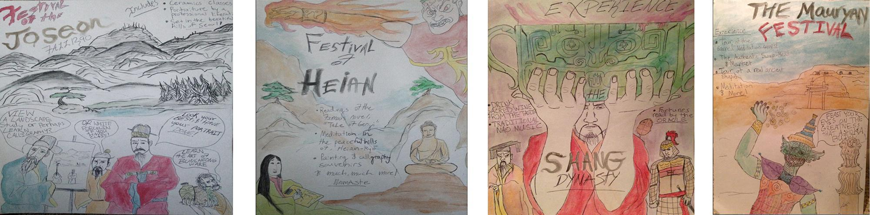Posters depicting festival ideas deriving from various Chinese dynasties and their characteristics.

Art 114-Fall 18
November 2018
Mauryan Dynasty
The Maurya Empire of India existed around 322-185 BC, and united lands of present-day India, stretching all the way to the border of where Afghanistan exists today. The empire was founded by leader, Chandragupta Maurya, and his empire was considered the first to unite ancient India, begin a coin currency and establish an international system of trade routes. Much of the Maurya period revolved around farming and trade between Eurasia (specifically the Greeks). With trade supporting the economy, the currency system flourished, and a balance of wealth was distributed between the classes. Chandragupta Maurya’s grandson, Ashoka, came into power around 273-232 BC. Ashoka the Great was heavily influenced by the growing spread of Buddhism. Although people still practiced Hinduism, Ashoka allowed religious freedom. The art of the Maurya period would reflect Ashoka’s Buddhist influence in the stupas he built all around the empire, the monoliths he built, and the caves he had carved in honor of meditating. Ashoka would ban hunting, and keep his army strong, but not wage war in order to keep peace between his empire and the rest of the surrounding civilizations. In my poster I incorporated the pillars of Ashoka to represent his power over the Mauryan empire, and especially with the symbolic Lion that sits atop. I also used a deity, called a yakshas to represent the stone carving of statues during the period, and the idealistic human form that artists wanted to replicate. The yakshas is holding the coin currency that was created during the time and provided much wealth to the empire. I included a stupa in the background to represent the immense popularity of Buddhism, and all 84,000 stupas that were built by Ashoka to hold relics in honor of Siddhartha Gautama, the founder of the religion, Buddhism. I wanted to convey the power and economic prosperity that occurred all throughout this dynasty. The elite and the farming classes enjoyed prosperous growth and were united with currency, peace, and vastly growing trade with Eurasia.

Shang Dynasty
The Shang Dynasty existed in ancient-China around 1600-1046 BC, and covered mostly the North-Eastern part of the country today. The culture of the Shang revolved around heavy-military influence due to the constant threat of war that surrounded the empire, and worshipping ancestors. With making bronze weapons for soldiers, came along the artistic influence of using the alloy to make art, and more specifically bronze vessels. The elite used these vessels to serve wine and offer tribute their ancestors. Alongside the belief in honoring those who came before, the Shang elite placed heavy emphasis on the royal court. Nobility, priests, and the royal family all had a place in the court, and were of the highest status, therefore, their funerals were decadent and ceremonial. Shang society believed in shamanistic practices and worshipping many gods or deities, and this influenced art in burial urns made of bronze, use animals in symbolism on pieces, and the carving of jade for the elite. A unique use of animal bones, or oracle bones was used to predict the future or answer questions of the elite within the royal court. In my poster I chose to utilize the symbolism of the taotie, or animal-looking creature that appears on bronze vessels during the period. The creature was very geometric and used on vessels, sometimes with the face used for the spout of the container, or the body decorated as a handle. Almost all art created by the Shang was used for religious and ceremonial purposes, and in which this deeply impacted how the Chinese would utilize practicality and creativity to make their art unique. I also used figures in the style of Shang portraits to represent the importance of the royal family. My poster also contains images of bronze wear and the military to show the militant power of the Shang and convey the message of how this dynasty utilized religion and ancestral worship in their culture.

Heian Period
The Heian period of Japan spanned from about 794 – 1185 CE, and was regarded as a golden age for the arts. The society was ruled over by an emperor, and the elite were regarded as highly trained artists, scholars, and patrons of the arts. After the end of the Genpei war, Japan was united under the Fujiwara clan for most of the period, and art began to take on a uniqueness that shied away from heavy Chinese influence. The samurai class and divisions in feudal society began to take hold, and the upper class would be ranked higher than those who were farmers, working class, or the poor. The rise of Esoteric Buddhism gave access to all the classes when it came to learning the virtues of the religion, however, the elite designed architectural spaces such as the temple, Todaiji, to exclusively practice separately. This temple would house relics and many statues of Buddha in Amitabha style, and guardians of the temple carved from wood and painted bright colors. The elite enjoyed temples such as Todaiji and the surrounding nature that still symbolized core values of Shinto. Those who were educated in the upper class, could read one of Japan’s first books such as The Tale of Genji by female-poet, Murasaki Shikibu. In my poster, I chose to represent figures that appear in the style of the yamato-e, a painting style inspired by the Tang Dynasty. I also included figures that look similar to deities carved of wood, that sat as relics within Buddhist temples, such as the ones sitting in Todaiji, and a Pure Land Buddhist temple in Phoenix Hall. I used bright colors, such as the ones represented in many handscrolls, and blue-green styled paintings. I wanted to convey how Buddhism, and the influences of China greatly impacted the unique style of Japan. The Heian period was a time of first novels, sculptural advancements and a splurge in religious iconism.

Joseon Period
The Joseon Dynasty lasted from 1392-1910 in Korea, and was founded by military leader, Yi Seong-gye. Yi Seong-gye commanded that Korea establish a strong military, and take on Confucian ideals, which would form the resurgence of the philosophy as neo-Confucianism. Buddhism would be outlawed by Yi, but ultimately, Buddhism and Buddhist art would still remain tied to Korean culture. Patrons of the arts, the elites, and royal family members often commissioned works to represent Confucius ideas, such as portraiture that showed merit, or the idealistic way of acting. Alongside portraits of court life, landscape painting was very popular and painted to show government officials or people of higher status enjoying nature. Ceramics would become a unique addition to Korean art, especially white porcelain and Buncheong ware. Both were created through experimental practices with shaping and firing done by the Koreans, who originally were influenced by imports from mainland China. The elite enjoyed ceramics thoroughly because of the practically and purity they represented. White porcelain was used exclusively by the upper class, while Buncheong was initially used by them, but then became mass produced and sold in markets for the middle class. In this poster, I’ve included a background of a landscape painting that signifies the style of the Joseon period. I added ceramics advertised, as they were a staple for Korea’s unique artistic identity at the time. I included royal figures to represent the upper class, and show how their interest in the arts shaped the spread of artistic ideals. I wanted to convey the importance of ceramics, and how art of the courts would make the identity of the Joseon dynasty.

Bibliography
"Boundless Art History." Lumen Learning. Accessed November 19, 2018. https://courses.lumenlearning.com/boundless-arthistory/chapter/the-heian-period/.
"Art of the Korean Renaissance, 1400–1600." The Met's Heilbrunn Timeline of Art History, The Metropolitan Museum of Art, Accessed November 18, 2018. https://www.metmuseum.org/toah/hd/kore/hd_kore.htm.
“Mauryan Empire (Ca. 323–185 B.C.).” The Met's Heilbrunn Timeline of Art History, The Metropolitan Museum of Art, Accessed November 18, 2018. www.metmuseum.org/toah/hd/maur/hd_maur.htm.
“The Maurya Empire” Lumen Learning, Accessed November 17, 2018. https://courses.lumenlearning.com/boundless-worldhistory/chapter/the-maurya-empire/
“Mauryan Empire Art & Culture” Study.com, Accessed November 17, 2018. https://study.com/academy/lesson/mauryan-empire-art-culture.html
"Shang Dynasty - China's First Recorded History." Ushistory.org. Accessed November 21, 2018. http://www.ushistory.org/civ/9b.asp.
Lai, Selena, and Waka Takahashi Brown. "The Shang Dynasty, 1600 to 1050 BCE." FSI | SPICE. November 2006. Accessed November 20, 2018. https://spice.fsi.stanford.edu/docs/the_shang_dynasty_1600_to_1050_bce.

Art 124A samples:
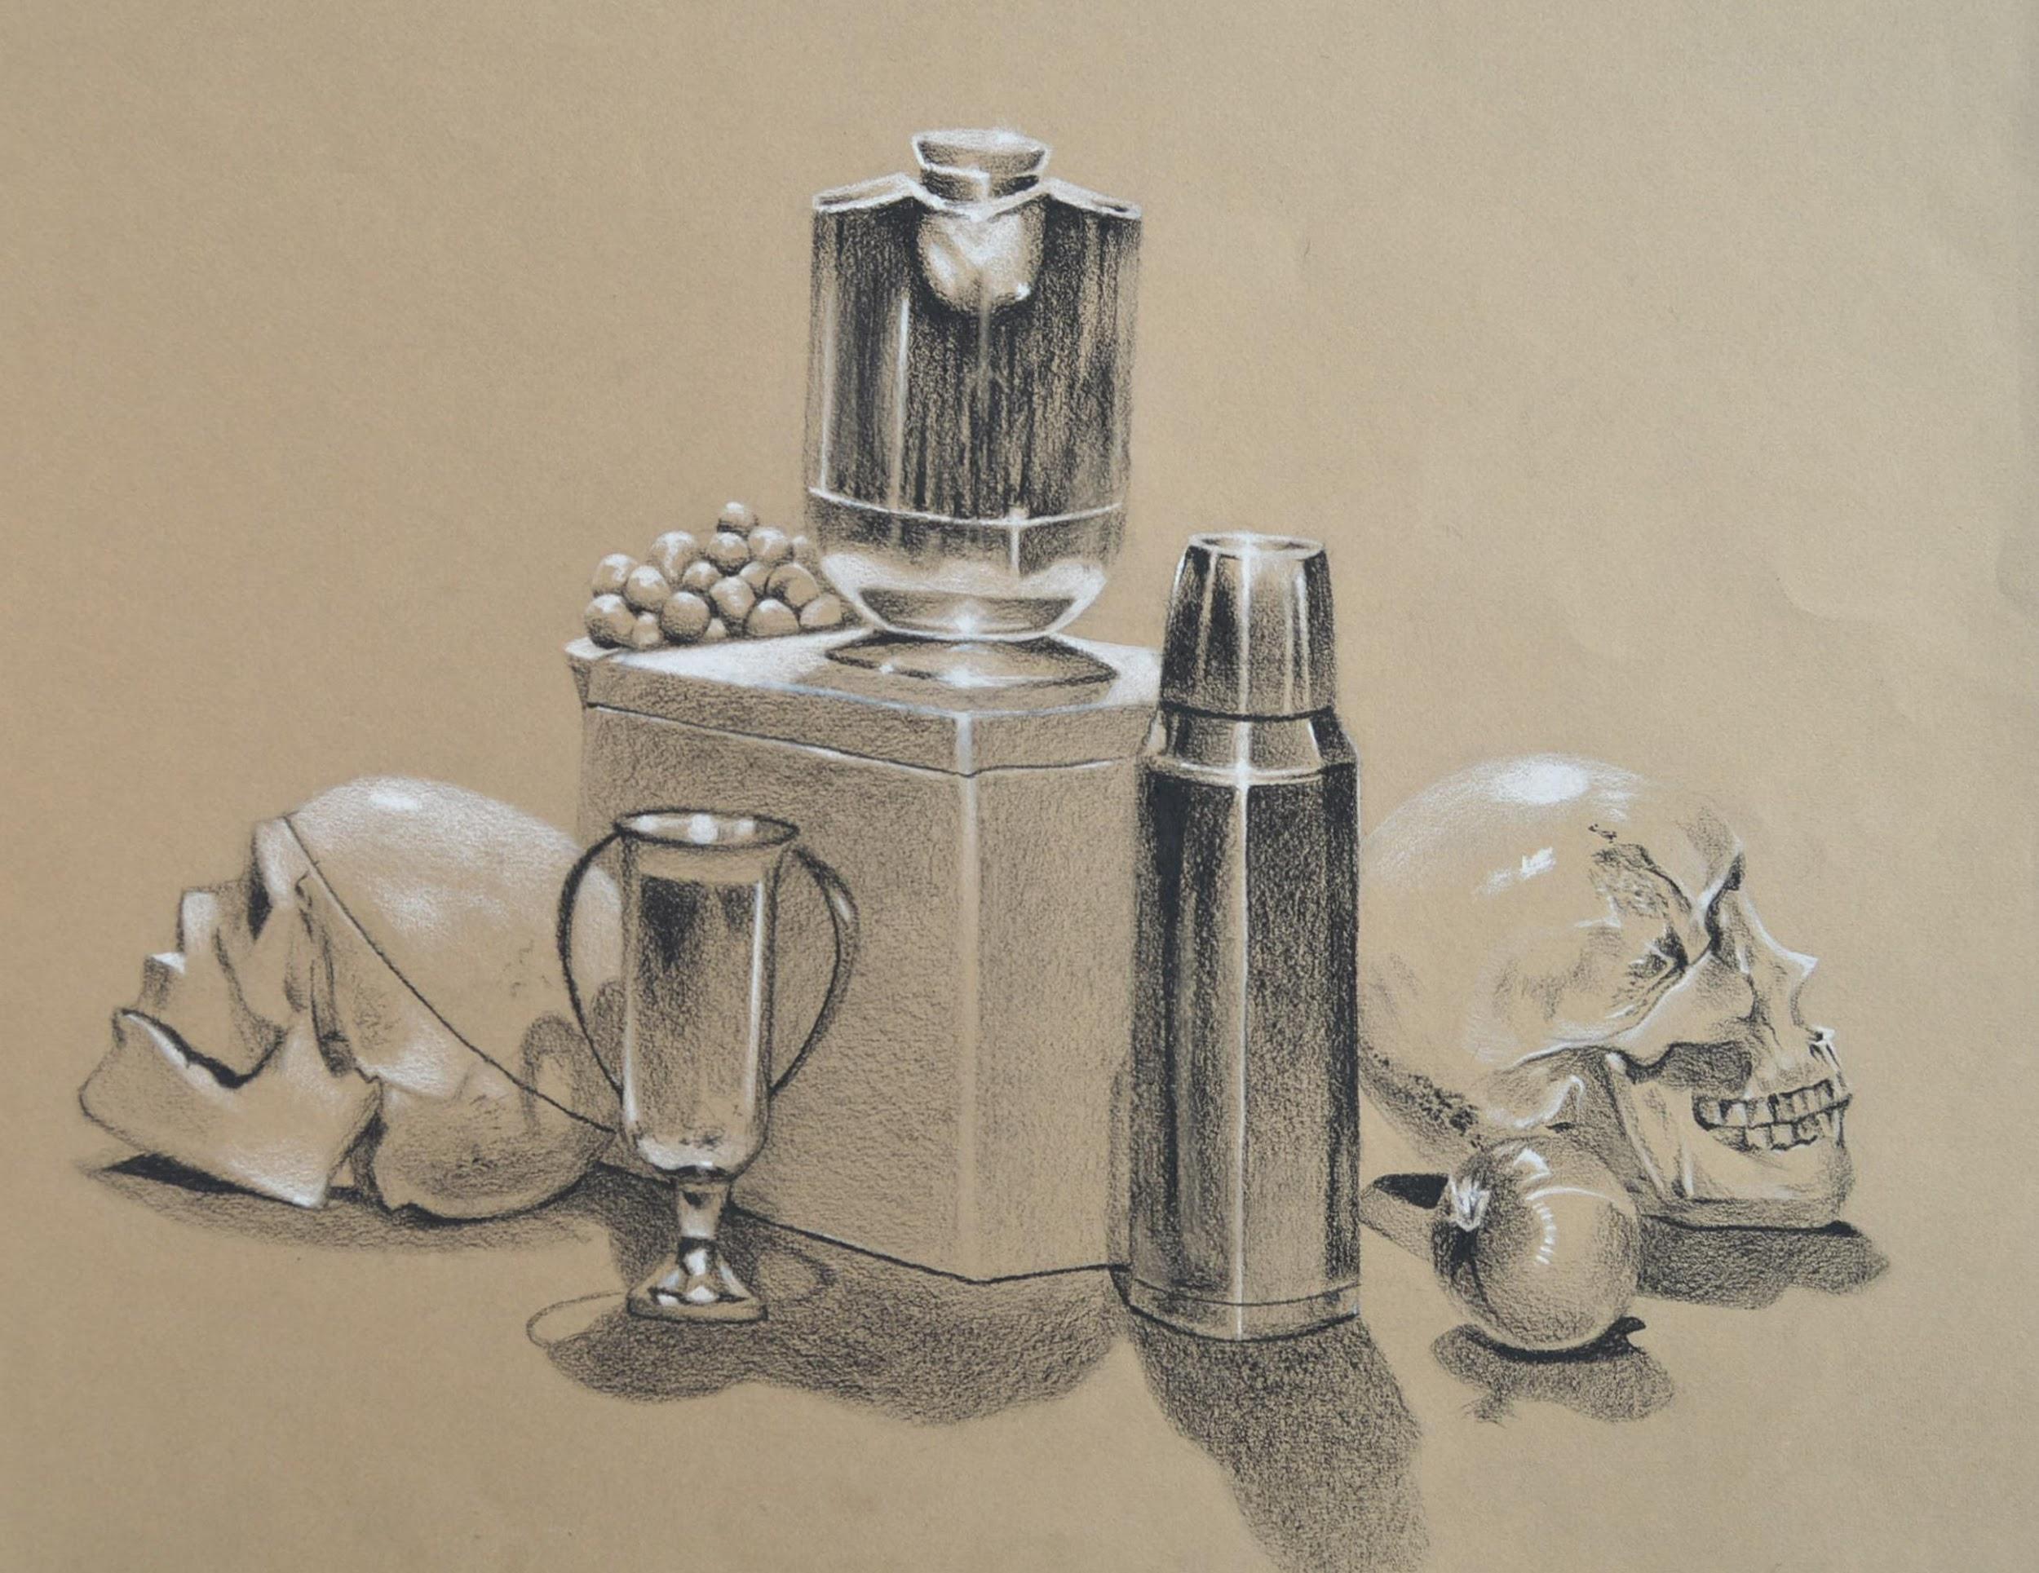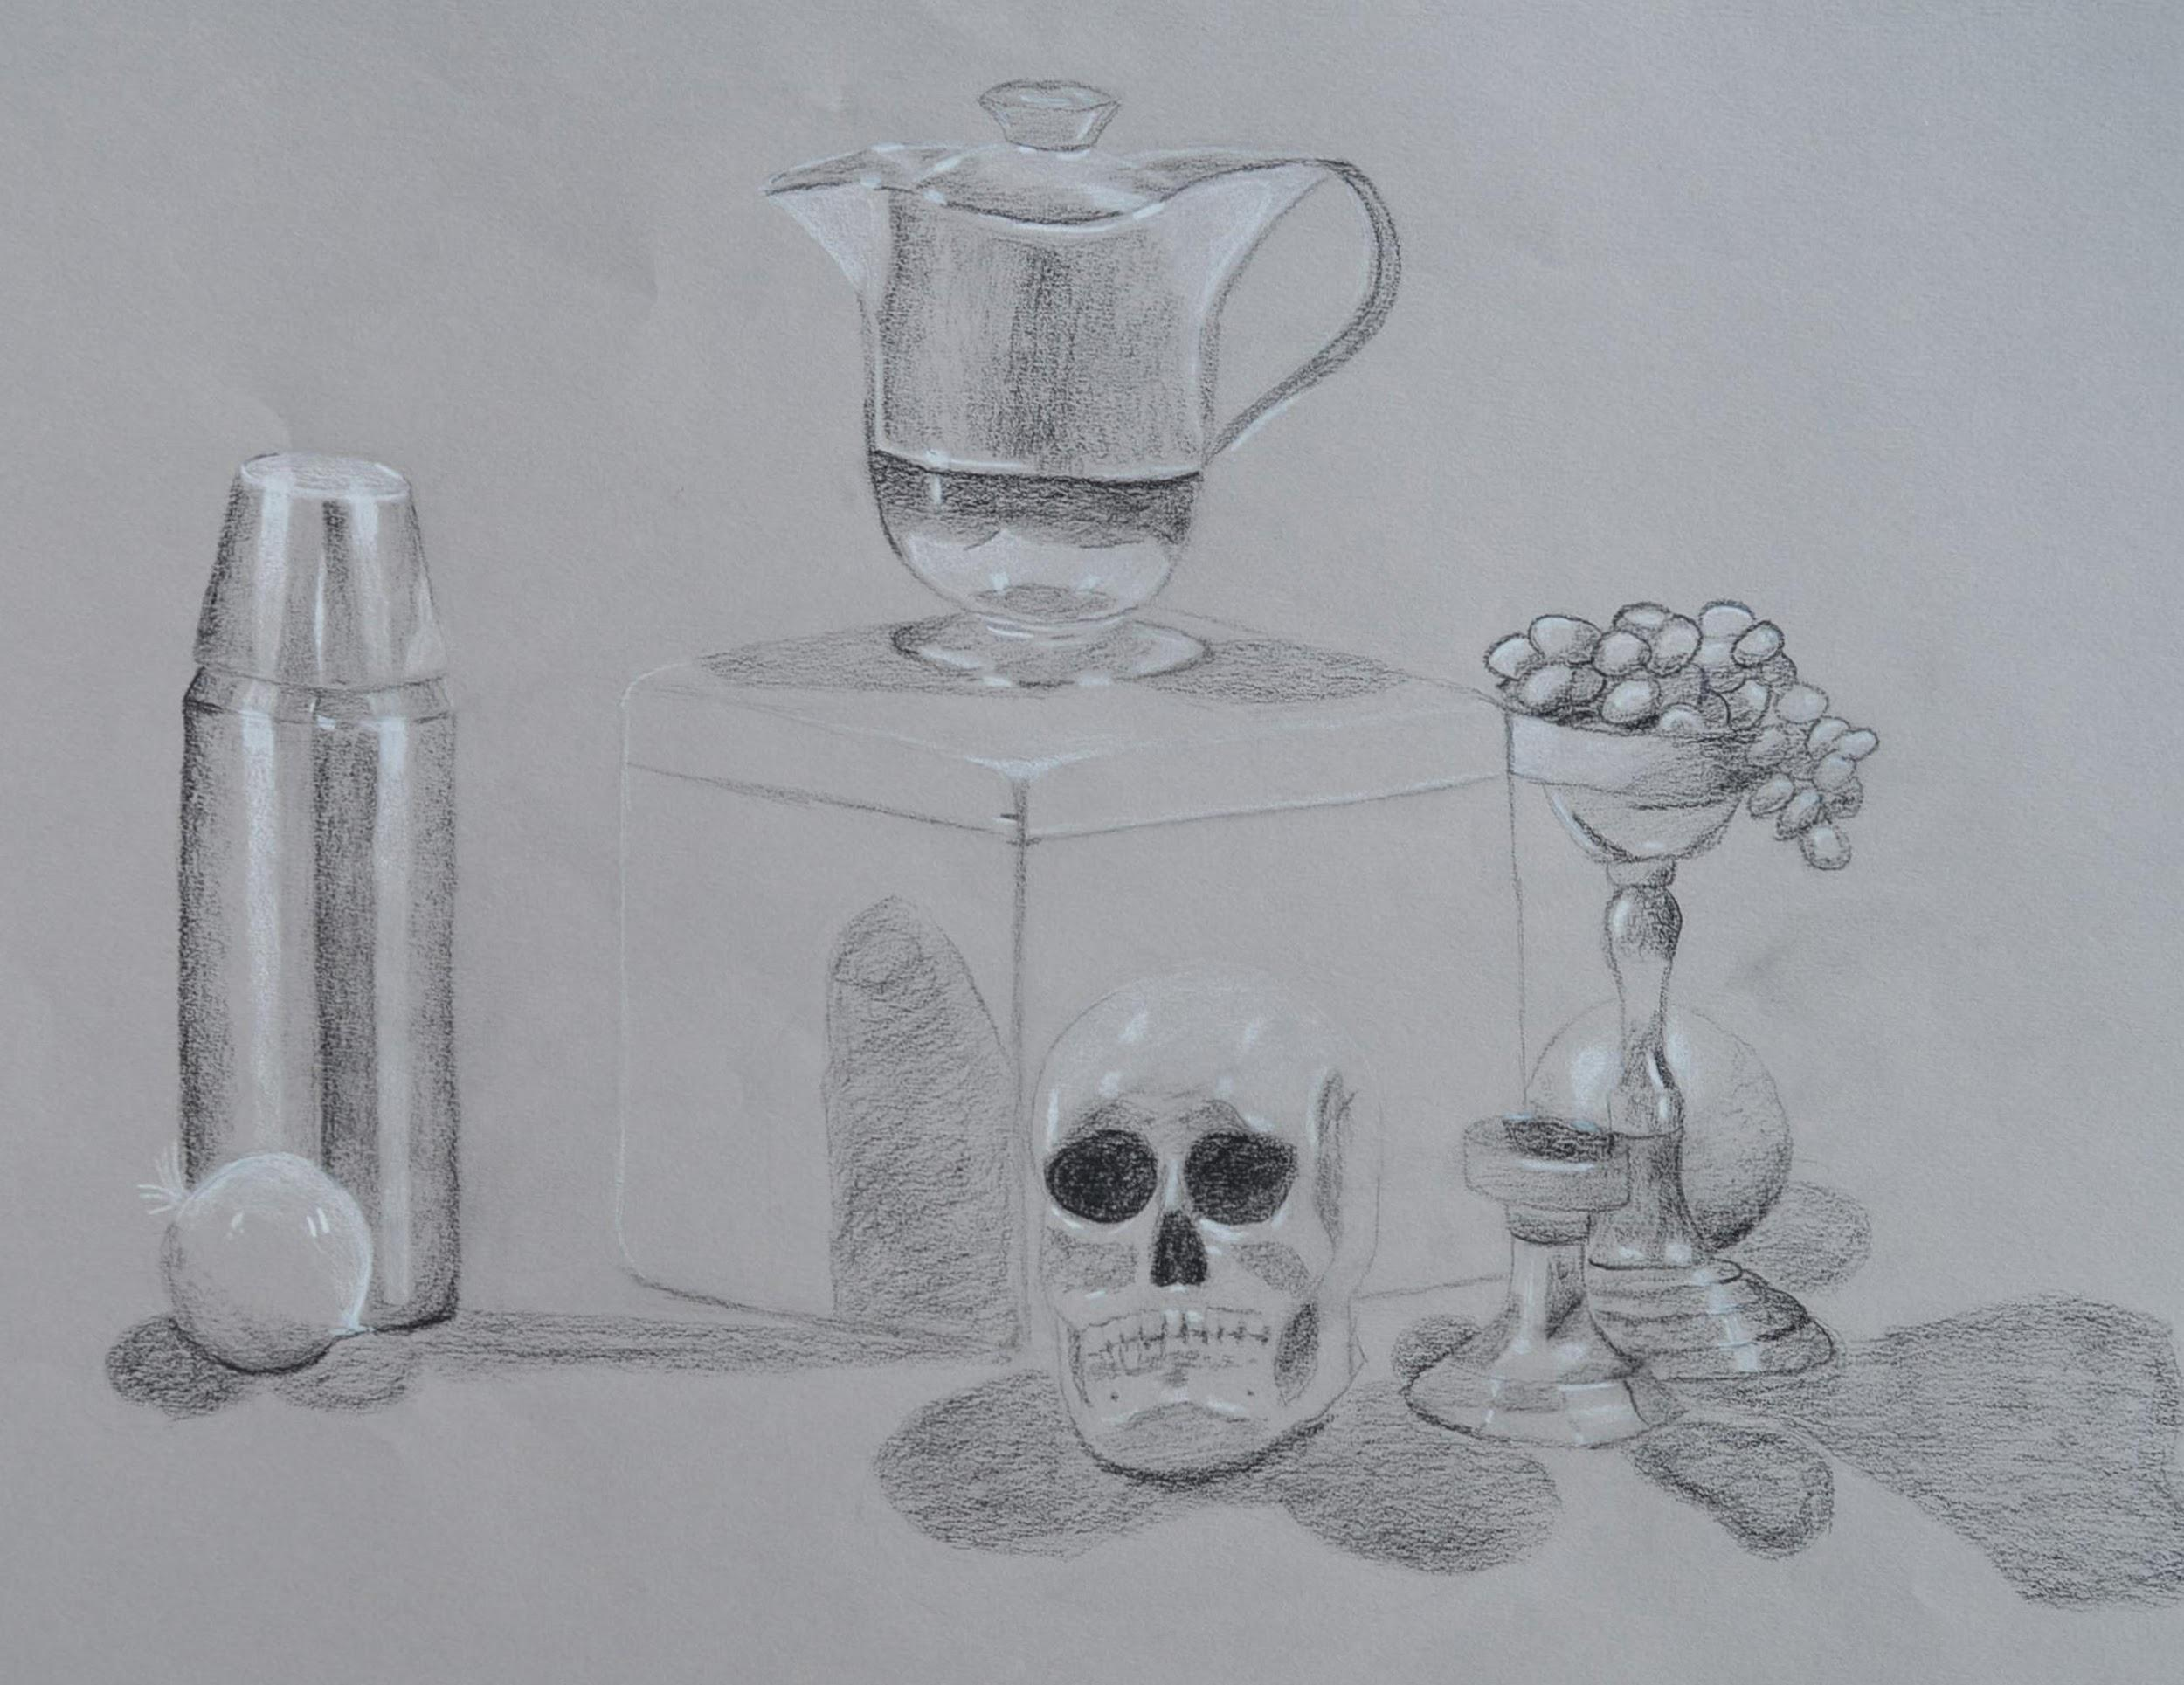
Drawing samples depicting a still life with skulls, metal thermos, metal vase, metal pitcher, and fruits.

Art 140 samples:
Three frames showing a young girl walking through a portal in tree to find a Christmas wonderland.

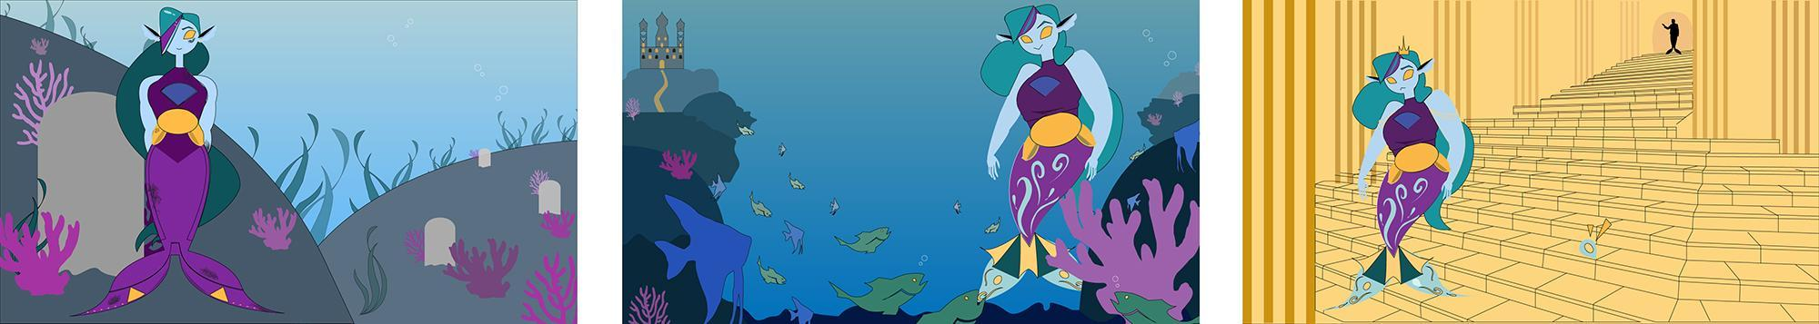
Three frames showing a mermaid in different undersea scenes.

Art 141 samples:
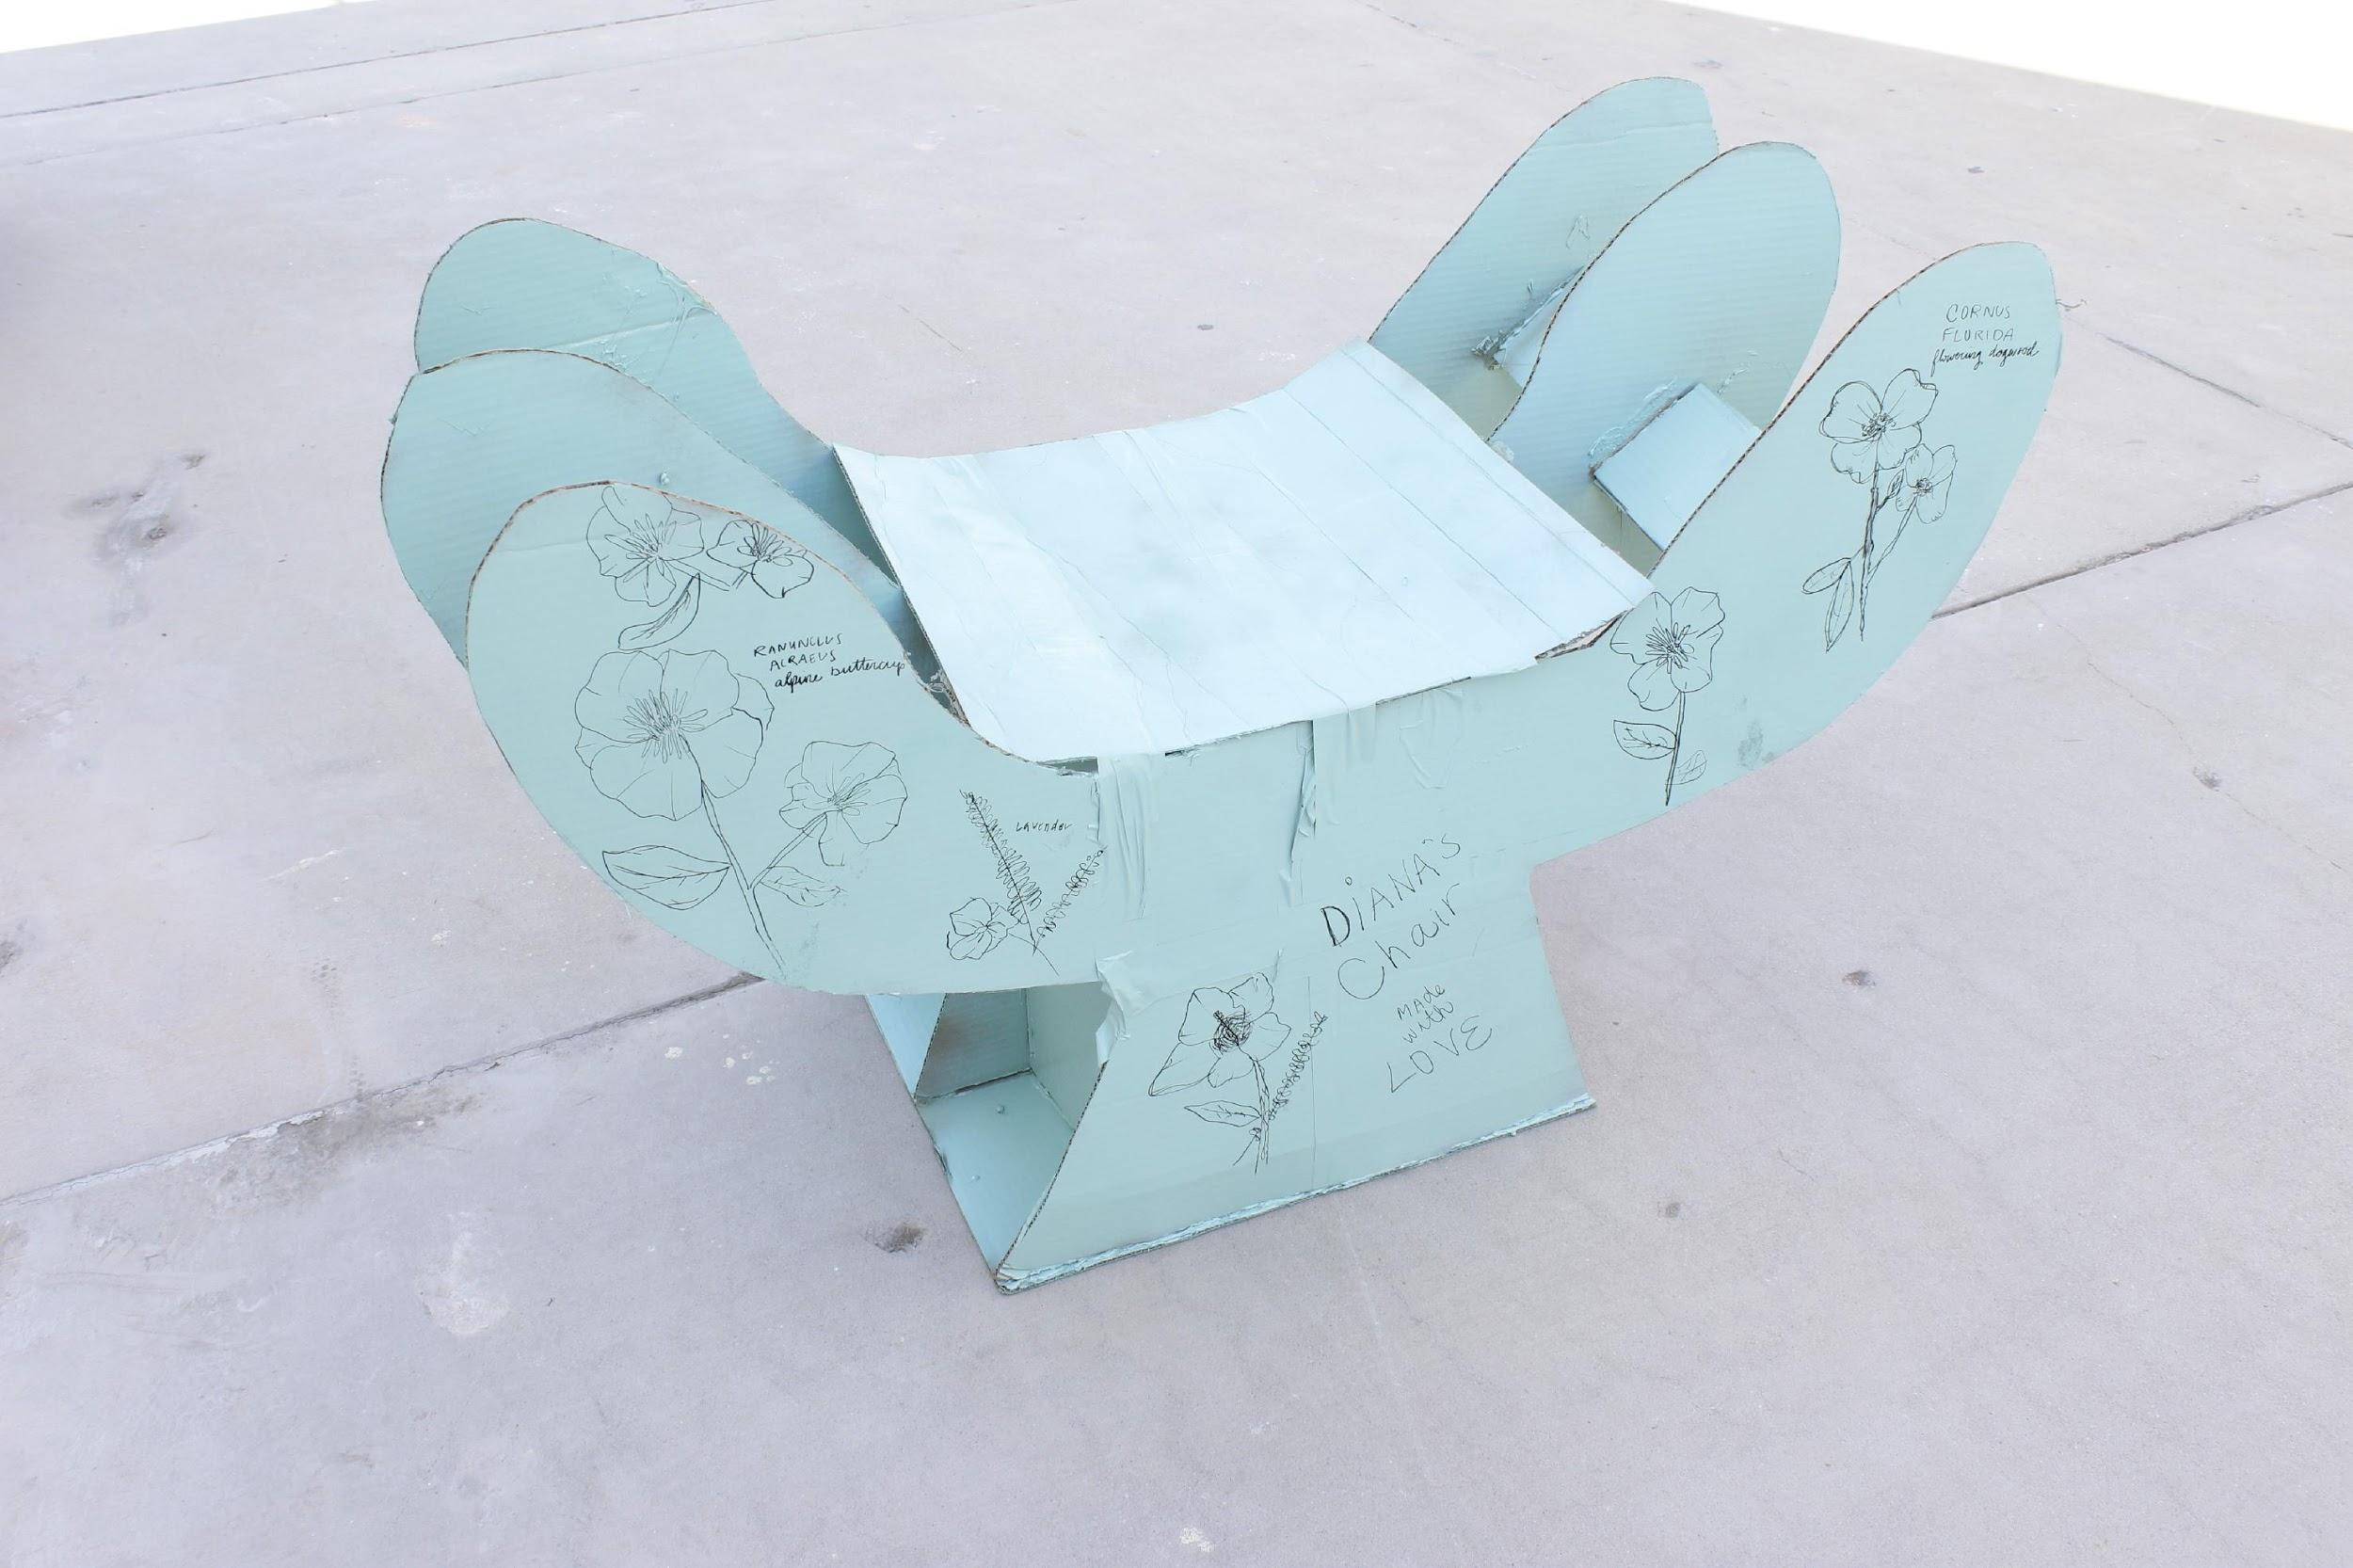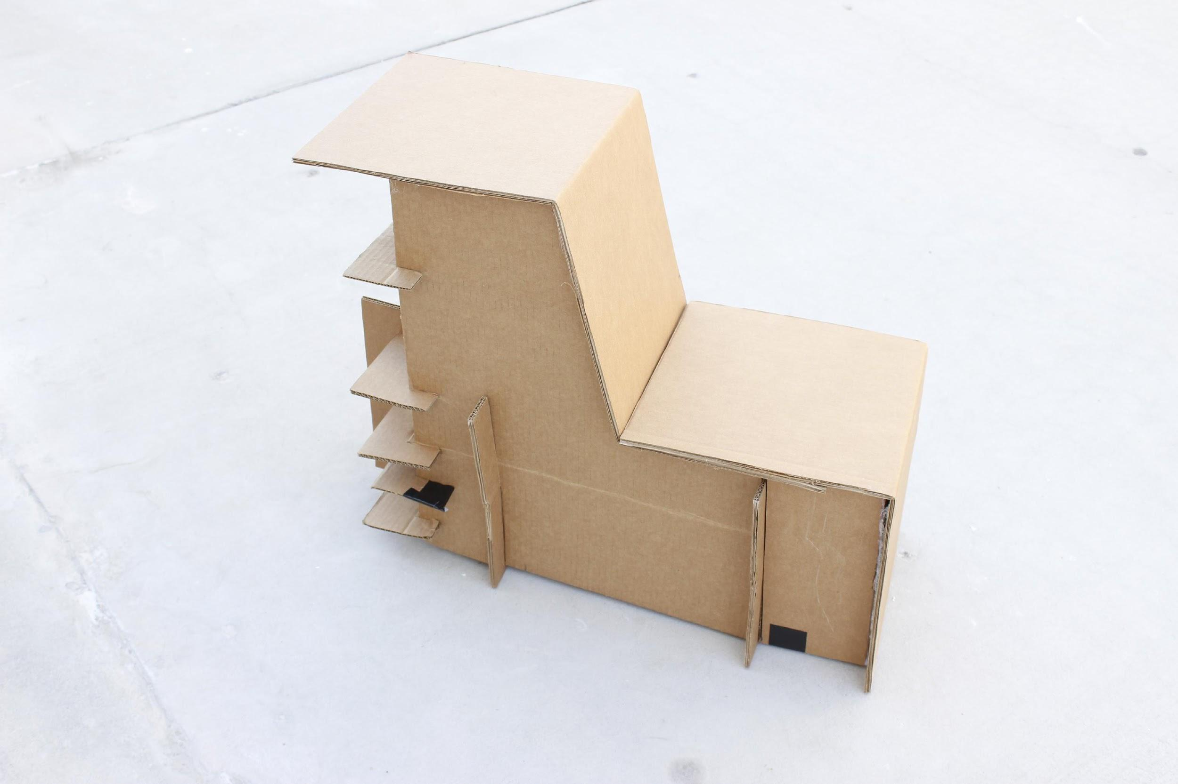
Two samples of seats created from cardboard, glue, paint, and markers.

Art 305 sample:
Art 305 Art & Mass Culture
Advertisements in the 20th Century
November 16, 2018
Advertisement in the world we live in today has become the backbone of the consumer society. When a new product comes out: billboards are erected, posters are pasted, and mile high window appliqués go up. We are constantly being told what we should want and how we should want it, all through advertisements. In this essay I will analyse two ads: one advertisement from print, and one that was pasted on the side of a building in New York City. I will break down what is being sold, what type of lifestyle or fantasy each product is projecting or promising, and if it is playing on or reinforcing any stereotypes surrounding homosexuals or young adults, as a mode of product sale.
Print ads were one of the first modes of advertisement after the town crier; since there has been print, there have been ads. Advertisements used to be printed to push people to buy everything from a new horse to medicine, and to support things like people on the political campaign trail. Nowadays, ads are everywhere and for everything in print media. Absolut Vodka is specifically known for their high quality and sometimes grandiose advertisements, going so far as to hire famous artists like Salvador Dali and Picasso to design high art print advertisements for them. In one of the chosen ads, Absolut Vodka has decided to use their marketing team to push the sale of not only their alcohol, but also marriage equality and equal rights for LGBTQ+ people. The ad comes in two versions: one of two men kissing and one of two women kissing, their lips highlighted inside of a rainbow Absolut bottle outline. This ad is simultaneously telling consumers about Absolut’s political views, drawing attention to what they believe still needs to change in the world in relation to the queer community, what you can have if you buy their vodka, and celebrating gay marriage being legal for 50 years in the United Kingdom. In all definitions of the word, this is an effective ad, but to understand why it is effective, it must be broken down further.
At the root of the Absolut ad, the vodka is being sold, but there is so much more within the ad as well. Absolut Vodka is focusing on a highlight of their alcohol: they are leading the consumers to believe that if they drink their alcohol, they will find someone to be intimate with. Absolut is even going so far as to include consumers who may like the same sex, which is a demographic that is often ignored in advertisements. The company is leading the consumers to believe that they will be happy if they drink their alcohol, because they will find someone to share their evening with. Absolut Vodka is focusing on sex and political appeal over all other means of attention grabbing. This is a popular trope within alcohol ads and sales: leading consumers to believe that why will be happy with someone else, under the influence of their alcohol. There may also be a type of stereotyping at play within the ad, due to the fact that many people believe LGBTQ+ people to be sexually promiscuous, but this may be an out of line assumption. The ad in itself is effective, while steering away from needlessly stereotyping or degrading a group of people in order to reach a different target audience.
The other type of incredibly prominent ads is those that are found outside, on the streets that people walk daily. These ads are billboards, window displays, and posters put up by the companies. The ad being used for this example is one that is a collaborative effort between Delta, Wieden+Kennedy, and New York and Colossal Media. The ad itself wraps the outside corner of a building and features many backgrounds made from destination shots, blown up big enough to be used as a photo backdrop. The advertisement, though long winded and grandiose, is selling people flights and destination trips through Delta, under the guise of being more sought after on dating sites. Delta does this by writing in the advertisement that “world travellers are more likely to be swiped right.”, on what is aptly named the Delta Dating Wall.
This Dating Wall is selling flights and travel packages to consumers by telling them, once again, that if you use their product, or in this case buy their plane tickets, you are more likely to find a boyfriend or girlfriend. Delta is spinning a web of lust by telling consumers that they can help them get the attention that they’re looking for on the dating sites that they’re using. Delta plays on the insecurities of their target audience, as well as playing to the cultural ideal that to be happy you have to be wanted, and that you have to be in a relationship. This type of advertisement also finds a way around utilising stereotypes in an overt way, while still creating an effective and engaging ad. It does this by leaving out any and all human subjects, allowing the consumers to insert themselves directly into and participate in the ad instead. However, stereotyping still plays a small part: Delta is stereotyping those who use dating apps to be inherently boring or shut ins, therefore they need to use this wall of selfie backdrops to help them be more appealing.
Advertisements have always been prevalent in our society; the prevalence even dates back hundreds of years. However, even though ads have been around for as long as most people can remember, this does not mean that they have not adapted and evolved as society has. Ads today are exceptional at playing on society’s insecurities, lusts, values, political views, and social norms. By utilising all of these and constructing ads around them, companies are able to produce effective and influential ads like the Absolut Vodka & Equality ad and Delta & Tinder ad. These types of advertisements are the perfect blend of company power and purpose.
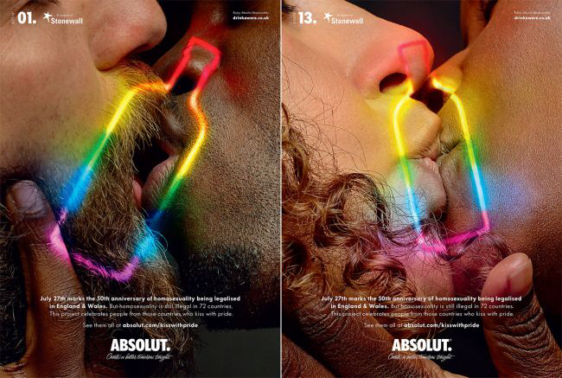
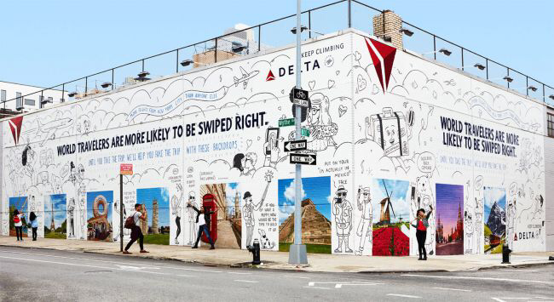
Absolut ad depicting same sex kisses with superimposed rainbow silhouette A building with a Delta Airlines ad wrapping around it.
of an Absolut bottle shape.

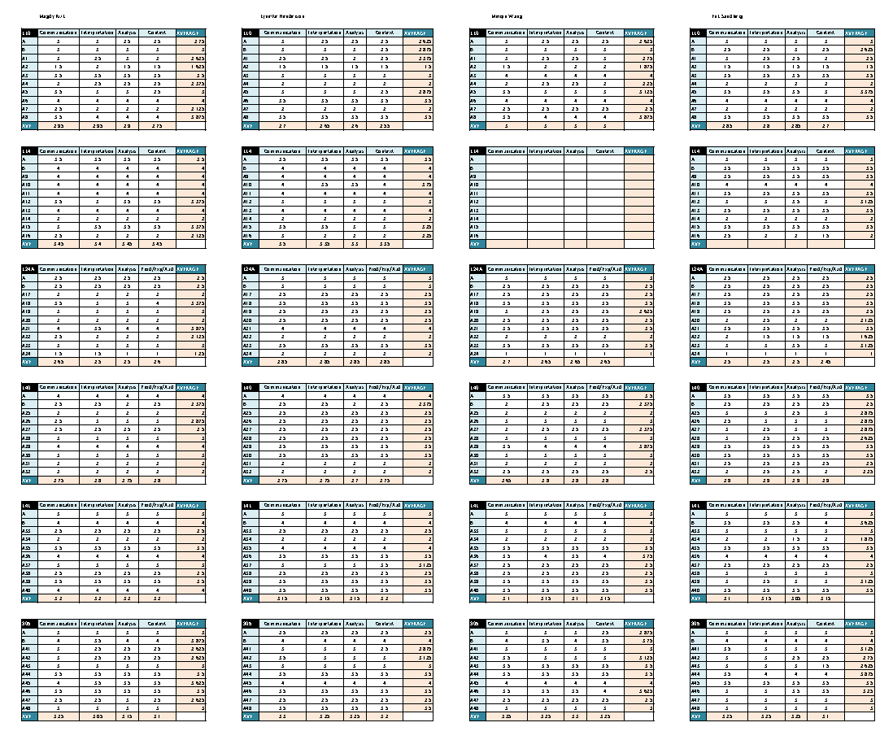
The following charts are a result of gathered scores from each member of the committee. Attachment 2 shows a complete chart for each project assessed, the overall averages in the first column, then individual breakdown of the average in each category. The charts for each specific course or discipline area, are similarly laid out and show the distinct difference in performance.
Attachment 2 : GE Critical Thinking and Historical Context Project Raw Scores

The following charts show a breakdown of averages and percentages for each course and their correlating categories.
Attachment 3 : GE Critical Thinking and Historical Context Analysis

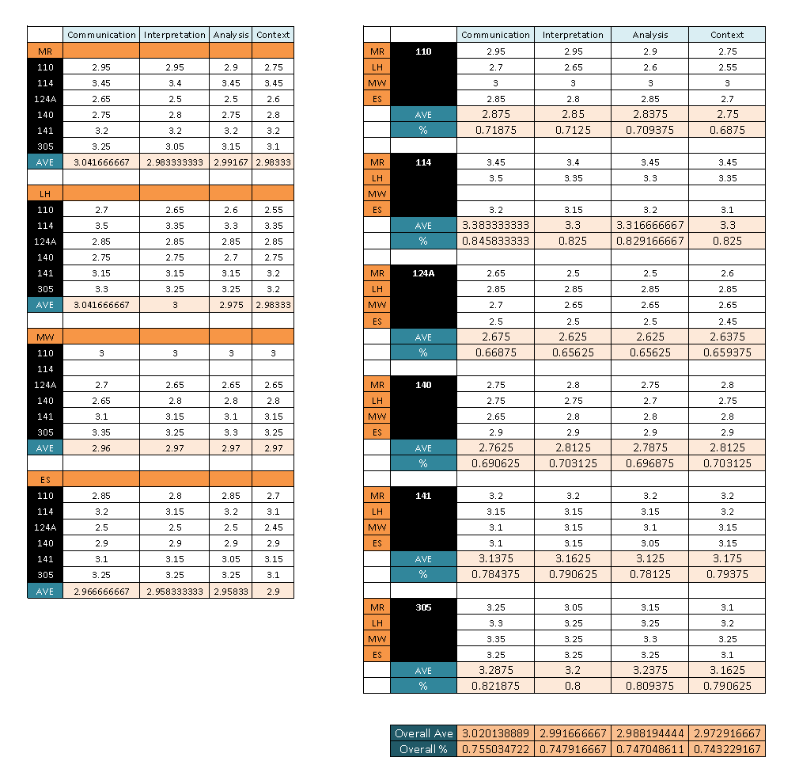

The following charts show DFU rates from Spring 2017 to Spring 2018. Special attention was paid to Spring 2018, as the caps for theses course were set at 35. The following year shows results of the efforts to curtail DFU rates
Attachment 4 : Art 110, Art 112, Art 114 DFU rates from Fall 2017/Spring 2018 followed by Fall 2018/Spring 2019
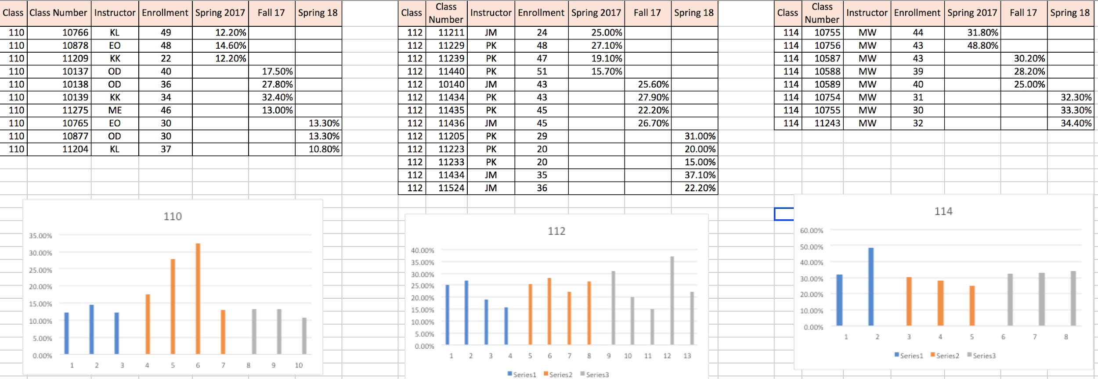
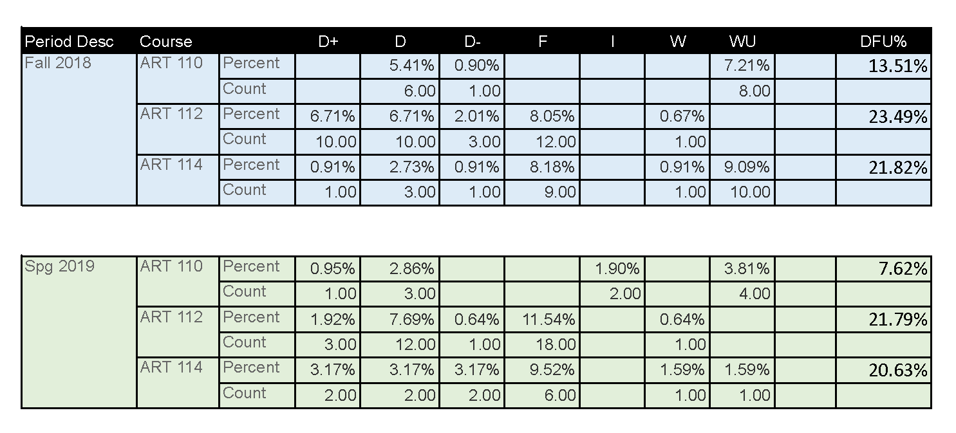

“The Maurya Empire” Lumen Learning, 2018. https://courses.lumenlearning.com/boundless-worldhistory/chapter/the-maurya-empire/.
“Mauryan Empire Art & Culture” Study.com, Accessed November 17, 2018. https://study.com/academy/lesson/mauryan-empire-art-culture.html.
Ibid.
“The Maurya Empire” Lumen Learning, 2018. https://courses.lumenlearning.com/boundless-worldhistory/chapter/the-maurya-empire/.
“Mauryan Empire (Ca. 323–185 B.C.).” The Met's Heilbrunn Timeline of Art History, The Metropolitan Museum of Art, 2018. www.metmuseum.org/toah/hd/maur/hd_maur.htm.
Selena Lai and Waka Takahashi Brown. "The Shang Dynasty, 1600 to 1050 BCE." FSI | SPICE. November 2006. https://spice.fsi.stanford.edu/docs/the_shang_dynasty_1600_to_1050_bce.
"Shang Dynasty - China's First Recorded History." Ushistory.org. 2018. http://www.ushistory.org/civ/9b.asp.
"Boundless Art History." Lumen Learning, 2018. https://courses.lumenlearning.com/boundless-arthistory/chapter/the-heian-period/.
Ibid
"Art of the Korean Renaissance, 1400–1600." The Met's Heilbrunn Timeline of Art History, The Metropolitan Museum of Art, 2018. https://www.metmuseum.org/toah/hd/kore/hd_kore.htm.
Ibid

