**2017-2018 Annual Program Assessment Report**

Please submit report to your department chair or program coordinator, the Associate Dean of your College, and to [james.solomon@csun.edu](mailto:james.solomon@csun.edu), Director of the Office of Academic Assessment and Program Review, by September 28, 2018. You may, but are not required to, submit a separate report for each program, including graduate degree programs, which conducted assessment activities, or you may combine programs in a single report. **Please identify your department/program in the file name for your report.**

**College: MCCAMC**

**Department: MUSIC**

**Program: B.M./G.E./M.M.**

**Assessment liaison: ALEXANDRA MONCHICK**

1. **Please check off whichever is applicable:**

**A. ____X__ Measured student work within program major/options.**

**B. ____X___ Analyzed results of measurement within program major/options.**

**C. ____X___ Applied results of analysis to program review/curriculum/review/revision major/options.**

**D. _________ Focused exclusively on the direct assessment measurement of General Education Social Sciences learning outcomes**

Undergraduate Summary:

At the suggestion of the dean’s office, the music department’s assessment goal for the 2017-18 year was to attempt to determine reasons for high DFWU classes. At the undergraduate level, we focused on a required class for all music majors (BM students), MUS 111, as well as MUS 105, a popular general education class. At the graduate level, we continued our focus on MUS 601, adding to our sample size for the 2017-2018 academic year.

MUS 111/111L is a required class within a six-semester sequence, in which students learn “basic skills in music making, including ear training, sightsinging, conducting exercises and fundamental terminology.” (Curriculum is currently in review to change this from a six-semester sequence to a four-semester sequence. This class meets SLO 1 “demonstrate the ability to hear, identify, and work conceptually with the elements of music, through sight-reading, basic keyboard proficiency, and musical analysis.” In particular, we looked at the success rate of transfer students vs. first-time freshman in this course. We discerned that there was little difference in student success in this class between the two groups. From 2012-2016, the average G.P.A. of a transfer student was 2.93, as compared with a first-time freshman’s of 3.0. From this data, we have deemed that our articulation agreements are serving the students.

Music Faculty have long complained that several students in MUS 111 were not receiving passing grades due to the department’s “concert card policy,” a pass/fail component of the class where students must attend thirteen concerts. The data backs up that roughly 12% of students were not passing because of failure to complete this component. The department has since changed its concert card policy so that this course component is now 10% of the grade, rather than a required component for passing the course.

The department began a two-year evaluation of its general education course in music appreciation, MUS 105 “Understanding Music.” The primary goal of the 2017-2018 assessment was to determine why students were failing the course (we will assess the general education SLOs for the arts and humanities for this course in 2018-2019). It had been surmised by the faculty that a potential reason for DFWUs in this class were due to a “concert report” assignment, where students were to review two live concerts in prose. While this proved true in one section, this turned out not to be the case in two others. In one section, only 8.2% who failed did not turn in the concert reports, but they were only 10% of the grade. In the second section, no one failed due to the concert report when 20% of the grade.  In the third section, 39% of those who failed, failed due to the concert report when it was 30% of the grade. In sum, the concert report was not as large a factor as was expected in student DFWUs, but it was a factor nonetheless. [Please see attached concert report assignments and rubrics for all three sections as Example 1].

Because there was a discrepancy in failure rates among the three sections, perhaps in the future there should be some coordination in the syllabi and standardization of rubrics across the sections.

Future assessment should be conducted to determine what are other reasons for students’ failures in MUS 105. Instructors were asked about other possible reasons as to why students are failing and, as one faculty member put it, “they just stop trying for one reason or another.” Another replied that students “stop going to class.” While this appears to be an overly simplistic explanation, after having reviewed the class grade sheets, more students seem to fail over not turning in anything at all than for receiving poor grades on what is in fact handed in.

It was determined that concert reports should probably not count more than 10% of the grade for this course. Faculty all agreed that it was a very important assignment particularly for the assessment of Arts and Humanities SLO 2 (Analyze, interpret and reflect critically upon ideas of value, meaning, discourse and expression from a variety of perspectives from the arts and/or humanities.) and SLO 5 (Use appropriate critical vocabulary to describe and analyze works of artistic expression, literature, philosophy or religion and a comprehension of the historical context within which a body of work was created or a tradition emerged.) In 2018-2019, we will determine whether this assignment is effectively addressing the appropriate SLO. Faculty did agree that accommodations could be made for the assignment, such as allowing students to watch an online concert pre-approved by the faculty member, which would not create financial hardship nor evening time conflicts for the student. The diversity of the student body was taken into consideration when making this accommodation, as several of our students work evening jobs or have conflicting evening commitments.

In sum, the music department has reconsidered the requirement for music majors and non-music majors to attend live concerts. Because of national music departmental accreditation requirements, this appears to be non-negotiable for music majors, but accommodations can be made for non-majors. In both cases, limiting the weight of such assignments to no more than 10% of the grade would likely decrease DFWU rates.

Graduate Summary:

In 2016-2017, we assessed graduate SLO 1 (“demonstrate artistic and intellectual rigor in the organization, interpretation, communication, and dissemination of musical knowledge.”) This SLO will generally be met through the academic courses (rather than lessons or ensembles) for the Master of Music (M.M.), particularly Music 601 (Research and Bibliography). While the assessment yielded some results last year, we did not get a significant response rate so a comparable assessment was conducted in 2017-2018.

22 additional student responses (15 gateway and 7 capstone students) to a comparable test (graded by a faculty member not teaching the class) were gathered. In contrast to last year, there was significant improvement from the gateway to capstone tests. There was an increase score in the communication area (1.5 points increase, 3 points maximum) where students were asked to write a short paragraph analyzing an abstract of an article. There were also increases in score between the gateway in AND capstone in “dissemination” (1.3 points increase, 2 points maximum) and “interpretation (1.6 points increase, 2 points maximum)” In these activities, the students were asked to name peer-reviewed journals and primary sources in music respectively. In the organization area, where students were asked to identify a thesis, students also improved (.47 points, 1 point maximum). Even though last year’s sample size was small, feedback was given to the instructor(s) of MUS 601 that improvements needed to be made in each of these areas, as the scores did not show significant increases between the gateway and capstone. This year’s sample size has shown that there has been a marked improvement.

Next year’s activities:

In a concerted effort to address DFU rates and curricular issues in the most popular general education courses in the music department, MUS105: Understanding Music (online and in class), and MUS:107: Music Today (online), five faculty participated in a CSUN eLearning Community from June 2017-May 2018.

Here is the hyperlink to our final report posted on *Merlot*, May 1, 2018:

<https://contentbuilder.merlot.org/toolkit/html/snapshot.php?id=8015636296957392>

Excerpts from the report:

In response to increasing student success, our department cohort has worked to created common student learning objectives, identified common assignments, quizzes, and examinations. We have met to clarify and make assignments and learning expectations transparent. We have studied new learning strategies and technologies, and we have implemented them to encourage growth mindset in music and to increase a continuing student engagement in the course.

Instructional Need for eLearning:

* Many students enter introductory music courses with a fixed mindset and have not previously engaged in a discussion of the nature of music. We worked towards transparency in assignments and in growth mindset.
* A significant number of students disengage from the course by mid-semester, where they fail to complete assignments and, therefore, are unsuccessful in the course. We implemented strategies to increase a continuing student engagement in the course.

By the end of the eLearning Project, the students will:

1. Gain more confidence in their understanding of course expectations through modified and clarified student learning objectives and assignments.
2. Utilize a growth mindset through newly implemented learning strategies and technologies.
3. Engage more throughout the course through newly implemented learning strategies and technologies that enhance a sense of community of learners.

Ideas/Lessons Learned

* Clear student learning outcomes and transparent assignments provide critical information to students for their success in the course.
* Fostering a growth mindset through discussion questions also builds a sense of social belonging and helps to create a learning community.
* Testing every week helps students to organize their learning habits and gives good feedback early in their process.
* Well-structured weekly discussions help students organize their thoughts, restate what they have learned in their own words, and received positive feedback from their classmates. This helps reinforce learning and helps build a learning community.
* There are many successful instructional strategies and technological tools for creating and maintaining student success.

For 2018-2019, the department, coordinating with the course instructors, needs to look at the grade data for semester grades and for individual assignments. We will also examine the data from the eLearning Project, and design one or two assignments to be used for assessing one-two of the GE SLOs for Arts and Humanities that might also foster a growth mindset as well as increase and maintain student success.

Graduate Music Assessment for 2018-2019:

The Music Department, in coordination with the Master of Arts in Music Industry Advisor, the Music Department Graduate Advisor, and the Curriculum Committee, will select appropriate courses and assignments to assess SLO 5:

Demonstrate professional competence in the execution of business processes and practices commonly employed within their area of specialization.

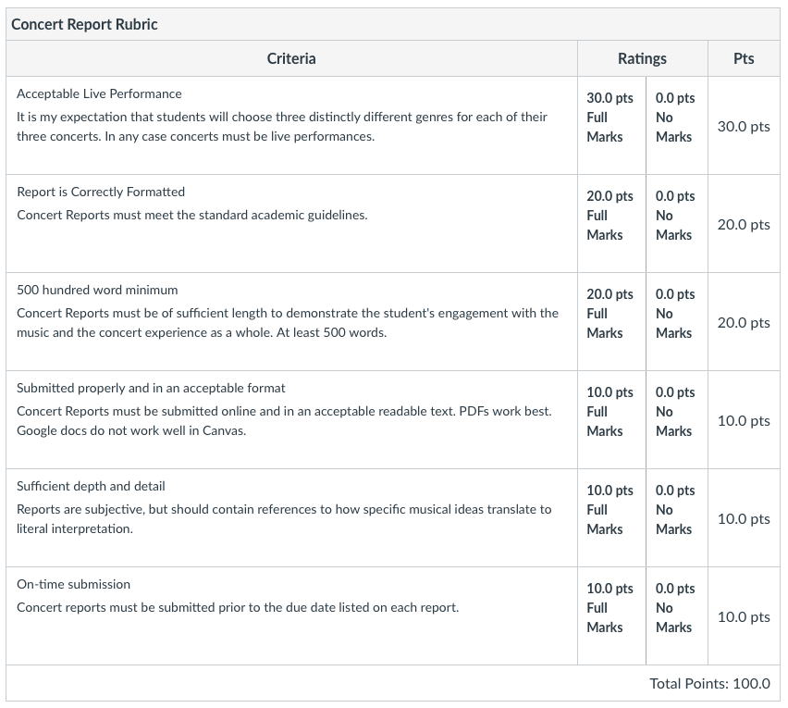



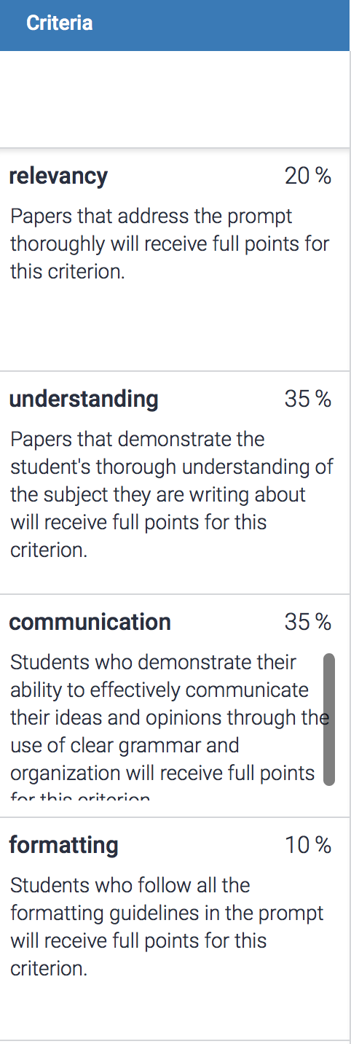

Gateway/Capstone Test Graduate SLO 1

Part III: Research Diagnostic

Please indicate yes or no if you have successfully passed Music 601: yes no

1. Please name two peer-reviewed music journals: (2 points)
2. Please name two types of primary sources for obtaining information on Beethoven (2 points)
3. Which is the clearest thesis? Pick one letter (1 point)  
     
   a. I will draw on Frank Smith’s work in my analysis of the score to Star Wars.  
   b. This paper argues that interactions involved in singing and dancing the Delaware Skin Dance link the past with the present in ways meaningful to Delaware and Iroquois people while reaffirming and renewing an extension of interconnected relationships   
   c. The funeral xylophone traditions of the Birifor peoples of Ghana are renowned across the West African hinter- land for the cultural narratives and social critiques they convey through public ceremonies over owing with musical artistry, surrogated song texts, and symbolic meaning.   
   d. The early fourteenth-century *Speculum musice* is the most extensive and comprehensive music treatise of the Middle Ages.
4. Please read the following abstract and in complete sentences, state its thesis, methodology, and contribution to musicological scholarship (significance of the topic). (3 points)

Recent scholarship has examined the ways that music crossed national boundaries during the long nineteenth century; some notable examples include Kreuzer’s account of Verdi’s German reception, and, in the volume edited by Fauser and Everist, Paris’s role as a center of cultural transfer. The international success of Jules Massenet’s operas, however, has received relatively little attention. This paper analyzes the Italian premiere of Massenet’s *Thaïs* through contemporary Franco-Italian relations, demonstrating the ways in which Massenet’s opera benefitted from the political context of its time and the ways in which it served as a tool of a broader political agenda. Drawing on previously undiscussed material from the Italian and French press, I argue that Massenet’s opera owed much of its success to its arrival in Italy at the end of a ten-year cold war between Italy and France.

*Thaïs*’s Italian premiere was also part of a larger cycle of musical and political exchanges between France and Italy. Massenet’s visit to Milan corresponded with an official state visit to Paris by the Italian king and with Giacomo Puccini’s trip to Paris for the Parisian premiere of *Tosca*. Thee pro-French rhetoric surrounding both the premiere and Italian newspapers’ coverage of the king’s French visit undoubtedly affected the audience and the critics. The crowd’s behavior at the premiere betrayed a political stance: most of the curtain calls were for Massenet, not the singers, and instead of an encore, some audience members demanded the “Marseillaise.” Some Milanese newspapers acclaimed Massenet, now sixty-one years old, as the living embodiment of French music; others sought to claim him as an honorary Italian. His status as a politically significant artist was confirmed at a grand banquet to celebrate the new friendship between France and Italy, in which Massenet was the sole musician to give a public speech among a crowd of politicians. *Thaïs*, as part of Massenet’s oeuvre, thus played an important role in celebrating the diplomatic reconciliation between France and Italy.