Seating Chart for Dr. Herr’s Advanced Placement Physics Class

Bethe | Boltzman | 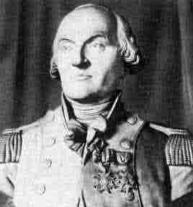  Coulomb | 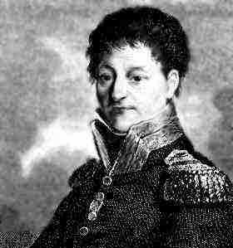  Carnot
Curie | Einstein | Fermi | 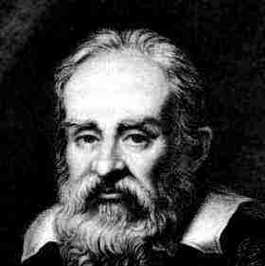  Galileo
Gibbs | Hawking | Kepler | 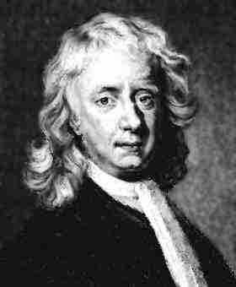  Newton
Oppenheimer | Tesla | 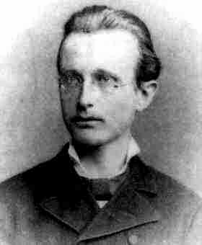  Planck | 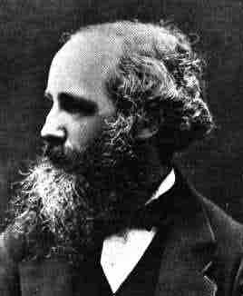  Maxwell

