Annual Assessment Report to the College 2011-12

College: Engineering & Computer Science___
Department: Civil Engineering & Construction Management
Program: Civil Engineering___________________________
Note: Please submit report to your department chair or program coordinator, the assessment office and to the Associate Dean of your College by September 28, 2012. You may submit a separate report for each program which conducted assessment activities.
Liaison: _Amine Ghanem____________________________
- Overview of Annual Assessment Project(s) (optional)
1a. Assessment Process Overview: Provide a brief overview of the assessment plan and process this year.
The CEAM department has a continuous assessment plan that is designed around the accreditation process required by ABET for the Civil Engineering Program. The assessment is done on three levels: (a) course assessment, (b) Outcome assessment and (c) Program assessment. The Civil Engineering courses are scheduled to be assessed by faculty as part of an on-going process. EBI senior surveys, senior exit interviews, and a Student advisory Board meeting are conducted once a year. Members of our departmental Industry Advisory board provide input to the assessment process as well.
Our department has a single Assessment Coordinator who oversees the assessment process, with significant assistance by the Department Chair.

2. Student Learning Outcome Assessment Project: Answer questions according to the individual SLO assessed this year. If you assessed an additional SLO, report in the next chart below.

2a. Which Student Learning Outcome was measured this year?
Last year data were collected for all program SLOs so that they can be evaluated this year as part of the ongoing improvement process.
The SLO’s are:
- an ability to apply knowledge of mathematics, science, and engineering
- an ability to design and conduct experiments, as well as to analyze and interpret data
- an ability to design a system, component, or process to meet desired needs
- an ability to function on multi-disciplinary teams
- an ability to identify, formulate, and solve engineering problems
- an understanding of professional and ethical responsibilities
- an ability to communicate effectively
- the broad education necessary to understand the impact of engineering solutions in a global and societal context
- a recognition of the need for, and an ability to engage in life-long learning
- a knowledge of contemporary issues
- an ability to use the techniques, skills, and modem engineering tools necessary for engineering practice.
- a proficiency in a minimum of four (4) recognized major civil engineering areas
- an ability to perform civil engineering design by means of design experiences integrated throughout the professional component of the curriculum;
- an understanding of professional practice issues such as: procurement of work-, bidding versus quality based selection processes; how the design professionals and the construction professions interact to construct a project; the importance of professional licensure and continuing education; and/or other professional practice issues.

2b. Does this learning outcome align with one of the following University Fundamental Learning Competencies? (check any which apply)
Critical Thinking____________________________________
Oral Communication__X______________________________
Written Communication__X___________________________
Quantitative Literacy________________________________
Information Literacy________________________________
Other (which?)___________________________________
2c. What direct and indirect instrument(s) were used to measure this SLO?
Direct Indirect
Student course evaluations Senior Exit interviews
Faculty evaluation of course material

2d. Describe the assessment design methodology: For example, was this SLO assessed longitudinally (same students at different points) or was a cross-sectional comparison used (comparing freshmen with seniors)? If so, describe the assessment points used.

Please check attachment Figure 1 for methodology of assessment.

2e. Assessment Results & Analysis of this SLO: Provide a summary of how the evidence was analyzed and highlight important findings from collected evidence.
At the time this report was written, the results were still being compiled and analyzed to fulfill ABET requirements.
Please check attachment 1 for our benchmark to compare the results obtained from our assessment.

2f. Use of Assessment Results of this SLO: Were assessment results from previous years or from this year used to make program changes in this reporting year?
Type of change:
changes to course content/topics covered: There has been adjustment to time allocated to some courses topics based on students performance and needs
course sequence: No______________________________________________________
addition/deletion of courses in program: No__________________________________
describe other academic programmatic changes: No changes_____________________________
student support services: There has been more tutoring session dedicated to classes where students have problems
revisions to program SLOs: No_____________________________________________
assessment instrument: Assessment methodology was changed last year and it is implemented this year
describe other assessment plan changes: No changes in the assessment plan______________________

Have any previous changes led to documented improvements in student learning? (describe)
Some programs assess multiple SLOs each year. If your program assessed an additional SLO, report the process for that individual SLO below. If you need additional SLO charts, please cut & paste the empty chart as many times as needed. If you did NOT assess another SLO, skip this section.
- How do your assessment activities connect with your program’s strategic plan and/or 5-yr assessment plan?
Our assessment activities connect with our program strategic plan and/or 5 year assessment plan submitted last year:
*Courses Self Assessment. Individuals have been assigned multiple courses to assess
*Senior Exit Interview
*This is a direct assessment. The assigned individuals for each course are performing a course self assessment based on the sample of students’ materials collected from each course (quizzes, exams, term project).
*(Indirect Assessment). Each spring semester, senior students are required to take an exit interview

- Other information, assessment or reflective activities or processes not captured above.
ABET accreditation is for the civil engineering program is Fall 2013. A full set of assessment report will be ready when next year report is due

- Has someone in your program completed, submitted or published a manuscript which uses or describes assessment activities in your program? Please provide citation or discuss.
Nothing for the past year. However, the Civil Engineering & Applied Mechanics Department is always striving to improve the student’s learning process.

Figure 1 Assessment, Evaluation and Improvement Process Flow Chart for the Civil Engineering Program
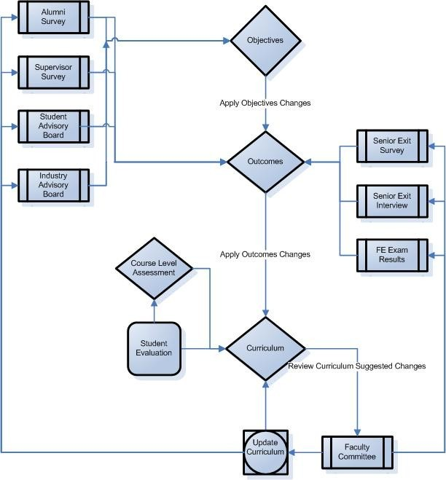

Table 1– Outcomes, Assessments, and Tools for Program Improvement

Outcomes | Assessments | Assessment Tools for Program Improvement
- Graduates have proficiency (ability to apply knowledge) in mathematics through differential equations, probability and statistics, calculus-based physics, and general chemistry. | - Grade of C or better in Math 150A and Math 150B; a C- or better in all other math and science courses and MSE 362.  - Performance of math skills in engineering courses.  - Performance on FE exam. | - Student Course Evaluations.  - Senior Exit Interview  - EBI Exit Survey  - Alumni Survey  - Supervisor Survey  6. CE Faculty
- Graduates have an ability to conduct laboratory experiments and to critically analyze and interpret data in more than one of the recognized major civil engineering areas | - Grade of C- or better in laboratory courses (PHYS 220AL, PHYS 220BL, AM317, CE308L, CE335L, CE 408L, CE426L, CE460L, and MSE227L) | - Student Course Evaluations  - Senior Exit Interview  - EBI Exit Survey  - Alumni Survey  - Supervisor Survey  - CE Faculty
- Graduates have an ability to design a civil engineering system, component, or process to meet desired needs | - Performance on senior design project. (CE488A/B)  - Grade of C- or better in engineering design courses (CE438, CE439)  - Performance in ASCE design competitions. | - Student Course Evaluations  - Senior Exit Interview  - EBI Exit Survey  - Alumni Survey  - Supervisor Survey  6. CE Faculty
- Graduates have an ability to function on multi-disciplinary teams. | - Performance on senior project.  - Performance in Laboratory courses.  - Performance in ASCE design competitions | - Senior Exit Interview  - EBI Exit Survey  - Alumni Survey  - Supervisor Survey  5. CE Faculty
- Graduates have an ability to identify, formulate, and solve engineering problems. | - Performance on senior design project. (CE488A/B)  - Grade of C- or better in engineering design courses (CE438, CE439)  - Performance in ASCE competitions. | - Student Course Evaluations  - EBI Exit Survey  - Alumni Survey  - CE Faculty
- Graduates have an understanding of professional and ethical responsibility | - Participation in student professional clubs and activities.  - Performance on Ethics portion of FE exam.  - Mead paper assigned in CE 488A | - Senior Exit Interview  - EBI Exit Survey  - Alumni Survey  - Supervisor Survey  - CE Faculty

- Graduates have an ability to communicate effectively | - Evaluation of Laboratory Reports.  - Evaluation of written reports and oral presentations in Senior Design  - Completion of Lower and Upper Division writing proficiency exams.  - 4) Passing grade in GE Oral Communication | - Senior Exit Interview  - EBI Exit Survey  - Alumni Survey  - Supervisor Survey  - CE Faculty
- Graduates have the broad education necessary to understand the impact of engineering solutions in a global and societal context. | - Passing grades in GE courses.  - Performance on senior design project. (CE488A/B) | - Senior Exit Interview  - EBI Exit Survey  - Alumni Survey  - Supervisor Survey  - CE Faculty
- Graduates have recognition of the need for, and an ability to engage in life-long learning. | - Discussion in course work.  - Planned enrollment in grad school.  - Taking of FE and PE exams  - ASCE/SEAOSC membership | - Senior Exit Interview  - EBI Exit Survey  - Alumni Survey  - Supervisor Survey  - CE Faculty
- Graduates have knowledge of contemporary issues. | - Passing grades in GE courses.  - Passing grade in Senior Design | - Senior Exit Interview  - Alumni Survey  - CE Faculty
- Graduates have an ability to use the techniques, skills and modern engineering tools necessary for engineering practice. | - Grades of C- or better in all 400 level engineering courses.  - Evaluation by Honors Co-op supervisors (Presently we have no Honor Co-op Students) | - Student Course Evaluations  - Senior Exit Interview  - EBI Exit Survey  - Alumni Survey  - Supervisor Survey  - CE Faculty
- Graduates have proficiency in a minimum of four recognized major civil engineering areas | - Grades of C- or better in courses in senior program. (Areas: Structures, Geotechnical, Hydraulics/Hydrology, and Surveying/Measurements.) | - Student Course Evaluations  - Senior Exit Interview  - Alumni Survey  - CE Faculty
- Graduates will have an ability to perform civil engineering design by means of design experiences integrated throughout the professional component of the curriculum. | - See Table B.8.1 for a summary of the design activities for each of the courses for which design units are claimed. | - Student Course Evaluations  - Senior Exit Interview  - EBI Survey  - Alumni Survey  - CE Faculty

- Graduates have an understanding of professional practice issues such as: procurement of work; bidding versus quality based selection processes; how the design professionals and the construction professionals interact to construct a project; the importance of professional licensure and continuing education: and/or other professional practice issues | - Performance in CE488A/B  - Percent taking FE exam.  - Graduate school admits. | - Senior Exit Interview  - EBI Exit Survey  - CE Faculty

