Program Assessment Plan, Fall 2013- Spring 2018

Department/Program: ECE Department, EE Program

Assessment Activity  Specify type of assessment activity and SLO (may refer by number to list below) | Time Period | Direct Measures  Describe student work to be used to provide evidence for outcome | Indirect Measures  Describe instrument: survey, interview | Where will evidence be gathered?  Course name, internship, etc | What results would indicate success or failure?  What is the expected level of achievement? | Status
SLO Assessment:  a – c, e – f, h - n | 2015  2018 | Embedded Test Questions, Graded Homework and Projects, Outcome-specific Quizzes |  | See curriculum maps. | Threshold Score: 6 out of 10, for declaring the SLO’s to be met
SLO Assessment: d | 2015  2018 | Faculty Observation of multidisciplinary teams |  | See curriculum maps. | Threshold Score: 6 out of 10, for declaring the SLO to be met
SLO Assessment: g | 2015  2018 | Faculty and Industrial advisors’ Evaluations (with rubrics) of Oral Presentations and Written Lab Reports; |  | See curriculum maps. | Threshold Score: 6 out of 10, for declaring the SLO to be met

Program Learning Outcomes List
List Program Learning Outcomes here:
a. An ability to apply knowledge of math, science, and engineering to the analysis of electrical engineering problems.
b. An ability to design and conduct scientific and engineering experiments, as well as to analyze and interpret data.
c. An ability to design systems which include hardware and/or software components within realistic constraints such as cost, manufacturability, safety and environmental concerns.
d. An ability to function in multidisciplinary teams.
e. An ability to identify, formulate, and solve electrical engineering problems.
f. An understanding of ethical and professional responsibility.
g. An ability to communicate effectively through written reports and oral presentations.
h. An understanding of the impact of engineering in a social context.
i. A recognition of the need for and an ability to engage in life-long learning.
j. A broad education and knowledge of contemporary issues.
k. An ability to use modern engineering techniques for analysis and design.
l. Knowledge of probability and statistics.
m. An ability to analyze and design complex devices and/or systems containing hardware and/or software components.
n. Knowledge of math including differential equations, linear algebra, complex variables and discrete math.

Curriculum Alignment: Resources for Assessment
Which courses or activities provide student learning opportunities for the program learning outcome?
See the following tables. (We do not identify the various levels at which the material is presented.)

Electrical Engineering Student Outcomes Addressed By Required Courses

Required Courses | EE Student Outcomes
 | a | b | c | d | e | f | g | h | i | j | k | l | m | n
Chem 101/L | X | X |  | X |  | X |  |  | X |  |  |  |  | X
Math 150A | X |  |  |  |  |  |  |  |  |  |  |  |  | X
Math 150B | X |  |  |  |  |  |  |  |  |  |  |  |  | X
Math 250 | X |  |  |  |  |  |  |  |  |  |  |  |  | X
Math 280 or ECE 280 | X |  |  |  |  |  |  |  |  |  |  |  |  | X
Phys 220A/L | X | X |  | X |  |  |  |  | X |  |  |  |  | X
Phys 220B/L | X | X |  | X |  |  |  |  | X |  |  |  |  | X
CE 240 | X |  |  |  |  |  |  |  |  |  | X |  |  | X
MSE 227 | X |  |  | X |  |  | X |  |  |  |  |  |  | X
MSE 304 | X |  |  | X |  |  |  |  |  |  | X |  |  | X
ME 370 or ME 375 | X |  |  | X |  |  |  |  |  |  |  |  |  | X
ECE 101/L | X | X | X | X | X | X | X | X |  |  | X
ECE 206/L | X |  |  |  | X
ECE 240/L | X | X | X | X | X |  | X |  | X |  | X |  | X | X
ECE 309 or ME 309 | X | X |  |  | X |  | X |  |  |  | X |  |  | X
ECE 320/L | X | X | X | X | X |  | X |  |  |  | X |  | X | X
ECE 340/L | X | X | X |  | X |  | X |  | X |  | X |  | X | X
ECE 350 | X | X | X |  | X |  |  |  |  |  | X |  |  | X
ECE 351 | X | X | X |  | X |  |  |  |  |  | X |  |  | X
ECE 370 | X | X | X |  | X |  |  |  | X |  | X |  |  | X
ECE 450 | X | X | X |  | X |  |  |  |  |  | X | X |  | X
ECE 455 | X |  | X |  | X |  |  |  |  |  | X |  |  | X
ECE 480 | X | X |  |  | X |  | X |  |  |  | X |  |  | X
ECE 492 | X | X | X | X | X | X | X | X | X | X | X | X | X | X
ECE 493 | X | X | X | X | X | X | X | X | X | X | X | X | X | X

Electrical Engineering Student Outcomes Addressed by Elective Courses

 | EE Student Outcomes
Elective Courses | a | b | c | d | e | f | g | h | i | j | k | l | m | n
ECE 370L | X | X | X |  | X |  | X |  | X |  | X |  | X | X
ECE 410/L | X | X | X |  | X |  | X |  | X |  | X |  | X | X
ECE 411 | X | X | X |  | X |  | X |  | X |  | X |  | X | X
ECE 412 | X | X | X |  | X |  | X |  | X |  | X |  | X | X
ECE 420 | X |  | X |  | X |  |  |  | X |  | X
ECE 422 | X | X | X |  | X |  |  |  |  |  |  |  | X
ECE 425/L | X | X | X | X |  |  | X |  | X |  | X |  | X
ECE 440/L | X | X | X |  | X |  | X |  | X |  | X |  | X | X
ECE 442/L | X | X | X |  | X |  | X |  | X |  | X |  | X | X
ECE 443/L | X | X | X | X | X |  | X |  | X |  | X |  | X | X
ECE 445 | X | X |  |  | X |  |  |  | X |  | X | X |  | X
ECE 451/L | X | X |  |  | X |  | X |  | X |  | X |  | X | X
ECE 460/L | X | X | X |  | X |  | X |  |  |  | X |  |  | X
ECE 480L | X | X | X | X | X |  |  | X | X | X | X |  | X | X
ECE 501 | X | X |  |  | X | X | X |  | X |  | X |  | X | X
ECE 503 | X | X |  |  | X | X | X |  | X |  | X |  | X | X
ECE 520/L | X |  | X |  | X |  |  |  | X |  | X |  | X
ECE 524/L | X | X | X |  | X |  | X |  |  |  | X |  | X
ECE 526/L | X | X | X |  | X |  | X |  |  |  | X |  | X
ECE 527/L | X | X | X |  | X |  | X |  |  |  | X |  | X
ECE 545 | X | X |  |  | X |  |  |  | X |  | X | X |  | X
ECE 546 | X | X |  |  | X |  |  |  | X |  | X | X |  | X
ECE 561 | X | X | X |  | X |  |  |  |  |  | X | X | X | X
ECE 561L | X | X | X |  | X |  | X |  |  |  | X | X | X
ECE 562 | X | X | X |  | X |  |  |  |  |  | X | X
ECE 571 | X |  | X |  | X |  |  |  | X |  | X |  |  | X
ECE 572 | X | X | X |  | X |  |  |  | X |  | X |  | X | X
ECE 578 | X | X | X |  | X |  | X |  | X |  | X |  | X | X
ECE 580 | X |  | X |  | X |  |  |  |  |  | X |  | X | X
ECE 581 | X | X | X | X | X |  |  |  | X |  | X |  | X | X

Five-Yr. Assessment Plan: Our plan involves a 3-year assessment cycle, as shown below.

Time Period | Phase | Activities
Fall ’13 – Fall -14 | Implementation Phase | Implement changes called for in the Sp ’13 Program Improvement Plan
2015 | Major Assessment Phase | Collect assessment data (direct assessment for SLO’s, direct and indirect for PEO’s)
Sp ‘16 | Major Evaluation Phase | Analyze & evaluate assessment data from 2015 Major Assessment Phase; Program Improvement Committee writes Program Improvement Plan
Fall ’16 – Fall ‘17 | Implementation Phase | Implement changes called for in the Sp ’16 Program Improvement Plan
2018 | Major Assessment Phase | Collect assessment data (direct assessment for SLO’s, direct and indirect for PEO’s)

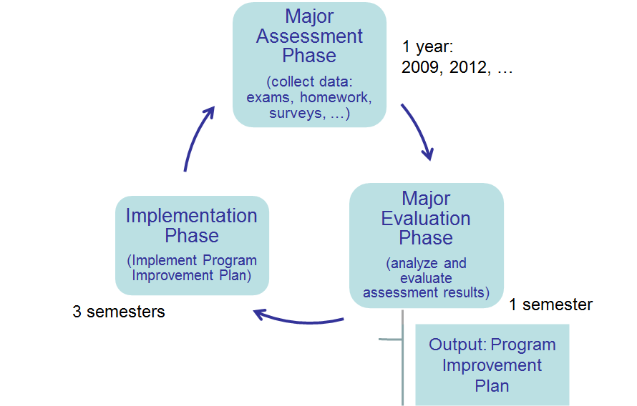
Duration - 1 semester:
…, Sp ’16, Sp ’19, …
Duration – 3 semesters

Duration - 1 year:
…, 2015, 2018, …

