**IS 441 Handout 1 (Relational Modeling 1):**

Understanding of Unary Relationship

*Dr. Yue Zhang, Version 2.2, 2/13/2018*

In this week’s class we covered the transformation from conceptual model (ER diagram) to logical model (relational model). One of the difficult points is to transform a unary relationship in ERD to relational data model. But the essence of this is truly the understanding of the unary relationship. Let us examine the following example in our slide #53 (2018):

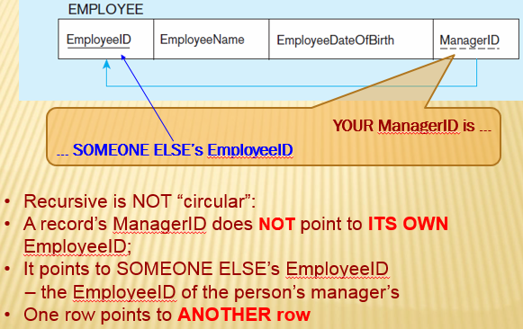

Let me clarify one important thing:

* the field ManagerID is the same as the field EmployeeID: in data type, data size, data source, data usage, data ownership… - they are the same by nature!
* The only distinction is: ManagerID is “the EmployeeID of an employee’s manager,” so that we can easily find out more about the other fields for THAT “employee who is a manager”: his/her LN, FN, DOB, Date_Hired, salary, …, through the (non-manager employee’s) “ManagerID” which is indeed the EmployeeID of this manager.

|  |  |  |  |  |
| --- | --- | --- | --- | --- |
| EmployeeID | EmpLN | Dept | Position | ManagerID |
| E011 | Adams | Accounting | Manager |  |
| E013 | Brown | Accounting | Accountant I | E011 |
| E017 | Cohen | Accounting | Accountant II | E011 |
| … … | … … | … … | … … | … … |
| E051 | Davis | Production | Manager |  |
| E056 | Edwards | Production | Group Supervisor | E051 |

**A non-manager employee’s “manager ID”, is his/her manager’s employee ID.**

With the above data, does it look much clearer (or even crystal clear)?

Looking back to Slide #53 (2018 Chap 4 PPT Part 1):

1. recursive is not “circular” – a row does NOT point to itself; specifically here:
2. A record’s ManagerID does NOT point to ITS OWN EmployeeID;
3. It points to SOMEONE ELSE’s EmployeeID – the person’s manager’s EmployeeID; example: E013 (Brown)’s ManagerID is E011, which points to Adams, the manager of the Accounting department, the manager of Brown’s. Therefore, it indeed is:
4. One row points to ANOTHER row – SOME rows in a relation point to some OTHER rows in the same relation.

I hope the above helps to clarify the puzzles and confusion around unary, once and for all ☺

I would like to express my appreciation to *Hovig Tchagaspanian* of F ’15 class, who asked me the question re ManagerID after class, which prompted me to create Version 1.1 of this handout, clarifying that

* ManagerID is nothing but EmployeeID (same type, same length, same requirement, same domain, same source, same owner, same everything); *BUT*,
* It is the EmployeeID of the *manager* of the employee (non-manager employee) whose row it (the ManagerID) appears at the end;
* This ManagerID helps to relate the current employee (non-manager) at the end of the employee’s row where the ManagerID resides to relate the current employee (non-manager) with his/her manager.

**“Employee’s manager ID, is manager’s employee ID”**