Database Basic Concepts Quick Review (with Microsoft Access®)
Dr. Yüe “Jeff” Zhang, Version 5.2, Spring 2018

Demo 1: Creating Tables:

- Fields: data type
- Primary key – Q: How many fields does it take to make a primary key?
- Foreign key – Q: Do all tables have a foreign key?
Logical | Physical
Entity | Table
Attribute | Column
Candidate key | Primary or unique key
Relationship | Foreign key

- Properties
  - Required field
  - Input mask definition characters:
0 – required digit (0-9), no + or – signs | > - cause letters that followed to become uppercase
L – required letter | A – required letter or digit

Create the table with the following fields and properties:

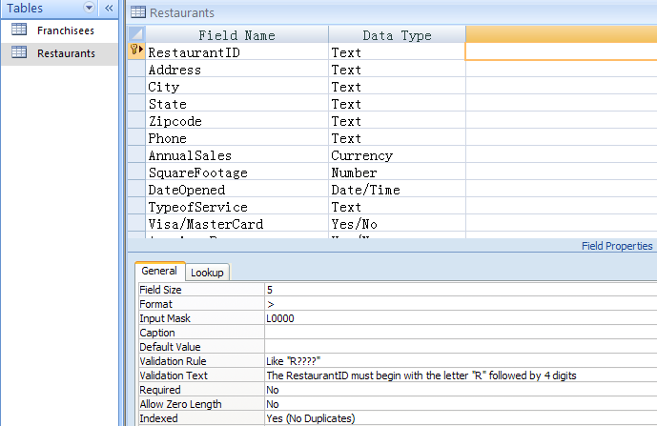
In SQL: _________

Demo 2: Creating Queries

Use of text, numeric, or date data as the criteria, combination of criteria using AND, OR, and NOT operators, wildcard character queries.

1. Simple queries
Types of data in Cri | Field/Column | Operator | Data to be compared
Text as criteria: | Type of service | is | Take-out Service
Number as criteria: | Annual Sales | at least | 200000
 | Annual Sales | more than | 200000
Date as criteria: | Date Opened | no later than | 1/1/2001
Pay attention to Boolean operators NOT, AND, OR, their precedence, and the use of parentheses
2. AND and OR
(1) (Different fields):
TypeofService is Table Service AND AnnualSales at least 750000
(2) (Different fields):
TypeofService = Table Service AND AnnualSales >= 750000
OR AnnualSales >= 1000000
(3) (Same field): Annual Sales at least 300000 AND at most 800000

3. NOT, BETWEEN, and Wildcard character
(1) NOT: Typeofservice = NOT Takeout Service; Typeofservice <> Takeout Service
(2) BETWEEN: DateOpened BETWEEN 1/1/2000 and 12/31/2000
(3)-(5) are wildcard queries:
(3) DateOpened is any date in the year 1999
[In 4-6, watch the position of the “*”]
(4) City is something-“cola”; “Talla”-something
(5) Address is on Grand (but am not sure Blvd or Ave or St)
(6) DateOpened is in the month of June (any year)

4. AND, OR, AND and OR, across two tables
(1) AND: CreditRating = AA AND AnnualSales >= 500000
(2) & (3) AND and OR combined:
(3) CreditRating = AA AND AnnualSales > 500000, OR
CreditRating = B AND AnnualSales < 400000
(Higher rating with higher sales, or lower rating with lower sales)

(4) City = Miami AND AnnualSales > 500000, OR
AnnualSales > 800000
(Review: Sequence of logical operators: AND, NOT, OR – in what order?)
Demo 3: Advanced Queries

1. Calculated fields
(1) Length of service in days: LengthOfService:NOW()-[DateOpened]
(2) Length of service in months: MonthOfLease:(NOW()-[DateOpened])/30
(assuming each month has 30 days; can use INT function)
(What’s the difference between INT and ROUND?)

(3) Length of service in months, as of 1/1/2015 – how to write the expression?
(4) Length of service at least 10 years, as of 1/1/2015 – how to write the expression and set criteria?
In SQL, these queries will use GROUP BY, involving SUM, COUNT, AVG, MIN, MAX, etc.

2. Total queries
Total squared footage, average annual sales, and number of restaurants for each type of service:
Group By TypeOfService, Count RestaurantID, Sum SquareFootage, Avg AnnualSales
Question: In addition to the above, if you also Group By RestaurantID or Address, what would happen? Observe, think, note the results, and act accordingly for your homework and project, as well as in future exams.
Group By only ____________________ type of fields – Do NOT Group by every field!
Count only _______________________ type of fields
Sum/Avg only ____________________ type of fields
More: GROUP BY City; GROUP BY Homecity; GROUP BY FranchiseeID
*** Observation: what type of fields to GROUP BY?

Watch these details:

Note | Details/Remarks
Table/query on which to base your report | Middle–left of the Wizard; select table/query from which your report will get data
Select a field to group on | The field must be one that truly has group nature
Do not miss the Summary Options button | In the window that says “you can sort records by up to four fields”

