IS 441 Final Exam Hands-On Section: SQL, Ver B
Last name: First name:
Section V Hands-on Portion (45+5 points): SQL statements. Given the following database (downloadable per instruction given), write SQL codes to accomplish the required tasks:

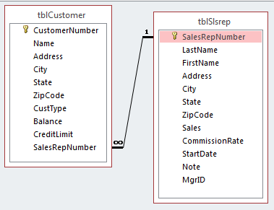

*** To submit the hands-on portion: upload -
(1) Word doc in “homework style” – code plus output screen; (2) completed Access database.
-------------------------------------------------------------------------------------------------------------------------------

1. (5 points) Add a new record to the customer table using INSERT statement:
Customer number: CR13
Name: Kitchen K’Asian
Address: 9759A Reseda
City: Northridge; Zipcode: 91324
Type: SPC
(No Balance data available)

2. (5 points) Update the customers in MI (Michigan), change their credit limits to $7,500.

3. (6 points) Display the average credit limit by states (so also display state), sort the results by the average, lowest first.

4. (8 points) Display (1) the number of customers, (2) average balance, (3) highest balance, (4) average credit limit, and (5) the state, by each state, for the customers in all the types except SPC. [The numbers 1~5 above are to help you avoid missing a required field. This is ONE query, not five]
Use the following alias for the summary fields: the number of customers – NumCust; average balance – AvgBal; highest balance – TopBal; average credit limit – AvgCr.

5. (10 points) Display the average credit (name it AvgCr) for customers for those states (so display state) whose average credit is lower than the average credit of all customers. Display also the average of the whole table under the header OverallAvg.

6. (11 points) List those sales reps whose commission rates are higher than their manager.

BONUS: Finish ALL the 6 questions above BEFORE you attempt the bonus question. ***The bonus question will NOT be graded unless you have earned 80% from questions 1~6.
7. (5 points) List the customers who are in the same state as their rep (Note: This one needs “passing argument into subquery”)

