IS 441 Final Exam Hands-On Section: SQL, Ver A
Last name: First name:
Section V Hands-on Portion (45+5 points): SQL statements. Given the following database (downloadable per instruction given), write SQL codes to accomplish the required tasks:

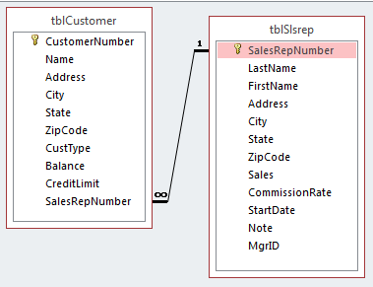

*** To submit the hands-on portion: upload -
(1) Word doc in “homework style” – code plus output screen; (2) completed Access database.
-------------------------------------------------------------------------------------------------------------------------------

1. (5 points) Add a new record to the customer table using INSERT statement:
Name: Chi’s Restaurant
Customer number: CR11
Address: 9753 Reseda
City: Northridge; Zipcode: 91324
Type: SPC
(No Balance data available)

2. (5 points) Update the customers in WI, change their credit limits to $8,000.

3. (6 points) Display the average balance by states (so also display state), sort the results by the average, highest first.

4. (8 points) Display (1) the number of customers, (2) average balance, (3) highest balance, (4) average credit limit, (5) the type of customers, and (6) the state, by each type, for the customers in all the states except IN (Indiana). [The numbers 1~6 above are to help you avoid missing a required field. This is ONE query, not six]
Use the following alias for the summary fields: the number of customers – NumberCust; average balance – AvgBal; highest balance – MaxBal; average credit limit – AvgCr.

5. (10 points) Display the average balance (name it AvgBal) for customers for those states (so display state) whose average balance is higher than the average balance of all customers. Display also the average of the whole table under the header AllAvg.

6. (11 points) List those sales reps who started working for the company before their manager.

BONUS: Finish ALL the 6 questions above BEFORE you attempt the bonus question. ***The bonus question will NOT be graded unless you have earned 80% from questions 1~6.
7. (5 points) List the customers who are NOT in the same state as their rep (Note: This one needs “passing argument into subquery”)

