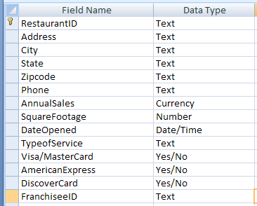
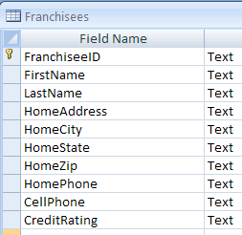

- List restaurants that have annual sales at least $750,000 or restaurants that have squared footage more than 2000.
- List restaurants that are in Miami with annual sales more thasn $500,000.
- List A or AA franchisees who are not in Miami.
- List List restaurants that have annual sales at least $750,000, or those whose franchisees have AA credit rating.
- List the average annual sales by city, and the highest sales of restaurants in each city.
- List the sales-to-area-ratio of restaurants, by their type of service.

