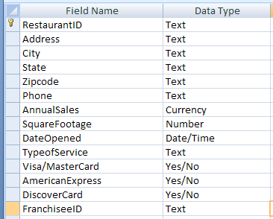
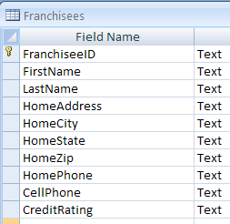

- List restaurants that have annual sales at least $750,000 or restaurants that have squared footage more than 2000.
SELECT RestaurantID, AnnualSales, SquareFootage
FROM RESTAURANTS
WHERE AnnualSales >= 750000 OR SquareFootage >2000;

- List restaurants that are in Miami with annual sales more thasn $500,000.
SELECT RestaurantID, AnnualSales, City
FROM RESTAURANTS
WHERE AnnualSales > 500000 AND City = “Miami”;

- List A or AA franchisees who are not in Miami.
SELECT FranchiseeD, LastName, CreditRating, HomeCity
FROM FRANCHISEES
WHERE CreditRating = (“A” OR “AA”) AND HomeCity != “Miami”;

- List List restaurants that have annual sales at least $750,000, or those whose franchisees have AA credit rating.
SELECT RestaurantID, AnnualSales, FranchiseeD, LastName, CreditRating
FROM RESTAURANTS, FRANCHISEES
WHERE
RESTAURANTS.FranchiseeID = FRANCHISEES. FranchiseeID AND
(AnnualSales >= 750000 OR CreditRating = “AA”);

- List the average annual sales by city, and the highest sales of restaurants in each city.
SELECT AVG (AnnualSales) AS AVERAGE, MAX(AnnualSales) AS MAXIMUM, City
FROM RESTAURANTS
GROUP BY City;

- List the sales-to-area-ratio of restaurants, order by their type of service.
SELECT RestaurantID, AnnualSales, SquareFootage, (AnnualSales/ SquareFootage) AS sales-to-area-ratio
FROM RESTAURANTS
ORDER BY TypeOfService;

