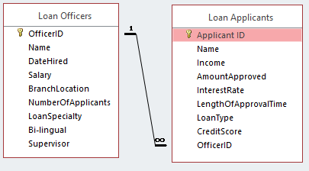

Task 1: Find the Max loan approved by each officer (Name), and the cust who got that loan.

SELECT [Applicant ID], LA.Name, AmountApproved, LO.Name,

(SELECT MAX(AmountApproved) FROM [Loan Applicants]

GROUP BY OfficerID

HAVING OfficerID = LA.OfficerID) **AS** GrpMaxc

FROM [Loan Applicants] LA, [Loan Officers] LO

WHERE LA.OfficerID = LO.OfficerID

AND AmountApproved =

(SELECT MAX(AmountApproved) FROM [Loan Applicants]

GROUP BY OfficerID

HAVING OfficerID = LA.OfficerID);

|  |  |
| --- | --- |
| SELECT [Applicant ID], LA.Name, AmountApproved, LO.Name,  (SELECT MAX(AmountApproved) FROM [Loan Applicants]  GROUP BY OfficerID  HAVING OfficerID = LA.OfficerID) **AS** GrpMaxc  FROM [Loan Applicants] LA, [Loan Officers] LO  WHERE LA.OfficerID = LO.OfficerID  AND AmountApproved =  (SELECT MAX(AmountApproved) FROM [Loan Applicants]  GROUP BY OfficerID  HAVING OfficerID = LA.OfficerID); |  |
| Including the output of subquery as one new column to display  … and also giving it an alias GrpMax |
|  |
| Join condition |
| Logic condition: YOUR amt = |
| THE MaX Amt among all amts approved by YOUR officer;  YOUR officer is assured by the “passing of parameter”,…  … executed thru forcing the officerID in the subq = the officerID of the OUTSIDE table “”LA”) |