IS 441 2019 0508 Demo on Self Join

Task: List loan officers who are bi-lingual, and who are under a supervisor who is also bi-lingual. List also the supervisors.

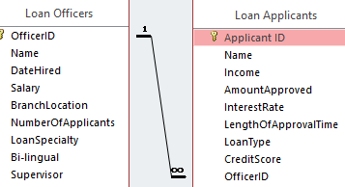

SELECT E.Name, E.[Bi-lingual], M.Name, M.[Bi-lingual]

FROM [Loan Officers] E, [Loan Officers] M

WHERE E.Supervisor=M.OfficerID

AND E.Bilingual=”Yes” and M.Bi-lingual=”Yes”;