ORDER BY, GROUP BY and Comparison of the Two

ORDER BY: Multi-field sort: City is the primary sort, Annualsales the secondary
SELECT RestaurantID, City, Annualsales  FROM Restaurants  ORDER BY City, Annualsales; | 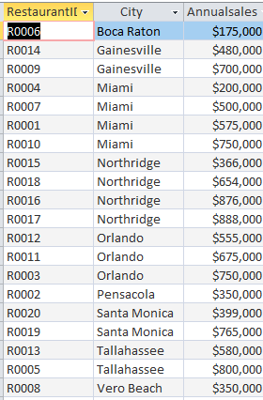

Compare GROUP BY and ORDER BY
SELECT City, COUNT(RestaurantID) AS NumRestInCity, AVG(Annualsales) AS AvgSales  FROM Restaurants  GROUP BY City; | 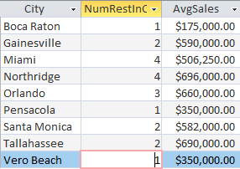  Twenty restaurants collapsed to 9 city groups

SELECT City, COUNT(RestaurantID) AS NumRestInCity, AVG(Annualsales) AS AvgSales  FROM Restaurants  GROUP BY City  ORDER BY AVG(Annualsales) DESC; | 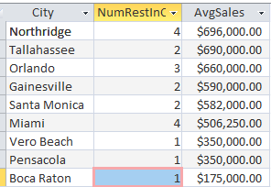

Aggregate function w and w/o group by
SELECT City, COUNT(RestaurantID) AS NumRestInCity, AVG(Annualsales) AS AvgSales
FROM Restaurants
GROUP BY City;

Without GROUP BY:
SELECT COUNT(RestaurantID) AS NumRestInCity, AVG(Annualsales) AS AvgSales  FROM Restaurants  (There was no grouping) | 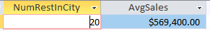  The above aggregate functions are performed over the WHOLE table

GROUP BY w conditions – “HAVING”
SELECT City, COUNT(RestaurantID) AS NumRestInCity, AVG(Annualsales) AS AvgSales  FROM Restaurants  GROUP BY City  HAVING COUNT(RestaurantID)>2; | 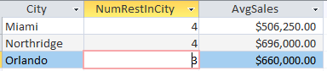  ONLY those cities w more than 2 restaurants were selected

