**IS 441 Week 2 Class Summary and Highlights, Version 2.1**

Dr. Yue Zhang **(Revised February 7, 2018)**

Business rules:

1. Each relationship needs TWO rules, one from each entity involved
2. A biz rule in a binary relationship cannot involve three entities

Basic Concepts:

1. Entity and entity instance:

Example:

Entity – STUDENT (FN, LN, Major),

entity instances: (1) John Smith, IS; (2) Juan Gonzalez, CIT; (3) Ming Wang, ACCT

1. Entities correspond to tables;

Entity instances correspond to rows;

Attributes correspond to columns;

Relationships correspond to PK-FK pairs.

1. Example of definition of entities: P. 57; excellent example of business rules: P. 58

Our own example: CLASS

“A CLASS is

* The delivery of defined contents in a specific subject
* In the setting of a school
* By a qualified instructor
* To a defined, intended audience (students of certain major(s))
* In a pre-arranged location
* At a pre-set time for a pre-defined duration”

1. ER Diagrams: two major types – Chen diagram (Dr. Peter Chen), and Information Engineering diagram (IE, the one that is used in the textbook). Get familiar with both formats.

Get familiar with: 1) entity symbols; 2) attribute symbols; 3) relationship symbols.

1. **Remember: a relationship must be described from BOTH directions (w TWO business rules)!
2. (1) Degree of relationship, and (2) cardinality of relationship:
3. Degree: about how many ENTITIES are involved; while
4. Cardinality: about how many entity INSTANCES in the other entity (the “ending entity”) are involved, **given EACH instance in the entity of interest** (the one the relationship starts – remember a relationship has direction)
5. Cardinality includes: (i) number (1 or M), and (ii) “intensity” (optional or mandatory).

There are MIN and MAX cardinalities in each direction of each relationship;

The MIN portion determines whether the relationship is optional or mandatory;

2017

The MAX portion determines whether the relationship is ONE or MANY.

Cardinality must be determined ONLY AFTER examining BOTH directions of the relationship.

1. Syntax to state business rules:

(Most general) ENTITY_1 *Relationiship_Verb_Phrase* number ENTITY_2

(More operational) ENTITY_1 *May/Must Do/Have* 1/M ENTITY_2

(Example) CUSTOMER *must* be served by only one EMPLOYEE

(Example) MANAGER *must* have at least one SUBORDINATE

Design of ER Diagram:

1. Associative entity: Consider assoc. ent. when the relationship –
2. Is Many-to-many
3. Has attributes of itself.
4. Cardinality: 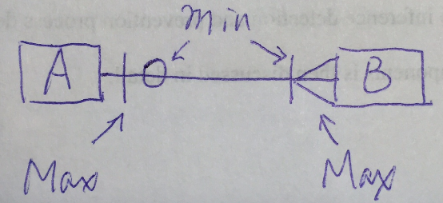
5. Min cardinalities are indicated “closer to the center”,

Max cardinalities are toward the “far ends” of the relationship.

1. **If minimum is zero (circle - O), the relationship is optional;**

**if minimum is one (stroke - I), the relationship is mandatory.**

|  |  |
| --- | --- |
| When a M-M relationship is converting to an associative entity, the cardinalities “in the eyes of each of the original entities are maintained” |  |

A better annotated copy of the figure:

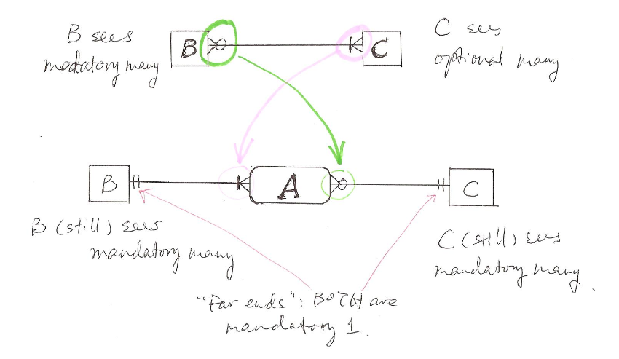

The “far ends” of a relationship involving assoc. ent are ALWAYS mandatory one.

From the PPT slide:

