IS 441 SQL Practice: Self-Join; Dr. Jeff Zhang, Fall 2016

In Thursday’s class, I planned a practice of SQL coding on self-join. | 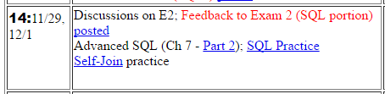

We did not have sufficient time in class; but this skill is needed for HW 6 and will appear in the final exam, so I feel it helps to give you a presentation of a complete solution process, so that you can have one more example (in addition to the one in the Chap 7, Part 2 slide) to learn and think about self-join.

I will use the database as posted on class web, to showcase the solution of a self-join problem.

Scenario: In the DB, there are students who are tutors, and students who are non-tutors. Each student may have a tutor, indicated by the non-tutor student’s tutor ID, which is actually of the student ID of that tutor.

ERD | Relational Model
Each STUDENT may tutor M students;  Each STUDENT may be tutored by one student  STUDENT | Recursive foreign key:

The meaning of the above ERD and relational model can be easily observed from the following section of the STUDENT table:

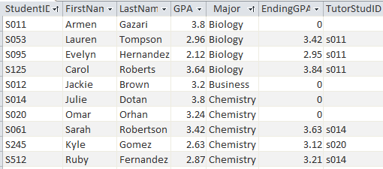 | Where S053, S095, and S125 all have S011 as their tutor; S061 and S512 have S014 as their tutor, and S245 has S020 as tutor, etc.

Problem: Find those tutors whose GPA is at least 1.2 times those of the tutee student’s GPA.
Thinking: Ref Slide #7-4 (Employees and their managers), we can see that we need to logically define the one physical table as two: T (Tutor) and NT (non-tutor), where non-tutor’s tutor ID (“TutorStudID” in the table) matches the tutor’s student ID:
L1  L2  L3  L4  L5 | SELECT NT.StudentID, NT.LastName, S.GPA, T.StudentID, T.LastName, T.GPA  FROM Students NT, Students T  WHERE NT.TutorStudID = T.StudentID AND T.GPA >= 1.2* S.GPA; | 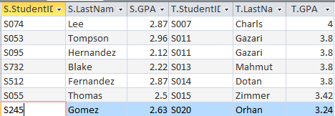
Line 3: Define one table into 2 logical tables; Line 4: Join condition – WATCH which is which;
Line 5: Logical condition
In the copy I sent you, I named the non-tutor student view (“table”) as S;
I realized that some of you might be confused;
so here I’m posting a revised version with the name changed to NT

