SQL Examples - WHERE vs HAVING; Join Two Tables; Simple Subquery
Dr. Yüe Zhang, August 6, 2018

- WHERE vs HAVING

SELECT COUNT(RestaurantID),AVG(AnnualSales),  Typeofservice  FROM restaurants  WHERE Annualsales>=650000  GROUP BY Typeofservice; | SELECT COUNT(RestaurantID),AVG(AnnualSales),  Typeofservice  FROM restaurants  GROUP BY Typeofservice  HAVING AVG(Annualsales)>=650000
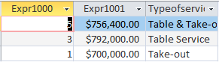 | 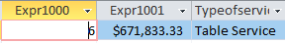  Observe the data and understand the codes

- Join two tables

Purpose: So that fields from different tables can be displayed.
Operation: Join two tables, based on the PK = FK relationship.
Points to watch:
- The PK (which is also FK) needs to be indicated the table it is from (fields that are in only one table do not need table designation);
- In addition to logical conditions there may be, there MUST be a join condition;
- Two common alternatives to implement the join condition:
  - WHERE-clause: FROM Table 1, Table 2 WHERE Table1.PK = Table2.FK
  - FROM-clause: FROM Table1 JOIN Table2 ON Table1.PK = Table2.FK
  - “a” is preferred for tis simplicity when there are three or more tables to join, while “b” is very much more complex when number of tables to join is three or more: parentheses are required which can be complex and error-prone.

Example:

SELECT Restaurants.RestaurantID, AnnualSales, LastName  FROM Restaurants, Franchisees  WHERE Restaurants.FranchiseeID = Franchisees.FranchiseeID  - Join condition | 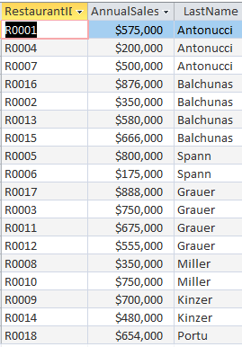

- Simple subquery
Subqueries are very useful. One of the usage of subqueries is to use them to by pass the limitation of “no mixture of aggregate function and field names in SELECT.”

SELECT RestaurantID, AnnualSales  FROM Restaurants  WHERE City = “Northridge”; | 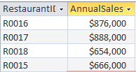
SELECT RestaurantID, AnnualSales, AVG(AnnnualSales)
FROM Restaurants
WHERE City = “Northridge”;

SELECT RestaurantID, AnnualSales,  (SELECT AVG(AnnualSales) FROM Restaurants)  FROM Restaurants  WHERE City = "Northridge"; | 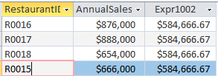
Continued next page…

SELECT RestaurantID, AnnualSales,  (SELECT AVG(AnnualSales) FROM Restaurants AS GrandAVG)  FROM Restaurants  WHERE City = "Northridge";  - Alias INSIDE subquery was not displayed | 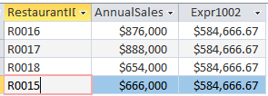
SELECT RestaurantID, AnnualSales,  (SELECT AVG(AnnualSales) FROM Restaurants ) AS GrandAVG  FROM Restaurants  WHERE City = "Northridge";  - Alias OUTSIDE subquery was displayed | 