IS 441 SQL Subquery Demo 2: Non-Correlated and Correlated Suqueries
Dr. Yue Zhang, August 8, 2018

Non-Correlated Subquery:

List restaurant IDs for those restaurants in the kind of cities where there are at least three restaurants

SELECT RestaurantID, City  FROM Restaurants  WHERE City IN  (SELECT City FROM Restaurants  GROUP BY City  HAVING COUNT(RestaurantID)>=3); | 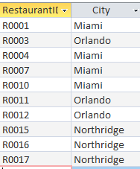

Correlated Subquery:

The above, PLUS the number of restaurants in the city a restaurant is in.
[An excellent example of a correlated query]
- We have seen (thru my “acting”) that there needs to be a “communication” from the outer query INTO the inner query on WHAT CITY you need to do the count
- - “Passing of parameter”

SELECT RestaurantID, City,  (SELECT COUNT(RestaurantID) FROM Restaurants  WHERE City=R_Outside.City  GROUP BY City) AS CountRest  FROM Restaurants R_Outside  WHERE City IN  (SELECT City FROM Restaurants  GROUP BY City  HAVING COUNT(RestaurantID)>=3); | 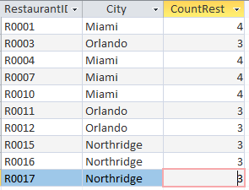

List restaurant IDs and cities, together with City sales average (= average annual sales in the city), for those restaurants whose sales are higher than ITS OWN city average.

SELECT RestaurantID, AnnualSales, City,  (SELECT AVG(AnnualSales)  FROM Restaurants  WHERE City=R.City  GROUP BY City) AS CityAVG  FROM Restaurants R  WHERE AnnualSales >  (SELECT AVG(AnnualSales)  FROM Restaurants  WHERE City=R.City  GROUP BY City); | 