SQL Examples Solved in Class of Apr 19

Self-Join:
SELECT E.EMP_LNAME, E.EMP_FNAME, m.emp_lname, m.emp_fname
FROM employee AS E, employee AS m
WHERE e.spv_num = m.emp_num;

HW #4 (SQL 1) Selected questions:
SELECT …
FROM employee
WHERE job_code NOT IN …

SELECT AVG(EMP_PCT), proj_num  FROM employee  GROUP BY proj_num  HAVING … | 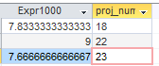
SELECT AVG(EMP_PCT), proj_num  FROM employee  WHERE …  GROUP BY proj_num | 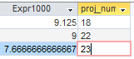

Subquery Examples:

SELECT emp_num,emp_lname,emp_pct,  (SELECT AVG(emp_pct) FROM employee)  FROM employee  WHERE emp_pct >  (SELECT AVG(emp_pct) FROM employee);  -- subqueries produce value(s) | 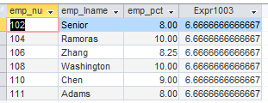

SELECT restaurantID, squarefootage  FROM Restaurants  WHERE squarefootage>=  1.5*  (SELECT AVG(squarefootage) FROM restaurants); | 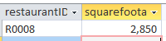
SELECT restaurantID, squarefootage,  (SELECT AVG(squarefootage) from RESTAURANTS) AS average,1.5*  (SELECT AVG(squarefootage) From RESTAURANTS) AS 150_Percent_AVG  FROM Restaurants  WHERE squarefootage>=  1.5*  (SELECT AVG(squarefootage) FROM restaurants); | 

