**IS 441 Summer 2019 Class session 4 Summary**

**Relational Modeling with Normalization**

Dr. Yüe “Jeff” Zhang, July 23 (for Class 0722), 2019

1. Referential integrity:

General rules:

In a one-to-many relationship,

1. We cannot delete a record on the one-side if there is(are) record(s) on the many-side that references this record (on one-side);
2. We cannot add a new record on the many-side that does not have a record on the one-side to reference to.

With our “Restaurants” example, the above two rules have the actual contents as follows:

1. We cannot delete a record on the Franchisees table if there is(are) restaurant(s) on that references this franchisee;
2. We cannot add a new restaurant that does not have a franchisee to reference to.
3. Example of Unary relationship converted to relational model:

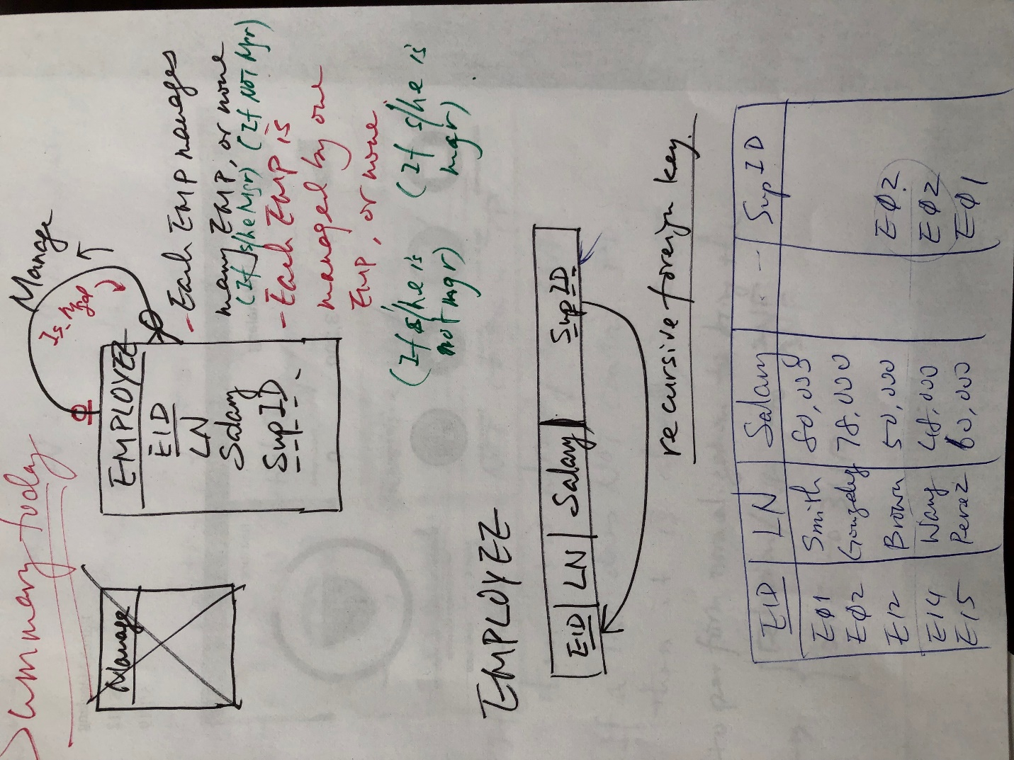

1. ERD “Short-term, long-term”:

If a cardinality is Optional in short term, it could become Mandatory in long term;

(“When something may happen, it will”)

If a cardinality is One in short term, it could become Many in long term.

(“What happens once in short term, can repeat in long term”)

No need to memorize the above: they are pretty much common sense.

1. Concepts of normal forms

|  |  |  |
| --- | --- | --- |
| Normal  Forms | Definition | Remarks |
| 1NF | A relation {no multi-valued field;  No repeated row} |  |
| 2NF | 1NF, with Partial Dependency (PD) removed | If a 1NF does not contain a PD, it is already in 2NF |
| 3NF | 2NF, with Transitive Dependency (TD) removed | If a 2NF does not contain a TD, it is already in 3NF |

1. Types of Functional Dependencies

|  |  |  |  |
| --- | --- | --- | --- |
| Determinant (D) is: | Type of Func. Dep. | Frunc Dep. Arrow goes: | Remark |
| Key (1-field or composite) | Full dependency (FD) | From key to non-key | ALWAYS exists |
| Part of key | Partial dependency (PD) | From part of key to non-key | Not always |
| Non-key | Transitive dependency (TD) | From non-key to non-key | Not always |

Func. Dep. End notes:

1. When do we need to worry about POSSIBLE PD? – Only when the key is composite.
2. Parts of a composite key do not determine each other.