**IS 441 Summer 2019 Class session 1 Summary: Entity Type; Business Rule; Degree and Cardinality**

Dr. Ye “Jeff” Zhang, July 11, 2019

Brand-new creation; hope it helps

1. Definition of Entity Type: What; Do what; Relationship with whom; Other important descriptions

Examples:

1. A local meeting of political parties

|  |  |
| --- | --- |
| An usually pre-planned meeting | What |
| Of a specific political party, | Possessive |
| Attended by the party members or supporters in a certain geographical region, | Does;  Relationship with |
| To present or support the party’s candidates, | Does |
| Or to discuss or promote the party’s regional or national political agenda or initiatives. | Does |
| Often times, there may be fundraising activities on the meeting. | Important description |

1. An order

|  |  |
| --- | --- |
| A request | what |
| That is placed | does |
| By a customer | Relationship with |
| To receive specified products or services | Does; Relationship with |
| From a specific provider | Relationship with |
| At certain agreed price | Important description |
| In agreed time scope. | Important description |
|  |  |

1. Business Rules

States the relationships between entity types;

Provides the ground for the determination of cardinality.

Format:

* A/An/Each <entity> <minimum cardinality> <relationship> <maximum cardinality> <entity>

Example:

1. A CUSTOMER may place many ORDERs, or may not place any ORDER.
2. An ORDER is placed by one CUSTOMER.
3. A CUSTOMER must place at least one ORDER. (= at least one, up to infinity).
4. An ORDER is placed by one customer.

1 – “optional”

3 – “mandatory”

**We base on business rules to determine the cardinality of the relationship (both numbers - one or many - and “intensity” – optional or mandatory).**

More examples about business rules determining cardinalities:

An ORDER **must** contains at least one PRODUCTs; a PRODUCT is contained in many ORDERs, or none.

* (Picture)
* 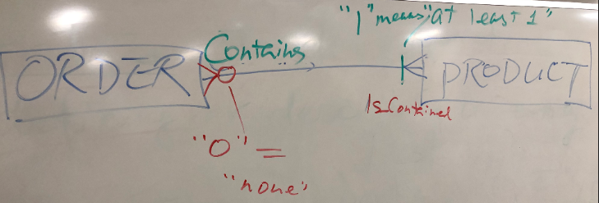

ENTITY_1 *Relationiship_Verb_Phrase* number ENTITY_2

(Entity 1: ORDER; Entity 2: PRODUCT)

An ORDER ***must*** *contain* at least one PRODUCTs

ENTITY_2 *Relationiship_Verb_Phrase* number ENTITY_1

A PRODUCT *is contained* in many ORDERs, or none

**A business rule only connects (only describes logical interactions between) TWO entity types!**

1. Cardinality: 1, numbers; 2, intensity

1. Numbers

Cardinality (using binary relationship – involving two entity types as example), is:

Take one row (one entity instance) in entity type A,

How many rows (entity instances) in entity type B can be related: 1? Many?

Example:

“One”:

Each STUDENT reports to one DEPARTMENT

= take one row from the STUDENT table, there can be only one row in the DEPARTMENT table related to (“reports to”) this one row in the STUDENT table.

“Many”:

Each FACULTY advises many STUDENTs

= take one row from the FACULTY table, there can be many rows in the STUDENT table related to (“is advised by”) this one row in the FACULTY table.

1. “Intensity”: Optional and Mandatory

Cardinality has maximum and minimum:

Min zero, Min 1 (none-zero);

Max 1, Max many (please note Max cannot be zero).

When Min is zero, the relationship is optional: “You do NOT need to have a related record in another table, so this relationship is optional” – sounds like a very natural reasoning right?

*** A relationship has FOUR cardinalities, two on each side (or each end):

Two minimum cardinalities are closer to the center;

Two maximum cardinalities are farther from center (or closer to the entities at the two ends).

Excerpt from Figure 2-16:

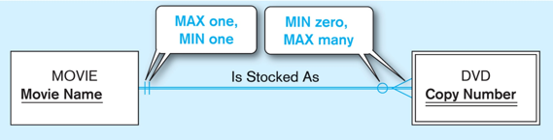

Mins are closer to the center

Maxes are farther from center or closer to the entities at the two ends