**November 30 In-Class Exercises: Self-Join and Subqueries**

Dr. Yue Zhang, December 1, 2017

Part I Self-Join: Find loan officers who earn more than their supervisors.

|  |  |
| --- | --- |
| SELECT Officer.OfficerID, Officer.Name, Officer.salary, Spv.OfficerID, Spv.Name, Spv.salary  FROM [Loan Officers] Officer, [Loan Officers] Spv  WHERE Officer.[Supervisor] = Spv.[OfficerID]  AND Officer.Salary > Spv.Salary; | Notes:  1, Here we take one physical table and use it as two logical views: Officer and Spv (for Supervisor).  2, The key is the join condition, which is marked in red.  3, [Loan Officers] – in bracket since the field’s name contains two words, and SQL need that one field to be identified with the brackets |

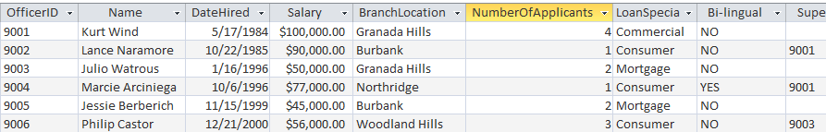

Part II: Subquery – Non-Correlated and Correlated



1. Non-Correlated subquery - Find: Applicants whose AmountApproved is higher than the overall average

SELECT [Applicant ID], Name, (SELECT AVG(AmountApproved) FROM [Loan Applicants])

AS AVG

FROM [Loan Applicants]

WHERE AmountApproved >

(SELECT AVG(AmountApproved) FROM [Loan Applicants]);

1. Correlated subquery - Find: Aplicants (w amount), and side-by-side comparison with the avg amount of his/her own type,

For those applicants whose amount is greater than the avg of its type

SELECT [Applicant ID], Name, LoanType, AmountApproved,

(SELECT AVG(AmountApproved) FROM [Loan Applicants] LA_Inside

WHERE LA_Inside.LoanType = LA_Outside.LoanType

GROUP BY LoanType) AS TypeAVG

FROM [Loan Applicants] LA_Outside

WHERE AmountApproved >

(SELECT AVG(AmountApproved) FROM [Loan Applicants] LA_Inside

WHERE LA_Inside.LoanType = LA_Outside.LoanType

GROUP BY LoanType)

One more example on **GROUP BY**:

Total loan amounts from applicants who have the same loan officer, together with the officer’s name

|  |  |
| --- | --- |
| SELECT SUM(AmountApproved) AS OfficerTotal, [Loan Applicants].OfficerID, [Loan Officers].Name  FROM [Loan Applicants], [Loan Officers]  WHERE [Loan Officers].OfficerID = [Loan Applicants].OfficerID  GROUP BY [Loan Applicants].OfficerID, [Loan Officers].Name | Suggestion: When joining tables and in the case where there’re logical conditions, state the join condition first so it is not forgotten, then the logical condition(s). |